**MINISTRY OF EDUCATION AND TRAINING**

**FPT UNIVERSITY**

Capstone Project Final Report

**STUDY ONLINE**

|  |  |
| --- | --- |
| **SO Team** | |
| **Group Members** | Nguyễn Quang Nhật- SE04924  Đỗ Tùng Dương - SE04940  Nguyễn Anh Đức - SE04962  Nguyễn Khắc Phát – SE05140  Phùng Đắc Giang – SE04744 |
| **Supervisor** | Lecturer: Nguyễn Trung Kiên |
| **Capstone Project code** | SWP490_G16 |

### Hanoi, December 2019

## Table of Contents

Table of Contents

Hanoi, December 2019 1

Table of Contents 2

Chapter 1: Introduction 9

1. Purpose 9

2. The people 10

3. Background 10

4. Existing Solutions 10

5. Proposal of system 12

6.1 System introduction 12

6.2 System roles 12

6.3 Business flows 13

6.4 Out of scope functions 13

Chapter 2: Project Plan 15

1. Purpose 15

2. Project Overview 2.1.Scope 16

2.2. Objectives 16

2.3. Milestone and deliverables 16

3. Project Organization 18

3.2 Roles and Responsibilities 19

3.2.2 Project Team Member 19

3.2.3 Organization Structure 20

4. Project Schedule 21

5. Communication Management 23

5.2 Communication with supervisor 24

5.3 Meeting Plan 24

6. Configuration Management 25

6.2 Conventions Coding Conventions 25

Document conventions 26

Filename Conventions 26

7. Risk Management Plan 26

7.1 Risk register 27

7.2 Probability – Impact Matrix 28

Chapter 3: Software Requirement Specification 29

1. Purpose 29

2. Functional Requirements 29

3. Non-functional Requirement 110

3.2 Maintainability 110

3.3 Availability and Scalability 110

3.4 Performance 110

3.5 Security 110

4. Entity Relationship Diagram 112

Chapter 4: Software Design 116

1. Introduction 116

1.1 Purpose 116

1.2 Scope 116

1.3 Constrainst 116

2. Architecture Overview 116

2.1 System Overview 116

2.1.1 Protocol Explanation 117

2.1.1 SF – Backend Design 121

2.2 Package Diagram 121

3.1 Detailed Description of Components 122

4.1 Database Design 214

Chapter 5: Software Testing Documentation 214

Introduction 214

1. Purpose 214

2. Test Plan 216

2.1.1 Testing Tools and environment 216

3. Resources and responsibilities 218

4. Test Strategy 219

5. Test Schedule 220

3.1Test Approach 221

3.1.1 Unit test with NUnit 221

3.1.2 Integration and System test 222

3.1.2 Defect log 222

4.1 Test report 222

4.1.1 Unit test report 222

4.1.2 Integration and System test report 223

Chapter 6: USER’S MANUAL 223

1.Purpose 223

1.1 Detailed Guidelines 223

**Acknowledgements**

*We wish to express our deepest gratitude to our supervisor Mr. Nguyen Trung Kien for his continuously sharing and motivating throughout the project. Under the instructions of Mr.Kien, the project team has always felt comfortable and confident. Apart from all the technologies and methodologies, Mr.Kien shared with us the philosophy of keeping the right attitude towards problems. We believe that was the most important factor that led to the success of this project.*

*We would also like to thanks the instructors at FPT University for all the classes. We hope you will find this project as a reflection of the knowledge and experiences you have given us during this period of four years.*

*Finally, we truly appreciate the random fellows on the internet who has discussed with us. Without them, it would have likely been a real struggle to solve every tiny problem.*

**Definitions and Acronyms**

|  |  |  |
| --- | --- | --- |
| **Acronym** | **Definition** | **Note** |
| ST | Study Online |  |
| API | Application Programming Interface |  |
| N/A | Not available |  |
| PM | Project Manager |  |
| SRS | Software Requirement Specification |  |
| UC | Use case |  |
| UI | User Interface |  |
| QA | Question and answer |  |

**List of tables**

Table 1: Supervisor’s information 16

Table 2: Team member’s information 16

Table 3. Types of user in SF System 19

Table 4. Milestone and Deliverables' information 21

Table 5. Project Team Member 23

Table 6. Project Structure 24

Table 7: Meeting Minutes Template 27

Table 8. Risk Management 29

Table 9. The probability and impact matrix 30

Table 10. List functions of this system 32

Table 11. Database entity description table 84

Table 12. answer table design 84

Table 13. answer_upvoted_user_ids design 84

Table 14. app_user table design 85

Table 15. app_user_tag table design 85

Table 16. article table design 85

Table 17. article_tags design 85

Table 18. article_upvoted_user_ids 86

Table 19. edited_question table design 86

Table 20. edited_question_tags 86

Table 21. question table design 87

Table 22. question_tags table design 87

Table 23. question_upvoted_user_ids table design 87

Table 24. report table design 87

Table 25. social_user table design 88

Table 26. tag table design 88

Table 27. uploaded_file table design 88

Table 28. comment table design 89

Table 29. comment_upvoted_user_ids table design 89

Table 30. article_subcribers table design 89

Table 31. notification table design 90

Table 32. question_subcribers tables design 90

Table 33. Test schedule 159

Table 34. Deliverables schedule 159

Table 35. Check list of acceptance test table 160

Table 36. Integration Test Report 163

Table 37. Sample Add Article in Manage Article module test case 167

**List of figures**

Figure 1. Vietnam Agricultural Newspaper system 18

Figure 2. Regional Brand system 18

Figure 3. The Posting question process on SF 20

Figure 4. The Answering the question process on SF 20

Figure 5. Iterative Software Process Model 22

Figure 6. Project team organization 23

Figure 7. Project Management file 24

Figure 8. Communication via Excel online 25

Figure 9. Actor use case 33

Figure 10. Level 1 use case 34

Figure 11. Use case diagram of Logged in User actor and Anonymous – Manage question 35

Figure 12. Use case diagram of Admin actor – Manage question 36

Figure 13. Use case diagram of Manage answer 48

Figure 14. Use case diagram of Logged in User and Anonymous – Manage article 53

Figure 15. Use case diagram of Admin – Manage article 54

Figure 16. Use case diagram of Manage user 61

Figure 17. Use case diagram of Manage tag 66

Figure 18. Use case diagram of Admin– Manage report 68

Figure 19. Use case diagram of Manage notification 69

Figure 20. Use case diagram of Other functions 72

Figure 21. Entity Relationship Diagram 76

Figure 22. System Overview 78

Figure 23. Font-end Design 79

Figure 24. SF – Backend Overview Design of each Controller 80

Figure 25. SF – Backend Design 80

Figure 26. SF – Entity Design 81

Figure 27. Package diagram 81

Figure 28. Database Diagram 82

Figure 29. Manage question Class diagram 91

Figure 30. Manage answer Class diagram 108

Figure 31. Manage Article Class diagram 115

Figure 32. Manage Users class diagram 128

Figure 33. Search all Class diagram 150

Figure 34. V model 156

Figure 35. Test process 158

Figure 36. Defect log by Excel online 161

# Chapter 1: Introduction

### Purpose

This chapter provides an overview of the Online Learning project. In this document includes project information, supervisor, project team members, the overview of existing systems, the problems and solution of the project, brief description of out expected application and some critical assumptions, constraints. In the end, it will be some out of scope of the project.

Project Information

* + Project name: **Studing** **Online**
  + Project code: **SWP_G16**
  + Project group name**: Good Team**
  + Product type: **Website application**
  + Timeline: **09 September 2019 – 19th December 2019**

### The people

* 1. **Supervisor**

|  |  |  |  |  |
| --- | --- | --- | --- | --- |
| **Role** | **Full name** | **Phone** | **E-Mail** | **Title** |
| Supervisor | Nguyễn Trung Kiên | 0912656836 | [**kiennt@gmail.com**](mailto:kiennt@gmail.com)  **kiennt@fpt.edu.vn** | Lecturer |

*Table 1: Supervisor’s information*

* 1. **Team members**

|  |  |  |  |  |  |
| --- | --- | --- | --- | --- | --- |
|  | **Full name** | **Student code** | **Phone** | **E-mail** | **Role in Group** |
| 1 | Nguyễn Quang Nhật | SE04924 | 0339856504 | [nhatnqse04924@fpt.edu.vn](mailto:haltthe131024@fpt.edu.vn) | Leader |
| 2 | Nguyễn Anh Đức | SE04962 | 01258819536 | [ducnase04962@fpt.edu.vn](mailto:ducnase04810@fpt.edu.vn) | Member |
| 3 | Nguyễn Khắc Phát | SE05140 | 0962121023 | [phatnkse05140@fpt.edu.vn](mailto:phatnkse05140@fpt.edu.vn) | Member |
| 4 | Phùng Đắc Giang | SE04744 | 0947939762 | [giangdpse04744@fpt.edu.vn](mailto:giangdpse04744@fpt.edu.vn) | Member |
| 5 | Đỗ Tùng Dương | SE04940 | 0984298666 | [duongdtse04940@fpt.edu.vn](mailto:duongdtse04940@fpt.edu.vn) | Member |

*Table 2: Team member’s information*

### Background

Our Online has been proving the development trend of society: reading online newspapers, shopping online, social networking online, booking online tickets, buying movie tickets online. Learning online is definitely not out of that trend.

  Online learning, also known as E-Learning, is a popular study model around the world, but this model is completely new and strange to young people in the S-shaped country. Many You are afraid that online learning is more effective than studying in centers? The amount of knowledge between learning Online & Offline is different.

    Many of you must be familiar with the old learning model of carrying your backpack up and going to the centers every day, and you have also experienced some emotional states such as waiting for teachers to come because they are late or you have to go to school on rainy days, and there are plenty of other reasons like traffic jams, housework. And the consequences are very serious if for those reasons that day. You can not go to class will be You will lose work that day and will not keep up the schedule of lectures, losing friends in class. And you will start to get discouraged because of the unexpected results with the money you have spent so to solve such problems, learning online will help many people.

### Existing Solutions

There is a part of us and you can study online..

#### Udemy solution

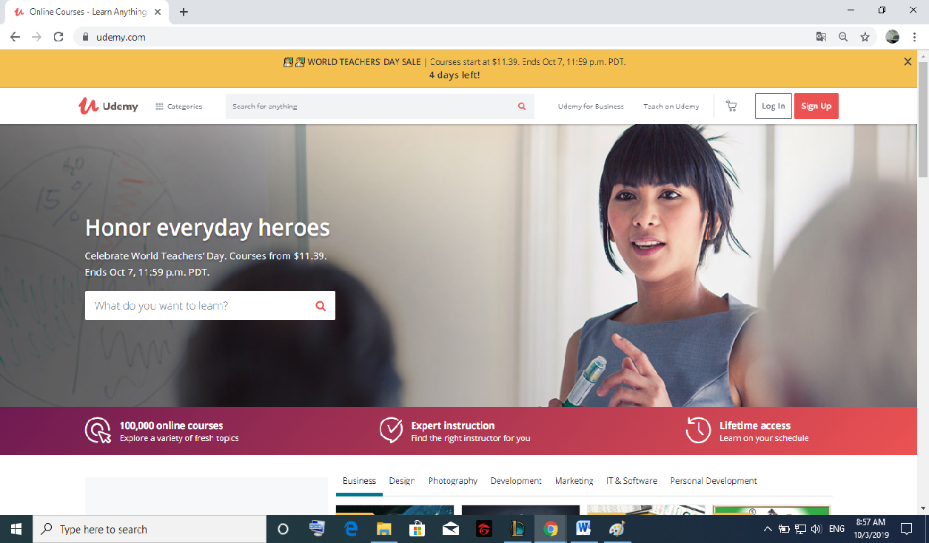

*Figure 1. Online learning system*

This is a great news agency for students to study online best and be close to university students, but the information on the website is mostly knowledge and useful videos in foreign languages ​​and can be expensive..

#### Online coursera and Credentials solution



*Figure 2. Online coursera and Credentials system*

Like other useful online learning software for students, it is one of the software that offers the best course, but there are many limitations and the most special thing is the high cost.

### Proposal of system

After reviewing all properties of the current system as well as our target customer being everyone in Vietnam, we have come to a decision to choose which features and functions we will provide in our system.

### System introduction

Online Learning is an program for student. Specifically, there are two main types of users:

For *Ordinary user*:

* + - Online Learning is a program interesting and rewarding for everyone.
    - We accompany you to find and share the answers and knowledge related to course
    - With every valuable contribution from the course,we help you build the best leaderboard to conquer employers.

For *Employers*:

* + - Our mission is to help you find "experts" and become "experts".
    - Moreover, provide them with an environment to share knowledge, learn and improve productivity

### System roles

There are 3 types of user in SO system:

|  |  |
| --- | --- |
| **Type of user** | **Description** |
| Admin | A person who has the highest permission level and is responsible for managing the website: users, questions, answers, reports, and managing all in the web. |
| User | Everyone who has a Gmail account and logged in to system to read, search, ,… All activities are up voted, share or report by others. For each activity on the web, they are scored to beautify the history of the activity. They can also post their CV in pdf format for everyone to see. This creates an advantage when employers look to them. |
| Teacher |  |

*Table 3. Types of user in SO System*

### Business flows

* + 1. **Business flows Users**

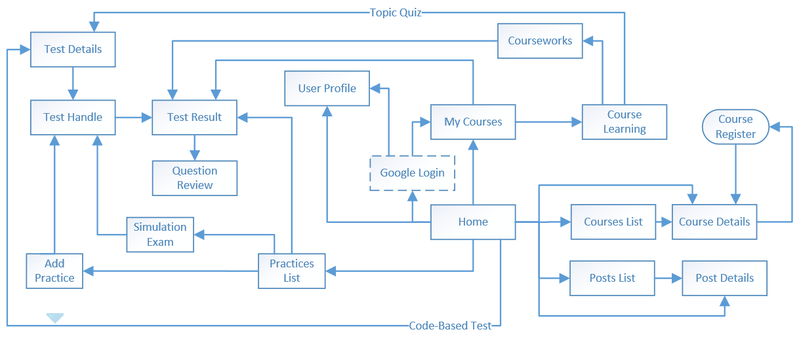

* + 1. **Business flows Admin/CMS**

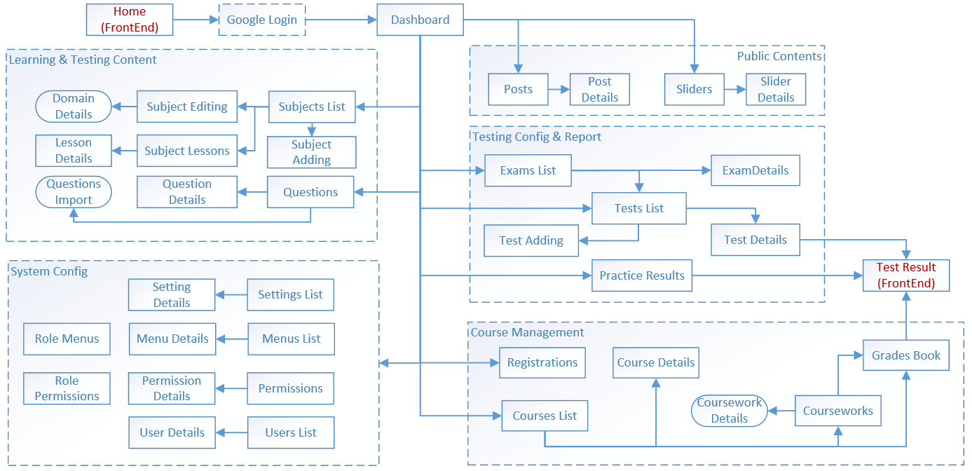

### 6.4 Out of scope functions

We only do all the features listed in Chapter 3, section 2.2. Any functions not listed will not be executed.

# Chapter 2: Project Plan

### Purpose

This chapter provides an overview of the project plan including project organization and project management plan.

### Project Overview 2.1.Scope

The scope of this project includes these stages:

* + Collect user requirement and software requirement specification.
  + Develop architecture and detailed design document.
  + Code and unit test.
  + Develop test case and execute combination test.

This application has these main functions:

* + Study and Test for Student.
  + Student management and teaching for teachers
  + Online learning management software for Admin :
* Public Contents
* Learning and Testing Content
* Testing config and report
* System config
* Course Management

### Objectives

Project must be finished before 20/12/2019 with three main deliverables:

* + - Web application (covers 100% of requirements described in chapter 3)
    - Project documentation (meet FPT University capstone project template)
    - Project presentation slides

### Milestone and deliverables

|  |  |  |  |
| --- | --- | --- | --- |
| **No** | **Milestones** | **Deliverables** | **Date** |
| 1 | Project Registration | Project Registration document | 12/09/2019 |
| 2 | SRS completion | SRS documents | 27/10/2019 |
| 3 | System Design completion | Software Design document | 27/10/2019 |
| 4 | Coding completion | Source Code | 20/11/2019 |
| 4.1 | Iteration 1 (Coding completion ) | Source Code | 27/10/2019 |
| 4.2 | Iteration 2 (Coding completion) | Source Code | 10/11/2019 |
| 4.3 | Iteration 3 (Coding completion) | Source Code | 24/11/2019 |
| 5 | Test case completion | List test cases | 25/11/2019 |
| 5.1 | Iteration 1 (Test case completion) | List test cases | 27/10/2019 |
| 5.2 | Iteration 2 (Test case completion) | List test cases | 10/11/2019 |
| 5.3 | Iteration 3 (Test case completion) | List test cases | 24/11/2019 |
| 6 | Software Test Documentation (STD) | Test case document | 26/11/2019 |
| 7 | Go live | Public website | 02/12/2019 |
| 8 | Project defense | Presentation | 12/12/2019 |

*Table 4. Milestone and Deliverables*

### Project Organization

* 1. **Software Process Model**

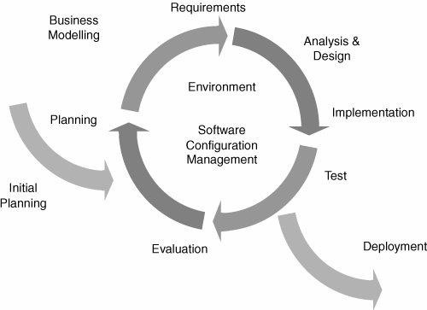

*Figure 5. Iterative Software Process Model*

Online Learning project uses the Iterative Software Process Model.

The Iterative Software Process Model is mostly used when the scope of the project is normal, the major requirements are defined, while some functionalities and requested enhancements evolve with the process of the development process.

In this project, we apply Incremental model as development process model because this model has these useful advantages:

* + - Some main functions can be developed early & quickly
    - More flexible - Easy & less costly to change if having.
    - Testing and debugging during smaller iteration is easy
    - Iterations may be run simultaneously. A design team starts the next iteration while the current one is under test
    - The project team learns from first iterations and may use best practices and experiences in next iterations
    - Easier to manage risk because risky pieces are identified and handled during its iteration.

### Roles and Responsibilities

* + 1. **Roles and responsibilities**

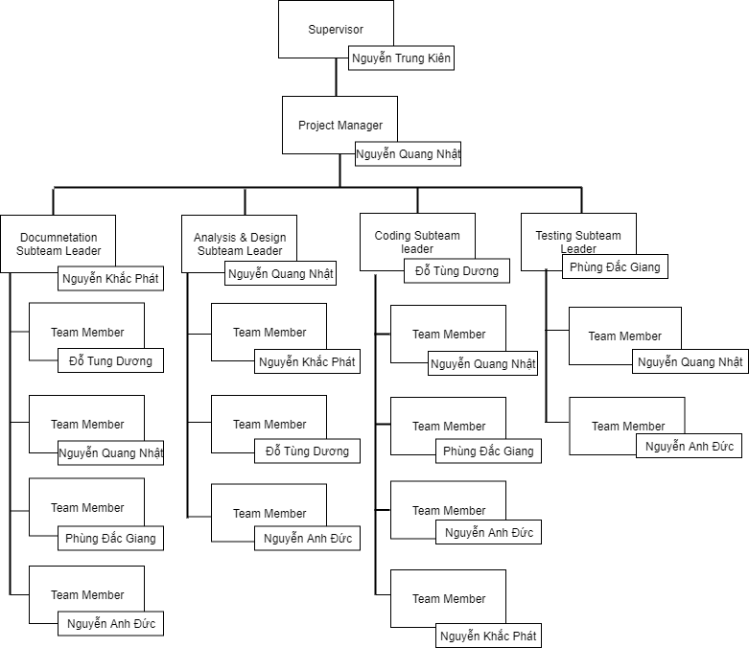

*Figure 6. Project team organization*

### Project Team Member

|  |  |
| --- | --- |
| **Team Member** | **Role** |
| NhatNQ | Project Manager, Business Analyst, Developer, Tester |
| DuongDT | Technical Leader, Business Analyst, Developer |
| PhatNK | Developer, Secretary, Tester |
| GiangPD | Tester Leader, Developer |
| DucNA | Developer, Tester |

*Table 5. Project Team Member*

### Organization Structure

|  |  |
| --- | --- |
| **Role** | **Responsibility** |
| Project Manager | Planning, developing schedules, coordinating communication, generally responsible for keeping the team’s focus on the main goal. |
| Technical Leader | Responsible for choosing and deciding what technologies should be used, as well as for overseeing the work being done by other developers. |

|  |  |
| --- | --- |
| Quality Assurance Manager | Ensuring the product meets the certain standards of quality from requirements. |
| Test Leader | Responsible for test execution, including test set-up and test run, evaluation of test run and error recovery, defect logging and test results recording. |
| Developer | Involve to code the product and review code of other developers. |
| Designer | Involve to design product’s user interface. |
| Tester | Involve to test the product. |
| Business Analyst | Analyzes an organization or business domain and documents its business or processes or systems. |

*Table 6. Project Structure*

### Project Schedule

Refers to “OL_CapstoneProject.mpp” file.

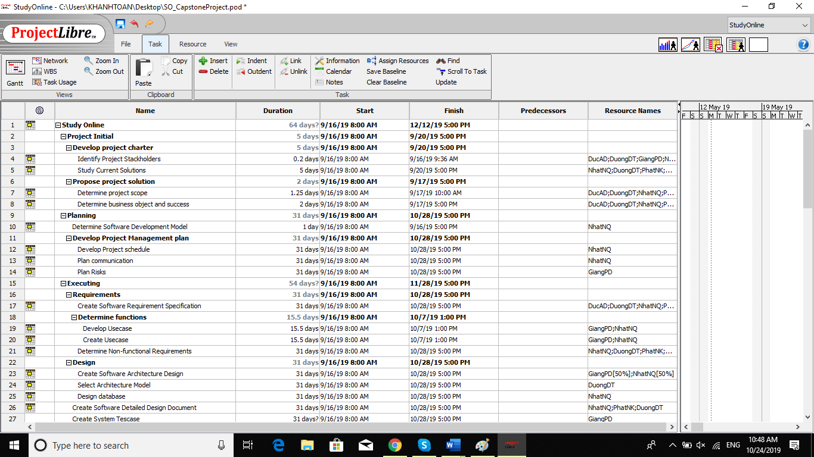

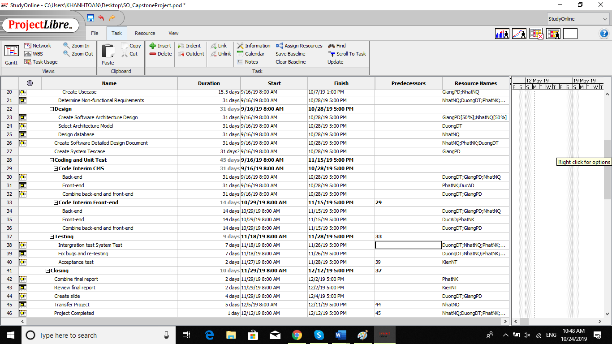

*Figure 7. Online Learning Project Management file*

### Communication Management

* 1. **Communication with members**

**Weekly meeting Schedule:** We use Iterative and Incremental Process Model, then we divide the system into two sub-systems (SF Backend and SF Frontend), each sub-system is divided into a series of small tasks. Each task is logged to Excel online then estimated depending on difficulty and the amount of work by the whole team, after that the task will be assigned to team members by the Team Leader and depending on difficulty the Technical Leader will assign deadlines for each task. We will have a meeting every Tuesday to inform to all team about what each member finished last week, the status (fast, on time or slow), the issues met and how to solve them. If any member raises any issue, the whole team will help to find out a solution together. After that, the team will define detailed stories for next week tasks.

**Unscheduled meeting:** If someone has an important want to be solved immediately, we will have a meeting for discussion.

**Communication channel**: Our main communication channel is [Facebook](https://kajkai.slack.com/). On the other hand, we use face-to-face meeting, and comment on Excel online issues. However, we sometimes make a phone call or instant message if someone has a problem.

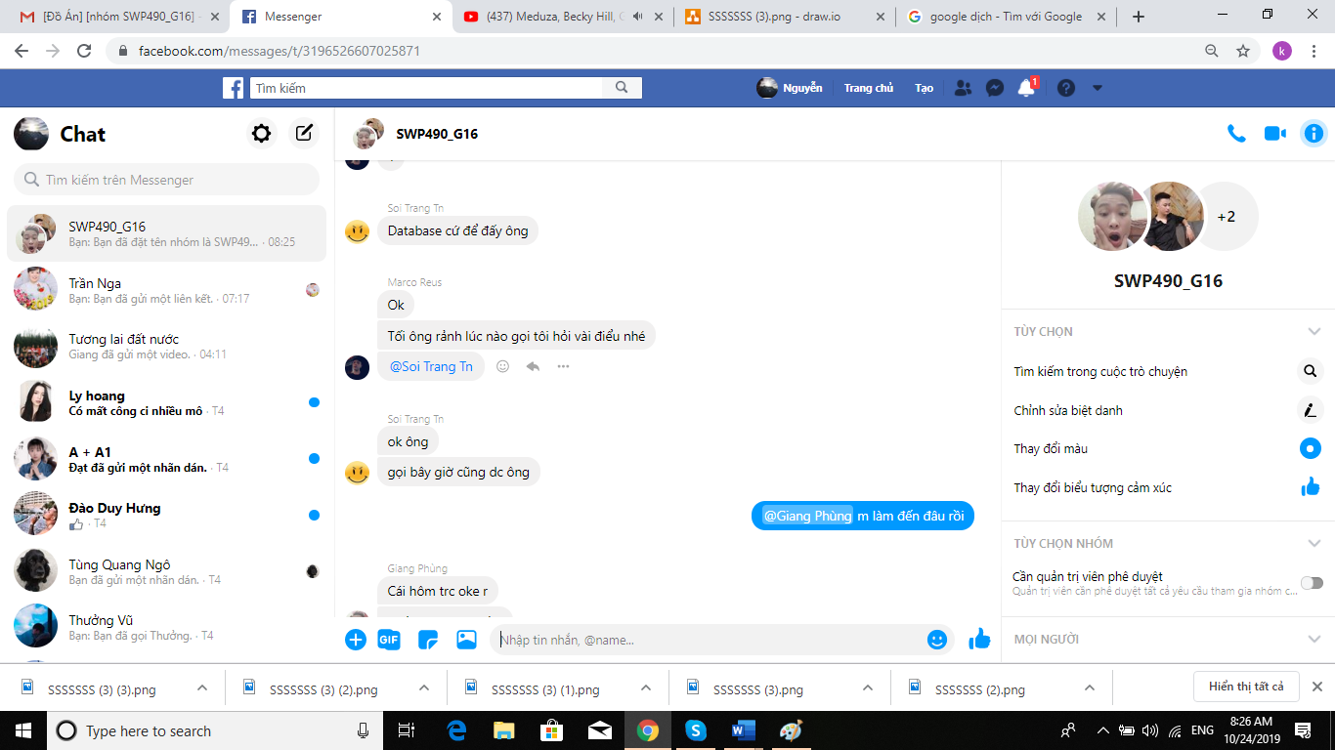

*Figure 8. Communication via Skype*

### Communication with supervisor

**Face-to-face meeting:** Weekly on every Saturday afternoon to make sure that supervisor can keep tracking of the team’s progress.

**E-mail:** Gmail is the fastest way to get advice and document checking form supervisor.

**Mobile Phone:** Is used to get time and place arranged for the meeting every week.

### Meeting Plan

Within 15 weeks from 15/09/2019 to 12/12/2019, project team has meeting with instructor on every Thursday of the week. When implementing process, if we had issue need instructor’s consultation, we will proactively arrange meetings.

All meeting minutes will be written following this template:

|  |  |  |  |  |  |  |  |  |
| --- | --- | --- | --- | --- | --- | --- | --- | --- |
| ***Meeting/Project Name:*** | | *Studing Online* | | | | | | |
| ***Date of Meeting:*** | | *15/09/2019* | | | ***Time: (Type)*** | *17:40 – 21:00 (Face-to-*  *face)* | | |
| ***Meeting Called by:*** | | *NhatNQ* | | | ***Location:*** | *202r – Alpha building* | | |
| ***Note Taker:*** | | *NhatNQ* | | | ***Time Keeper:*** | *GiangPD* | | |
| 1. Meeting Objective | | | | | | | | |
| 1. Assign new task for member 2. Do report No.1 | | | | | | | | |
| 2. Attendance | | | | | | | | |
| ***Name*** | | ***Roles*** | ***E-mail*** | | | | | ***Phone*** |
| Nguyễn Quang Nhật | | Project Manager | [nhatnqse04924@fpt.edu.vn](mailto:haltthe131024@fpt.edu.vn) | | | | | 0339856504 |
| Nguyễn Đức Anh | | Developer | [anhndse04810@fpt.edu.vn](mailto:anhndse04810@fpt.edu.vn) | | | | | 0858819536 |
| Đỗ Tùng Dương | | Tester | [phatnkse05140@fpt.edu.vn](mailto:phatnkse05140@fpt.edu.vn) | | | | | 0962121023 |
| Nguyễn Khắc Phát | | Developer | [giangdpse04744@fpt.edu.vn](mailto:giangdpse04744@fpt.edu.vn) | | | | | 0984298666 |
| Phùng Đắc Giang | | Developer | [duongdtse04940@fpt.edu.vn](mailto:duongdtse04940@fpt.edu.vn) | | | | | 0947939762 |
| 3. Done task | | | | | | | | |
| 1. Build project structure 2. Configure git repository with security 3. Do report No.1 | | | | | | | | |
| 4. New task | | | | | | | | |
| Task | Assign for | | | Deadline | | | Note | |
| Back end | | | | | | | | |
| Set up environment | DucNA | | | 15/09/2019 | | |  | |

|  |  |  |  |
| --- | --- | --- | --- |
| Code Authentication API | GiangPD | 18/092019 |  |
| Sign up API | NhatNQ | 16/09/2019 |  |
| Log in by Google account | DuongDT | 22/10/2019 |  |
| Front end | | | |
| Set up environment | PhatNK | 16/10/2019 |  |
| Design Home page | DucNA | 20/10/2019 |  |
| Design QA Page | GiangPD | 20/10/2019 |  |
| Do report No.2 | GiangPD | 30/10/2019 |  |
| 5. Risk & Difficulty | | | |
| N/A | | | |

*Table 7: Meeting Minutes Template*

### Configuration Management

* 1. **Tools and Techniques**

There are the tools and infrastructure the project team will use to develop the system:

|  |  |
| --- | --- |
| **Category** | **Tools and Technical** |
| Programming languages | Angular JS, Java |
| Framework | Hibernate, Spring MVC |
| Software architecture | MVP, Multilayers |
| IDEs/Editors | WebStorm, IntelliJ, Lucene |
| UML tools | Lucid Chart |
| DBMS | Microsoft SQL Server |
| Deployment server | IIS, Apache Tomcat |
| Project management tool | Google spreadsheet |
| Process model | Iterative Software Process Model |
| Communication Tool | Facebook Messenger Skype  Gmail |
| File Management Tool | Google Drive |

### Conventions Coding Conventions

Coding Conventions are a set of rules that define how to write the code of a program that programmers must follow when participating in a project development program. This set of rules helps members write code in a consistent way about naming variables, class names, and interfaces... This makes it easy to read code, merge code between members and conveniently maintain than.

Coding conventions that we choose are:

* Files and Folders Naming Convention: use Camel case for folders and camel case for files
* Java Coding Conventions: follow official Java Coding Convention in <https://google.github.io/styleguide/javaguide.html>

### Document conventions

Main Section Titles

* Font: Times New Roman
* Face: Bold
* Size: 20

Sub-section Titles

* Font: Times New Roman
* Face: Bold
* Size: 12

Other Text Explanations

* Font: Times New Roman
* Face: Normal
* Size: 12

### Filename Conventions

We are naming files follow this convention: SO_filename

### Risk Management Plan

The project manager works with the project team and guarantees that risks are actively identified, analyzed, and controlled throughout the life of the project. Risks will be identified as early as possible in the project so as to minimize their impact. The steps for achieving this are described in the following sections. The project manager will serve as the Risk Manager for this project.

### Risk register

|  |  |  |  |  |  |
| --- | --- | --- | --- | --- | --- |
| **No** | **Name** | **Probability** | **Prevention** | **Correction** | **Impact** |
| R1 | **Lack of skill and knowledge for a specified work** | Medium | Have detail training plan.  All members must know what skills and what kinds of knowledge they must have. | Team members help each other improve skill and ability | Medium |
| R2 | **Illness or absence of team members** | Medium | Member has to notice to the team as soon as possible if member need to absence.  Provide detailed schedule in advance | Make sure absence of a member will not impact on other member’s performance. Always plan time and resource to deal with this problem. | High |
| R3 | **Business problem** | Medium | Every ideas, comment need to meet reality and possibility | Make sure idea’s business logic is carefully analyzed. Ask the supervisor or other teachers. | High |
| R4 | **Requirement change** | Low | Every new update of requirement has to be reviewed by all team members and supervisor. Team member has to analyze requirement carefully before raise up to team | If requirement has new update, all members have to join the meeting to aware and make decision | High |
| R5 | **Conflict among team members** | High | Each member works independent to avoid conflicts  When there are 2 or more member working on the same task, the leader, project manager, supervisor’s decision is final | Project Manager must find out the root cause of the conflict and resolve it | Medium |
| R6 | **Misunderstanding requirements, design, tests** | Low | Write documents clearly and in detail, simple to understand | Leaders clear up confusion by directly explaining | High |

*Table 8. Risk Management*

### Probability – Impact Matrix

|  |  |  |  |  |
| --- | --- | --- | --- | --- |
| Probability | High |  | **R5** |  |
| Medium |  | **R1** | **R2, R3** |
| Low |  |  | **R4, R6** |
|  |  | Low | Medium | High |
|  |  | **Impact** | | |

*Table 9. The probability and impact matrix*

The probability and impact of occurrence for each identified risk will be assessed by the project manager, with input from the project team using the following approach:

* Probability:
  + 1. High – Greater than <70%> probability of occurrence.
    2. Medium – Between <30%> and <70%> probability of occurrence.
    3. Low – Below <30%> probability of occurrence.
* Impact:

1. High – Risk that has the potential to greatly impact project cost, project schedule or performance.
2. Medium – Risk that has the potential to slightly impact project cost, project schedule or performance.
3. Low – Risk that has relatively little impact on cost, schedule or performance.

# Chapter 3: Software Requirement Specification

### Purpose

This chapter outlines functional and non-functional requirements of our website. It also provides some format constraints in common requirements and project success criteria. All members will work based on the information provided in this chapter.

### Functional Requirements

1. **List of functions**

|  |  |  |  |  |  |
| --- | --- | --- | --- | --- | --- |
| ID | Function | | Role | | |
|  |  | | Admin | Student | Teacher |
| Manage Public Contents | | | | | |
| UC - 1.1 | Post View | | X |  |  |
| UC - 1.2 | Post Adding | | X |  |  |
| UC - 1.3 | Post Editing | | X |  |  |
| UC - 1.4 | Post Delete | | X |  |  |
| UC - 1.5 | Slider View | | X |  |  |
| UC - 1.6 | Slider Adding | | X |  |  |
| UC - 1.7 | Slider Eddting | | X |  |  |
| UC - 1.8 | Slider Delete | | X |  |  |
| Manage Learning & Testing Content | | | | | |
| UC - 2.1 | Subject View | | X |  | X |
| UC - 2.2 | Subject Adding | | X |  | X |
| UC - 2.3 | Subject Eddting | | X |  | X |
| UC - 2.4 | Domain View | | X |  | X |
| UC - 2.5 | Domain Adding | | X |  | X |
| UC - 2.6 | Lesson View | | X |  | X |
| UC - 2.7 | Lesson Adding | | X |  | X |
| UC - 2.8 | Lesson Eddting | | X |  | X |
| UC - 2.9 | Questions View | | X |  | X |
| UC - 2.10 | Questions Adding | | X |  | X |
| UC - 2.11 | Questions Eddting | | X |  | X |
| UC - 2.12 | Questions Delete | | X |  | X |
| Manage Testing config and report | | | | | |
| UC - 3.1 | Exam View | | X |  | X |
| UC - 3.2 | Exam Adding | | X |  | X |
| UC - 3.3 | Exam Editing | | X |  | X |
| UC – 3.4 | Test View | | X |  | X |
| UC – 3.5 | Test Adding | | X |  | X |
| UC – 3.6 | Test Editing | | X |  | X |
| UC – 3.7 | Exam Test Result View | | X |  | X |
| UC – 3.8 | Exam Test Result Delete | | X |  | X |
| UC – 3.9 | Practice Result View | | X |  | X |
| Manage System Config | | | | | |
| UC - 4.1 | Setting View | | X |  |  |
| UC - 4.2 | Setting Adding | | X |  |  |
| UC - 4.3 | Setting Editing | | X |  |  |
| UC - 4.4 | Setting Delete | | X |  |  |
| UC – 4.5 | Menu View | | X |  |  |
| UC – 4.6 | Menu Adding | | X |  |  |
| UC – 4.7 | Menu Editing | | X |  |  |
| UC – 4.8 | Menu Delete | | X |  |  |
| UC – 4.9 | Role Menu | | X |  |  |
| UC – 4.10 | User Adding | | X |  |  |
| UC – 4.11 | User Editing | | X |  |  |
| UC – 4.12 | User Delete | | X |  |  |
| UC – 4.13 | User View | | X |  |  |
| Manage Course | | | | | |
| UC - 5.1 | Course View | | X |  | X |
| UC - 5.2 | Course Adding | | X |  | X |
| UC - 5.3 | Course Editing | | X |  | X |
| UC – 5.5 | Course Registrations Update Status | | X |  |  |
| UC – 5.6 | Course Registrations Import | | X |  |  |
| UC – 5.7 | Coursework View | | X |  | X |
| UC – 5.8 | Coursework Adding | | X |  | X |
| UC – 5.9 | Coursework Eddting | | X |  | X |
| UC – 5.10 | Grade Book View | | X |  | X |
| Learning | | | | | |
| UC – 6.1 | | Course Learning |  | X |  |
| UC – 6.2 | | Quiz |  | X |  |
| UC – 6.3 | | Course Register |  | X |  |
| Practice | | | | | |
| UC –7.4 | | Test Handle |  | X |  |
| UC –7.5 | | Anwser Review |  | X |  |
| UC –7.6 | | Result Review |  | X |  |
| Common | | | | | |
| UC –8.1 | | Google Login | X | X | X |
| UC –8.2 | | User Profile | X | X | X |
| UC –8.3 | | Home | X | X | X |
| UC –8.4 | | Post Details | X | X | X |

*Table 10. List functions of this system*

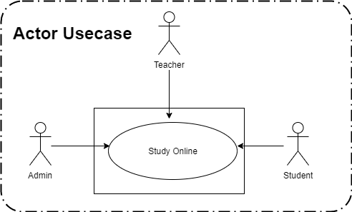

*Figure 9*. *Actor use case*

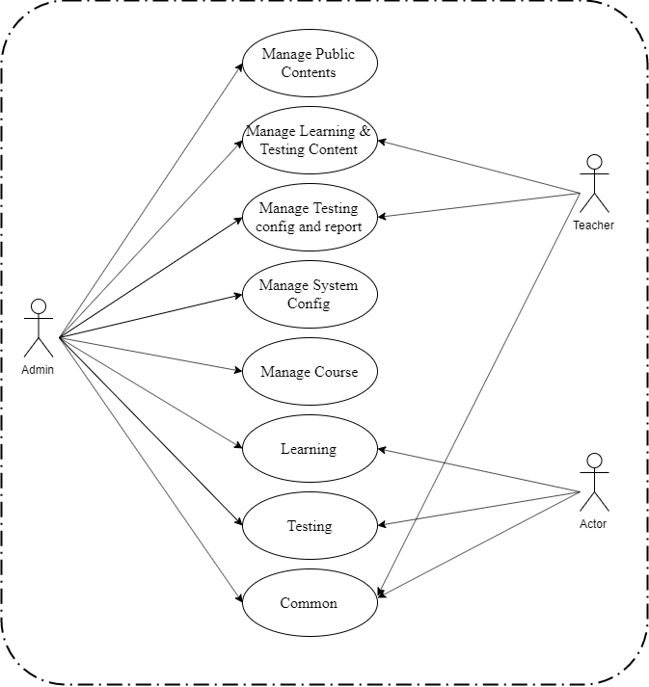

*Figure 10. Level 1 use case*

* + 1. **Manage Public Contents**

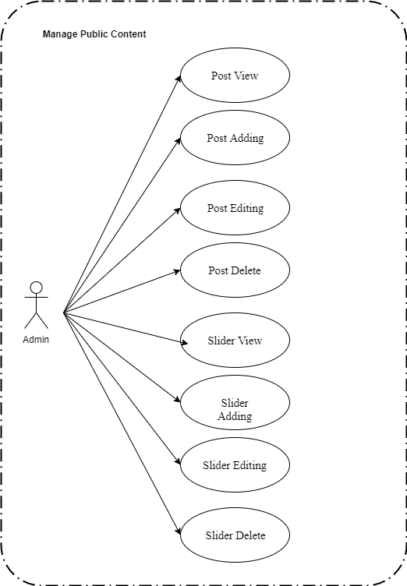

*Figure 11. Manage Public Content*

**2.2.1.1 Post View**

*Use Case Specification*

|  |  |  |  |  |  |  |
| --- | --- | --- | --- | --- | --- | --- |
| **UC ID** | UC-1.1 | |  | **Use Case Name** | Post View |  |
|  |  |  |  |  |  |  |
| **Created by:** | PhatNK | |  | Date Created: | 17/10/2019 |  |
|  |  |  |  |  |  |  |
| **Actor:** | Admin | | | |  |  |
|  |  |  |  | |  |  |
| **Trigger:** | - Actor clicks “Posts List” “Public Content” in side bar in admin page | | | | |  |
|  |  |  |  | | |  |
| **Description:** | Remember the tutorial articles, learning resources | | | | |  |
|  |  |  |  | |  |  |
| **Preconditions:** | Access account is admin. | | | |  |  |
|  |  |  |  |  |  |  |
| **Post conditions:** | Remember the tutorial articles, learning resources success in the system. | | | | |  |
|  |  |  |  | | |  |
| **Normal Flow:** | 1 | Actor | Actor clicks “Posts List” “Public Content” in side bar in admin page. | | |  |
|  |  |  |  |  |  |
|  |  |  |  | | |  |
|  | 2 | System | Displays Post screen. | | |  |
|  |  |  |  |  |  |

36

|  |  |  |  |  |  |  |  |  |  |
| --- | --- | --- | --- | --- | --- | --- | --- | --- | --- |
|  |  |  |  |  |  |  |  | |  |
|  |  |  |  |  |  |  |  |  |  |
| **Extension Flows:** |  | | | | | | |  |  |
|  |  | | | | | |  |  |  |
|  |  |  |  |  |  |  |  |  |  |
| **Alternative Flows:** | N/A | |  |  |  |  |  |  |  |
|  |  |  |  |  |  |  |  |  |  |
| **Exceptions:** |  |  |  |  |  |  |  |  |  |
|  |  |  | |  |  |  |  |  |  |
| **Priority:** | High | | | |  |  |  |  |  |
|  |  |  | |  |  |  |  |  |  |
| **Frequency of Use:** | High | | | |  |  |  |  |  |
|  |  |  | |  | |  |  |  |  |
| **Business Rules:** |  | | | | | |  |  |  |
|  |  | | | | | | |  |  |
|  |  |  |  |  |  |  |  |  |  |
| **Other Information:** |  |  |  |  |  |  |  |  |  |
|  |  |  |  |  |  |  |  |  |  |
| **Assumptions:** |  |  |  |  |  |  |  |  |  |
|  |  |  |  |  |  |  |  |  |  |
|  |  |  |  |  |  |  |  |  |  |

**2.2.1.2 Post Adding**

*Use Case Specification*

|  |  |  |  |  |  |  |
| --- | --- | --- | --- | --- | --- | --- |
| **UC ID** | UC-1.2 | |  | **Use Case Name** | Post Adding |  |
|  |  |  |  |  |  |  |
| **Created by:** | PhatNK | |  | Date Created: | 17/10/2019 |  |
|  |  |  |  |  |  |  |
| **Actor:** | Admin | | | |  |  |
|  |  |  |  | |  |  |
| **Trigger:** | - Actor clicks “Posts List” “Public Content” in side bar in admin page  - Actor click “Add new ” in Post List page | | | | |  |
|  |  |  |  | | |  |
| **Description:** | Remember the tutorial articles, learning resources | | | | |  |
|  |  |  |  | |  |  |
| **Preconditions:** | Actor accessed Post List page. | | | |  |  |
|  |  |  |  |  |  |  |
| **Post conditions:** | A new post is Added to the system successfully. | | | | |  |
|  |  |  |  | | |  |
| **Normal Flow:** | 1 | Actor | Clicks “Add new” button on Post List page. | | |  |
|  |  |  |  |  |  |
|  |  |  |  | | |  |
|  | 2 | System | Displays Post Details screen. | | |  |
|  |  |  |  |  |  |

36

|  |  |  |  |  |  |  |  |  |  |
| --- | --- | --- | --- | --- | --- | --- | --- | --- | --- |
|  |  |  |  |  |  |  |  | |  |
|  |  |  |  |  |  |  |  |  |  |
|  | 3 |  | Actor | | Enter imformation on page.  Click “Submit” button. | | |  |  |
|  |  |  |  |  | | |  |  |
|  |  |  |  |  |  |  |
|  |  |  |  |  |  | |  |  |  |
|  |  |  |  |  |  |  |  |  |  |
|  | 4 |  | System | | Uploads and displays Post List on Post Deatails | | |  |  |
|  |  |  |  | screen. | |  |  |  |
|  |  |  |  |  |  |  |  |
|  |  |  |  |  | Saves new post data in database. | | |  |  |
|  |  |  |  |  |  |  |  |  |  |
| **Extension Flows:** |  | | | | | | |  |  |
|  |  | | | | | |  |  |  |
|  |  |  |  |  |  |  |  |  |  |
| **Alternative Flows:** | N/A | |  |  |  |  |  |  |  |
|  |  |  |  |  |  |  |  |  |  |
| **Exceptions:** |  |  |  |  |  |  |  |  |  |
|  |  |  | |  |  |  |  |  |  |
| **Priority:** | High | | | |  |  |  |  |  |
|  |  |  | |  |  |  |  |  |  |
| **Frequency of Use:** | High | | | |  |  |  |  |  |
|  |  |  | |  | |  |  |  |  |
| **Business Rules:** |  | | | | | |  |  |  |
|  |  | | | | | | |  |  |
|  |  |  |  |  |  |  |  |  |  |
| **Other Information:** |  |  |  |  |  |  |  |  |  |
|  |  |  |  |  |  |  |  |  |  |
| **Assumptions:** |  |  |  |  |  |  |  |  |  |
|  |  |  |  |  |  |  |  |  |  |
|  |  |  |  |  |  |  |  |  |  |

**2.2.1.1 Post Editing**

*Use Case Specification*

|  |  |  |  |  |  |  |
| --- | --- | --- | --- | --- | --- | --- |
| **UC ID** | UC-1.1 | |  | **Use Case Name** | Post Editing |  |
|  |  |  |  |  |  |  |
| **Created by:** | PhatNK | |  | Date Created: | 17/10/2019 |  |
|  |  |  |  |  |  |  |
| **Actor:** | Admin | | | |  |  |
|  |  |  |  | |  |  |
| **Trigger:** | - Actor clicks “Posts List” “Public Content” in side bar in admin page  - Actor click “ Edit ” in Post List page | | | | |  |
|  |  |  |  | | |  |
| **Description:** | Remember the tutorial articles, learning resources | | | | |  |
|  |  |  |  | |  |  |
| **Preconditions:** | Actor accessed Post List page. | | | |  |  |
|  |  |  |  |  |  |  |
| **Post conditions:** | A new post is Edited to the system successfully. | | | | |  |
|  |  |  |  | | |  |
| **Normal Flow:** | 1 | Actor | Clicks “Edit ” button on Post List page. | | |  |
|  |  |  |  |  |  |
|  |  |  |  | | |  |
|  | 2 | System | Displays Post Details screen. | | |  |
|  |  |  |  |  |  |

36

|  |  |  |  |  |  |  |  |  |  |
| --- | --- | --- | --- | --- | --- | --- | --- | --- | --- |
|  |  |  |  |  |  |  |  | |  |
|  |  |  |  |  |  |  |  |  |  |
|  | 3 |  | Actor | | Writes imformation on page.  Click “Submit” button. | | |  |  |
|  |  |  |  |  | | |  |  |
|  |  |  |  |  |  |  |
|  |  |  |  |  |  | |  |  |  |
|  |  |  |  |  |  |  |  |  |  |
|  | 4 |  | System | | Uploads and displays Post List on Post Deatails | | |  |  |
|  |  |  |  | screen. | |  |  |  |
|  |  |  |  |  |  |  |  |
|  |  |  |  |  | Saves new post data in database. | | |  |  |
|  |  |  |  |  |  |  |  |  |  |
| **Extension Flows:** |  | | | | | | |  |  |
|  |  | | | | | |  |  |  |
|  |  |  |  |  |  |  |  |  |  |
| **Alternative Flows:** | N/A | |  |  |  |  |  |  |  |
|  |  |  |  |  |  |  |  |  |  |
| **Exceptions:** |  |  |  |  |  |  |  |  |  |
|  |  |  | |  |  |  |  |  |  |
| **Priority:** | High | | | |  |  |  |  |  |
|  |  |  | |  |  |  |  |  |  |
| **Frequency of Use:** | High | | | |  |  |  |  |  |
|  |  |  | |  | |  |  |  |  |
| **Business Rules:** |  | | | | | |  |  |  |
|  |  | | | | | | |  |  |
|  |  |  |  |  |  |  |  |  |  |
| **Other Information:** |  |  |  |  |  |  |  |  |  |
|  |  |  |  |  |  |  |  |  |  |
| **Assumptions:** |  |  |  |  |  |  |  |  |  |
|  |  |  |  |  |  |  |  |  |  |
|  |  |  |  |  |  |  |  |  |  |

**2.2.1.4 Post Delete**

*Use Case Specification*

|  |  |  |  |  |  |  |
| --- | --- | --- | --- | --- | --- | --- |
| **UC ID** | UC-1.4 | |  | **Use Case Name** | Post Delete |  |
|  |  |  |  |  |  |  |
| **Created by:** | PhatNK | |  | Date Created: | 17/10/2019 |  |
|  |  |  |  |  |  |  |
| **Actor:** | Admin | | | |  |  |
|  |  |  |  | |  |  |
| **Trigger:** | - Actor clicks “Posts List” “Public Content” in side bar in admin page  - Actor click “ Delete ” in Post List page | | | | |  |
|  |  |  |  | | |  |
| **Description:** | Remember the tutorial articles, learning resources | | | | |  |
|  |  |  |  | |  |  |
| **Preconditions:** | Actor accessed Post List page. | | | |  |  |
|  |  |  |  |  |  |  |
| **Post conditions:** | A new post is Delete to the system successfully. | | | | |  |
|  |  |  |  | | |  |
| **Normal Flow:** | 1 | Actor | Clicks “Delete ” button on Post List page. | | |  |
|  |  |  |  |  |  |
|  |  |  |  | | |  |
|  | 2 | System | Show message Delete success. | | |  |
|  |  |  |  |  |  |

36

|  |  |  |  |  |  |  |  |  |  |
| --- | --- | --- | --- | --- | --- | --- | --- | --- | --- |
|  |  |  |  |  |  |  |  | |  |
| **Extension Flows:** |  | | | | | | |  |  |
|  |  | | | | | |  |  |  |
|  |  |  |  |  |  |  |  |  |  |
| **Alternative Flows:** | N/A | |  |  |  |  |  |  |  |
|  |  |  |  |  |  |  |  |  |  |
| **Exceptions:** |  |  |  |  |  |  |  |  |  |
|  |  |  | |  |  |  |  |  |  |
| **Priority:** | High | | | |  |  |  |  |  |
|  |  |  | |  |  |  |  |  |  |
| **Frequency of Use:** | High | | | |  |  |  |  |  |
|  |  |  | |  | |  |  |  |  |
| **Business Rules:** |  | | | | | |  |  |  |
|  |  | | | | | | |  |  |
|  |  |  |  |  |  |  |  |  |  |
| **Other Information:** |  |  |  |  |  |  |  |  |  |
|  |  |  |  |  |  |  |  |  |  |
| **Assumptions:** |  |  |  |  |  |  |  |  |  |
|  |  |  |  |  |  |  |  |  |  |
|  |  |  |  |  |  |  |  |  |  |

**2.2.1.5 Slider View**

*Use Case Specification*

|  |  |  |  |  |  |  |
| --- | --- | --- | --- | --- | --- | --- |
| **UC ID** | UC-1.5 | |  | **Use Case Name** | Slider View |  |
|  |  |  |  |  |  |  |
| **Created by:** | PhatNK | |  | Date Created: | 17/10/2019 |  |
|  |  |  |  |  |  |  |
| **Actor:** | Admin | | | |  |  |
|  |  |  |  | |  |  |
| **Trigger:** | - Actor clicks “ SlidersList” of “Public Content” in side bar in admin page | | | | |  |
|  |  |  |  | | |  |
| **Description:** | Information on sliders displayed on the home page | | | | |  |
|  |  |  |  | |  |  |
| **Preconditions:** | Access account is admin. | | | |  |  |
|  |  |  |  |  |  |  |
| **Post conditions:** | Information on sliders displayed on the home page success in the system. | | | | |  |
|  |  |  |  | | |  |
| **Normal Flow:** | 1 | Actor | Actor clicks “ SlidersList” of “Public Content” in side bar in admin page. | | |  |
|  |  |  |  |  |  |
|  |  |  |  | | |  |
|  | 2 | System | Displays Slider screen. | | |  |
|  |  |  |  |  |  |

36

|  |  |  |  |  |  |  |  |  |  |
| --- | --- | --- | --- | --- | --- | --- | --- | --- | --- |
|  |  |  |  |  |  |  |  | |  |
|  |  |  |  |  |  |  |  |  |  |
| **Extension Flows:** |  | | | | | | |  |  |
|  |  | | | | | |  |  |  |
|  |  |  |  |  |  |  |  |  |  |
| **Alternative Flows:** | N/A | |  |  |  |  |  |  |  |
|  |  |  |  |  |  |  |  |  |  |
| **Exceptions:** |  |  |  |  |  |  |  |  |  |
|  |  |  | |  |  |  |  |  |  |
| **Priority:** | High | | | |  |  |  |  |  |
|  |  |  | |  |  |  |  |  |  |
| **Frequency of Use:** | High | | | |  |  |  |  |  |
|  |  |  | |  | |  |  |  |  |
| **Business Rules:** |  | | | | | |  |  |  |
|  |  | | | | | | |  |  |
|  |  |  |  |  |  |  |  |  |  |
| **Other Information:** |  |  |  |  |  |  |  |  |  |
|  |  |  |  |  |  |  |  |  |  |
| **Assumptions:** |  |  |  |  |  |  |  |  |  |
|  |  |  |  |  |  |  |  |  |  |
|  |  |  |  |  |  |  |  |  |  |

**2.2.1.6 Slider Adding**

*Use Case Specification*

|  |  |  |  |  |  |  |
| --- | --- | --- | --- | --- | --- | --- |
| **UC ID** | UC-1.6 | |  | **Use Case Name** | Slider Adding |  |
|  |  |  |  |  |  |  |
| **Created by:** | PhatNK | |  | Date Created: | 17/10/2019 |  |
|  |  |  |  |  |  |  |
| **Actor:** | Admin | | | |  |  |
|  |  |  |  | |  |  |
| **Trigger:** | - Actor clicks “Slider List” “Public Content” in side bar in admin page  - Actor click “Add new ” in Post List page | | | | |  |
|  |  |  |  | | |  |
| **Description:** | Information on sliders displayed on the home page | | | | |  |
|  |  |  |  | |  |  |
| **Preconditions:** | Actor accessed Slider List page. | | | |  |  |
|  |  |  |  |  |  |  |
| **Post conditions:** | A new slider is added to the system successfully. | | | | |  |
|  |  |  |  | | |  |
| **Normal Flow:** | 1 | Actor | Clicks “Add new” button on Slider List page. | | |  |
|  |  |  |  |  |  |
|  |  |  |  | | |  |
|  | 2 | System | Displays Slider Details screen. | | |  |
|  |  |  |  |  |  |

36

|  |  |  |  |  |  |  |  |  |  |
| --- | --- | --- | --- | --- | --- | --- | --- | --- | --- |
|  |  |  |  |  |  |  |  | |  |
|  |  |  |  |  |  |  |  |  |  |
|  | 3 |  | Actor | | Enter imformation on page.  Click “Submit” button. | | |  |  |
|  |  |  |  |  | | |  |  |
|  |  |  |  |  |  |  |
|  |  |  |  |  |  | |  |  |  |
|  |  |  |  |  |  |  |  |  |  |
|  | 4 |  | System | | Uploads and displays Slider List on Slider Deatails | | |  |  |
|  |  |  |  | screen. | |  |  |  |
|  |  |  |  |  |  |  |  |
|  |  |  |  |  | Saves new slider data in database. | | |  |  |
|  |  |  |  |  |  |  |  |  |  |
| **Extension Flows:** |  | | | | | | |  |  |
|  |  | | | | | |  |  |  |
|  |  |  |  |  |  |  |  |  |  |
| **Alternative Flows:** | N/A | |  |  |  |  |  |  |  |
|  |  |  |  |  |  |  |  |  |  |
| **Exceptions:** |  |  |  |  |  |  |  |  |  |
|  |  |  | |  |  |  |  |  |  |
| **Priority:** | High | | | |  |  |  |  |  |
|  |  |  | |  |  |  |  |  |  |
| **Frequency of Use:** | High | | | |  |  |  |  |  |
|  |  |  | |  | |  |  |  |  |
| **Business Rules:** |  | | | | | |  |  |  |
|  |  | | | | | | |  |  |
|  |  |  |  |  |  |  |  |  |  |
| **Other Information:** |  |  |  |  |  |  |  |  |  |
|  |  |  |  |  |  |  |  |  |  |
| **Assumptions:** |  |  |  |  |  |  |  |  |  |
|  |  |  |  |  |  |  |  |  |  |
|  |  |  |  |  |  |  |  |  |  |

**2.2.1.7 Slider** **Editing**

*Use Case Specification*

|  |  |  |  |  |  |  |
| --- | --- | --- | --- | --- | --- | --- |
| **UC ID** | UC-1.7 | |  | **Use Case Name** | Slider Editing |  |
|  |  |  |  |  |  |  |
| **Created by:** | PhatNK | |  | Date Created: | 17/10/2019 |  |
|  |  |  |  |  |  |  |
| **Actor:** | Admin | | | |  |  |
|  |  |  |  | |  |  |
| **Trigger:** | - Actor clicks “Slider List” “Public Content” in side bar in admin page  - Actor click “ Edit ” in Post List page | | | | |  |
|  |  |  |  | | |  |
| **Description:** | Information on sliders displayed on the home page | | | | |  |
|  |  |  |  | |  |  |
| **Preconditions:** | Actor accessed Slider List page. | | | |  |  |
|  |  |  |  |  |  |  |
| **Post conditions:** | A slider is Edited to the system successfully. | | | | |  |
|  |  |  |  | | |  |
| **Normal Flow:** | 1 | Actor | Clicks “Edit ” button on Slider List page. | | |  |
|  |  |  |  |  |  |
|  |  |  |  | | |  |
|  | 2 | System | Displays Slider Details screen. | | |  |
|  |  |  |  |  |  |

36

|  |  |  |  |  |  |  |  |  |  |
| --- | --- | --- | --- | --- | --- | --- | --- | --- | --- |
|  |  |  |  |  |  |  |  | |  |
|  |  |  |  |  |  |  |  |  |  |
|  | 3 |  | Actor | | Writes imformation on page.  Click “Submit” button. | | |  |  |
|  |  |  |  |  | | |  |  |
|  |  |  |  |  |  |  |
|  |  |  |  |  |  | |  |  |  |
|  |  |  |  |  |  |  |  |  |  |
|  | 4 |  | System | | Uploads and displays Post List on Post Deatails | | |  |  |
|  |  |  |  | screen. | |  |  |  |
|  |  |  |  |  |  |  |  |
|  |  |  |  |  | Saves new post data in database. | | |  |  |
|  |  |  |  |  |  |  |  |  |  |
| **Extension Flows:** |  | | | | | | |  |  |
|  |  | | | | | |  |  |  |
|  |  |  |  |  |  |  |  |  |  |
| **Alternative Flows:** | N/A | |  |  |  |  |  |  |  |
|  |  |  |  |  |  |  |  |  |  |
| **Exceptions:** |  |  |  |  |  |  |  |  |  |
|  |  |  | |  |  |  |  |  |  |
| **Priority:** | High | | | |  |  |  |  |  |
|  |  |  | |  |  |  |  |  |  |
| **Frequency of Use:** | High | | | |  |  |  |  |  |
|  |  |  | |  | |  |  |  |  |
| **Business Rules:** |  | | | | | |  |  |  |
|  |  | | | | | | |  |  |
|  |  |  |  |  |  |  |  |  |  |
| **Other Information:** |  |  |  |  |  |  |  |  |  |
|  |  |  |  |  |  |  |  |  |  |
| **Assumptions:** |  |  |  |  |  |  |  |  |  |
|  |  |  |  |  |  |  |  |  |  |
|  |  |  |  |  |  |  |  |  |  |

**2.2.1.8 Slider** **Delete**

*Use Case Specification*

|  |  |  |  |  |  |  |
| --- | --- | --- | --- | --- | --- | --- |
| **UC ID** | UC-1.8 | |  | **Use Case Name** | Slider Delete |  |
|  |  |  |  |  |  |  |
| **Created by:** | PhatNK | |  | Date Created: | 17/10/2019 |  |
|  |  |  |  |  |  |  |
| **Actor:** | Admin | | | |  |  |
|  |  |  |  | |  |  |
| **Trigger:** | - Actor clicks “Slider List” “Public Content” in side bar in admin page  - Actor click “ Delete ” in Post List page | | | | |  |
|  |  |  |  | | |  |
| **Description:** | Information on sliders displayed on the home page | | | | |  |
|  |  |  |  | |  |  |
| **Preconditions:** | Actor accessed Slider List page. | | | |  |  |
|  |  |  |  |  |  |  |
| **Post conditions:** | A slider is Delete to the system successfully. | | | | |  |
|  |  |  |  | | |  |
| **Normal Flow:** | 1 | Actor | Clicks “Delete ” button on Post List page. | | |  |
|  |  |  |  |  |  |
|  |  |  |  | | |  |
|  | 2 | System | Show message Delete success. | | |  |
|  |  |  |  |  |  |

36

|  |  |  |  |  |  |  |  |  |  |
| --- | --- | --- | --- | --- | --- | --- | --- | --- | --- |
|  |  |  |  |  |  |  |  | |  |
| **Extension Flows:** |  | | | | | | |  |  |
|  |  | | | | | |  |  |  |
|  |  |  |  |  |  |  |  |  |  |
| **Alternative Flows:** | N/A | |  |  |  |  |  |  |  |
|  |  |  |  |  |  |  |  |  |  |
| **Exceptions:** |  |  |  |  |  |  |  |  |  |
|  |  |  | |  |  |  |  |  |  |
| **Priority:** | High | | | |  |  |  |  |  |
|  |  |  | |  |  |  |  |  |  |
| **Frequency of Use:** | High | | | |  |  |  |  |  |
|  |  |  | |  | |  |  |  |  |
| **Business Rules:** |  | | | | | |  |  |  |
|  |  | | | | | | |  |  |
|  |  |  |  |  |  |  |  |  |  |
| **Other Information:** |  |  |  |  |  |  |  |  |  |
|  |  |  |  |  |  |  |  |  |  |
| **Assumptions:** |  |  |  |  |  |  |  |  |  |
|  |  |  |  |  |  |  |  |  |  |
|  |  |  |  |  |  |  |  |  |  |

**2.2.2** **Manage Learning & Testing Content**

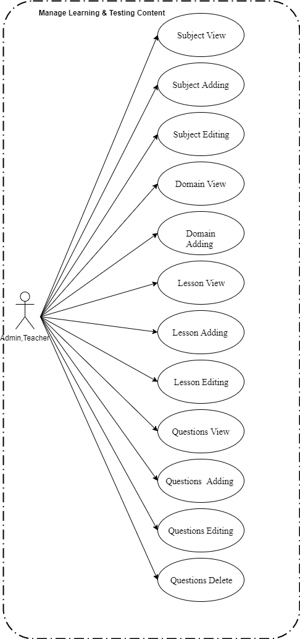

*Figure 12. Manage Learning&Testing Content*

**2.2.2.1 Subject View**

*Use Case Specification*

|  |  |  |  |  |  |  |
| --- | --- | --- | --- | --- | --- | --- |
| **UC ID** | UC-2.1 | |  | **Use Case Name** | Subject View |  |
|  |  |  |  |  |  |  |
| **Created by:** | PhatNK | |  | Date Created: | 17/10/2019 |  |
|  |  |  |  |  |  |  |
| **Actor:** | Admin, Teacher | | | |  |  |
|  |  |  |  | |  |  |
| **Trigger:** | - Actor clicks “Subjects List” of “Learning & Testing Content” in side bar in admin page | | | | |  |
|  |  |  |  | | |  |
| **Description:** | The function allows all actors to view subject information. | | | | |  |
|  |  |  |  | |  |  |
| **Preconditions:** | Access account is admin. | | | |  |  |
|  |  |  |  |  |  |  |
| **Post conditions:** | The function allows all actors to view subject information to the system successfully. | | | | |  |
|  |  |  |  | | |  |
| **Normal Flow:** | 1 | Actor | Actor clicks “Subjects List” of “Learning & Testing Content” in side bar in admin page | | |  |
|  |  |  |  |  |  |
|  |  |  |  | | |  |
|  | 2 | System | Displays Subject screen. | | |  |
|  |  |  |  |  |  |

36

|  |  |  |  |  |  |  |  |  |  |
| --- | --- | --- | --- | --- | --- | --- | --- | --- | --- |
|  |  |  |  |  |  |  |  | |  |
|  |  |  |  |  |  |  |  |  |  |
| **Extension Flows:** |  | | | | | | |  |  |
|  |  | | | | | |  |  |  |
|  |  |  |  |  |  |  |  |  |  |
| **Alternative Flows:** | N/A | |  |  |  |  |  |  |  |
|  |  |  |  |  |  |  |  |  |  |
| **Exceptions:** |  |  |  |  |  |  |  |  |  |
|  |  |  | |  |  |  |  |  |  |
| **Priority:** | High | | | |  |  |  |  |  |
|  |  |  | |  |  |  |  |  |  |
| **Frequency of Use:** | High | | | |  |  |  |  |  |
|  |  |  | |  | |  |  |  |  |
| **Business Rules:** |  | | | | | |  |  |  |
|  |  | | | | | | |  |  |
|  |  |  |  |  |  |  |  |  |  |
| **Other Information:** |  |  |  |  |  |  |  |  |  |
|  |  |  |  |  |  |  |  |  |  |
| **Assumptions:** |  |  |  |  |  |  |  |  |  |
|  |  |  |  |  |  |  |  |  |  |
|  |  |  |  |  |  |  |  |  |  |

**2.2.2.2 Subject Adding**

*Use Case Specification*

|  |  |  |  |  |  |  |
| --- | --- | --- | --- | --- | --- | --- |
| **UC ID** | UC-2.2 | |  | **Use Case Name** | Subject Adding |  |
|  |  |  |  |  |  |  |
| **Created by:** | PhatNK | |  | Date Created: | 17/10/2019 |  |
|  |  |  |  |  |  |  |
| **Actor:** | Admin , Teacher | | | |  |  |
|  |  |  |  | |  |  |
| **Trigger:** | - Actor clicks “Subjects List” of “Learning & Testing Content” in side bar in admin page  - Actor click “Add new” | | | | |  |
|  |  |  |  | | |  |
| **Description:** | The function allows all actors to add subject. | | | | |  |
|  |  |  |  | |  |  |
| **Preconditions:** | Actor accessed Subjects List page. | | | |  |  |
|  |  |  |  |  |  |  |
| **Post conditions:** | A new subject is added to the system successfully. | | | | |  |
|  |  |  |  | | |  |
| **Normal Flow:** | 1 | Actor | Clicks “Add new” button on Subject List page. | | |  |
|  |  |  |  |  |  |
|  |  |  |  | | |  |
|  | 2 | System | Displays Subject Details screen. | | |  |
|  |  |  |  |  |  |

36

|  |  |  |  |  |  |  |  |  |  |
| --- | --- | --- | --- | --- | --- | --- | --- | --- | --- |
|  |  |  |  |  |  |  |  | |  |
|  |  |  |  |  |  |  |  |  |  |
|  | 3 |  | Actor | | Enter imformation on page.  Click “Submit” button. | | |  |  |
|  |  |  |  |  | | |  |  |
|  |  |  |  |  |  |  |
|  |  |  |  |  |  | |  |  |  |
|  |  |  |  |  |  |  |  |  |  |
|  | 4 |  | System | | Uploads and displays Post List on Post Deatails | | |  |  |
|  |  |  |  | screen. | |  |  |  |
|  |  |  |  |  |  |  |  |
|  |  |  |  |  | Saves new post data in database. | | |  |  |
|  |  |  |  |  |  |  |  |  |  |
| **Extension Flows:** |  | | | | | | |  |  |
|  |  | | | | | |  |  |  |
|  |  |  |  |  |  |  |  |  |  |
| **Alternative Flows:** | N/A | |  |  |  |  |  |  |  |
|  |  |  |  |  |  |  |  |  |  |
| **Exceptions:** |  |  |  |  |  |  |  |  |  |
|  |  |  | |  |  |  |  |  |  |
| **Priority:** | High | | | |  |  |  |  |  |
|  |  |  | |  |  |  |  |  |  |
| **Frequency of Use:** | High | | | |  |  |  |  |  |
|  |  |  | |  | |  |  |  |  |
| **Business Rules:** |  | | | | | |  |  |  |
|  |  | | | | | | |  |  |
|  |  |  |  |  |  |  |  |  |  |
| **Other Information:** |  |  |  |  |  |  |  |  |  |
|  |  |  |  |  |  |  |  |  |  |
| **Assumptions:** |  |  |  |  |  |  |  |  |  |
|  |  |  |  |  |  |  |  |  |  |
|  |  |  |  |  |  |  |  |  |  |

**2.2.2.3 Subject Editing**

*Use Case Specification*

|  |  |  |  |  |  |  |
| --- | --- | --- | --- | --- | --- | --- |
| **UC ID** | UC-2.3 | |  | **Use Case Name** | Subject Editing |  |
|  |  |  |  |  |  |  |
| **Created by:** | PhatNK | |  | Date Created: | 17/10/2019 |  |
|  |  |  |  |  |  |  |
| **Actor:** | Admin,Teacher | | | |  |  |
|  |  |  |  | |  |  |
| **Trigger:** | - Actor clicks “Subjects List” of “Learning & Testing Content” in side bar in admin page  - Actor click “Edit ” | | | | |  |
|  |  |  |  | | |  |
| **Description:** | The function allows all Admin,Teacher to edit subject. | | | | |  |
|  |  |  |  | |  |  |
| **Preconditions:** | Actor accessed Subject List page. | | | |  |  |
|  |  |  |  |  |  |  |
| **Post conditions:** | A new subject is edited to the system successfully. | | | | |  |
|  |  |  |  | | |  |
| **Normal Flow:** | 1 | Actor | Clicks “Edit” button on Subject List screen. | | |  |
|  |  |  |  |  |  |
|  |  |  |  | | |  |
|  | 2 | System | Displays Subject Detail screen. | | |  |
|  |  |  |  |  |  |

36

|  |  |  |  |  |  |  |  |  |  |
| --- | --- | --- | --- | --- | --- | --- | --- | --- | --- |
|  |  |  |  |  |  |  |  | |  |
|  |  |  |  |  |  |  |  |  |  |
|  | 3 |  | Actor | | Writes imformation on page. | | |  |  |
|  |  |  |  | Click “Save draft or submit or publish or hide” button input information. | | |  |  |
|  |  |  |  |  |  |  |
|  |  |  |  |  |  | |  |  |  |
|  |  |  |  |  |  |  |  |  |  |
|  | 4 |  | System | | Uploads and displays subject on Subject detail  Saves new subject in database. | | |  |  |
|  |  |  |  |  | |  |  |  |
|  |  |  |  |  |  |  |  |
|  |  |  |  |  |  | | |  |  |
|  |  |  |  |  |  |  |  |  |  |
| **Extension Flows:** |  | | | | | | |  |  |
|  |  | | | | | |  |  |  |
|  |  |  |  |  |  |  |  |  |  |
| **Alternative Flows:** | N/A | |  |  |  |  |  |  |  |
|  |  |  |  |  |  |  |  |  |  |
| **Exceptions:** |  |  |  |  |  |  |  |  |  |
|  |  |  | |  |  |  |  |  |  |
| **Priority:** | High | | | |  |  |  |  |  |
|  |  |  | |  |  |  |  |  |  |
| **Frequency of Use:** | High | | | |  |  |  |  |  |
|  |  |  | |  | |  |  |  |  |
| **Business Rules:** |  | | | | | |  |  |  |
|  |  | | | | | | |  |  |
|  |  |  |  |  |  |  |  |  |  |
| **Other Information:** |  |  |  |  |  |  |  |  |  |
|  |  |  |  |  |  |  |  |  |  |
| **Assumptions:** |  |  |  |  |  |  |  |  |  |
|  |  |  |  |  |  |  |  |  |  |
|  |  |  |  |  |  |  |  |  |  |

**2.2.2.4 Domain View**

*Use Case Specification*

|  |  |  |  |  |  |  |
| --- | --- | --- | --- | --- | --- | --- |
| **UC ID** | UC-2.4 | |  | **Use Case Name** | Domain View |  |
|  |  |  |  |  |  |  |
| **Created by:** | PhatNK | |  | Date Created: | 17/10/2019 |  |
|  |  |  |  |  |  |  |
| **Actor:** | Admin, Teacher | | | |  |  |
|  |  |  |  | |  |  |
| **Trigger:** | - Actor clicks “Subjects List” of “Learning & Testing Content” in side bar in admin page  - Actor click “Domains” | | | | |  |
|  |  |  |  | | |  |
| **Description:** | List of content groups of the subject (divided by different dimensions. This content group can be used to show content types such as skills, process groups, etc. - used to classify sentences. ask questions as well as structure the exam questions | | | | |  |
|  |  |  |  | |  |  |
| **Preconditions:** | Access account is admin. | | | |  |  |
|  |  |  |  |  |  |  |
| **Post conditions:** | Show imformation of domain in the system | | | | |  |
|  |  |  |  | | |  |
| **Normal Flow:** | 1 | Actor | - Actor clicks “Subjects List” of “Learning & Testing Content” in side bar in admin page  - Actor click “Domains” | | |  |
|  |  |  |  |  |  |
|  |  |  |  | | |  |
|  | 2 | System | Displays Domain screen. | | |  |
|  |  |  |  |  |  |

36

|  |  |  |  |  |  |  |  |  |  |
| --- | --- | --- | --- | --- | --- | --- | --- | --- | --- |
|  |  |  |  |  |  |  |  | |  |
|  |  |  |  |  |  |  |  |  |  |
| **Extension Flows:** |  | | | | | | |  |  |
|  |  | | | | | |  |  |  |
|  |  |  |  |  |  |  |  |  |  |
| **Alternative Flows:** | N/A | |  |  |  |  |  |  |  |
|  |  |  |  |  |  |  |  |  |  |
| **Exceptions:** |  |  |  |  |  |  |  |  |  |
|  |  |  | |  |  |  |  |  |  |
| **Priority:** | High | | | |  |  |  |  |  |
|  |  |  | |  |  |  |  |  |  |
| **Frequency of Use:** | High | | | |  |  |  |  |  |
|  |  |  | |  | |  |  |  |  |
| **Business Rules:** |  | | | | | |  |  |  |
|  |  | | | | | | |  |  |
|  |  |  |  |  |  |  |  |  |  |
| **Other Information:** |  |  |  |  |  |  |  |  |  |
|  |  |  |  |  |  |  |  |  |  |
| **Assumptions:** |  |  |  |  |  |  |  |  |  |
|  |  |  |  |  |  |  |  |  |  |
|  |  |  |  |  |  |  |  |  |  |

**2.2.2.5 Domain Adding**

*Use Case Specification*

|  |  |  |  |  |  |  |
| --- | --- | --- | --- | --- | --- | --- |
| **UC ID** | UC-2.5 | |  | **Use Case Name** | Domain Adding |  |
|  |  |  |  |  |  |  |
| **Created by:** | PhatNK | |  | Date Created: | 17/10/2019 |  |
|  |  |  |  |  |  |  |
| **Actor:** | Admin , Teacher | | | |  |  |
|  |  |  |  | |  |  |
| **Trigger:** | - Actor clicks “Subjects List” of “Learning & Testing Content” in side bar in admin page  - Actor click “Domains”  - Actor click “Add new ” | | | | |  |
|  |  |  |  | | |  |
| **Description:** | List of content groups of the subject (divided by different dimensions. This content group can be used to show content types such as skills, process groups, etc. - used to classify sentences. ask questions as well as structure the exam questions. | | | | |  |
|  |  |  |  | |  |  |
| **Preconditions:** | Actor accessed Subjects List page. | | | |  |  |
|  |  |  |  |  |  |  |
| **Post conditions:** | A new Domain is added to the system successfully. | | | | |  |
|  |  |  |  | | |  |
| **Normal Flow:** | 1 | Actor | - Actor clicks “Subjects List” of “Learning & Testing Content” in side bar in admin page  - Actor click “Domains”  - Actor click “Add new ” | | |  |
|  |  |  |  |  |  |
|  |  |  |  | | |  |
|  | 2 | System | Displays Domain Details screen. | | |  |
|  |  |  |  |  |  |

36

|  |  |  |  |  |  |  |  |  |  |
| --- | --- | --- | --- | --- | --- | --- | --- | --- | --- |
|  |  |  |  |  |  |  |  | |  |
|  |  |  |  |  |  |  |  |  |  |
|  | 3 |  | Actor | | Enter imformation on page.  Click “Submit” button. | | |  |  |
|  |  |  |  |  | | |  |  |
|  |  |  |  |  |  |  |
|  |  |  |  |  |  | |  |  |  |
|  |  |  |  |  |  |  |  |  |  |
|  | 4 |  | System | | Uploads and displays Post List on Post Deatails | | |  |  |
|  |  |  |  | screen. | |  |  |  |
|  |  |  |  |  |  |  |  |
|  |  |  |  |  | Saves new post data in database. | | |  |  |
|  |  |  |  |  |  |  |  |  |  |
| **Extension Flows:** |  | | | | | | |  |  |
|  |  | | | | | |  |  |  |
|  |  |  |  |  |  |  |  |  |  |
| **Alternative Flows:** | N/A | |  |  |  |  |  |  |  |
|  |  |  |  |  |  |  |  |  |  |
| **Exceptions:** |  |  |  |  |  |  |  |  |  |
|  |  |  | |  |  |  |  |  |  |
| **Priority:** | High | | | |  |  |  |  |  |
|  |  |  | |  |  |  |  |  |  |
| **Frequency of Use:** | High | | | |  |  |  |  |  |
|  |  |  | |  | |  |  |  |  |
| **Business Rules:** |  | | | | | |  |  |  |
|  |  | | | | | | |  |  |
|  |  |  |  |  |  |  |  |  |  |
| **Other Information:** |  |  |  |  |  |  |  |  |  |
|  |  |  |  |  |  |  |  |  |  |
| **Assumptions:** |  |  |  |  |  |  |  |  |  |
|  |  |  |  |  |  |  |  |  |  |
|  |  |  |  |  |  |  |  |  |  |

**2.2.2.6 Lesson View**

*Use Case Specification*

|  |  |  |  |  |  |  |
| --- | --- | --- | --- | --- | --- | --- |
| **UC ID** | UC-2.6 | |  | **Use Case Name** | Lesson View |  |
|  |  |  |  |  |  |  |
| **Created by:** | PhatNK | |  | Date Created: | 17/10/2019 |  |
|  |  |  |  |  |  |  |
| **Actor:** | Admin, Teacher | | | |  |  |
|  |  |  |  | |  |  |
| **Trigger:** | - Actor clicks “Subjects List” of “Learning & Testing Content” in side bar in admin page  - Actor click “Lesson” | | | | |  |
|  |  |  |  | | |  |
| **Description:** | "List of lessons for each subject. Lessons include 2 levels:  - Level 1 or topic level (topic), equivalent to the content chapter in textbooks  - Level 2 or lesson level (lesson), each lesson belongs to a specific topic. Content can be in the form of Video, HTML content (text format), or Topic Quiz (multiple choice quiz on topic). The content of the multiple-choice test by topic is linked to a specific test (explained), explained below " . | | | | |  |
|  |  |  |  | |  |  |
| **Preconditions:** | Access account is admin. | | | |  |  |
|  |  |  |  |  |  |  |
| **Post conditions:** | The function allows all actors to view lesson information to the system successfully. | | | | |  |
|  |  |  |  | | |  |
| **Normal Flow:** | 1 | Actor | - Actor clicks “Subjects List” of “Learning & Testing Content” in side bar in admin page  - Actor click “Lesson” | | |  |
|  |  |  |  |  |  |
|  |  |  |  | | |  |
|  | 2 | System | Displays Lesson screen. | | |  |
|  |  |  |  |  |  |

36

|  |  |  |  |  |  |  |  |  |  |
| --- | --- | --- | --- | --- | --- | --- | --- | --- | --- |
|  |  |  |  |  |  |  |  | |  |
|  |  |  |  |  |  |  |  |  |  |
| **Extension Flows:** |  | | | | | | |  |  |
|  |  | | | | | |  |  |  |
|  |  |  |  |  |  |  |  |  |  |
| **Alternative Flows:** | N/A | |  |  |  |  |  |  |  |
|  |  |  |  |  |  |  |  |  |  |
| **Exceptions:** |  |  |  |  |  |  |  |  |  |
|  |  |  | |  |  |  |  |  |  |
| **Priority:** | High | | | |  |  |  |  |  |
|  |  |  | |  |  |  |  |  |  |
| **Frequency of Use:** | High | | | |  |  |  |  |  |
|  |  |  | |  | |  |  |  |  |
| **Business Rules:** |  | | | | | |  |  |  |
|  |  | | | | | | |  |  |
|  |  |  |  |  |  |  |  |  |  |
| **Other Information:** |  |  |  |  |  |  |  |  |  |
|  |  |  |  |  |  |  |  |  |  |
| **Assumptions:** |  |  |  |  |  |  |  |  |  |
|  |  |  |  |  |  |  |  |  |  |
|  |  |  |  |  |  |  |  |  |  |

**2.2.2.7 Lesson Adding**

*Use Case Specification*

|  |  |  |  |  |  |  |
| --- | --- | --- | --- | --- | --- | --- |
| **UC ID** | UC-2.7 | |  | **Use Case Name** | Lesson Adding |  |
|  |  |  |  |  |  |  |
| **Created by:** | PhatNK | |  | Date Created: | 17/10/2019 |  |
|  |  |  |  |  |  |  |
| **Actor:** | Admin , Teacher | | | |  |  |
|  |  |  |  | |  |  |
| **Trigger:** | - Actor clicks “Subjects List” of “Learning & Testing Content” in side bar in admin page  - Actor click “Lesson”  - Actor click “Add new ” | | | | |  |
|  |  |  |  | | |  |
| **Description:** | "List of lessons for each subject. Lessons include 2 levels:  - Level 1 or topic level (topic), equivalent to the content chapter in textbooks  - Level 2 or lesson level (lesson), each lesson belongs to a specific topic. Content can be in the form of Video, HTML content (text format), or Topic Quiz (multiple choice quiz on topic). The content of the multiple-choice test by topic is linked to a specific test (explained), explained below ". | | | | |  |
|  |  |  |  | |  |  |
| **Preconditions:** | Actor accessed Subjects List page. | | | |  |  |
|  |  |  |  |  |  |  |
| **Post conditions:** | A new lesson is added to the system successfully. | | | | |  |
|  |  |  |  | | |  |
| **Normal Flow:** | 1 | Actor | - Actor clicks “Subjects List” of “Learning & Testing Content” in side bar in admin page  - Actor click “Lesson”  - Actor click “Add new ” | | |  |
|  |  |  |  |  |  |
|  |  |  |  | | |  |
|  | 2 | System | Displays Lesson Details screen. | | |  |
|  |  |  |  |  |  |

36

|  |  |  |  |  |  |  |  |  |  |
| --- | --- | --- | --- | --- | --- | --- | --- | --- | --- |
|  |  |  |  |  |  |  |  | |  |
|  |  |  |  |  |  |  |  |  |  |
|  | 3 |  | Actor | | Enter imformation on page.  Click “Submit” button. | | |  |  |
|  |  |  |  |  | | |  |  |
|  |  |  |  |  |  |  |
|  |  |  |  |  |  | |  |  |  |
|  |  |  |  |  |  |  |  |  |  |
|  | 4 |  | System | | Uploads and displays Lesson List on Lesson Deatails | | |  |  |
|  |  |  |  | screen. | |  |  |  |
|  |  |  |  |  |  |  |  |
|  |  |  |  |  | Saves new lesson data in database. | | |  |  |
|  |  |  |  |  |  |  |  |  |  |
| **Extension Flows:** |  | | | | | | |  |  |
|  |  | | | | | |  |  |  |
|  |  |  |  |  |  |  |  |  |  |
| **Alternative Flows:** | N/A | |  |  |  |  |  |  |  |
|  |  |  |  |  |  |  |  |  |  |
| **Exceptions:** |  |  |  |  |  |  |  |  |  |
|  |  |  | |  |  |  |  |  |  |
| **Priority:** | High | | | |  |  |  |  |  |
|  |  |  | |  |  |  |  |  |  |
| **Frequency of Use:** | High | | | |  |  |  |  |  |
|  |  |  | |  | |  |  |  |  |
| **Business Rules:** |  | | | | | |  |  |  |
|  |  | | | | | | |  |  |
|  |  |  |  |  |  |  |  |  |  |
| **Other Information:** |  |  |  |  |  |  |  |  |  |
|  |  |  |  |  |  |  |  |  |  |
| **Assumptions:** |  |  |  |  |  |  |  |  |  |
|  |  |  |  |  |  |  |  |  |  |
|  |  |  |  |  |  |  |  |  |  |

**2.2.2.8 Lesson Editing**

*Use Case Specification*

|  |  |  |  |  |  |  |
| --- | --- | --- | --- | --- | --- | --- |
| **UC ID** | UC-2.8 | |  | **Use Case Name** | Lesson Editing |  |
|  |  |  |  |  |  |  |
| **Created by:** | PhatNK | |  | Date Created: | 17/10/2019 |  |
|  |  |  |  |  |  |  |
| **Actor:** | Admin,Teacher | | | |  |  |
|  |  |  |  | |  |  |
| **Trigger:** | - Actor clicks “Subjects List” of “Learning & Testing Content” in side bar in admin page  - Actor click “Lesson”  - Actor click “ Edit ” | | | | |  |
|  |  |  |  | | |  |
| **Description:** | "List of lessons for each subject. Lessons include 2 levels:  - Level 1 or topic level (topic), equivalent to the content chapter in textbooks  - Level 2 or lesson level (lesson), each lesson belongs to a specific topic. Content can be in the form of Video, HTML content (text format), or Topic Quiz (multiple choice quiz on topic). The content of the multiple-choice test by topic is linked to a specific test (explained), explained below " | | | | |  |
|  |  |  |  | |  |  |
| **Preconditions:** | Actor accessed Subject List page. | | | |  |  |
|  |  |  |  |  |  |  |
| **Post conditions:** | A lesson is edited to the system successfully. | | | | |  |
|  |  |  |  | | |  |
| **Normal Flow:** | 1 | Actor | - Actor clicks “Subjects List” of “Learning & Testing Content” in side bar in admin page  - Actor click “Lesson”  - Actor click “ Edit ” | | |  |
|  |  |  |  |  |  |
|  |  |  |  | | |  |
|  | 2 | System | Displays Lesson Detail screen. | | |  |
|  |  |  |  |  |  |

36

|  |  |  |  |  |  |  |  |  |  |
| --- | --- | --- | --- | --- | --- | --- | --- | --- | --- |
|  |  |  |  |  |  |  |  | |  |
|  |  |  |  |  |  |  |  |  |  |
|  | 3 |  | Actor | | Writes imformation on page. | | |  |  |
|  |  |  |  | Click “Save draft or submit or publish or hide” button input information. | | |  |  |
|  |  |  |  |  |  |  |
|  |  |  |  |  |  | |  |  |  |
|  |  |  |  |  |  |  |  |  |  |
|  | 4 |  | System | | Uploads and displays subject on Lesson detail  Saves new subject in database. | | |  |  |
|  |  |  |  |  | |  |  |  |
|  |  |  |  |  |  |  |  |
|  |  |  |  |  |  | | |  |  |
|  |  |  |  |  |  |  |  |  |  |
| **Extension Flows:** |  | | | | | | |  |  |
|  |  | | | | | |  |  |  |
|  |  |  |  |  |  |  |  |  |  |
| **Alternative Flows:** | N/A | |  |  |  |  |  |  |  |
|  |  |  |  |  |  |  |  |  |  |
| **Exceptions:** |  |  |  |  |  |  |  |  |  |
|  |  |  | |  |  |  |  |  |  |
| **Priority:** | High | | | |  |  |  |  |  |
|  |  |  | |  |  |  |  |  |  |
| **Frequency of Use:** | High | | | |  |  |  |  |  |
|  |  |  | |  | |  |  |  |  |
| **Business Rules:** |  | | | | | |  |  |  |
|  |  | | | | | | |  |  |
|  |  |  |  |  |  |  |  |  |  |
| **Other Information:** |  |  |  |  |  |  |  |  |  |
|  |  |  |  |  |  |  |  |  |  |
| **Assumptions:** |  |  |  |  |  |  |  |  |  |
|  |  |  |  |  |  |  |  |  |  |
|  |  |  |  |  |  |  |  |  |  |

**2.2.2.9 Question View**

*Use Case Specification*

|  |  |  |  |  |  |  |
| --- | --- | --- | --- | --- | --- | --- |
| **UC ID** | UC-2.9 | |  | **Use Case Name** | Question View |  |
|  |  |  |  |  |  |  |
| **Created by:** | PhatNK | |  | Date Created: | 17/10/2019 |  |
|  |  |  |  |  |  |  |
| **Actor:** | Admin, Teacher | | | |  |  |
|  |  |  |  | |  |  |
| **Trigger:** | - Actor clicks “Questions” of “Learning & Testing Content” in side bar in admin page | | | | |  |
|  |  |  |  | | |  |
| **Description:** | Question bank of subjects, which can be grouped specifically by lesson and / or domain | | | | |  |
|  |  |  |  | |  |  |
| **Preconditions:** | Access account is admin. | | | |  |  |
|  |  |  |  |  |  |  |
| **Post conditions:** | Information on question displayed on the home page success in the system. | | | | |  |
|  |  |  |  | | |  |
| **Normal Flow:** | 1 | Actor | - Actor clicks “Questions” of “Learning & Testing Content” in side bar in admin page. | | |  |
|  |  |  |  |  |  |
|  |  |  |  | | |  |
|  | 2 | System | Displays Question screen. | | |  |
|  |  |  |  |  |  |

36

|  |  |  |  |  |  |  |  |  |  |
| --- | --- | --- | --- | --- | --- | --- | --- | --- | --- |
|  |  |  |  |  |  |  |  | |  |
|  |  |  |  |  |  |  |  |  |  |
| **Extension Flows:** |  | | | | | | |  |  |
|  |  | | | | | |  |  |  |
|  |  |  |  |  |  |  |  |  |  |
| **Alternative Flows:** | N/A | |  |  |  |  |  |  |  |
|  |  |  |  |  |  |  |  |  |  |
| **Exceptions:** |  |  |  |  |  |  |  |  |  |
|  |  |  | |  |  |  |  |  |  |
| **Priority:** | High | | | |  |  |  |  |  |
|  |  |  | |  |  |  |  |  |  |
| **Frequency of Use:** | High | | | |  |  |  |  |  |
|  |  |  | |  | |  |  |  |  |
| **Business Rules:** |  | | | | | |  |  |  |
|  |  | | | | | | |  |  |
|  |  |  |  |  |  |  |  |  |  |
| **Other Information:** |  |  |  |  |  |  |  |  |  |
|  |  |  |  |  |  |  |  |  |  |
| **Assumptions:** |  |  |  |  |  |  |  |  |  |
|  |  |  |  |  |  |  |  |  |  |
|  |  |  |  |  |  |  |  |  |  |

**2.2.2.10 Question Adding**

*Use Case Specification*

|  |  |  |  |  |  |  |
| --- | --- | --- | --- | --- | --- | --- |
| **UC ID** | UC-2.10 | |  | **Use Case Name** | Question Adding |  |
|  |  |  |  |  |  |  |
| **Created by:** | PhatNK | |  | Date Created: | 17/10/2019 |  |
|  |  |  |  |  |  |  |
| **Actor:** | Admin, Teacher | | | |  |  |
|  |  |  |  | |  |  |
| **Trigger:** | - Actor clicks “Questions” of “Learning & Testing Content” in side bar in admin page  - Actor click “Add new ” | | | | |  |
|  |  |  |  | | |  |
| **Description:** | Question bank of subjects, which can be grouped specifically by lesson and / or domain | | | | |  |
|  |  |  |  | |  |  |
| **Preconditions:** | Actor accessed Question List page. | | | |  |  |
|  |  |  |  |  |  |  |
| **Post conditions:** | A new question is added to the system successfully. | | | | |  |
|  |  |  |  | | |  |
| **Normal Flow:** | 1 | Actor | - Actor clicks “Questions” of “Learning & Testing Content” in side bar in admin page  - Actor click “Add new ” | | |  |
|  |  |  |  |  |  |
|  |  |  |  | | |  |
|  | 2 | System | Displays Question Details screen. | | |  |
|  |  |  |  |  |  |

36

|  |  |  |  |  |  |  |  |  |  |
| --- | --- | --- | --- | --- | --- | --- | --- | --- | --- |
|  |  |  |  |  |  |  |  | |  |
|  |  |  |  |  |  |  |  |  |  |
|  | 3 |  | Actor | | Enter imformation on page.  Click “Submit” button. | | |  |  |
|  |  |  |  |  | | |  |  |
|  |  |  |  |  |  |  |
|  |  |  |  |  |  | |  |  |  |
|  |  |  |  |  |  |  |  |  |  |
|  | 4 |  | System | | Uploads and displays Question List on Question Deatails screen.  Saves new question data in database. | | |  |  |
|  |  |  |  |  |  |
|  |  |  |  |  |  |  |
|  |  |  |  |  |  |  |
|  |  |  |  |  |  |  |  |  |  |
| **Extension Flows:** |  | | | | | | |  |  |
|  |  | | | | | |  |  |  |
|  |  |  |  |  |  |  |  |  |  |
| **Alternative Flows:** | N/A | |  |  |  |  |  |  |  |
|  |  |  |  |  |  |  |  |  |  |
| **Exceptions:** |  |  |  |  |  |  |  |  |  |
|  |  |  | |  |  |  |  |  |  |
| **Priority:** | High | | | |  |  |  |  |  |
|  |  |  | |  |  |  |  |  |  |
| **Frequency of Use:** | High | | | |  |  |  |  |  |
|  |  |  | |  | |  |  |  |  |
| **Business Rules:** |  | | | | | |  |  |  |
|  |  | | | | | | |  |  |
|  |  |  |  |  |  |  |  |  |  |
| **Other Information:** |  |  |  |  |  |  |  |  |  |
|  |  |  |  |  |  |  |  |  |  |
| **Assumptions:** |  |  |  |  |  |  |  |  |  |
|  |  |  |  |  |  |  |  |  |  |
|  |  |  |  |  |  |  |  |  |  |

**2.2.2.11 Question** **Editing**

*Use Case Specification*

|  |  |  |  |  |  |  |
| --- | --- | --- | --- | --- | --- | --- |
| **UC ID** | UC-2.11 | |  | **Use Case Name** | Question Editing |  |
|  |  |  |  |  |  |  |
| **Created by:** | PhatNK | |  | Date Created: | 17/10/2019 |  |
|  |  |  |  |  |  |  |
| **Actor:** | Admin, Teacher | | | |  |  |
|  |  |  |  | |  |  |
| **Trigger:** | - Actor clicks “Questions” of “Learning & Testing Content” in side bar in admin page  - Actor click “ Edit ” | | | | |  |
|  |  |  |  | | |  |
| **Description:** | Question bank of subjects, which can be grouped specifically by lesson and / or domain | | | | |  |
|  |  |  |  | |  |  |
| **Preconditions:** | Actor accessed Question List page. | | | |  |  |
|  |  |  |  |  |  |  |
| **Post conditions:** | A Question is Edited to the system successfully. | | | | |  |
|  |  |  |  | | |  |
| **Normal Flow:** | 1 | Actor | - Actor clicks “Questions” of “Learning & Testing Content” in side bar in admin page  - Actor click “ Edit ”. | | |  |
|  |  |  |  |  |  |
|  |  |  |  | | |  |
|  | 2 | System | Displays Question Details screen. | | |  |
|  |  |  |  |  |  |

36

|  |  |  |  |  |  |  |  |  |  |
| --- | --- | --- | --- | --- | --- | --- | --- | --- | --- |
|  |  |  |  |  |  |  |  | |  |
|  |  |  |  |  |  |  |  |  |  |
|  | 3 |  | Actor | | Writes imformation on page.  Click “Submit” button. | | |  |  |
|  |  |  |  |  | | |  |  |
|  |  |  |  |  |  |  |
|  |  |  |  |  |  | |  |  |  |
|  |  |  |  |  |  |  |  |  |  |
|  | 4 |  | System | | Uploads and displays Question List on Question Deatails screen.  Saves new post data in database. | | |  |  |
|  |  |  |  |  |  |
|  |  |  |  |  |  |  |
|  |  |  |  |  |  |  |
|  |  |  |  |  |  |  |
| **Extension Flows:** |  | | | | | | |  |  |
|  |  | | | | | |  |  |  |
|  |  |  |  |  |  |  |  |  |  |
| **Alternative Flows:** | N/A | |  |  |  |  |  |  |  |
|  |  |  |  |  |  |  |  |  |  |
| **Exceptions:** |  |  |  |  |  |  |  |  |  |
|  |  |  | |  |  |  |  |  |  |
| **Priority:** | High | | | |  |  |  |  |  |
|  |  |  | |  |  |  |  |  |  |
| **Frequency of Use:** | High | | | |  |  |  |  |  |
|  |  |  | |  | |  |  |  |  |
| **Business Rules:** |  | | | | | |  |  |  |
|  |  | | | | | | |  |  |
|  |  |  |  |  |  |  |  |  |  |
| **Other Information:** |  |  |  |  |  |  |  |  |  |
|  |  |  |  |  |  |  |  |  |  |
| **Assumptions:** |  |  |  |  |  |  |  |  |  |
|  |  |  |  |  |  |  |  |  |  |
|  |  |  |  |  |  |  |  |  |  |

**2.2.2.12 Question** **Delete**

*Use Case Specification*

|  |  |  |  |  |  |  |
| --- | --- | --- | --- | --- | --- | --- |
| **UC ID** | UC-2.12 | |  | **Use Case Name** | Question Delete |  |
|  |  |  |  |  |  |  |
| **Created by:** | PhatNK | |  | Date Created: | 17/10/2019 |  |
|  |  |  |  |  |  |  |
| **Actor:** | Admin, Teacher | | | |  |  |
|  |  |  |  | |  |  |
| **Trigger:** | - Actor clicks “Questions” of “Learning & Testing Content” in side bar in admin page  - Actor click “ Delete ” | | | | |  |
|  |  |  |  | | |  |
| **Description:** | Question bank of subjects, which can be grouped specifically by lesson and / or domain | | | | |  |
|  |  |  |  | |  |  |
| **Preconditions:** | Actor accessed Question List page. | | | |  |  |
|  |  |  |  |  |  |  |
| **Post conditions:** | A question is Delete to the system successfully. | | | | |  |
|  |  |  |  | | |  |
| **Normal Flow:** | 1 | Actor | Clicks “Delete ” button on Question List page. | | |  |
|  |  |  |  |  |  |
|  |  |  |  | | |  |
|  | 2 | System | Show message Delete success. | | |  |
|  |  |  |  |  |  |

36

|  |  |  |  |  |  |  |  |  |  |
| --- | --- | --- | --- | --- | --- | --- | --- | --- | --- |
|  |  |  |  |  |  |  |  | |  |
| **Extension Flows:** |  | | | | | | |  |  |
|  |  | | | | | |  |  |  |
|  |  |  |  |  |  |  |  |  |  |
| **Alternative Flows:** | N/A | |  |  |  |  |  |  |  |
|  |  |  |  |  |  |  |  |  |  |
| **Exceptions:** |  |  |  |  |  |  |  |  |  |
|  |  |  | |  |  |  |  |  |  |
| **Priority:** | High | | | |  |  |  |  |  |
|  |  |  | |  |  |  |  |  |  |
| **Frequency of Use:** | High | | | |  |  |  |  |  |
|  |  |  | |  | |  |  |  |  |
| **Business Rules:** |  | | | | | |  |  |  |
|  |  | | | | | | |  |  |
|  |  |  |  |  |  |  |  |  |  |
| **Other Information:** |  |  |  |  |  |  |  |  |  |
|  |  |  |  |  |  |  |  |  |  |
| **Assumptions:** |  |  |  |  |  |  |  |  |  |
|  |  |  |  |  |  |  |  |  |  |
|  |  |  |  |  |  |  |  |  |  |

**2.2.3** **Manage Testing Config and Report**

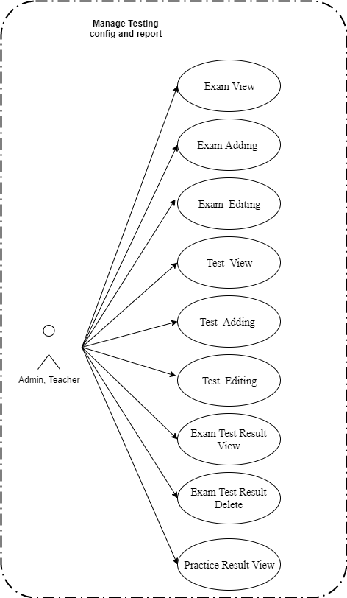

*Figure 13. Manage Testing Config and Report*

**2.2.3.1 Exam View**

*Use Case Specification*

|  |  |  |  |  |  |  |
| --- | --- | --- | --- | --- | --- | --- |
| **UC ID** | UC-3.1 | |  | **Use Case Name** | Exam View |  |
|  |  |  |  |  |  |  |
| **Created by:** | PhatNK | |  | Date Created: | 17/10/2019 |  |
|  |  |  |  |  |  |  |
| **Actor:** | Admin, Teacher | | | |  |  |
|  |  |  |  | |  |  |
| **Trigger:** | - Actor clicks “Exams Lists” of “ Testing Config & Report” in side bar in admin page | | | | |  |
|  |  |  |  | | |  |
| **Description:** | List of exams or exam groups. The table also stores information about the user's practice exercises | | | | |  |
|  |  |  |  | |  |  |
| **Preconditions:** | Access account is admin. | | | |  |  |
|  |  |  |  |  |  |  |
| **Post conditions:** | Information on Exam displayed on the home page success in the system. | | | | |  |
|  |  |  |  | | |  |
| **Normal Flow:** | 1 | Actor | - Actor clicks “Exams Lists” of “ Testing Config & Report” in side bar in admin page | | |  |
|  |  |  |  |  |  |
|  |  |  |  | | |  |
|  | 2 | System | Displays Exam screen. | | |  |
|  |  |  |  |  |  |

36

|  |  |  |  |  |  |  |  |  |  |
| --- | --- | --- | --- | --- | --- | --- | --- | --- | --- |
|  |  |  |  |  |  |  |  | |  |
|  |  |  |  |  |  |  |  |  |  |
| **Extension Flows:** |  | | | | | | |  |  |
|  |  | | | | | |  |  |  |
|  |  |  |  |  |  |  |  |  |  |
| **Alternative Flows:** | N/A | |  |  |  |  |  |  |  |
|  |  |  |  |  |  |  |  |  |  |
| **Exceptions:** |  |  |  |  |  |  |  |  |  |
|  |  |  | |  |  |  |  |  |  |
| **Priority:** | High | | | |  |  |  |  |  |
|  |  |  | |  |  |  |  |  |  |
| **Frequency of Use:** | High | | | |  |  |  |  |  |
|  |  |  | |  | |  |  |  |  |
| **Business Rules:** |  | | | | | |  |  |  |
|  |  | | | | | | |  |  |
|  |  |  |  |  |  |  |  |  |  |
| **Other Information:** |  |  |  |  |  |  |  |  |  |
|  |  |  |  |  |  |  |  |  |  |
| **Assumptions:** |  |  |  |  |  |  |  |  |  |
|  |  |  |  |  |  |  |  |  |  |
|  |  |  |  |  |  |  |  |  |  |

**2.2.3.2 Exam Adding**

*Use Case Specification*

|  |  |  |  |  |  |  |
| --- | --- | --- | --- | --- | --- | --- |
| **UC ID** | UC-3.2 | |  | **Use Case Name** | Exam Adding |  |
|  |  |  |  |  |  |  |
| **Created by:** | PhatNK | |  | Date Created: | 17/10/2019 |  |
|  |  |  |  |  |  |  |
| **Actor:** | Admin, Teacher | | | |  |  |
|  |  |  |  | |  |  |
| **Trigger:** | - Actor clicks “Exams Lists” of “ Testing Config & Report” in side bar in admin page  - Actor click “Add new ” | | | | |  |
|  |  |  |  | | |  |
| **Description:** | List of exams or exam groups. The table also stores information about the user's practice exercises | | | | |  |
|  |  |  |  | |  |  |
| **Preconditions:** | Actor accessed Exam List page. | | | |  |  |
|  |  |  |  |  |  |  |
| **Post conditions:** | A new exam is added to the system successfully. | | | | |  |
|  |  |  |  | | |  |
| **Normal Flow:** | 1 | Actor | - Actor clicks “Exams Lists” of “ Testing Config & Report” in side bar in admin page  - Actor click “Add new ” | | |  |
|  |  |  |  |  |  |
|  |  |  |  | | |  |
|  | 2 | System | Displays Exam Details screen. | | |  |
|  |  |  |  |  |  |

36

|  |  |  |  |  |  |  |  |  |  |
| --- | --- | --- | --- | --- | --- | --- | --- | --- | --- |
|  |  |  |  |  |  |  |  | |  |
|  |  |  |  |  |  |  |  |  |  |
|  | 3 |  | Actor | | Enter imformation on page.  Click “Submit” button. | | |  |  |
|  |  |  |  |  | | |  |  |
|  |  |  |  |  |  |  |
|  |  |  |  |  |  | |  |  |  |
|  |  |  |  |  |  |  |  |  |  |
|  | 4 |  | System | | Uploads and displays Exam List on Exam Deatails screen.  Saves new question data in database. | | |  |  |
|  |  |  |  |  |  |
|  |  |  |  |  |  |  |
|  |  |  |  |  |  |  |
|  |  |  |  |  |  |  |  |  |  |
| **Extension Flows:** |  | | | | | | |  |  |
|  |  | | | | | |  |  |  |
|  |  |  |  |  |  |  |  |  |  |
| **Alternative Flows:** | N/A | |  |  |  |  |  |  |  |
|  |  |  |  |  |  |  |  |  |  |
| **Exceptions:** |  |  |  |  |  |  |  |  |  |
|  |  |  | |  |  |  |  |  |  |
| **Priority:** | High | | | |  |  |  |  |  |
|  |  |  | |  |  |  |  |  |  |
| **Frequency of Use:** | High | | | |  |  |  |  |  |
|  |  |  | |  | |  |  |  |  |
| **Business Rules:** |  | | | | | |  |  |  |
|  |  | | | | | | |  |  |
|  |  |  |  |  |  |  |  |  |  |
| **Other Information:** |  |  |  |  |  |  |  |  |  |
|  |  |  |  |  |  |  |  |  |  |
| **Assumptions:** |  |  |  |  |  |  |  |  |  |
|  |  |  |  |  |  |  |  |  |  |
|  |  |  |  |  |  |  |  |  |  |

**2.2.3.3 Exam** **Editing**

*Use Case Specification*

|  |  |  |  |  |  |  |
| --- | --- | --- | --- | --- | --- | --- |
| **UC ID** | UC-3.3 | |  | **Use Case Name** | Exam Editing |  |
|  |  |  |  |  |  |  |
| **Created by:** | PhatNK | |  | Date Created: | 17/10/2019 |  |
|  |  |  |  |  |  |  |
| **Actor:** | Admin, Teacher | | | |  |  |
|  |  |  |  | |  |  |
| **Trigger:** | - Actor clicks “Exams Lists” of “ Testing Config & Report” in side bar in admin page  - Actor click “ Edit ” | | | | |  |
|  |  |  |  | | |  |
| **Description:** | List of exams or exam groups. The table also stores information about the user's practice exercises | | | | |  |
|  |  |  |  | |  |  |
| **Preconditions:** | Actor accessed Exam List page. | | | |  |  |
|  |  |  |  |  |  |  |
| **Post conditions:** | A exam is Edited to the system successfully. | | | | |  |
|  |  |  |  | | |  |
| **Normal Flow:** | 1 | Actor | - Actor clicks “Exams Lists” of “ Testing Config & Report” in side bar in admin page  - Actor click “ Edit ”. | | |  |
|  |  |  |  |  |  |
|  |  |  |  | | |  |
|  | 2 | System | Displays Exam Details screen. | | |  |
|  |  |  |  |  |  |

36

|  |  |  |  |  |  |  |  |  |  |
| --- | --- | --- | --- | --- | --- | --- | --- | --- | --- |
|  |  |  |  |  |  |  |  | |  |
|  |  |  |  |  |  |  |  |  |  |
|  | 3 |  | Actor | | Writes imformation on page.  Click “Submit” button. | | |  |  |
|  |  |  |  |  | | |  |  |
|  |  |  |  |  |  |  |
|  |  |  |  |  |  | |  |  |  |
|  |  |  |  |  |  |  |  |  |  |
|  | 4 |  | System | | Uploads and displays Exam List on Exam Deatails screen.  Saves new post data in database. | | |  |  |
|  |  |  |  |  |  |
|  |  |  |  |  |  |  |
|  |  |  |  |  |  |  |
|  |  |  |  |  |  |  |
| **Extension Flows:** |  | | | | | | |  |  |
|  |  | | | | | |  |  |  |
|  |  |  |  |  |  |  |  |  |  |
| **Alternative Flows:** | N/A | |  |  |  |  |  |  |  |
|  |  |  |  |  |  |  |  |  |  |
| **Exceptions:** |  |  |  |  |  |  |  |  |  |
|  |  |  | |  |  |  |  |  |  |
| **Priority:** | High | | | |  |  |  |  |  |
|  |  |  | |  |  |  |  |  |  |
| **Frequency of Use:** | High | | | |  |  |  |  |  |
|  |  |  | |  | |  |  |  |  |
| **Business Rules:** |  | | | | | |  |  |  |
|  |  | | | | | | |  |  |
|  |  |  |  |  |  |  |  |  |  |
| **Other Information:** |  |  |  |  |  |  |  |  |  |
|  |  |  |  |  |  |  |  |  |  |
| **Assumptions:** |  |  |  |  |  |  |  |  |  |
|  |  |  |  |  |  |  |  |  |  |
|  |  |  |  |  |  |  |  |  |  |

**2.2.3.4 Test View**

*Use Case Specification*

|  |  |  |  |  |  |  |
| --- | --- | --- | --- | --- | --- | --- |
| **UC ID** | UC-3.4 | |  | **Use Case Name** | Test View |  |
|  |  |  |  |  |  |  |
| **Created by:** | PhatNK | |  | Date Created: | 17/10/2019 |  |
|  |  |  |  |  |  |  |
| **Actor:** | Admin, Teacher | | | |  |  |
|  |  |  |  | |  |  |
| **Trigger:** | - Actor clicks “Test Lists” of “ Testing Config & Report” in side bar in admin page | | | | |  |
|  |  |  |  | | |  |
| **Description:** | List of questions from each test (exam_test) | | | | |  |
|  |  |  |  | |  |  |
| **Preconditions:** | Access account is admin. | | | |  |  |
|  |  |  |  |  |  |  |
| **Post conditions:** | Information on Test displayed on the home page success in the system. | | | | |  |
|  |  |  |  | | |  |
| **Normal Flow:** | 1 | Actor | - Actor clicks “Test Lists” of “ Testing Config & Report” in side bar in admin page | | |  |
|  |  |  |  |  |  |
|  |  |  |  | | |  |
|  | 2 | System | Displays Exam screen. | | |  |
|  |  |  |  |  |  |

36

|  |  |  |  |  |  |  |  |  |  |
| --- | --- | --- | --- | --- | --- | --- | --- | --- | --- |
|  |  |  |  |  |  |  |  | |  |
|  |  |  |  |  |  |  |  |  |  |
| **Extension Flows:** |  | | | | | | |  |  |
|  |  | | | | | |  |  |  |
|  |  |  |  |  |  |  |  |  |  |
| **Alternative Flows:** | N/A | |  |  |  |  |  |  |  |
|  |  |  |  |  |  |  |  |  |  |
| **Exceptions:** |  |  |  |  |  |  |  |  |  |
|  |  |  | |  |  |  |  |  |  |
| **Priority:** | High | | | |  |  |  |  |  |
|  |  |  | |  |  |  |  |  |  |
| **Frequency of Use:** | High | | | |  |  |  |  |  |
|  |  |  | |  | |  |  |  |  |
| **Business Rules:** |  | | | | | |  |  |  |
|  |  | | | | | | |  |  |
|  |  |  |  |  |  |  |  |  |  |
| **Other Information:** |  |  |  |  |  |  |  |  |  |
|  |  |  |  |  |  |  |  |  |  |
| **Assumptions:** |  |  |  |  |  |  |  |  |  |
|  |  |  |  |  |  |  |  |  |  |
|  |  |  |  |  |  |  |  |  |  |

**2.2.3.5 Test Adding**

*Use Case Specification*

|  |  |  |  |  |  |  |
| --- | --- | --- | --- | --- | --- | --- |
| **UC ID** | UC-3.5 | |  | **Use Case Name** | Test Adding |  |
|  |  |  |  |  |  |  |
| **Created by:** | PhatNK | |  | Date Created: | 17/10/2019 |  |
|  |  |  |  |  |  |  |
| **Actor:** | Admin, Teacher | | | |  |  |
|  |  |  |  | |  |  |
| **Trigger:** | - Actor clicks “Test Lists” of “ Testing Config & Report” in side bar in admin page  - Actor click “Add new ” | | | | |  |
|  |  |  |  | | |  |
| **Description:** | List of questions from each test (exam_test) | | | | |  |
|  |  |  |  | |  |  |
| **Preconditions:** | Actor accessed Exam List page. | | | |  |  |
|  |  |  |  |  |  |  |
| **Post conditions:** | A new test is added to the system successfully. | | | | |  |
|  |  |  |  | | |  |
| **Normal Flow:** | 1 | Actor | - Actor clicks “Test Lists” of “ Testing Config & Report” in side bar in admin page  - Actor click “Add new ” | | |  |
|  |  |  |  |  |  |
|  |  |  |  | | |  |
|  | 2 | System | Displays Exam Details screen. | | |  |
|  |  |  |  |  |  |

36

|  |  |  |  |  |  |  |  |  |  |
| --- | --- | --- | --- | --- | --- | --- | --- | --- | --- |
|  |  |  |  |  |  |  |  | |  |
|  |  |  |  |  |  |  |  |  |  |
|  | 3 |  | Actor | | Enter imformation on page.  Click “Submit” button. | | |  |  |
|  |  |  |  |  | | |  |  |
|  |  |  |  |  |  |  |
|  |  |  |  |  |  | |  |  |  |
|  |  |  |  |  |  |  |  |  |  |
|  | 4 |  | System | | Uploads and displays Test List on Exam Deatails screen.  Saves new test data in database. | | |  |  |
|  |  |  |  |  |  |
|  |  |  |  |  |  |  |
|  |  |  |  |  |  |  |
|  |  |  |  |  |  |  |  |  |  |
| **Extension Flows:** |  | | | | | | |  |  |
|  |  | | | | | |  |  |  |
|  |  |  |  |  |  |  |  |  |  |
| **Alternative Flows:** | N/A | |  |  |  |  |  |  |  |
|  |  |  |  |  |  |  |  |  |  |
| **Exceptions:** |  |  |  |  |  |  |  |  |  |
|  |  |  | |  |  |  |  |  |  |
| **Priority:** | High | | | |  |  |  |  |  |
|  |  |  | |  |  |  |  |  |  |
| **Frequency of Use:** | High | | | |  |  |  |  |  |
|  |  |  | |  | |  |  |  |  |
| **Business Rules:** |  | | | | | |  |  |  |
|  |  | | | | | | |  |  |
|  |  |  |  |  |  |  |  |  |  |
| **Other Information:** |  |  |  |  |  |  |  |  |  |
|  |  |  |  |  |  |  |  |  |  |
| **Assumptions:** |  |  |  |  |  |  |  |  |  |
|  |  |  |  |  |  |  |  |  |  |
|  |  |  |  |  |  |  |  |  |  |

**2.2.3.6 Exam** **Editing**

*Use Case Specification*

|  |  |  |  |  |  |  |
| --- | --- | --- | --- | --- | --- | --- |
| **UC ID** | UC-3.6 | |  | **Use Case Name** | Test Editing |  |
|  |  |  |  |  |  |  |
| **Created by:** | PhatNK | |  | Date Created: | 17/10/2019 |  |
|  |  |  |  |  |  |  |
| **Actor:** | Admin, Teacher | | | |  |  |
|  |  |  |  | |  |  |
| **Trigger:** | - Actor clicks “Test Lists” of “ Testing Config & Report” in side bar in admin page  - Actor click “ Edit ” | | | | |  |
|  |  |  |  | | |  |
| **Description:** | List of questions from each test (exam_test) | | | | |  |
|  |  |  |  | |  |  |
| **Preconditions:** | Actor accessed Test List page. | | | |  |  |
|  |  |  |  |  |  |  |
| **Post conditions:** | A test is Edited to the system successfully. | | | | |  |
|  |  |  |  | | |  |
| **Normal Flow:** | 1 | Actor | - Actor clicks “Test Lists” of “ Testing Config & Report” in side bar in admin page  - Actor click “ Edit ”. | | |  |
|  |  |  |  |  |  |
|  |  |  |  | | |  |
|  | 2 | System | Displays Test Details screen. | | |  |
|  |  |  |  |  |  |

36

|  |  |  |  |  |  |  |  |  |  |
| --- | --- | --- | --- | --- | --- | --- | --- | --- | --- |
|  |  |  |  |  |  |  |  | |  |
|  |  |  |  |  |  |  |  |  |  |
|  | 3 |  | Actor | | Writes imformation on page.  Click “Submit” button. | | |  |  |
|  |  |  |  |  | | |  |  |
|  |  |  |  |  |  |  |
|  |  |  |  |  |  | |  |  |  |
|  |  |  |  |  |  |  |  |  |  |
|  | 4 |  | System | | Uploads and displays Test List on Test Deatails screen.  Saves new test data in database. | | |  |  |
|  |  |  |  |  |  |
|  |  |  |  |  |  |  |
|  |  |  |  |  |  |  |
|  |  |  |  |  |  |  |
| **Extension Flows:** |  | | | | | | |  |  |
|  |  | | | | | |  |  |  |
|  |  |  |  |  |  |  |  |  |  |
| **Alternative Flows:** | N/A | |  |  |  |  |  |  |  |
|  |  |  |  |  |  |  |  |  |  |
| **Exceptions:** |  |  |  |  |  |  |  |  |  |
|  |  |  | |  |  |  |  |  |  |
| **Priority:** | High | | | |  |  |  |  |  |
|  |  |  | |  |  |  |  |  |  |
| **Frequency of Use:** | High | | | |  |  |  |  |  |
|  |  |  | |  | |  |  |  |  |
| **Business Rules:** |  | | | | | |  |  |  |
|  |  | | | | | | |  |  |
|  |  |  |  |  |  |  |  |  |  |
| **Other Information:** |  |  |  |  |  |  |  |  |  |
|  |  |  |  |  |  |  |  |  |  |
| **Assumptions:** |  |  |  |  |  |  |  |  |  |
|  |  |  |  |  |  |  |  |  |  |
|  |  |  |  |  |  |  |  |  |  |

**2.2.3.7 Exam Test Result View**

*Use Case Specification*

|  |  |  |  |  |  |  |
| --- | --- | --- | --- | --- | --- | --- |
| **UC ID** | UC-3.7 | |  | **Use Case Name** | Exam Test Result View |  |
|  |  |  |  |  |  |  |
| **Created by:** | PhatNK | |  | Date Created: | 17/10/2019 |  |
|  |  |  |  |  |  |  |
| **Actor:** | Admin, Teacher | | | |  |  |
|  |  |  |  | |  |  |
| **Trigger:** | - Actor clicks “Test Lists” of “ Testing Config & Report” in side bar in admin page  -Actor click “Results” | | | | |  |
|  |  |  |  | | |  |
| **Description:** | Score notification for students | | | | |  |
|  |  |  |  | |  |  |
| **Preconditions:** | Access account is admin. | | | |  |  |
|  |  |  |  |  |  |  |
| **Post conditions:** | Information on Test displayed on the home page success in the system. | | | | |  |
|  |  |  |  | | |  |
| **Normal Flow:** | 1 | Actor | - Actor clicks “Test Lists” of “ Testing Config & Report” in side bar in admin page  -Actor click “Results” | | |  |
|  |  |  |  |  |  |
|  |  |  |  | | |  |
|  | 2 | System | Displays Exam Test Result screen. | | |  |
|  |  |  |  |  |  |

36

|  |  |  |  |  |  |  |  |  |  |
| --- | --- | --- | --- | --- | --- | --- | --- | --- | --- |
|  |  |  |  |  |  |  |  | |  |
|  |  |  |  |  |  |  |  |  |  |
| **Extension Flows:** |  | | | | | | |  |  |
|  |  | | | | | |  |  |  |
|  |  |  |  |  |  |  |  |  |  |
| **Alternative Flows:** | N/A | |  |  |  |  |  |  |  |
|  |  |  |  |  |  |  |  |  |  |
| **Exceptions:** |  |  |  |  |  |  |  |  |  |
|  |  |  | |  |  |  |  |  |  |
| **Priority:** | High | | | |  |  |  |  |  |
|  |  |  | |  |  |  |  |  |  |
| **Frequency of Use:** | High | | | |  |  |  |  |  |
|  |  |  | |  | |  |  |  |  |
| **Business Rules:** |  | | | | | |  |  |  |
|  |  | | | | | | |  |  |
|  |  |  |  |  |  |  |  |  |  |
| **Other Information:** |  |  |  |  |  |  |  |  |  |
|  |  |  |  |  |  |  |  |  |  |
| **Assumptions:** |  |  |  |  |  |  |  |  |  |
|  |  |  |  |  |  |  |  |  |  |
|  |  |  |  |  |  |  |  |  |  |

**2.2.3.8 Exam Test Result** **Delete**

*Use Case Specification*

|  |  |  |  |  |  |  |
| --- | --- | --- | --- | --- | --- | --- |
| **UC ID** | UC-3.8 | |  | **Use Case Name** | Exam Test Result Delete |  |
|  |  |  |  |  |  |  |
| **Created by:** | PhatNK | |  | Date Created: | 17/10/2019 |  |
|  |  |  |  |  |  |  |
| **Actor:** | Admin, Teacher | | | |  |  |
|  |  |  |  | |  |  |
| **Trigger:** | - Actor clicks “Test Lists” of “ Testing Config & Report” in side bar in admin page  - Actor click “ Delete ” | | | | |  |
|  |  |  |  | | |  |
| **Description:** | Score notification for students | | | | |  |
|  |  |  |  | |  |  |
| **Preconditions:** | Access account is admin. | | | |  |  |
|  |  |  |  |  |  |  |
| **Post conditions:** | A Exam Test Result is Delete to the system successfully. | | | | |  |
|  |  |  |  | | |  |
| **Normal Flow:** | 1 | Actor | - Actor clicks “Test Lists” of “ Testing Config & Report” in side bar in admin page  - Actor click “ Delete ” | | |  |
|  |  |  |  |  |  |
|  |  |  |  | | |  |
|  | 2 | System | Show message Delete success. | | |  |
|  |  |  |  |  |  |

36

|  |  |  |  |  |  |  |  |  |  |
| --- | --- | --- | --- | --- | --- | --- | --- | --- | --- |
|  |  |  |  |  |  |  |  | |  |
| **Extension Flows:** |  | | | | | | |  |  |
|  |  | | | | | |  |  |  |
|  |  |  |  |  |  |  |  |  |  |
| **Alternative Flows:** | N/A | |  |  |  |  |  |  |  |
|  |  |  |  |  |  |  |  |  |  |
| **Exceptions:** |  |  |  |  |  |  |  |  |  |
|  |  |  | |  |  |  |  |  |  |
| **Priority:** | High | | | |  |  |  |  |  |
|  |  |  | |  |  |  |  |  |  |
| **Frequency of Use:** | High | | | |  |  |  |  |  |
|  |  |  | |  | |  |  |  |  |
| **Business Rules:** |  | | | | | |  |  |  |
|  |  | | | | | | |  |  |
|  |  |  |  |  |  |  |  |  |  |
| **Other Information:** |  |  |  |  |  |  |  |  |  |
|  |  |  |  |  |  |  |  |  |  |
| **Assumptions:** |  |  |  |  |  |  |  |  |  |
|  |  |  |  |  |  |  |  |  |  |
|  |  |  |  |  |  |  |  |  |  |

**2.2.3.9 Practice Result View**

*Use Case Specification*

|  |  |  |  |  |  |  |
| --- | --- | --- | --- | --- | --- | --- |
| **UC ID** | UC-3.9 | |  | **Use Case Name** | Practice ResultView |  |
|  |  |  |  |  |  |  |
| **Created by:** | PhatNK | |  | Date Created: | 17/10/2019 |  |
|  |  |  |  |  |  |  |
| **Actor:** | Admin, Teacher | | | |  |  |
|  |  |  |  | |  |  |
| **Trigger:** | - Actor clicks “Practice Results ” of “ Testing Config & Report” in side bar in admin page | | | | |  |
|  |  |  |  | | |  |
| **Description:** | The function allows Admin, Teacher show imformation of Practice Result. | | | | |  |
|  |  |  |  | |  |  |
| **Preconditions:** | Access account is admin. | | | |  |  |
|  |  |  |  |  |  |  |
| **Post conditions:** |  | | | | |  |
|  |  |  |  | | |  |
| **Normal Flow:** | 1 | Actor | - Actor clicks “Practice Results ” of “ Testing Config & Report” in side bar in admin page | | |  |
|  |  |  |  |  |  |
|  |  |  |  | | |  |
|  | 2 | System | Displays Practice Result screen. | | |  |
|  |  |  |  |  |  |

36

|  |  |  |  |  |  |  |  |  |  |
| --- | --- | --- | --- | --- | --- | --- | --- | --- | --- |
|  |  |  |  |  |  |  |  | |  |
|  |  |  |  |  |  |  |  |  |  |
| **Extension Flows:** |  | | | | | | |  |  |
|  |  | | | | | |  |  |  |
|  |  |  |  |  |  |  |  |  |  |
| **Alternative Flows:** | N/A | |  |  |  |  |  |  |  |
|  |  |  |  |  |  |  |  |  |  |
| **Exceptions:** |  |  |  |  |  |  |  |  |  |
|  |  |  | |  |  |  |  |  |  |
| **Priority:** | High | | | |  |  |  |  |  |
|  |  |  | |  |  |  |  |  |  |
| **Frequency of Use:** | High | | | |  |  |  |  |  |
|  |  |  | |  | |  |  |  |  |
| **Business Rules:** |  | | | | | |  |  |  |
|  |  | | | | | | |  |  |
|  |  |  |  |  |  |  |  |  |  |
| **Other Information:** |  |  |  |  |  |  |  |  |  |
|  |  |  |  |  |  |  |  |  |  |
| **Assumptions:** |  |  |  |  |  |  |  |  |  |
|  |  |  |  |  |  |  |  |  |  |
|  |  |  |  |  |  |  |  |  |  |

**2.2.4** **Manage System Config**

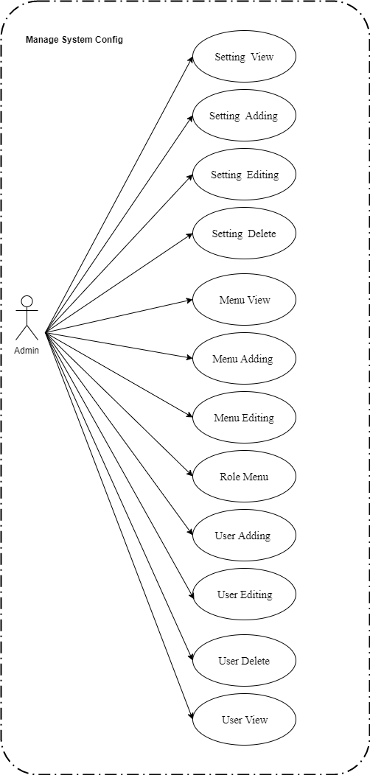

*Figure 14. Use case diagram of Manage System Config*

**2.2.4.1 Setting View**

*Use Case Specification*

|  |  |  |  |  |  |  |
| --- | --- | --- | --- | --- | --- | --- |
| **UC ID** | UC-4.1 | |  | **Use Case Name** | Setting View |  |
|  |  |  |  |  |  |  |
| **Created by:** | PhatNK | |  | Date Created: | 17/10/2019 |  |
|  |  |  |  |  |  |  |
| **Actor:** | Admin | | | |  |  |
|  |  |  |  | |  |  |
| **Trigger:** | - Actor clicks “Setting List” of “System Config” in side bar in admin page | | | | |  |
|  |  |  |  | | |  |
| **Description:** | "List of system configurations. Where group_value is the group of configuration information (the name / description of the group is taken from the configuration file). Configuration groups in the system  1: System Roles  2: User Groups  3: Post Types (Guide, Resource)  4: Lesson Types (Subject Topic, Video Lesson, HTML Lesson, Quiz)  5: Subject Types (Exam, Online, Offline, Blended, External)  6: Subject Categories  7: Guide Categories  8: Resource Categories  9: Question Levels (Hard, Medium, Easy)  10: Exam Types (Simulation, Lesson-Based, Course-Based, Paper-Based, Code-Based) " | | | | |  |
|  |  |  |  | |  |  |
| **Preconditions:** | Access account is admin. | | | |  |  |
|  |  |  |  |  |  |  |
| **Post conditions:** | Information on Setting displayed on the home page success in the system. | | | | |  |
|  |  |  |  | | |  |
| **Normal Flow:** | 1 | Actor | - Actor clicks “Setting List” of “ Setting Config” in side bar in admin page | | |  |
|  |  |  |  |  |  |
|  |  |  |  | | |  |
|  | 2 | System | Displays Setting screen. | | |  |
|  |  |  |  |  |  |

36

|  |  |  |  |  |  |  |  |  |  |
| --- | --- | --- | --- | --- | --- | --- | --- | --- | --- |
|  |  |  |  |  |  |  |  | |  |
|  |  |  |  |  |  |  |  |  |  |
| **Extension Flows:** |  | | | | | | |  |  |
|  |  | | | | | |  |  |  |
|  |  |  |  |  |  |  |  |  |  |
| **Alternative Flows:** | N/A | |  |  |  |  |  |  |  |
|  |  |  |  |  |  |  |  |  |  |
| **Exceptions:** |  |  |  |  |  |  |  |  |  |
|  |  |  | |  |  |  |  |  |  |
| **Priority:** | High | | | |  |  |  |  |  |
|  |  |  | |  |  |  |  |  |  |
| **Frequency of Use:** | High | | | |  |  |  |  |  |
|  |  |  | |  | |  |  |  |  |
| **Business Rules:** |  | | | | | |  |  |  |
|  |  | | | | | | |  |  |
|  |  |  |  |  |  |  |  |  |  |
| **Other Information:** |  |  |  |  |  |  |  |  |  |
|  |  |  |  |  |  |  |  |  |  |
| **Assumptions:** |  |  |  |  |  |  |  |  |  |
|  |  |  |  |  |  |  |  |  |  |
|  |  |  |  |  |  |  |  |  |  |

**2.2.4.2 Setting Adding**

*Use Case Specification*

|  |  |  |  |  |  |  |
| --- | --- | --- | --- | --- | --- | --- |
| **UC ID** | UC-4.2 | |  | **Use Case Name** | SettingAdding |  |
|  |  |  |  |  |  |  |
| **Created by:** | PhatNK | |  | Date Created: | 17/10/2019 |  |
|  |  |  |  |  |  |  |
| **Actor:** | Admin | | | |  |  |
|  |  |  |  | |  |  |
| **Trigger:** | - Actor clicks “Settings List ” of “ System Config ” in side bar in admin page  - Actor click “Add new ” | | | | |  |
|  |  |  |  | | |  |
| **Description:** | "List of system configurations. Where group_value is the group of configuration information (the name / description of the group is taken from the configuration file). Configuration groups in the system  1: System Roles  2: User Groups  3: Post Types (Guide, Resource)  4: Lesson Types (Subject Topic, Video Lesson, HTML Lesson, Quiz)  5: Subject Types (Exam, Online, Offline, Blended, External)  6: Subject Categories  7: Guide Categories  8: Resource Categories  9: Question Levels (Hard, Medium, Easy)  10: Exam Types (Simulation, Lesson-Based, Course-Based, Paper-Based, Code-Based) " | | | | |  |
|  |  |  |  | |  |  |
| **Preconditions:** | Actor accessed Setting List page. | | | |  |  |
|  |  |  |  |  |  |  |
| **Post conditions:** | A new setting is added to the system successfully. | | | | |  |
|  |  |  |  | | |  |
| **Normal Flow:** | 1 | Actor | - Actor clicks “Setting List ” of “ System Config ” in side bar in admin page  - Actor click “Add new ” | | |  |
|  |  |  |  |  |  |
|  |  |  |  | | |  |
|  | 2 | System | Displays Setting Details screen. | | |  |
|  |  |  |  |  |  |

36

|  |  |  |  |  |  |  |  |  |  |
| --- | --- | --- | --- | --- | --- | --- | --- | --- | --- |
|  |  |  |  |  |  |  |  | |  |
|  |  |  |  |  |  |  |  |  |  |
|  | 3 |  | Actor | | Enter imformation on page.  Click “Submit” button. | | |  |  |
|  |  |  |  |  | | |  |  |
|  |  |  |  |  |  |  |
|  |  |  |  |  |  | |  |  |  |
|  |  |  |  |  |  |  |  |  |  |
|  | 4 |  | System | | Uploads and displays Setting List on Setting Deatails screen.  Saves new question data in database. | | |  |  |
|  |  |  |  |  |  |
|  |  |  |  |  |  |  |
|  |  |  |  |  |  |  |
|  |  |  |  |  |  |  |  |  |  |
| **Extension Flows:** |  | | | | | | |  |  |
|  |  | | | | | |  |  |  |
|  |  |  |  |  |  |  |  |  |  |
| **Alternative Flows:** | N/A | |  |  |  |  |  |  |  |
|  |  |  |  |  |  |  |  |  |  |
| **Exceptions:** |  |  |  |  |  |  |  |  |  |
|  |  |  | |  |  |  |  |  |  |
| **Priority:** | High | | | |  |  |  |  |  |
|  |  |  | |  |  |  |  |  |  |
| **Frequency of Use:** | High | | | |  |  |  |  |  |
|  |  |  | |  | |  |  |  |  |
| **Business Rules:** |  | | | | | |  |  |  |
|  |  | | | | | | |  |  |
|  |  |  |  |  |  |  |  |  |  |
| **Other Information:** |  |  |  |  |  |  |  |  |  |
|  |  |  |  |  |  |  |  |  |  |
| **Assumptions:** |  |  |  |  |  |  |  |  |  |
|  |  |  |  |  |  |  |  |  |  |
|  |  |  |  |  |  |  |  |  |  |

**2.2.4.3 Setting Editing**

*Use Case Specification*

|  |  |  |  |  |  |  |
| --- | --- | --- | --- | --- | --- | --- |
| **UC ID** | UC-3.3 | |  | **Use Case Name** | Setting Editing |  |
|  |  |  |  |  |  |  |
| **Created by:** | PhatNK | |  | Date Created: | 17/10/2019 |  |
|  |  |  |  |  |  |  |
| **Actor:** | Admin | | | |  |  |
|  |  |  |  | |  |  |
| **Trigger:** | - Actor clicks “Setting Lists” of “ System Config ” in side bar in admin page  - Actor click “ Edit ” | | | | |  |
|  |  |  |  | | |  |
| **Description:** | "List of system configurations. Where group_value is the group of configuration information (the name / description of the group is taken from the configuration file). Configuration groups in the system  1: System Roles  2: User Groups  3: Post Types (Guide, Resource)  4: Lesson Types (Subject Topic, Video Lesson, HTML Lesson, Quiz)  5: Subject Types (Exam, Online, Offline, Blended, External)  6: Subject Categories  7: Guide Categories  8: Resource Categories  9: Question Levels (Hard, Medium, Easy)  10: Exam Types (Simulation, Lesson-Based, Course-Based, Paper-Based, Code-Based) " | | | | |  |
|  |  |  |  | |  |  |
| **Preconditions:** | Actor accessed Setting List page. | | | |  |  |
|  |  |  |  |  |  |  |
| **Post conditions:** | A setting is Edited to the system successfully. | | | | |  |
|  |  |  |  | | |  |
| **Normal Flow:** | 1 | Actor | - Actor clicks “Setting Lists” of “ System Config ” in side bar in admin page  - Actor click “ Edit ” | | |  |
|  |  |  |  |  |  |
|  |  |  |  | | |  |
|  | 2 | System | Displays Setting Details screen. | | |  |
|  |  |  |  |  |  |

36

|  |  |  |  |  |  |  |  |  |  |
| --- | --- | --- | --- | --- | --- | --- | --- | --- | --- |
|  |  |  |  |  |  |  |  | |  |
|  |  |  |  |  |  |  |  |  |  |
|  | 3 |  | Actor | | Writes imformation on page.  Click “Submit” button. | | |  |  |
|  |  |  |  |  | | |  |  |
|  |  |  |  |  |  |  |
|  |  |  |  |  |  | |  |  |  |
|  |  |  |  |  |  |  |  |  |  |
|  | 4 |  | System | | Uploads and displays Setting List on Setting Deatails screen.  Saves new setting data in database. | | |  |  |
|  |  |  |  |  |  |
|  |  |  |  |  |  |  |
|  |  |  |  |  |  |  |
|  |  |  |  |  |  |  |
| **Extension Flows:** |  | | | | | | |  |  |
|  |  | | | | | |  |  |  |
|  |  |  |  |  |  |  |  |  |  |
| **Alternative Flows:** | N/A | |  |  |  |  |  |  |  |
|  |  |  |  |  |  |  |  |  |  |
| **Exceptions:** |  |  |  |  |  |  |  |  |  |
|  |  |  | |  |  |  |  |  |  |
| **Priority:** | High | | | |  |  |  |  |  |
|  |  |  | |  |  |  |  |  |  |
| **Frequency of Use:** | High | | | |  |  |  |  |  |
|  |  |  | |  | |  |  |  |  |
| **Business Rules:** |  | | | | | |  |  |  |
|  |  | | | | | | |  |  |
|  |  |  |  |  |  |  |  |  |  |
| **Other Information:** |  |  |  |  |  |  |  |  |  |
|  |  |  |  |  |  |  |  |  |  |
| **Assumptions:** |  |  |  |  |  |  |  |  |  |
|  |  |  |  |  |  |  |  |  |  |
|  |  |  |  |  |  |  |  |  |  |

**2.2.4.4 Setting** **Delete**

*Use Case Specification*

|  |  |  |  |  |  |  |
| --- | --- | --- | --- | --- | --- | --- |
| **UC ID** | UC-4.4 | |  | **Use Case Name** | Setting Delete |  |
|  |  |  |  |  |  |  |
| **Created by:** | PhatNK | |  | Date Created: | 17/10/2019 |  |
|  |  |  |  |  |  |  |
| **Actor:** | Admin, Teacher | | | |  |  |
|  |  |  |  | |  |  |
| **Trigger:** | - Actor clicks “Setting List ” of “ System Config ” in side bar in admin page  - Actor click “ Delete ” | | | | |  |
|  |  |  |  | | |  |
| **Description:** | "List of system configurations. Where group_value is the group of configuration information (the name / description of the group is taken from the configuration file). Configuration groups in the system  1: System Roles  2: User Groups  3: Post Types (Guide, Resource)  4: Lesson Types (Subject Topic, Video Lesson, HTML Lesson, Quiz)  5: Subject Types (Exam, Online, Offline, Blended, External)  6: Subject Categories  7: Guide Categories  8: Resource Categories  9: Question Levels (Hard, Medium, Easy)  10: Exam Types (Simulation, Lesson-Based, Course-Based, Paper-Based, Code-Based) " | | | | |  |
|  |  |  |  | |  |  |
| **Preconditions:** | Actor accessed Setting List page. | | | |  |  |
|  |  |  |  |  |  |  |
| **Post conditions:** | A setting is Delete to the system successfully. | | | | |  |
|  |  |  |  | | |  |
| **Normal Flow:** | 1 | Actor | - Actor clicks “Setting List ” of “ System Config ” in side bar in admin page  - Actor click “ Delete ” | | |  |
|  |  |  |  |  |  |
|  |  |  |  | | |  |
|  | 2 | System | Show message Delete success. | | |  |
|  |  |  |  |  |  |

36

|  |  |  |  |  |  |  |  |  |  |
| --- | --- | --- | --- | --- | --- | --- | --- | --- | --- |
|  |  |  |  |  |  |  |  | |  |
| **Extension Flows:** |  | | | | | | |  |  |
|  |  | | | | | |  |  |  |
|  |  |  |  |  |  |  |  |  |  |
| **Alternative Flows:** | N/A | |  |  |  |  |  |  |  |
|  |  |  |  |  |  |  |  |  |  |
| **Exceptions:** |  |  |  |  |  |  |  |  |  |
|  |  |  | |  |  |  |  |  |  |
| **Priority:** | High | | | |  |  |  |  |  |
|  |  |  | |  |  |  |  |  |  |
| **Frequency of Use:** | High | | | |  |  |  |  |  |
|  |  |  | |  | |  |  |  |  |
| **Business Rules:** |  | | | | | |  |  |  |
|  |  | | | | | | |  |  |
|  |  |  |  |  |  |  |  |  |  |
| **Other Information:** |  |  |  |  |  |  |  |  |  |
|  |  |  |  |  |  |  |  |  |  |
| **Assumptions:** |  |  |  |  |  |  |  |  |  |
|  |  |  |  |  |  |  |  |  |  |
|  |  |  |  |  |  |  |  |  |  |

**2.2.4.5 Menu View**

*Use Case Specification*

|  |  |  |  |  |  |  |
| --- | --- | --- | --- | --- | --- | --- |
| **UC ID** | UC-4.5 | |  | **Use Case Name** | Menu View |  |
|  |  |  |  |  |  |  |
| **Created by:** | PhatNK | |  | Date Created: | 17/10/2019 |  |
|  |  |  |  |  |  |  |
| **Actor:** | Admin | | | |  |  |
|  |  |  |  | |  |  |
| **Trigger:** | - Actor clicks “Menu List” of “System Config” in side bar in admin page | | | | |  |
|  |  |  |  | | |  |
| **Description:** | Information of menus in CMS / Admin module (located in the menu tree) | | | | |  |
|  |  |  |  | |  |  |
| **Preconditions:** | Access account is admin. | | | |  |  |
|  |  |  |  |  |  |  |
| **Post conditions:** | Information on Menu displayed on the home page success in the system. | | | | |  |
|  |  |  |  | | |  |
| **Normal Flow:** | 1 | Actor | - Actor clicks “Menu List” of “System Config” in side bar in admin page | | |  |
|  |  |  |  |  |  |
|  |  |  |  | | |  |
|  | 2 | System | Displays Menu screen. | | |  |
|  |  |  |  |  |  |

36

|  |  |  |  |  |  |  |  |  |  |
| --- | --- | --- | --- | --- | --- | --- | --- | --- | --- |
|  |  |  |  |  |  |  |  | |  |
|  |  |  |  |  |  |  |  |  |  |
| **Extension Flows:** |  | | | | | | |  |  |
|  |  | | | | | |  |  |  |
|  |  |  |  |  |  |  |  |  |  |
| **Alternative Flows:** | N/A | |  |  |  |  |  |  |  |
|  |  |  |  |  |  |  |  |  |  |
| **Exceptions:** |  |  |  |  |  |  |  |  |  |
|  |  |  | |  |  |  |  |  |  |
| **Priority:** | High | | | |  |  |  |  |  |
|  |  |  | |  |  |  |  |  |  |
| **Frequency of Use:** | High | | | |  |  |  |  |  |
|  |  |  | |  | |  |  |  |  |
| **Business Rules:** |  | | | | | |  |  |  |
|  |  | | | | | | |  |  |
|  |  |  |  |  |  |  |  |  |  |
| **Other Information:** |  |  |  |  |  |  |  |  |  |
|  |  |  |  |  |  |  |  |  |  |
| **Assumptions:** |  |  |  |  |  |  |  |  |  |
|  |  |  |  |  |  |  |  |  |  |
|  |  |  |  |  |  |  |  |  |  |

**2.2.4.6 Menu Adding**

*Use Case Specification*

|  |  |  |  |  |  |  |
| --- | --- | --- | --- | --- | --- | --- |
| **UC ID** | UC-4.6 | |  | **Use Case Name** | Menu Adding |  |
|  |  |  |  |  |  |  |
| **Created by:** | PhatNK | |  | Date Created: | 17/10/2019 |  |
|  |  |  |  |  |  |  |
| **Actor:** | Admin | | | |  |  |
|  |  |  |  | |  |  |
| **Trigger:** | - Actor clicks “Menu List ” of “ System Config ” in side bar in admin page  - Actor click “Add new ” | | | | |  |
|  |  |  |  | | |  |
| **Description:** | Information of menus in CMS / Admin module (located in the menu tree) | | | | |  |
|  |  |  |  | |  |  |
| **Preconditions:** | Actor accessed Menu List page. | | | |  |  |
|  |  |  |  |  |  |  |
| **Post conditions:** | A new menu is added to the system successfully. | | | | |  |
|  |  |  |  | | |  |
| **Normal Flow:** | 1 | Actor | - Actor clicks “Menu List ” of “ System Config ” in side bar in admin page  - Actor click “Add new ” | | |  |
|  |  |  |  |  |  |
|  |  |  |  | | |  |
|  | 2 | System | Displays Menu Details screen. | | |  |
|  |  |  |  |  |  |

36

|  |  |  |  |  |  |  |  |  |  |
| --- | --- | --- | --- | --- | --- | --- | --- | --- | --- |
|  |  |  |  |  |  |  |  | |  |
|  |  |  |  |  |  |  |  |  |  |
|  | 3 |  | Actor | | Enter imformation on page.  Click “Submit” button. | | |  |  |
|  |  |  |  |  | | |  |  |
|  |  |  |  |  |  |  |
|  |  |  |  |  |  | |  |  |  |
|  |  |  |  |  |  |  |  |  |  |
|  | 4 |  | System | | Uploads and displays Menu List on Menu Deatails screen.  Saves new menu data in database. | | |  |  |
|  |  |  |  |  |  |
|  |  |  |  |  |  |  |
|  |  |  |  |  |  |  |
|  |  |  |  |  |  |  |  |  |  |
| **Extension Flows:** |  | | | | | | |  |  |
|  |  | | | | | |  |  |  |
|  |  |  |  |  |  |  |  |  |  |
| **Alternative Flows:** | N/A | |  |  |  |  |  |  |  |
|  |  |  |  |  |  |  |  |  |  |
| **Exceptions:** |  |  |  |  |  |  |  |  |  |
|  |  |  | |  |  |  |  |  |  |
| **Priority:** | High | | | |  |  |  |  |  |
|  |  |  | |  |  |  |  |  |  |
| **Frequency of Use:** | High | | | |  |  |  |  |  |
|  |  |  | |  | |  |  |  |  |
| **Business Rules:** |  | | | | | |  |  |  |
|  |  | | | | | | |  |  |
|  |  |  |  |  |  |  |  |  |  |
| **Other Information:** |  |  |  |  |  |  |  |  |  |
|  |  |  |  |  |  |  |  |  |  |
| **Assumptions:** |  |  |  |  |  |  |  |  |  |
|  |  |  |  |  |  |  |  |  |  |
|  |  |  |  |  |  |  |  |  |  |

**2.2.4.7 Menu** **Editing**

*Use Case Specification*

|  |  |  |  |  |  |  |
| --- | --- | --- | --- | --- | --- | --- |
| **UC ID** | UC-4.7 | |  | **Use Case Name** | Menu Editing |  |
|  |  |  |  |  |  |  |
| **Created by:** | PhatNK | |  | Date Created: | 17/10/2019 |  |
|  |  |  |  |  |  |  |
| **Actor:** | Admin | | | |  |  |
|  |  |  |  | |  |  |
| **Trigger:** | - Actor clicks “Menu List ” of “ System Config ” in side bar in admin page  - Actor click “ Edit ” | | | | |  |
|  |  |  |  | | |  |
| **Description:** | Information of menus in CMS / Admin module (located in the menu tree) | | | | |  |
|  |  |  |  | |  |  |
| **Preconditions:** | Actor accessed Menu List page. | | | |  |  |
|  |  |  |  |  |  |  |
| **Post conditions:** | A menu is Edited to the system successfully. | | | | |  |
|  |  |  |  | | |  |
| **Normal Flow:** | 1 | Actor | - Actor clicks “Menu List ” of “ System Config ” in side bar in admin page  - Actor click “ Edit ” | | |  |
|  |  |  |  |  |  |
|  |  |  |  | | |  |
|  | 2 | System | Displays Menu Details screen. | | |  |
|  |  |  |  |  |  |

36

|  |  |  |  |  |  |  |  |  |  |
| --- | --- | --- | --- | --- | --- | --- | --- | --- | --- |
|  |  |  |  |  |  |  |  | |  |
|  |  |  |  |  |  |  |  |  |  |
|  | 3 |  | Actor | | Writes imformation on page.  Click “Submit” button. | | |  |  |
|  |  |  |  |  | | |  |  |
|  |  |  |  |  |  |  |
|  |  |  |  |  |  | |  |  |  |
|  |  |  |  |  |  |  |  |  |  |
|  | 4 |  | System | | Uploads and displays Menu List on Menu Deatails screen.  Saves new menu data in database. | | |  |  |
|  |  |  |  |  |  |
|  |  |  |  |  |  |  |
|  |  |  |  |  |  |  |
|  |  |  |  |  |  |  |
| **Extension Flows:** |  | | | | | | |  |  |
|  |  | | | | | |  |  |  |
|  |  |  |  |  |  |  |  |  |  |
| **Alternative Flows:** | N/A | |  |  |  |  |  |  |  |
|  |  |  |  |  |  |  |  |  |  |
| **Exceptions:** |  |  |  |  |  |  |  |  |  |
|  |  |  | |  |  |  |  |  |  |
| **Priority:** | High | | | |  |  |  |  |  |
|  |  |  | |  |  |  |  |  |  |
| **Frequency of Use:** | High | | | |  |  |  |  |  |
|  |  |  | |  | |  |  |  |  |
| **Business Rules:** |  | | | | | |  |  |  |
|  |  | | | | | | |  |  |
|  |  |  |  |  |  |  |  |  |  |
| **Other Information:** |  |  |  |  |  |  |  |  |  |
|  |  |  |  |  |  |  |  |  |  |
| **Assumptions:** |  |  |  |  |  |  |  |  |  |
|  |  |  |  |  |  |  |  |  |  |
|  |  |  |  |  |  |  |  |  |  |

**2.2.4.8 Role Menu**

*Use Case Specification*

|  |  |  |  |  |  |  |
| --- | --- | --- | --- | --- | --- | --- |
| **UC ID** | UC-4.8 | |  | **Use Case Name** | Role Menu |  |
|  |  |  |  |  |  |  |
| **Created by:** | PhatNK | |  | Date Created: | 17/10/2019 |  |
|  |  |  |  |  |  |  |
| **Actor:** | Admin | | | |  |  |
|  |  |  |  | |  |  |
| **Trigger:** | - Actor clicks “Roles Menu ” of “ System Config ” in side bar in admin page  - Actor click check box Role 1 , 2 | | | | |  |
|  |  |  |  | | |  |
| **Description:** | Assign access to the roles to the menus | | | | |  |
|  |  |  |  | |  |  |
| **Preconditions:** | Access account is admin. | | | |  |  |
|  |  |  |  |  |  |  |
| **Post conditions:** | Information on Menu displayed on the home page success in the system. | | | | |  |
|  |  |  |  | | |  |
| **Normal Flow:**  3 | 1 | Actor | - Actor clicks “Roles Menu ” of “ System Config ” in side bar in admin page | | |  |
|  |  |  |  |  |
|  |  |  | | |  |
| 2 | System | Displays Menu screen. | | |  |
|  |  |  |  |  |  | System | Displays Menu screen. |
| 3 | Actor | Delegation of roles menu. | | |  |  | System | Displays Menu screen. |  |  |
| 4 | System | Saves new role menu data in database. | | |  |  |  |  |  |  |

36

|  |  |  |  |  |  |  |  |  |  |
| --- | --- | --- | --- | --- | --- | --- | --- | --- | --- |
|  |  |  |  |  |  |  |  | |  |
|  |  |  |  |  |  |  |  |  |  |
| **Extension Flows:** |  | | | | | | |  |  |
|  |  | | | | | |  |  |  |
|  |  |  |  |  |  |  |  |  |  |
| **Alternative Flows:** | N/A | |  |  |  |  |  |  |  |
|  |  |  |  |  |  |  |  |  |  |
| **Exceptions:** |  |  |  |  |  |  |  |  |  |
|  |  |  | |  |  |  |  |  |  |
| **Priority:** | High | | | |  |  |  |  |  |
|  |  |  | |  |  |  |  |  |  |
| **Frequency of Use:** | High | | | |  |  |  |  |  |
|  |  |  | |  | |  |  |  |  |
| **Business Rules:** |  | | | | | |  |  |  |
|  |  | | | | | | |  |  |
|  |  |  |  |  |  |  |  |  |  |
| **Other Information:** |  |  |  |  |  |  |  |  |  |
|  |  |  |  |  |  |  |  |  |  |
| **Assumptions:** |  |  |  |  |  |  |  |  |  |
|  |  |  |  |  |  |  |  |  |  |
|  |  |  |  |  |  |  |  |  |  |

**2.2.4.9 User View**

*Use Case Specification*

|  |  |  |  |  |  |  |
| --- | --- | --- | --- | --- | --- | --- |
| **UC ID** | UC-4.9 | |  | **Use Case Name** | User View |  |
|  |  |  |  |  |  |  |
| **Created by:** | PhatNK | |  | Date Created: | 17/10/2019 |  |
|  |  |  |  |  |  |  |
| **Actor:** | Admin | | | |  |  |
|  |  |  |  | |  |  |
| **Trigger:** | - Actor clicks “User List” of “System Config” in side bar in admin page | | | | |  |
|  |  |  |  | | |  |
| **Description:** | List of registered user information, access to the system. In this table, there will be a "super admin" user configured before (this user can not be deleted), the remaining users are brought into the system through login (from Google) with information returned from Google and the Other information entered by the user (in the User Profile) | | | | |  |
|  |  |  |  | |  |  |
| **Preconditions:** | Access account is admin. | | | |  |  |
|  |  |  |  |  |  |  |
| **Post conditions:** | Information on user displayed on the home page success in the system. | | | | |  |
|  |  |  |  | | |  |
| **Normal Flow:** | 1 | Actor | - Actor clicks “User List” of “System Config” in side bar in admin page | | |  |
|  |  |  |  |  |  |
|  |  |  |  | | |  |
|  | 2 | System | Displays User screen. | | |  |
|  |  |  |  |  |  |

36

|  |  |  |  |  |  |  |  |  |  |
| --- | --- | --- | --- | --- | --- | --- | --- | --- | --- |
|  |  |  |  |  |  |  |  | |  |
|  |  |  |  |  |  |  |  |  |  |
| **Extension Flows:** |  | | | | | | |  |  |
|  |  | | | | | |  |  |  |
|  |  |  |  |  |  |  |  |  |  |
| **Alternative Flows:** | N/A | |  |  |  |  |  |  |  |
|  |  |  |  |  |  |  |  |  |  |
| **Exceptions:** |  |  |  |  |  |  |  |  |  |
|  |  |  | |  |  |  |  |  |  |
| **Priority:** | High | | | |  |  |  |  |  |
|  |  |  | |  |  |  |  |  |  |
| **Frequency of Use:** | High | | | |  |  |  |  |  |
|  |  |  | |  | |  |  |  |  |
| **Business Rules:** |  | | | | | |  |  |  |
|  |  | | | | | | |  |  |
|  |  |  |  |  |  |  |  |  |  |
| **Other Information:** |  |  |  |  |  |  |  |  |  |
|  |  |  |  |  |  |  |  |  |  |
| **Assumptions:** |  |  |  |  |  |  |  |  |  |
|  |  |  |  |  |  |  |  |  |  |
|  |  |  |  |  |  |  |  |  |  |

**2.2.4.10 User Adding**

*Use Case Specification*

|  |  |  |  |  |  |  |
| --- | --- | --- | --- | --- | --- | --- |
| **UC ID** | UC-4.10 | |  | **Use Case Name** | User Adding |  |
|  |  |  |  |  |  |  |
| **Created by:** | PhatNK | |  | Date Created: | 17/10/2019 |  |
|  |  |  |  |  |  |  |
| **Actor:** | Admin | | | |  |  |
|  |  |  |  | |  |  |
| **Trigger:** | - Actor clicks “User List ” of “ System Config ” in side bar in admin page  - Actor click “Add new ” | | | | |  |
|  |  |  |  | | |  |
| **Description:** | List of registered user information, access to the system. In this table, there will be a "super admin" user configured before (this user can not be deleted), the remaining users are brought into the system through login (from Google) with information returned from Google and the Other information entered by the user (in the User Profile) | | | | |  |
|  |  |  |  | |  |  |
| **Preconditions:** | Actor accessed User List page. | | | |  |  |
|  |  |  |  |  |  |  |
| **Post conditions:** | A new user is added to the system successfully. | | | | |  |
|  |  |  |  | | |  |
| **Normal Flow:** | 1 | Actor | - Actor clicks “User List ” of “ System Config ” in side bar in admin page  - Actor click “Add new ” | | |  |
|  |  |  |  |  |  |
|  |  |  |  | | |  |
|  | 2 | System | Displays User Details screen. | | |  |
|  |  |  |  |  |  |

36

|  |  |  |  |  |  |  |  |  |  |
| --- | --- | --- | --- | --- | --- | --- | --- | --- | --- |
|  |  |  |  |  |  |  |  | |  |
|  |  |  |  |  |  |  |  |  |  |
|  | 3 |  | Actor | | Enter imformation on page.  Click “Submit” button. | | |  |  |
|  |  |  |  |  | | |  |  |
|  |  |  |  |  |  |  |
|  |  |  |  |  |  | |  |  |  |
|  |  |  |  |  |  |  |  |  |  |
|  | 4 |  | System | | Uploads and displays User List on Menu Deatails screen.  Saves new user data in database. | | |  |  |
|  |  |  |  |  |  |
|  |  |  |  |  |  |  |
|  |  |  |  |  |  |  |
|  |  |  |  |  |  |  |  |  |  |
| **Extension Flows:** |  | | | | | | |  |  |
|  |  | | | | | |  |  |  |
|  |  |  |  |  |  |  |  |  |  |
| **Alternative Flows:** | N/A | |  |  |  |  |  |  |  |
|  |  |  |  |  |  |  |  |  |  |
| **Exceptions:** |  |  |  |  |  |  |  |  |  |
|  |  |  | |  |  |  |  |  |  |
| **Priority:** | High | | | |  |  |  |  |  |
|  |  |  | |  |  |  |  |  |  |
| **Frequency of Use:** | High | | | |  |  |  |  |  |
|  |  |  | |  | |  |  |  |  |
| **Business Rules:** |  | | | | | |  |  |  |
|  |  | | | | | | |  |  |
|  |  |  |  |  |  |  |  |  |  |
| **Other Information:** |  |  |  |  |  |  |  |  |  |
|  |  |  |  |  |  |  |  |  |  |
| **Assumptions:** |  |  |  |  |  |  |  |  |  |
|  |  |  |  |  |  |  |  |  |  |
|  |  |  |  |  |  |  |  |  |  |

**2.2.4.11 User** **Editing**

*Use Case Specification*

|  |  |  |  |  |  |  |
| --- | --- | --- | --- | --- | --- | --- |
| **UC ID** | UC-4.11 | |  | **Use Case Name** | User Editing |  |
|  |  |  |  |  |  |  |
| **Created by:** | PhatNK | |  | Date Created: | 17/10/2019 |  |
|  |  |  |  |  |  |  |
| **Actor:** | Admin | | | |  |  |
|  |  |  |  | |  |  |
| **Trigger:** | - Actor clicks “User List ” of “ System Config ” in side bar in admin page  - Actor click “ Edit ” | | | | |  |
|  |  |  |  | | |  |
| **Description:** | List of registered user information, access to the system. In this table, there will be a "super admin" user configured before (this user can not be deleted), the remaining users are brought into the system through login (from Google) with information returned from Google and the Other information entered by the user (in the User Profile) | | | | |  |
|  |  |  |  | |  |  |
| **Preconditions:** | Actor accessed User List page. | | | |  |  |
|  |  |  |  |  |  |  |
| **Post conditions:** | A user is Edited to the system successfully. | | | | |  |
|  |  |  |  | | |  |
| **Normal Flow:** | 1 | Actor | - Actor clicks “User List ” of “ System Config ” in side bar in admin page  - Actor click “ Edit ” | | |  |
|  |  |  |  |  |  |
|  |  |  |  | | |  |
|  | 2 | System | Displays User Details screen. | | |  |
|  |  |  |  |  |  |

36

|  |  |  |  |  |  |  |  |  |  |
| --- | --- | --- | --- | --- | --- | --- | --- | --- | --- |
|  |  |  |  |  |  |  |  | |  |
|  |  |  |  |  |  |  |  |  |  |
|  | 3 |  | Actor | | Writes imformation on page.  Click “Submit” button. | | |  |  |
|  |  |  |  |  | | |  |  |
|  |  |  |  |  |  |  |
|  |  |  |  |  |  | |  |  |  |
|  |  |  |  |  |  |  |  |  |  |
|  | 4 |  | System | | Uploads and displays User List on User Deatails screen.  Saves new user data in database. | | |  |  |
|  |  |  |  |  |  |
|  |  |  |  |  |  |  |
|  |  |  |  |  |  |  |
|  |  |  |  |  |  |  |
| **Extension Flows:** |  | | | | | | |  |  |
|  |  | | | | | |  |  |  |
|  |  |  |  |  |  |  |  |  |  |
| **Alternative Flows:** | N/A | |  |  |  |  |  |  |  |
|  |  |  |  |  |  |  |  |  |  |
| **Exceptions:** |  |  |  |  |  |  |  |  |  |
|  |  |  | |  |  |  |  |  |  |
| **Priority:** | High | | | |  |  |  |  |  |
|  |  |  | |  |  |  |  |  |  |
| **Frequency of Use:** | High | | | |  |  |  |  |  |
|  |  |  | |  | |  |  |  |  |
| **Business Rules:** |  | | | | | |  |  |  |
|  |  | | | | | | |  |  |
|  |  |  |  |  |  |  |  |  |  |
| **Other Information:** |  |  |  |  |  |  |  |  |  |
|  |  |  |  |  |  |  |  |  |  |
| **Assumptions:** |  |  |  |  |  |  |  |  |  |
|  |  |  |  |  |  |  |  |  |  |
|  |  |  |  |  |  |  |  |  |  |

**2.2.4.12 User** **Delete**

*Use Case Specification*

|  |  |  |  |  |  |  |
| --- | --- | --- | --- | --- | --- | --- |
| **UC ID** | UC-4.12 | |  | **Use Case Name** | User Delete |  |
|  |  |  |  |  |  |  |
| **Created by:** | PhatNK | |  | Date Created: | 17/10/2019 |  |
|  |  |  |  |  |  |  |
| **Actor:** | Admin | | | |  |  |
|  |  |  |  | |  |  |
| **Trigger:** | - Actor clicks “User List ” of “ System Config ” in side bar in admin page  - Actor click “ Delete ” | | | | |  |
|  |  |  |  | | |  |
| **Description:** | List of registered user information, access to the system. In this table, there will be a "super admin" user configured before (this user can not be deleted), the remaining users are brought into the system through login (from Google) with information returned from Google and the Other information entered by the user (in the User Profile) | | | | |  |
|  |  |  |  | |  |  |
| **Preconditions:** | Actor accessed User List page. | | | |  |  |
|  |  |  |  |  |  |  |
| **Post conditions:** | A user is Delete to the system successfully. | | | | |  |
|  |  |  |  | | |  |
| **Normal Flow:** | 1 | Actor | - Actor clicks “User List ” of “ System Config ” in side bar in admin page  - Actor click “ Delete ” | | |  |
|  |  |  |  |  |  |
|  |  |  |  | | |  |
|  | 2 | System | Show message Delete success | | |  |
|  |  |  |  |  |  |

36

|  |  |  |  |  |  |  |  |  |  |
| --- | --- | --- | --- | --- | --- | --- | --- | --- | --- |
|  |  |  |  |  |  |  |  | |  |
|  |  |  |  |  |  |  |  |  |  |
| **Extension Flows:** |  | | | | | | |  |  |
|  |  | | | | | |  |  |  |
|  |  |  |  |  |  |  |  |  |  |
| **Alternative Flows:** | N/A | |  |  |  |  |  |  |  |
|  |  |  |  |  |  |  |  |  |  |
| **Exceptions:** |  |  |  |  |  |  |  |  |  |
|  |  |  | |  |  |  |  |  |  |
| **Priority:** | High | | | |  |  |  |  |  |
|  |  |  | |  |  |  |  |  |  |
| **Frequency of Use:** | High | | | |  |  |  |  |  |
|  |  |  | |  | |  |  |  |  |
| **Business Rules:** |  | | | | | |  |  |  |
|  |  | | | | | | |  |  |
|  |  |  |  |  |  |  |  |  |  |
| **Other Information:** |  |  |  |  |  |  |  |  |  |
|  |  |  |  |  |  |  |  |  |  |
| **Assumptions:** |  |  |  |  |  |  |  |  |  |
|  |  |  |  |  |  |  |  |  |  |
|  |  |  |  |  |  |  |  |  |  |

**2.2.5** **Manage Course**

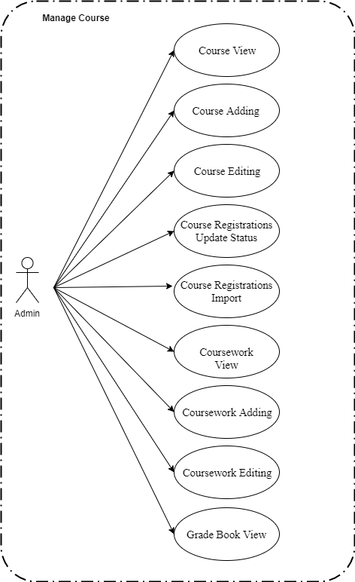

*Figure 15. Use case diagram of Manage Course*

**2.2.5.1 Course View**

*Use Case Specification*

|  |  |  |  |  |  |  |
| --- | --- | --- | --- | --- | --- | --- |
| **UC ID** | UC-5.1 | |  | **Use Case Name** | Course View |  |
|  |  |  |  |  |  |  |
| **Created by:** | PhatNK | |  | Date Created: | 17/10/2019 |  |
|  |  |  |  |  |  |  |
| **Actor:** | Admin,Teacher | | | |  |  |
|  |  |  |  | |  |  |
| **Trigger:** | - Actor clicks “Course List” of “Course Management” in side bar in admin page | | | | |  |
|  |  |  |  | | |  |
| **Description:** | Courses related to each subject. There will be 1 default course created for each course immediately after it is published | | | | |  |
|  |  |  |  | |  |  |
| **Preconditions:** | Access account is admin. | | | |  |  |
|  |  |  |  |  |  |  |
| **Post conditions:** | Information on course displayed on the home page success in the system. | | | | |  |
|  |  |  |  | | |  |
| **Normal Flow:** | 1 | Actor | - Actor clicks “Course List” of “Course Management” in side bar in admin page | | |  |
|  |  |  |  |  |  |
|  |  |  |  | | |  |
|  | 2 | System | Displays Course screen. | | |  |
|  |  |  |  |  |  |

36

|  |  |  |  |  |  |  |  |  |  |
| --- | --- | --- | --- | --- | --- | --- | --- | --- | --- |
|  |  |  |  |  |  |  |  | |  |
|  |  |  |  |  |  |  |  |  |  |
| **Extension Flows:** |  | | | | | | |  |  |
|  |  | | | | | |  |  |  |
|  |  |  |  |  |  |  |  |  |  |
| **Alternative Flows:** | N/A | |  |  |  |  |  |  |  |
|  |  |  |  |  |  |  |  |  |  |
| **Exceptions:** |  |  |  |  |  |  |  |  |  |
|  |  |  | |  |  |  |  |  |  |
| **Priority:** | High | | | |  |  |  |  |  |
|  |  |  | |  |  |  |  |  |  |
| **Frequency of Use:** | High | | | |  |  |  |  |  |
|  |  |  | |  | |  |  |  |  |
| **Business Rules:** |  | | | | | |  |  |  |
|  |  | | | | | | |  |  |
|  |  |  |  |  |  |  |  |  |  |
| **Other Information:** |  |  |  |  |  |  |  |  |  |
|  |  |  |  |  |  |  |  |  |  |
| **Assumptions:** |  |  |  |  |  |  |  |  |  |
|  |  |  |  |  |  |  |  |  |  |
|  |  |  |  |  |  |  |  |  |  |

**2.2.5.2 Course Adding**

*Use Case Specification*

|  |  |  |  |  |  |  |
| --- | --- | --- | --- | --- | --- | --- |
| **UC ID** | UC-5.2 | |  | **Use Case Name** | Course Adding |  |
|  |  |  |  |  |  |  |
| **Created by:** | PhatNK | |  | Date Created: | 17/10/2019 |  |
|  |  |  |  |  |  |  |
| **Actor:** | Admin,Teacher | | | |  |  |
|  |  |  |  | |  |  |
| **Trigger:** | - Actor clicks “Course List” of “Course Management” in side bar in admin page  - Actor click “Add new ” | | | | |  |
|  |  |  |  | | |  |
| **Description:** | Courses related to each subject. There will be 1 default course created for each course immediately after it is published | | | | |  |
|  |  |  |  | |  |  |
| **Preconditions:** | Actor accessed Course List page. | | | |  |  |
|  |  |  |  |  |  |  |
| **Post conditions:** | A new course is added to the system successfully. | | | | |  |
|  |  |  |  | | |  |
| **Normal Flow:** | 1 | Actor | - Actor clicks “Course List” of “Course Management” in side bar in admin page  - Actor click “Add new ” | | |  |
|  |  |  |  |  |  |
|  |  |  |  | | |  |
|  | 2 | System | Displays Course Details screen. | | |  |
|  |  |  |  |  |  |

36

|  |  |  |  |  |  |  |  |  |  |
| --- | --- | --- | --- | --- | --- | --- | --- | --- | --- |
|  |  |  |  |  |  |  |  | |  |
|  |  |  |  |  |  |  |  |  |  |
|  | 3 |  | Actor | | Enter imformation on page.  Click “Submit” button. | | |  |  |
|  |  |  |  |  | | |  |  |
|  |  |  |  |  |  |  |
|  |  |  |  |  |  | |  |  |  |
|  |  |  |  |  |  |  |  |  |  |
|  | 4 |  | System | | Uploads and displays Course List on Course Deatails screen.  Saves new course data in database. | | |  |  |
|  |  |  |  |  |  |
|  |  |  |  |  |  |  |
|  |  |  |  |  |  |  |
|  |  |  |  |  |  |  |  |  |  |
| **Extension Flows:** |  | | | | | | |  |  |
|  |  | | | | | |  |  |  |
|  |  |  |  |  |  |  |  |  |  |
| **Alternative Flows:** | N/A | |  |  |  |  |  |  |  |
|  |  |  |  |  |  |  |  |  |  |
| **Exceptions:** |  |  |  |  |  |  |  |  |  |
|  |  |  | |  |  |  |  |  |  |
| **Priority:** | High | | | |  |  |  |  |  |
|  |  |  | |  |  |  |  |  |  |
| **Frequency of Use:** | High | | | |  |  |  |  |  |
|  |  |  | |  | |  |  |  |  |
| **Business Rules:** |  | | | | | |  |  |  |
|  |  | | | | | | |  |  |
|  |  |  |  |  |  |  |  |  |  |
| **Other Information:** |  |  |  |  |  |  |  |  |  |
|  |  |  |  |  |  |  |  |  |  |
| **Assumptions:** |  |  |  |  |  |  |  |  |  |
|  |  |  |  |  |  |  |  |  |  |
|  |  |  |  |  |  |  |  |  |  |

**2.2.5.3 Course** **Editing**

*Use Case Specification*

|  |  |  |  |  |  |  |
| --- | --- | --- | --- | --- | --- | --- |
| **UC ID** | UC-5.3 | |  | **Use Case Name** | Course Editing |  |
|  |  |  |  |  |  |  |
| **Created by:** | PhatNK | |  | Date Created: | 17/10/2019 |  |
|  |  |  |  |  |  |  |
| **Actor:** | Admin,Teacher | | | |  |  |
|  |  |  |  | |  |  |
| **Trigger:** | - Actor clicks “Course List ” of “Course Management” in side bar in admin page  - Actor click “ Edit ” | | | | |  |
|  |  |  |  | | |  |
| **Description:** | Courses related to each subject. There will be 1 default course created for each course immediately after it is published | | | | |  |
|  |  |  |  | |  |  |
| **Preconditions:** | Actor accessed Course List page. | | | |  |  |
|  |  |  |  |  |  |  |
| **Post conditions:** | A Course is Edited to the system successfully. | | | | |  |
|  |  |  |  | | |  |
| **Normal Flow:** | 1 | Actor | - Actor clicks “Course List ” of “Course Management” in side bar in admin page  - Actor click “ Edit ” | | |  |
|  |  |  |  |  |  |
|  |  |  |  | | |  |
|  | 2 | System | Displays User Details screen. | | |  |
|  |  |  |  |  |  |

36

|  |  |  |  |  |  |  |  |  |  |
| --- | --- | --- | --- | --- | --- | --- | --- | --- | --- |
|  |  |  |  |  |  |  |  | |  |
|  |  |  |  |  |  |  |  |  |  |
|  | 3 |  | Actor | | Writes imformation on page.  Click “Submit” button. | | |  |  |
|  |  |  |  |  | | |  |  |
|  |  |  |  |  |  |  |
|  |  |  |  |  |  | |  |  |  |
|  |  |  |  |  |  |  |  |  |  |
|  | 4 |  | System | | Uploads and displays Course List on Course Deatails screen.  Saves new course data in database. | | |  |  |
|  |  |  |  |  |  |
|  |  |  |  |  |  |  |
|  |  |  |  |  |  |  |
|  |  |  |  |  |  |  |
| **Extension Flows:** |  | | | | | | |  |  |
|  |  | | | | | |  |  |  |
|  |  |  |  |  |  |  |  |  |  |
| **Alternative Flows:** | N/A | |  |  |  |  |  |  |  |
|  |  |  |  |  |  |  |  |  |  |
| **Exceptions:** |  |  |  |  |  |  |  |  |  |
|  |  |  | |  |  |  |  |  |  |
| **Priority:** | High | | | |  |  |  |  |  |
|  |  |  | |  |  |  |  |  |  |
| **Frequency of Use:** | High | | | |  |  |  |  |  |
|  |  |  | |  | |  |  |  |  |
| **Business Rules:** |  | | | | | |  |  |  |
|  |  | | | | | | |  |  |
|  |  |  |  |  |  |  |  |  |  |
| **Other Information:** |  |  |  |  |  |  |  |  |  |
|  |  |  |  |  |  |  |  |  |  |
| **Assumptions:** |  |  |  |  |  |  |  |  |  |
|  |  |  |  |  |  |  |  |  |  |
|  |  |  |  |  |  |  |  |  |  |

**2.2.5.4 Course Registration Update Status**

*Use Case Specification*

|  |  |  |  |  |  |  |
| --- | --- | --- | --- | --- | --- | --- |
| **UC ID** | UC-5.4 | |  | **Use Case Name** | Course Registration Update Status |  |
|  |  |  |  |  |  |  |
| **Created by:** | PhatNK | |  | Date Created: | 17/10/2019 |  |
|  |  |  |  |  |  |  |
| **Actor:** | Admin,Teacher | | | |  |  |
|  |  |  |  | |  |  |
| **Trigger:** | - Actor clicks “Course List” of “Course Management” in side bar in admin page  -Actor click “Approve” , “Reject ” ,” Block ” | | | | |  |
|  |  |  |  | | |  |
| **Description:** | List of users who register for courses, including approved and rejected applications | | | | |  |
|  |  |  |  | |  |  |
| **Preconditions:** | Access account is admin. | | | |  |  |
|  |  |  |  |  |  |  |
| **Post conditions:** | Status updates for students when registering for the course | | | | |  |
|  |  |  |  | | |  |
| **Normal Flow:** | 1 | Actor | - Actor clicks “Course List” of “Course Management” in side bar in admin page  -Actor click “Approve” , “Reject ” ,” Block ” | | |  |
|  |  |  |  |  |  |
|  |  |  |  | | |  |
|  | 2 | System | Change enrollment status for students. | | |  |
|  |  |  |  |  |  |

36

|  |  |  |  |  |  |  |  |  |  |
| --- | --- | --- | --- | --- | --- | --- | --- | --- | --- |
|  |  |  |  |  |  |  |  | |  |
|  |  |  |  |  |  |  |  |  |  |
| **Extension Flows:** |  | | | | | | |  |  |
|  |  | | | | | |  |  |  |
|  |  |  |  |  |  |  |  |  |  |
| **Alternative Flows:** | N/A | |  |  |  |  |  |  |  |
|  |  |  |  |  |  |  |  |  |  |
| **Exceptions:** |  |  |  |  |  |  |  |  |  |
|  |  |  | |  |  |  |  |  |  |
| **Priority:** | High | | | |  |  |  |  |  |
|  |  |  | |  |  |  |  |  |  |
| **Frequency of Use:** | High | | | |  |  |  |  |  |
|  |  |  | |  | |  |  |  |  |
| **Business Rules:** |  | | | | | |  |  |  |
|  |  | | | | | | |  |  |
|  |  |  |  |  |  |  |  |  |  |
| **Other Information:** |  |  |  |  |  |  |  |  |  |
|  |  |  |  |  |  |  |  |  |  |
| **Assumptions:** |  |  |  |  |  |  |  |  |  |
|  |  |  |  |  |  |  |  |  |  |
|  |  |  |  |  |  |  |  |  |  |

**2.2.5.5 Course Resgistation Import**

*Use Case Specification*

|  |  |  |  |  |  |  |
| --- | --- | --- | --- | --- | --- | --- |
| **UC ID** | UC-5.5 | |  | **Use Case Name** | Course Resgistation Import |  |
|  |  |  |  |  |  |  |
| **Created by:** | PhatNK | |  | Date Created: | 17/10/2019 |  |
|  |  |  |  |  |  |  |
| **Actor:** | Admin,Teacher | | | |  |  |
|  |  |  |  | |  |  |
| **Trigger:** | - Actor clicks “ Registrations List ” of “ Course Management ” in side bar in admin page  -Actor click “ Import” | | | | |  |
|  |  |  |  | | |  |
| **Description:** | List of users who register for courses, including approved and rejected applications | | | | |  |
|  |  |  |  | |  |  |
| **Preconditions:** | Access account is admin. | | | |  |  |
|  |  |  |  |  |  |  |
| **Post conditions:** | Register the student list. | | | | |  |
|  |  |  |  | | |  |
| **Normal Flow:** | 1 | Actor | - Actor clicks “ Registrations List ” of “ Course Management ” in side bar in admin page  -Actor click “ Import”  -Upload the file to the system | | |  |
|  |  |  |  |  |  |
|  |  |  |  | | |  |
|  | 2 | System | Course registration system according to the student list. | | |  |
|  |  |  |  |  |  |

36

|  |  |  |  |  |  |  |  |  |  |
| --- | --- | --- | --- | --- | --- | --- | --- | --- | --- |
|  |  |  |  |  |  |  |  | |  |
|  |  |  |  |  |  |  |  |  |  |
| **Extension Flows:** |  | | | | | | |  |  |
|  |  | | | | | |  |  |  |
|  |  |  |  |  |  |  |  |  |  |
| **Alternative Flows:** | N/A | |  |  |  |  |  |  |  |
|  |  |  |  |  |  |  |  |  |  |
| **Exceptions:** |  |  |  |  |  |  |  |  |  |
|  |  |  | |  |  |  |  |  |  |
| **Priority:** | High | | | |  |  |  |  |  |
|  |  |  | |  |  |  |  |  |  |
| **Frequency of Use:** | High | | | |  |  |  |  |  |
|  |  |  | |  | |  |  |  |  |
| **Business Rules:** |  | | | | | |  |  |  |
|  |  | | | | | | |  |  |
|  |  |  |  |  |  |  |  |  |  |
| **Other Information:** |  |  |  |  |  |  |  |  |  |
|  |  |  |  |  |  |  |  |  |  |
| **Assumptions:** |  |  |  |  |  |  |  |  |  |
|  |  |  |  |  |  |  |  |  |  |
|  |  |  |  |  |  |  |  |  |  |

**2.2.5.6 Coursework View**

*Use Case Specification*

|  |  |  |  |  |  |  |
| --- | --- | --- | --- | --- | --- | --- |
| **UC ID** | UC-5.6 | |  | **Use Case Name** | Coursework View |  |
|  |  |  |  |  |  |  |
| **Created by:** | PhatNK | |  | Date Created: | 17/10/2019 |  |
|  |  |  |  |  |  |  |
| **Actor:** | Admin,Teacher | | | |  |  |
|  |  |  |  | |  |  |
| **Trigger:** | - Actor clicks “Course List” of “Course Management” in side bar in admin page  -Actor click “ Coursework ” | | | | |  |
|  |  |  |  | | |  |
| **Description:** | Practice exercises or exams assigned to students taking each course (course) | | | | |  |
|  |  |  |  | |  |  |
| **Preconditions:** | Access account is admin. | | | |  |  |
|  |  |  |  |  |  |  |
| **Post conditions:** | Information on coursework displayed on the home page success in the system. | | | | |  |
|  |  |  |  | | |  |
| **Normal Flow:** | 1 | Actor | - Actor clicks “Course List” of “Course Management” in side bar in admin page  -Actor click “ Coursework ” | | |  |
|  |  |  |  |  |  |
|  |  |  |  | | |  |
|  | 2 | System | Displays Coursework screen. | | |  |
|  |  |  |  |  |  |

36

|  |  |  |  |  |  |  |  |  |  |
| --- | --- | --- | --- | --- | --- | --- | --- | --- | --- |
|  |  |  |  |  |  |  |  | |  |
|  |  |  |  |  |  |  |  |  |  |
| **Extension Flows:** |  | | | | | | |  |  |
|  |  | | | | | |  |  |  |
|  |  |  |  |  |  |  |  |  |  |
| **Alternative Flows:** | N/A | |  |  |  |  |  |  |  |
|  |  |  |  |  |  |  |  |  |  |
| **Exceptions:** |  |  |  |  |  |  |  |  |  |
|  |  |  | |  |  |  |  |  |  |
| **Priority:** | High | | | |  |  |  |  |  |
|  |  |  | |  |  |  |  |  |  |
| **Frequency of Use:** | High | | | |  |  |  |  |  |
|  |  |  | |  | |  |  |  |  |
| **Business Rules:** |  | | | | | |  |  |  |
|  |  | | | | | | |  |  |
|  |  |  |  |  |  |  |  |  |  |
| **Other Information:** |  |  |  |  |  |  |  |  |  |
|  |  |  |  |  |  |  |  |  |  |
| **Assumptions:** |  |  |  |  |  |  |  |  |  |
|  |  |  |  |  |  |  |  |  |  |
|  |  |  |  |  |  |  |  |  |  |

**2.2.5.7 Coursework**  **Adding**

*Use Case Specification*

|  |  |  |  |  |  |  |
| --- | --- | --- | --- | --- | --- | --- |
| **UC ID** | UC-5.7 | |  | **Use Case Name** | Coursework Adding |  |
|  |  |  |  |  |  |  |
| **Created by:** | PhatNK | |  | Date Created: | 17/10/2019 |  |
|  |  |  |  |  |  |  |
| **Actor:** | Admin,Teacher | | | |  |  |
|  |  |  |  | |  |  |
| **Trigger:** | - Actor clicks “Course List” of “Course Management” in side bar in admin page  - Actor click “Coursework ”  - Actor click “Add new ” | | | | |  |
|  |  |  |  | | |  |
| **Description:** | Practice exercises or exams assigned to students taking each course (course) | | | | |  |
|  |  |  |  | |  |  |
| **Preconditions:** | Actor accessed Coursework List page. | | | |  |  |
|  |  |  |  |  |  |  |
| **Post conditions:** | A new Coursework is added to the system successfully. | | | | |  |
|  |  |  |  | | |  |
| **Normal Flow:** | 1 | Actor | - Actor clicks “Course List” of “Course Management” in side bar in admin page  - Actor click “Coursework ”  - Actor click “Add new ” | | |  |
|  |  |  |  |  |  |
|  |  |  |  | | |  |
|  | 2 | System | Displays Coursework Details screen. | | |  |
|  |  |  |  |  |  |

36

|  |  |  |  |  |  |  |  |  |  |
| --- | --- | --- | --- | --- | --- | --- | --- | --- | --- |
|  |  |  |  |  |  |  |  | |  |
|  |  |  |  |  |  |  |  |  |  |
|  | 3 |  | Actor | | Enter imformation on page.  Click “Submit” button. | | |  |  |
|  |  |  |  |  | | |  |  |
|  |  |  |  |  |  |  |
|  |  |  |  |  |  | |  |  |  |
|  |  |  |  |  |  |  |  |  |  |
|  | 4 |  | System | | Uploads and displays Coursework List on Coursework Deatails screen.  Saves new coursework data in database. | | |  |  |
|  |  |  |  |  |  |
|  |  |  |  |  |  |  |
|  |  |  |  |  |  |  |
|  |  |  |  |  |  |  |  |  |  |
| **Extension Flows:** |  | | | | | | |  |  |
|  |  | | | | | |  |  |  |
|  |  |  |  |  |  |  |  |  |  |
| **Alternative Flows:** | N/A | |  |  |  |  |  |  |  |
|  |  |  |  |  |  |  |  |  |  |
| **Exceptions:** |  |  |  |  |  |  |  |  |  |
|  |  |  | |  |  |  |  |  |  |
| **Priority:** | High | | | |  |  |  |  |  |
|  |  |  | |  |  |  |  |  |  |
| **Frequency of Use:** | High | | | |  |  |  |  |  |
|  |  |  | |  | |  |  |  |  |
| **Business Rules:** |  | | | | | |  |  |  |
|  |  | | | | | | |  |  |
|  |  |  |  |  |  |  |  |  |  |
| **Other Information:** |  |  |  |  |  |  |  |  |  |
|  |  |  |  |  |  |  |  |  |  |
| **Assumptions:** |  |  |  |  |  |  |  |  |  |
|  |  |  |  |  |  |  |  |  |  |
|  |  |  |  |  |  |  |  |  |  |

**2.2.5.8 Coursework**  **Editing**

*Use Case Specification*

|  |  |  |  |  |  |  |
| --- | --- | --- | --- | --- | --- | --- |
| **UC ID** | UC-5.8 | |  | **Use Case Name** | Coursework Editing |  |
|  |  |  |  |  |  |  |
| **Created by:** | PhatNK | |  | Date Created: | 17/10/2019 |  |
|  |  |  |  |  |  |  |
| **Actor:** | Admin,Teacher | | | |  |  |
|  |  |  |  | |  |  |
| **Trigger:** | - Actor clicks “Course List ” of “Course Management” in side bar in admin page  - Actor click “Coursework ”  - Actor click “ Edit ” | | | | |  |
|  |  |  |  | | |  |
| **Description:** | Practice exercises or exams assigned to students taking each course (course) | | | | |  |
|  |  |  |  | |  |  |
| **Preconditions:** | Actor accessed Coursework List page. | | | |  |  |
|  |  |  |  |  |  |  |
| **Post conditions:** | A coursework  is Edited to the system successfully. | | | | |  |
|  |  |  |  | | |  |
| **Normal Flow:** | 1 | Actor | - Actor clicks “Course List ” of “Course Management” in side bar in admin page  - Actor click “Coursework ”  - Actor click “ Edit ” | | |  |
|  |  |  |  |  |  |
|  |  |  |  | | |  |
|  | 2 | System | Displays Coursework Details screen. | | |  |
|  |  |  |  |  |  |

36

|  |  |  |  |  |  |  |  |  |  |
| --- | --- | --- | --- | --- | --- | --- | --- | --- | --- |
|  |  |  |  |  |  |  |  | |  |
|  |  |  |  |  |  |  |  |  |  |
|  | 3 |  | Actor | | Writes imformation on page.  Click “Submit” button. | | |  |  |
|  |  |  |  |  | | |  |  |
|  |  |  |  |  |  |  |
|  |  |  |  |  |  | |  |  |  |
|  |  |  |  |  |  |  |  |  |  |
|  | 4 |  | System | | Uploads and displays Coursework List on Coursework Deatails screen.  Saves new coursework data in database. | | |  |  |
|  |  |  |  |  |  |
|  |  |  |  |  |  |  |
|  |  |  |  |  |  |  |
|  |  |  |  |  |  |  |
| **Extension Flows:** |  | | | | | | |  |  |
|  |  | | | | | |  |  |  |
|  |  |  |  |  |  |  |  |  |  |
| **Alternative Flows:** | N/A | |  |  |  |  |  |  |  |
|  |  |  |  |  |  |  |  |  |  |
| **Exceptions:** |  |  |  |  |  |  |  |  |  |
|  |  |  | |  |  |  |  |  |  |
| **Priority:** | High | | | |  |  |  |  |  |
|  |  |  | |  |  |  |  |  |  |
| **Frequency of Use:** | High | | | |  |  |  |  |  |
|  |  |  | |  | |  |  |  |  |
| **Business Rules:** |  | | | | | |  |  |  |
|  |  | | | | | | |  |  |
|  |  |  |  |  |  |  |  |  |  |
| **Other Information:** |  |  |  |  |  |  |  |  |  |
|  |  |  |  |  |  |  |  |  |  |
| **Assumptions:** |  |  |  |  |  |  |  |  |  |
|  |  |  |  |  |  |  |  |  |  |
|  |  |  |  |  |  |  |  |  |  |

**2.2.5.10 Grade Book View**

*Use Case Specification*

|  |  |  |  |  |  |  |
| --- | --- | --- | --- | --- | --- | --- |
| **UC ID** | UC-5.10 | |  | **Use Case Name** | Grade Book View |  |
|  |  |  |  |  |  |  |
| **Created by:** | PhatNK | |  | Date Created: | 17/10/2019 |  |
|  |  |  |  |  |  |  |
| **Actor:** | Admin,Teacher | | | |  |  |
|  |  |  |  | |  |  |
| **Trigger:** | - Actor clicks “Course List” of “Course Management” in side bar in admin page  -Actor click “Grade Book ” | | | | |  |
|  |  |  |  | | |  |
| **Description:** | Scores and assessments of practice exercises and course tests of each student | | | | |  |
|  |  |  |  | |  |  |
| **Preconditions:** | Access account is admin. | | | |  |  |
|  |  |  |  |  |  |  |
| **Post conditions:** | Information on grade book displayed on the home page success in the system. | | | | |  |
|  |  |  |  | | |  |
| **Normal Flow:** | 1 | Actor | - Actor clicks “Course List” of “Course Management” in side bar in admin page  -Actor click “Grade Book  ” | | |  |
|  |  |  |  |  |  |
|  |  |  |  | | |  |
|  | 2 | System | Displays Grade Book  screen. | | |  |
|  |  |  |  |  |  |

36

|  |  |  |  |  |  |  |  |  |  |
| --- | --- | --- | --- | --- | --- | --- | --- | --- | --- |
|  |  |  |  |  |  |  |  | |  |
|  |  |  |  |  |  |  |  |  |  |
| **Extension Flows:** |  | | | | | | |  |  |
|  |  | | | | | |  |  |  |
|  |  |  |  |  |  |  |  |  |  |
| **Alternative Flows:** | N/A | |  |  |  |  |  |  |  |
|  |  |  |  |  |  |  |  |  |  |
| **Exceptions:** |  |  |  |  |  |  |  |  |  |
|  |  |  | |  |  |  |  |  |  |
| **Priority:** | High | | | |  |  |  |  |  |
|  |  |  | |  |  |  |  |  |  |
| **Frequency of Use:** | High | | | |  |  |  |  |  |
|  |  |  | |  | |  |  |  |  |
| **Business Rules:** |  | | | | | |  |  |  |
|  |  | | | | | | |  |  |
|  |  |  |  |  |  |  |  |  |  |
| **Other Information:** |  |  |  |  |  |  |  |  |  |
|  |  |  |  |  |  |  |  |  |  |
| **Assumptions:** |  |  |  |  |  |  |  |  |  |
|  |  |  |  |  |  |  |  |  |  |
|  |  |  |  |  |  |  |  |  |  |

**2.2.6** **Learning**

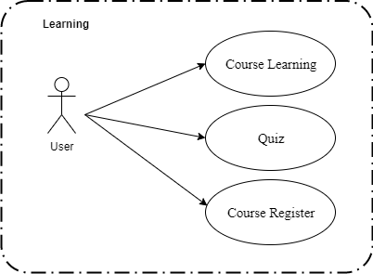

*Figure 16. Use case diagram of Learning*

**2.2.6.1 Course Learning**

*Use Case Specification*

|  |  |  |  |  |  |  |
| --- | --- | --- | --- | --- | --- | --- |
| **UC ID** | UC-6.1 | |  | **Use Case Name** | Course Learning |  |
|  |  |  |  |  |  |  |
| **Created by:** | PhatNK | |  | Date Created: | 17/10/2019 |  |
|  |  |  |  |  |  |  |
| **Actor:** | User | | | |  |  |
|  |  |  |  | |  |  |
| **Trigger:** | Actor click “My Course ” | | | |  |  |
|  |  |  |  | | |  |
| **Description:** | Show knowledge for students to learn. | | | | |  |
|  |  |  |  | |  |  |
| **Preconditions:** | Sign up for the course. | | | |  |  |
|  |  |  |  |  |  |  |
| **Post conditions:** | Show knowledge for students to learn inculde :  -Video  -Content | | | | |  |
|  |  |  |  | | |  |
| **Normal Flow:** | 1 | Actor | Actor click “My Course ”. | | |  |
|  |  |  |  |  |  |
|  |  |  |  | | |  |
|  | 2 | System | Displays knowledge for students to learn. | | |  |
|  |  |  |  |  |  |

36

|  |  |  |  |  |  |  |  |  |  |
| --- | --- | --- | --- | --- | --- | --- | --- | --- | --- |
|  |  |  |  |  |  |  |  | |  |
| **Extension Flows:** |  | | | | | | |  |  |
|  |  | | | | | |  |  |  |
|  |  |  |  |  |  |  |  |  |  |
| **Alternative Flows:** | N/A | |  |  |  |  |  |  |  |
|  |  |  |  |  |  |  |  |  |  |
| **Exceptions:** |  |  |  |  |  |  |  |  |  |
|  |  |  | |  |  |  |  |  |  |
| **Priority:** | High | | | |  |  |  |  |  |
|  |  |  | |  |  |  |  |  |  |
| **Frequency of Use:** | High | | | |  |  |  |  |  |
|  |  |  | |  | |  |  |  |  |
| **Business Rules:** |  | | | | | |  |  |  |
|  | - | | | | | | |  |  |
|  |  |  |  |  |  |  |  |  |  |
| **Other Information:** |  |  |  |  |  |  |  |  |  |
|  |  |  |  |  |  |  |  |  |  |
| **Assumptions:** |  |  |  |  |  |  |  |  |  |
|  |  |  |  |  |  |  |  |  |  |
|  |  |  |  |  |  |  |  |  |  |

**2.2.6.2 Quiz**

*Use Case Specification*

|  |  |  |  |  |  |  |
| --- | --- | --- | --- | --- | --- | --- |
| **UC ID** | UC-6.2 | |  | **Use Case Name** | Coursework |  |
|  |  |  |  |  |  |  |
| **Created by:** | PhatNK | |  | Date Created: | 17/10/2019 |  |
|  |  |  |  |  |  |  |
| **Actor:** | User | | | |  |  |
|  |  |  |  | |  |  |
| **Trigger:** | -Actor click “My Course ”  - Actor click “Quiz” | | | |  |  |
|  |  |  |  | | |  |
| **Description:** | Help students re-test their knowledge after lessons. | | | | |  |
|  |  |  |  | |  |  |
| **Preconditions:** | Sign up for the course. | | | |  |  |
|  |  |  |  |  |  |  |
| **Post conditions:** | Take the quiz successfully. | | | | |  |
|  |  |  |  | | |  |
| **Normal Flow:** | 1 | Actor | -Actor click “My Course ”  - Actor click “Quiz”. | | |  |
|  |  |  |  |  |  |
|  |  |  |  | | |  |
|  | 2 | System | Students do a quiz according to the lesson. | | |  |
|  |  |  |  |  |  |

36

|  |  |  |  |  |  |  |  |  |  |
| --- | --- | --- | --- | --- | --- | --- | --- | --- | --- |
|  |  |  |  |  |  |  |  | |  |
| **Extension Flows:** |  | | | | | | |  |  |
|  |  | | | | | |  |  |  |
|  |  |  |  |  |  |  |  |  |  |
| **Alternative Flows:** | N/A | |  |  |  |  |  |  |  |
|  |  |  |  |  |  |  |  |  |  |
| **Exceptions:** |  |  |  |  |  |  |  |  |  |
|  |  |  | |  |  |  |  |  |  |
| **Priority:** | High | | | |  |  |  |  |  |
|  |  |  | |  |  |  |  |  |  |
| **Frequency of Use:** | High | | | |  |  |  |  |  |
|  |  |  | |  | |  |  |  |  |
| **Business Rules:** |  | | | | | |  |  |  |
|  | - | | | | | | |  |  |
|  |  |  |  |  |  |  |  |  |  |
| **Other Information:** |  |  |  |  |  |  |  |  |  |
|  |  |  |  |  |  |  |  |  |  |
| **Assumptions:** |  |  |  |  |  |  |  |  |  |
|  |  |  |  |  |  |  |  |  |  |
|  |  |  |  |  |  |  |  |  |  |

**2.2.6.3 Course Register**

*Use Case Specification*

|  |  |  |  |  |  |  |
| --- | --- | --- | --- | --- | --- | --- |
| **UC ID** | UC-6.3 | |  | **Use Case Name** | Course Register |  |
|  |  |  |  |  |  |  |
| **Created by:** | PhatNK | |  | Date Created: | 17/10/2019 |  |
|  |  |  |  |  |  |  |
| **Actor:** | User | | | |  |  |
|  |  |  |  | |  |  |
| **Trigger:** | -Actor clicks “Course” button on header on home page.  - Actor clicks “Join Course” | | | | |  |
|  |  |
| **Description:** | Help students register for courses. | | | | |  |
|  |  |  |  | |  |  |
| **Preconditions:** | Students login to their online learning software page | | | | |  |
|  |  |
| **Post conditions:** | Register the course successfully on the system | | | | |  |
|  |  |  |  | | |  |
| **Normal Flow:** | 1 | Actor | -Actor clicks “Course” button on header on home page.  - Actor clicks “Join Course”. | | |  |
|  |  |  |  |  |  |
|  |  |  |  | | |  |
|  | 2 | System | Displays “Registraion List” screen. | | |  |
|  |  |  |  |  |  |

36

|  |  |  |  |  |  |  |  |  |  |
| --- | --- | --- | --- | --- | --- | --- | --- | --- | --- |
|  |  |  |  |  |  |  |  | |  |
| **Extension Flows:** |  | | | | | | |  |  |
|  |  | | | | | |  |  |  |
|  |  |  |  |  |  |  |  |  |  |
| **Alternative Flows:** | N/A | |  |  |  |  |  |  |  |
|  |  |  |  |  |  |  |  |  |  |
| **Exceptions:** |  |  |  |  |  |  |  |  |  |
|  |  |  | |  |  |  |  |  |  |
| **Priority:** | High | | | |  |  |  |  |  |
|  |  |  | |  |  |  |  |  |  |
| **Frequency of Use:** | High | | | |  |  |  |  |  |
|  |  |  | |  | |  |  |  |  |
| **Business Rules:** |  | | | | | |  |  |  |
|  | - | | | | | | |  |  |
|  |  |  |  |  |  |  |  |  |  |
| **Other Information:** |  |  |  |  |  |  |  |  |  |
|  |  |  |  |  |  |  |  |  |  |
| **Assumptions:** |  |  |  |  |  |  |  |  |  |
|  |  |  |  |  |  |  |  |  |  |
|  |  |  |  |  |  |  |  |  |  |

**2.2.7** **Practice**

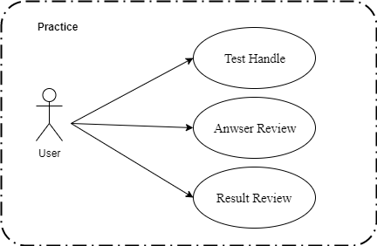

*Figure 17. Use case diagram of Testing*

**2.2.7.1 Test Handle**

*Use Case Specification*

|  |  |  |  |  |  |  |
| --- | --- | --- | --- | --- | --- | --- |
| **UC ID** | UC-7.1 | |  | **Use Case Name** | Test Handle |  |
|  |  |  |  |  |  |  |
| **Created by:** | PhatNK | |  | Date Created: | 17/10/2019 |  |
|  |  |  |  |  |  |  |
| **Actor:** | User | | | |  |  |
|  |  |  |  | |  |  |
| **Trigger:** | Actor clicks “Practice” button on header on home page. | | | | |  |
|  |  |  |  | | |  |
| **Description:** | Function for students to check after the lessons. | | | | |  |
|  |  |  |  | |  |  |
| **Preconditions:** | User must register for the course. | | | |  |  |
|  |  |  |  |  |  |  |
| **Post conditions:** | Complete the test | | | | |  |
|  |  |  |  | | |  |
| **Normal Flow:** | 1 | Actor | Actor clicks “Practice” button on header on home page. | | |  |
|  |  |  |  |  |  |
|  |  |  |  | | |  |
|  | 2 | System | Students come to take the test. | | |  |
|  |  |  |  |  |  |

36

|  |  |  |  |  |  |  |  |  |  |
| --- | --- | --- | --- | --- | --- | --- | --- | --- | --- |
|  |  |  |  |  |  |  |  | |  |
| **Extension Flows:** |  | | | | | | |  |  |
|  |  | | | | | |  |  |  |
|  |  |  |  |  |  |  |  |  |  |
| **Alternative Flows:** | N/A | |  |  |  |  |  |  |  |
|  |  |  |  |  |  |  |  |  |  |
| **Exceptions:** |  |  |  |  |  |  |  |  |  |
|  |  |  | |  |  |  |  |  |  |
| **Priority:** | High | | | |  |  |  |  |  |
|  |  |  | |  |  |  |  |  |  |
| **Frequency of Use:** | High | | | |  |  |  |  |  |
|  |  |  | |  | |  |  |  |  |
| **Business Rules:** |  | | | | | |  |  |  |
|  | - | | | | | | |  |  |
|  |  |  |  |  |  |  |  |  |  |
| **Other Information:** |  |  |  |  |  |  |  |  |  |
|  |  |  |  |  |  |  |  |  |  |
| **Assumptions:** |  |  |  |  |  |  |  |  |  |
|  |  |  |  |  |  |  |  |  |  |
|  |  |  |  |  |  |  |  |  |  |

**2.2.7.2 Anwser Review**

*Use Case Specification*

|  |  |  |  |  |  |  |
| --- | --- | --- | --- | --- | --- | --- |
| **UC ID** | UC-7.2 | |  | **Use Case Name** | Anwser Review |  |
|  |  |  |  |  |  |  |
| **Created by:** | PhatNK | |  | Date Created: | 17/10/2019 |  |
|  |  |  |  |  |  |  |
| **Actor:** | User | | | |  |  |
|  |  |  |  | |  |  |
| **Trigger:** | Actor clicks “Practice” button on header on home page.  Actor review the answer | | | | |  |
|  |  |  |  | | |  |
| **Description:** | The function helps students review previous answers. | | | | |  |
|  |  |  |  | |  |  |
| **Preconditions:** | User must register for the course. | | | |  |  |
|  |  |  |  |  |  |  |
| **Post conditions:** | Successful test | | | | |  |
|  |  |  |  | | |  |
| **Normal Flow:** | 1 | Actor | Actor clicks “Practice” button on header on home page.  Actor review the answer. | | |  |
|  |  |  |  |  |  |
|  |  |  |  | | |  |
|  | 2 | System | Show anwser review. | | |  |
|  |  |  |  |  |  |

36

|  |  |  |  |  |  |  |  |  |  |
| --- | --- | --- | --- | --- | --- | --- | --- | --- | --- |
|  |  |  |  |  |  |  |  | |  |
| **Extension Flows:** |  | | | | | | |  |  |
|  |  | | | | | |  |  |  |
|  |  |  |  |  |  |  |  |  |  |
| **Alternative Flows:** | N/A | |  |  |  |  |  |  |  |
|  |  |  |  |  |  |  |  |  |  |
| **Exceptions:** |  |  |  |  |  |  |  |  |  |
|  |  |  | |  |  |  |  |  |  |
| **Priority:** | High | | | |  |  |  |  |  |
|  |  |  | |  |  |  |  |  |  |
| **Frequency of Use:** | High | | | |  |  |  |  |  |
|  |  |  | |  | |  |  |  |  |
| **Business Rules:** |  | | | | | |  |  |  |
|  | - | | | | | | |  |  |
|  |  |  |  |  |  |  |  |  |  |
| **Other Information:** |  |  |  |  |  |  |  |  |  |
|  |  |  |  |  |  |  |  |  |  |
| **Assumptions:** |  |  |  |  |  |  |  |  |  |
|  |  |  |  |  |  |  |  |  |  |
|  |  |  |  |  |  |  |  |  |  |

**2.2.7.3 Result Review**

*Use Case Specification*

|  |  |  |  |  |  |  |
| --- | --- | --- | --- | --- | --- | --- |
| **UC ID** | UC-7.3 | |  | **Use Case Name** | Result Review |  |
|  |  |  |  |  |  |  |
| **Created by:** | PhatNK | |  | Date Created: | 17/10/2019 |  |
|  |  |  |  |  |  |  |
| **Actor:** | User | | | |  |  |
|  |  |  |  | |  |  |
| **Trigger:** | Actor clicks “Practice” button on header on home page.  Actor complete test | | | | |  |
|  |  |  |  | | |  |
| **Description:** | The function helps students review result . | | | | |  |
|  |  |  |  | |  |  |
| **Preconditions:** | User complete test . | | | |  |  |
|  |  |  |  |  |  |  |
| **Post conditions:** | Successful test | | | | |  |
|  |  |  |  | | |  |
| **Normal Flow:** | 1 | Actor | Actor clicks “Practice” button on header on home page.  Actor complete test. | | |  |
|  |  |  |  |  |  |
|  |  |  |  | | |  |
|  | 2 | System | Show review result. | | |  |
|  |  |  |  |  |  |

36

|  |  |  |  |  |  |  |  |  |  |
| --- | --- | --- | --- | --- | --- | --- | --- | --- | --- |
|  |  |  |  |  |  |  |  | |  |
| **Extension Flows:** |  | | | | | | |  |  |
|  |  | | | | | |  |  |  |
|  |  |  |  |  |  |  |  |  |  |
| **Alternative Flows:** | N/A | |  |  |  |  |  |  |  |
|  |  |  |  |  |  |  |  |  |  |
| **Exceptions:** |  |  |  |  |  |  |  |  |  |
|  |  |  | |  |  |  |  |  |  |
| **Priority:** | High | | | |  |  |  |  |  |
|  |  |  | |  |  |  |  |  |  |
| **Frequency of Use:** | High | | | |  |  |  |  |  |
|  |  |  | |  | |  |  |  |  |
| **Business Rules:** |  | | | | | |  |  |  |
|  | - | | | | | | |  |  |
|  |  |  |  |  |  |  |  |  |  |
| **Other Information:** |  |  |  |  |  |  |  |  |  |
|  |  |  |  |  |  |  |  |  |  |
| **Assumptions:** |  |  |  |  |  |  |  |  |  |
|  |  |  |  |  |  |  |  |  |  |
|  |  |  |  |  |  |  |  |  |  |

**2.2.8** **Common**

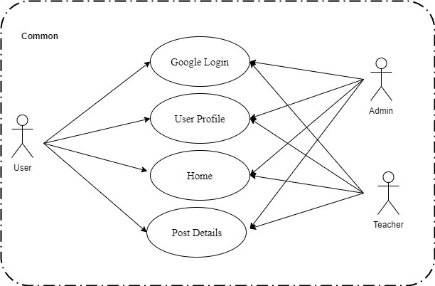

*Figure 18. Use case diagram of Common*

**2.2.8.1 Google Login**

*Use Case Specification*

|  |  |  |  |  |  |  |
| --- | --- | --- | --- | --- | --- | --- |
| **UC ID** | UC-8.1 | |  | **Use Case Name** | Google Login |  |
|  |  |  |  |  |  |  |
| **Created by:** | PhatNK | |  | Date Created: | 17/10/2019 |  |
|  |  |  |  |  |  |  |
| **Actor:** | Admin, Teacher,User | | | |  |  |
|  |  |  |  | |  |  |
| **Trigger:** | -Actor clicks “Sign In with Google” button on home page.  -Actor enter Account and Password | | | | |  |
|  |  |
| **Description:** | Use your Google Account to log in to other websites or applications | | | | |  |
|  |  |  |  | |  |  |
| **Preconditions:** | Admin, Teacher , User Access the online software learning website | | | |  |  |
|  |  |  |  |  |  |  |
| **Post conditions:** | -Sign In with Google in the system | | | | |  |
|  |  |  |  | | |  |
| **Normal Flow:** | 1 | Actor | Clicks “Sign In with Google” button on sidebar home page. | | |  |
|  |  |  |  |  |  |
|  |  |  |  | | |  |
|  | 2 | System | Displays “Dialog Sign in Account” screen. | | |  |
|  |  |  |  |  |  | System | Displays “Dialog Sign in Account” screen. |
| 3 | Actor | Enter Imformation including Account and Password | | |  |  | System | Displays “Dialog Sign in Account” screen. |  |  |
| 4 | System | Sign in susscess in the system | | |  |  |  |  |  |  |

36

|  |  |  |  |  |  |  |  |  |  |
| --- | --- | --- | --- | --- | --- | --- | --- | --- | --- |
|  |  |  |  |  |  |  |  | |  |
| **Extension Flows:** |  | | | | | | |  |  |
|  |  | | | | | |  |  |  |
|  |  |  |  |  |  |  |  |  |  |
| **Alternative Flows:** | N/A | |  |  |  |  |  |  |  |
|  |  |  |  |  |  |  |  |  |  |
| **Exceptions:** |  |  |  |  |  |  |  |  |  |
|  |  |  | |  |  |  |  |  |  |
| **Priority:** | High | | | |  |  |  |  |  |
|  |  |  | |  |  |  |  |  |  |
| **Frequency of Use:** | High | | | |  |  |  |  |  |
|  |  |  | |  | |  |  |  |  |
| **Business Rules:** |  | | | | | |  |  |  |
|  | - | | | | | | |  |  |
|  |  |  |  |  |  |  |  |  |  |
| **Other Information:** |  |  |  |  |  |  |  |  |  |
|  |  |  |  |  |  |  |  |  |  |
| **Assumptions:** |  |  |  |  |  |  |  |  |  |
|  |  |  |  |  |  |  |  |  |  |
|  |  |  |  |  |  |  |  |  |  |

**2.2.8.2 User Profile**

*Use Case Specification*

|  |  |  |  |  |  |  |
| --- | --- | --- | --- | --- | --- | --- |
| **UC ID** | UC-8.2 | |  | **Use Case Name** | User Profile |  |
|  |  |  |  |  |  |  |
| **Created by:** | PhatNK | |  | Date Created: | 17/10/2019 |  |
|  |  |  |  |  |  |  |
| **Actor:** | Admin, Teacher, User | | | |  |  |
|  |  |  |  | |  |  |
| **Trigger:** | -Actor clicks “Sign In with Google” button on home page.  -Actor enter Account and Password  - Actor click button Profile | | | | |  |
|  |  |
| **Description:** | Admin, Teacher , User Access the online software learning website | | | | |  |
|  |  |  |  | |  |  |
| **Preconditions:** | Admin, Teacher , User accessed sidebar on home page. | | | |  |  |
|  |  |  |  |  |  |  |
| **Post conditions:** | Update imformation of Admin, Teacher , User susscess in the system | | | | |  |
|  |  |  |  | | |  |
| **Normal Flow:** | 1 | Actor | Clicks “ Profile ” button | | |  |
|  |  |  |  |  |  |
|  |  |  |  | | |  |
|  | 2 | System | Displays “Your Account Information” screen. | | |  |
|  |  |  |  |  |  |  | System | Displays “Registraion List” screen. |
|  | 3 | Actor | Update information and click “ Update” | | |  |  | System | Displays “Registraion List” screen. |  |  |
|  | 4 | System | Show message “ Update sussces ” and save database | | |  |  |  |  |  |  |

36

|  |  |  |  |  |  |  |  |  |  |
| --- | --- | --- | --- | --- | --- | --- | --- | --- | --- |
|  |  |  |  |  |  |  |  | |  |
| **Extension Flows:** |  | | | | | | |  |  |
|  |  | | | | | |  |  |  |
|  |  |  |  |  |  |  |  |  |  |
| **Alternative Flows:** | N/A | |  |  |  |  |  |  |  |
|  |  |  |  |  |  |  |  |  |  |
| **Exceptions:** |  |  |  |  |  |  |  |  |  |
|  |  |  | |  |  |  |  |  |  |
| **Priority:** | High | | | |  |  |  |  |  |
|  |  |  | |  |  |  |  |  |  |
| **Frequency of Use:** | High | | | |  |  |  |  |  |
|  |  |  | |  | |  |  |  |  |
| **Business Rules:** |  | | | | | |  |  |  |
|  | - | | | | | | |  |  |
|  |  |  |  |  |  |  |  |  |  |
| **Other Information:** |  |  |  |  |  |  |  |  |  |
|  |  |  |  |  |  |  |  |  |  |
| **Assumptions:** |  |  |  |  |  |  |  |  |  |
|  |  |  |  |  |  |  |  |  |  |
|  |  |  |  |  |  |  |  |  |  |

**2.2.8.3 Home**

*Use Case Specification*

|  |  |  |  |  |  |  |
| --- | --- | --- | --- | --- | --- | --- |
| **UC ID** | UC-8.3 | |  | **Use Case Name** | Home |  |
|  |  |  |  |  |  |  |
| **Created by:** | PhatNK | |  | Date Created: | 17/10/2019 |  |
|  |  |  |  |  |  |  |
| **Actor:** | Admin, Teacher, User | | | |  |  |
|  |  |  |  | |  |  |
| **Trigger:** | Actor access the online software learning website | | | | |  |
|  |  |
| **Description:** | The function allows Admin, Teacher show imformation of Study Online | | | | |  |
|  |  |  |  | |  |  |
| **Preconditions:** | Actor access the online software learning website | | | | |  |
|  |  |
| **Post conditions:** | Show imformation home pages of Study Online | | | | |  |
|  |  |  |  | | |  |
| **Normal Flow:** | 1 | Actor | Actor access the online software learning website. | | |  |
|  |  |  |  |  |  |
|  |  |  |  | | |  |
|  | 2 | System | Displays “Home” screen. | | |  |
|  |  |  |  |  |  |

36

|  |  |  |  |  |  |  |  |  |  |
| --- | --- | --- | --- | --- | --- | --- | --- | --- | --- |
|  |  |  |  |  |  |  |  | |  |
| **Extension Flows:** |  | | | | | | |  |  |
|  |  | | | | | |  |  |  |
|  |  |  |  |  |  |  |  |  |  |
| **Alternative Flows:** | N/A | |  |  |  |  |  |  |  |
|  |  |  |  |  |  |  |  |  |  |
| **Exceptions:** |  |  |  |  |  |  |  |  |  |
|  |  |  | |  |  |  |  |  |  |
| **Priority:** | High | | | |  |  |  |  |  |
|  |  |  | |  |  |  |  |  |  |
| **Frequency of Use:** | High | | | |  |  |  |  |  |
|  |  |  | |  | |  |  |  |  |
| **Business Rules:** |  | | | | | |  |  |  |
|  | - | | | | | | |  |  |
|  |  |  |  |  |  |  |  |  |  |
| **Other Information:** |  |  |  |  |  |  |  |  |  |
|  |  |  |  |  |  |  |  |  |  |
| **Assumptions:** |  |  |  |  |  |  |  |  |  |
|  |  |  |  |  |  |  |  |  |  |
|  |  |  |  |  |  |  |  |  |  |

**2.2.8.4 Post Details**

*Use Case Specification*

|  |  |  |  |  |  |  |  |  |
| --- | --- | --- | --- | --- | --- | --- | --- | --- |
| **UC ID** | UC-8.4 | |  | **Use Case Name** | Post Details |  | | |
|  |  |  |  |  |  |  | | |
| **Created by:** | PhatNK | |  | Date Created: | 17/10/2019 | |  |
|  |  |  |  |  |  |  | | |
| **Actor:** | Admin, Teacher , User | | | |  |  | | |
|  |  |  |  | |  |  | | |
| **Trigger:** | Actor clicks “Guide” and “Resourse ” button on header on home page. | | | | |  | | |
|  |  | | |
| **Description:** | Remember the tutorial articles, learning resources . | | | | |  | | |
|  |  |  |  | |  |  | | |
| **Preconditions:** | Actor access the online software learning website | | | | |  | | |
|  |  | | |
| **Post conditions:** | - Information on the tutorial articles, learning resources | | | | |  | | |
|  |  |  |  | | |  | | |
| **Normal Flow:** | 1 | Actor | Actor clicks “Guide” and “Resourse ” button on header on home page. | | |  | | |
|  |  |  |  |  |  | | |
|  |  |  |  | | |  | | |
|  | 2 | System | Displays “Post ” screen. | | |  | | |
|  |  |  |  |  |  | | |

36

|  |  |  |  |  |  |  |  |  |  |
| --- | --- | --- | --- | --- | --- | --- | --- | --- | --- |
|  |  |  |  |  |  |  |  | |  |
| **Extension Flows:** |  | | | | | | |  |  |
|  |  | | | | | |  |  |  |
|  |  |  |  |  |  |  |  |  |  |
| **Alternative Flows:** | N/A | |  |  |  |  |  |  |  |
|  |  |  |  |  |  |  |  |  |  |
| **Exceptions:** |  |  |  |  |  |  |  |  |  |
|  |  |  | |  |  |  |  |  |  |
| **Priority:** | High | | | |  |  |  |  |  |
|  |  |  | |  |  |  |  |  |  |
| **Frequency of Use:** | High | | | |  |  |  |  |  |
|  |  |  | |  | |  |  |  |  |
| **Business Rules:** |  | | | | | |  |  |  |
|  | - | | | | | | |  |  |
|  |  |  |  |  |  |  |  |  |  |
| **Other Information:** |  |  |  |  |  |  |  |  |  |
|  |  |  |  |  |  |  |  |  |  |
| **Assumptions:** |  |  |  |  |  |  |  |  |  |
|  |  |  |  |  |  |  |  |  |  |
|  |  |  |  |  |  |  |  |  |  |

### Non-functional Requirement

* 1. **Usability**
     + The interface is friendly, simple and easy to use.
     + The steps are short and easy to use so that the user can interact without training.
     + Main functions are organized into tabs with big size for easier access.
     + Links, buttons are easier clickable.
     + Search box is wide enough for users to see what they have typed.
     + Search is available on every page, not just the Home page.

### Maintainability

* + - Application is easily to maintain without any crashes.

### Availability and Scalability

* + - The system is easy to extend and add new feature.

### Performance

* + - Other functions of system perform normal while have many other requests running on the system

### Security

* + - Information of user on server is secured.

### Entity Relationship Diagram

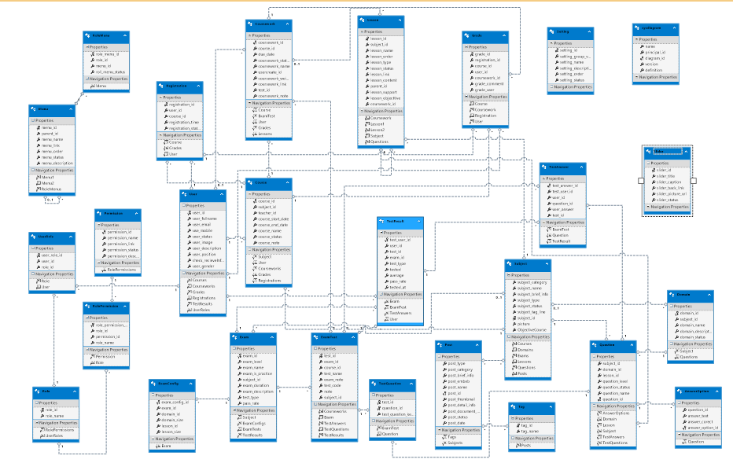

*Figure 21*. *Entity Relationship Diagram*

# Chapter 4: Software Design

### Introduction

### Purpose

This chapter is to give the developer team the overview and detailed design of what the system’s architecture is, and how they should be implemented. This chapter consists of:

* + Architecture overview
  + Detailed design
  + Detailed description of components
  + Database design

### Scope

This Software Design Document is for a base level system which will work as a proof of concept for the use of building a system the provides a base level of functionality to show feasibility for large scale production use. This Software Design is focused on the base level system and critical parts of the system. For this particular Software Design Document, the focus is placed on generation of the documents and modification of the documents. The system will be used in conjunction with other pre-existing systems and will consist largely of a document interaction facade that abstracts document interactions and handling of the document objects.

### Constrainst

Technical constraints are fixed technical design decisions that absolutely cannot be changed.  Most often technical constraints are provided by stakeholders (perhaps after some digging) at the outset of the project. Sometimes a team may choose to create a constraint, perhaps to simplify the world in which they are working.  Regardless of the origin, these architecture drivers are technical in nature and are considered unchangeable and indeed very soon become so.  
  
There are many common examples of technical constraints that you've likely seen.

*Programming language* - often times a specific programming language will be required for various reasons.  For example, the customer may be a Java or Ruby or Microsoft shop.  You might simply prefer a certain language over another, or have specific expertise that dictates using a particular programming language.  Nearly always, once you've picked a language you are stuck with that choice for the remainder of the project,

*Operating system or platforms supported* - It must work on Windows, or Linux, or iOS, or Qt on Solaris, or IE 6 on Windows XP, or ... building software that does not satisfy the platform constraint means you have failed to design a software system that satisfies stakeholders' key concerns.

*Use of a specific library or framework*- Sometimes a specific library might be required to be used.  The specific origin might come from the business but the influence is very technical.  A common example at many companies is the use of specific open source libraries.  Some companies might require that open source always be used.  Other companies, might have an approved list indicating which open source software may be used.  An interesting example at IBM is that we are required to target the "Blue" JVM,[IBM's JDK](http://www.ibm.com/developerworks/java/jdk/) for all JVM-based projects.

### Architecture Overview

### System Overview

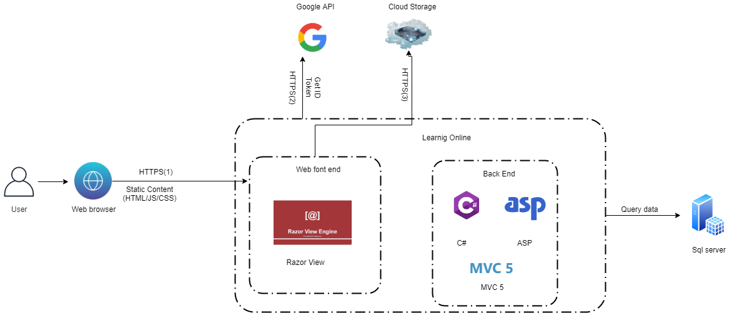

*Figure 22. System Overview*

### 2.1.1 Protocol Explanation

(1)Users interact with the system by visiting Learning Online website on a browser with MetaMask extension installed. Browser will load the CertNet Front-end Application and render the website’s user interface with React. The front-end application executes smart contract methods by communicating with MetaMask extension via the Web3 instance injected to the browser’s environment[1]

(2)Users interact with the system by visiting Learning Online website on a browser with MetaMask extension installed. Browser will load the Learning Online Front-end Application and render the website’s user interface with React. The front-end application executes smart contract methods by communicating with MetaMask extension via the Web3 instance injected to the browser’s environment[2].

(3) Learning Online Front-end Application loads images like issuer’s logo, visual templates, etc. via public URL from Google Cloud Storage.

**Web Browser**



Web Browser

User can use all most browsers to access our website such as: Chrome, Mozilla Firefox, Microsoft Edge, and Opera…

**Google API**



Google API

To verify access to web server. User who logged-in Google successfully can access to web server.

**SQL Server**



SQL Server

Microsoft SQL Server is a relational database management system developed by Microsoft. As a database server, it is a software product whose main function is to store and retrieve data as required by other software applications..

**Razor view**



Razor view

is an ASP.NET programming syntax used to create dynamic web pages with the C # or VB.NET programming languages. Razor was developed in June 2010 and released for Microsoft Visual Studio 2010 in January 2011..

**C#**



C#

C # is an object-oriented programming language developed by Microsoft, which is the beginning of their .NET plan. The name of the language includes the characters followed by Microsoft, but according to ECMA, C #, only the lowercase digits. Microsoft develops C # based on C ++ and Java.

**Cloud storage**



Clould Storage

Is a model of computer data storage, in which digital data is stored in logical reservoirs. Physical storage spreads across multiple servers and the physical environment is usually owned and managed by a hosting company.

**ASP**



ASP

ASP.NET is a web application platform developed and provided by Microsoft that allows programmers to create dynamic web pages, web applications and web services.

**MVC 5**



MVC

### SF – Backend Design

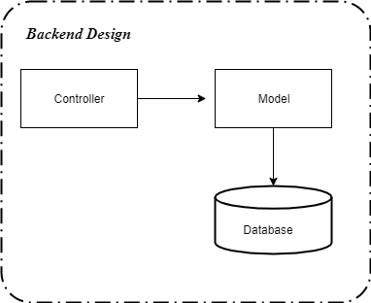

*Figure 24. SF – Backend Overview Design of each Controller*

### Package Diagram

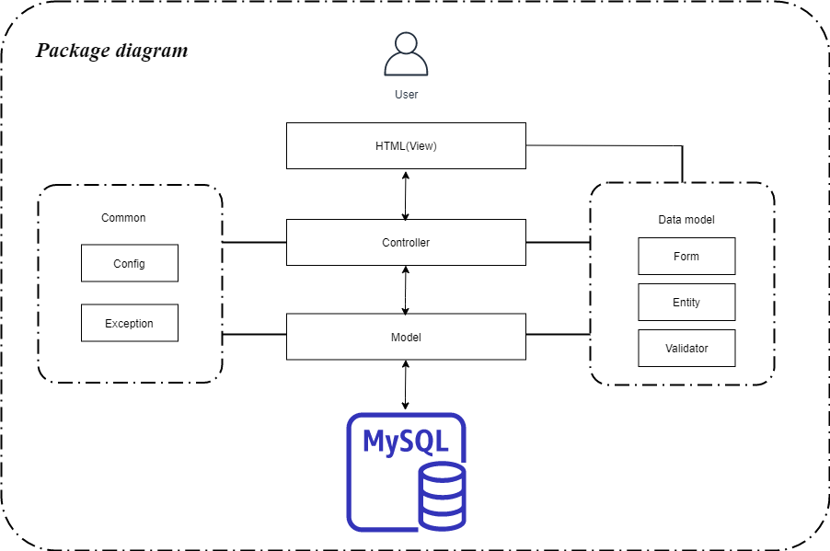

*Figure 27. Package diagram*

### Detailed Description of Components

#### CRC Cards (Class-Responsibility-Collaborators)

##### Post View

###### Screen Design

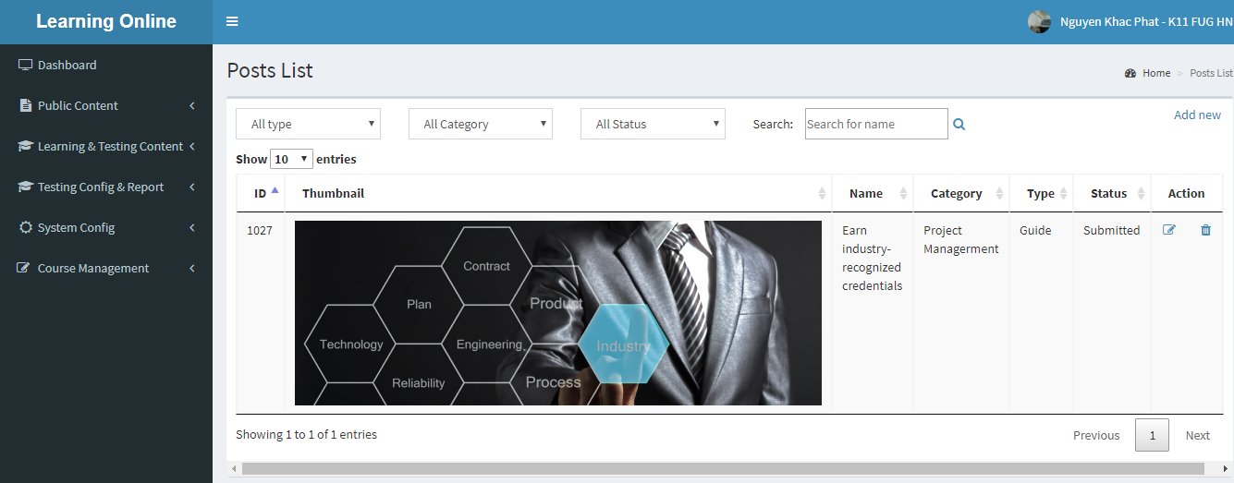

Figure 4-3: Post screen design

###### Class Diagram

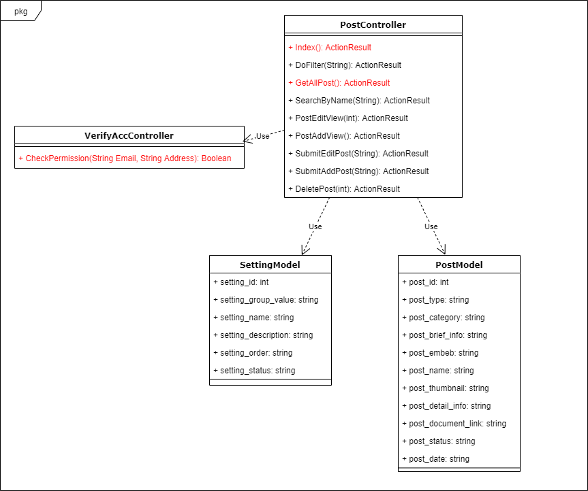

Figure 4-4: Post View class diagram

###### Sequence Diagram

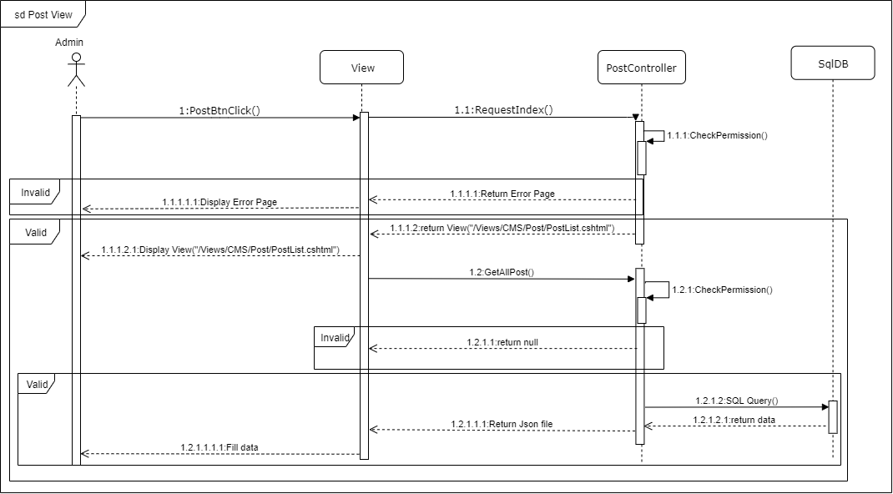

Figure 4-5: Post View sequence diagram

##### Post Add new

###### Screen Design

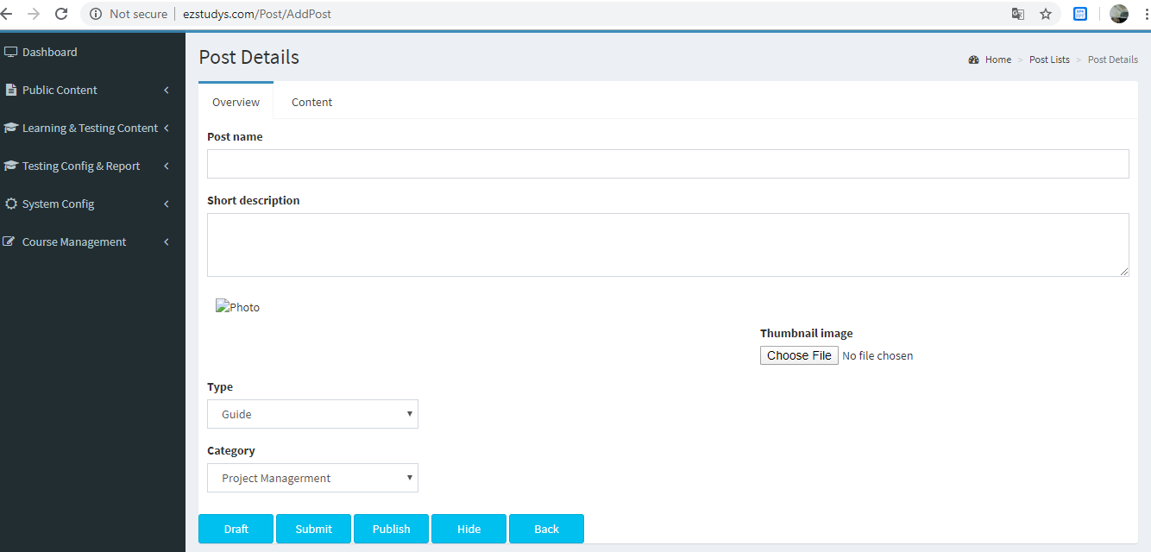

Figure 4-3: Post add new screen design

###### Class Diagram

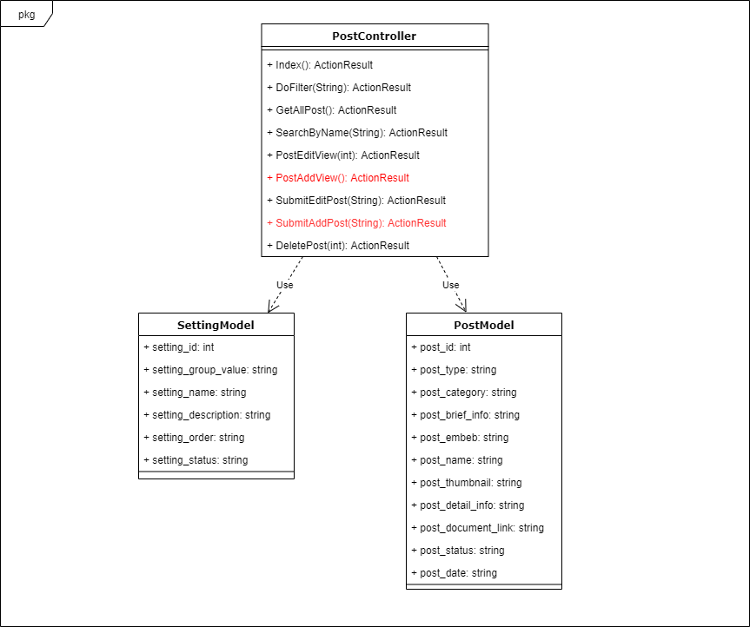

Figure 4-4: Post Add new class diagram

###### Sequence Diagram

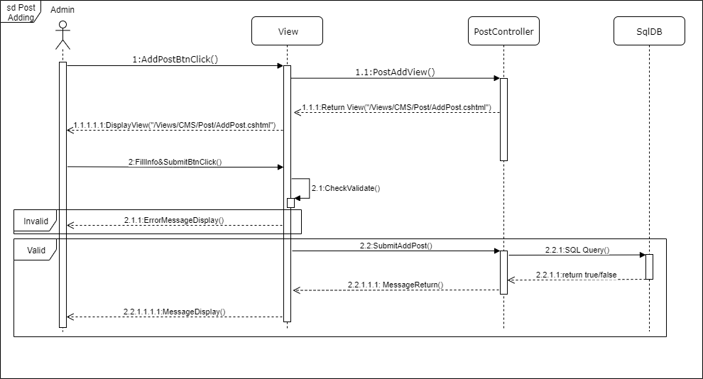

Figure 4-5: Login sequence diagram

##### Post Editing

###### Screen Design

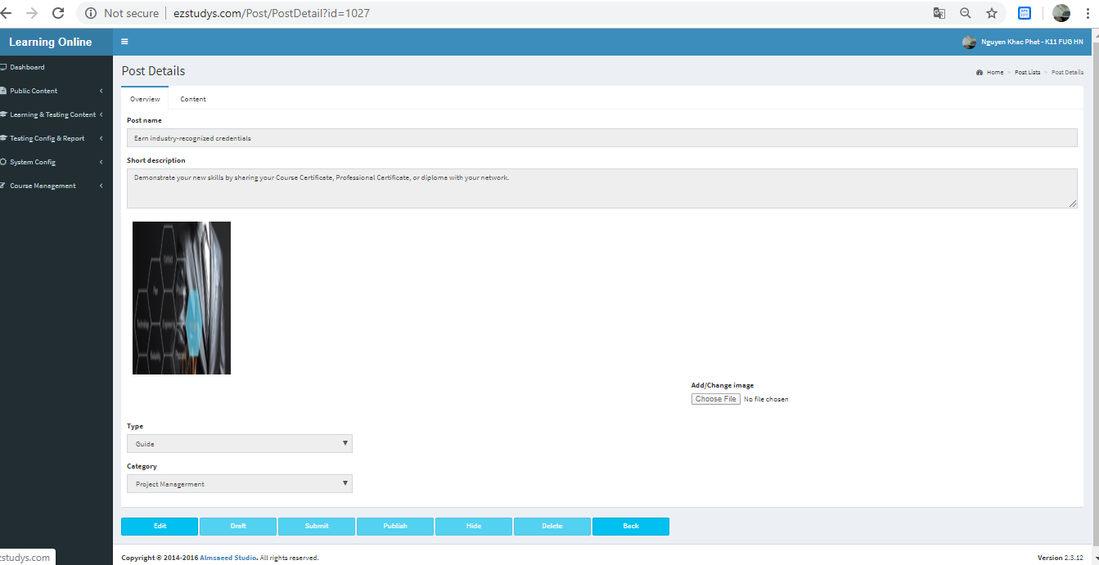

Figure 4-3: Post Editting screen design

###### Class Diagram

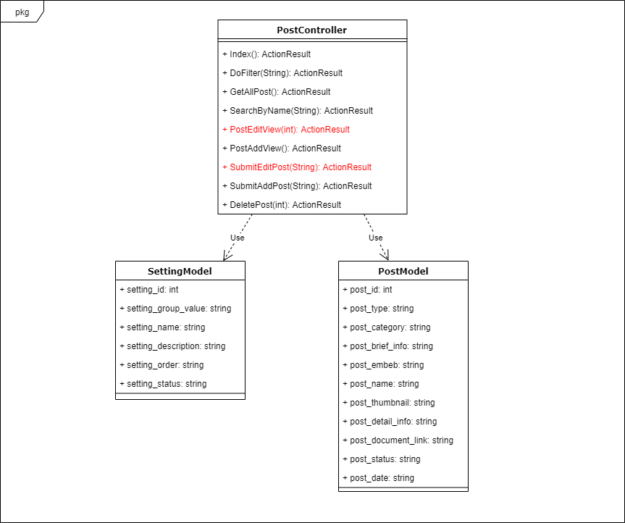

Figure 4-4: Post Editting class diagram

###### Sequence Diagram

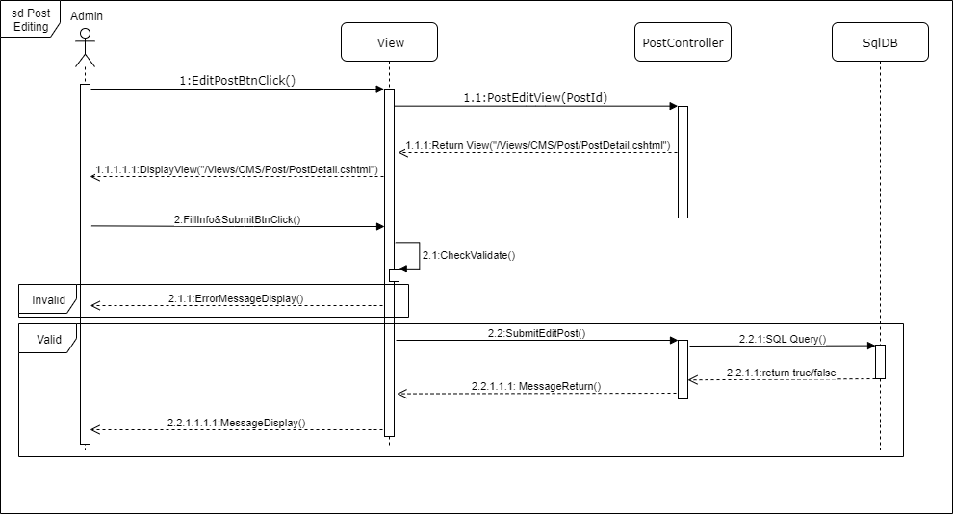

Figure 4-5: Post Editting sequence diagram

##### Post Delete

###### Screen Design

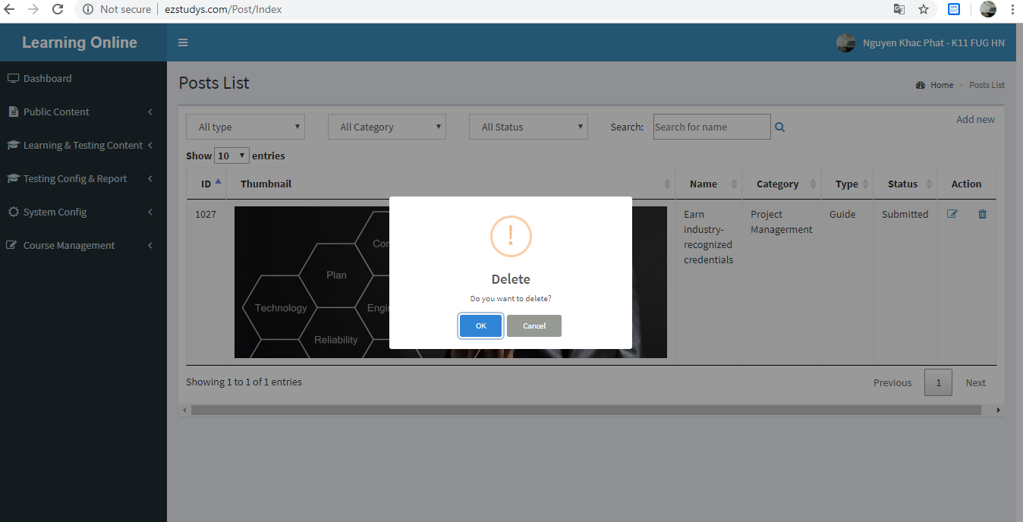

Figure 4-3: Post Delete screen design

###### Class Diagram

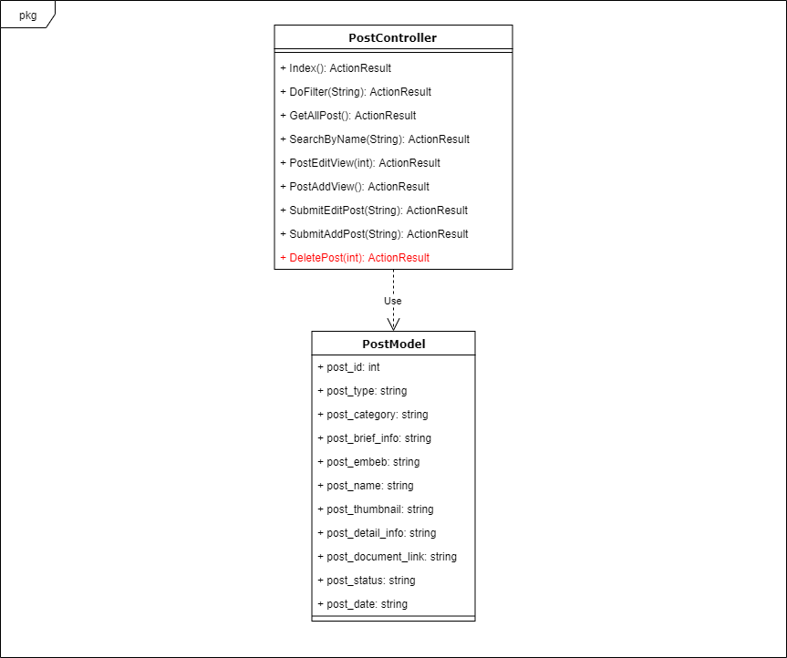

Figure 4-4: Post Delete class diagram

###### Sequence Diagram

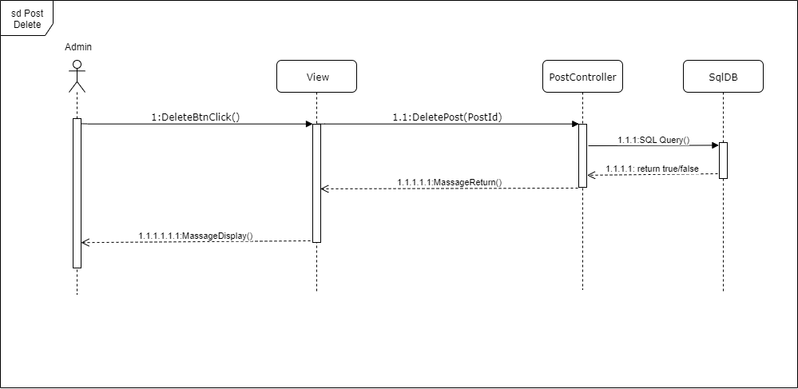

Figure 4-5: Post Delete sequence diagram

##### Slider View

###### Screen Design

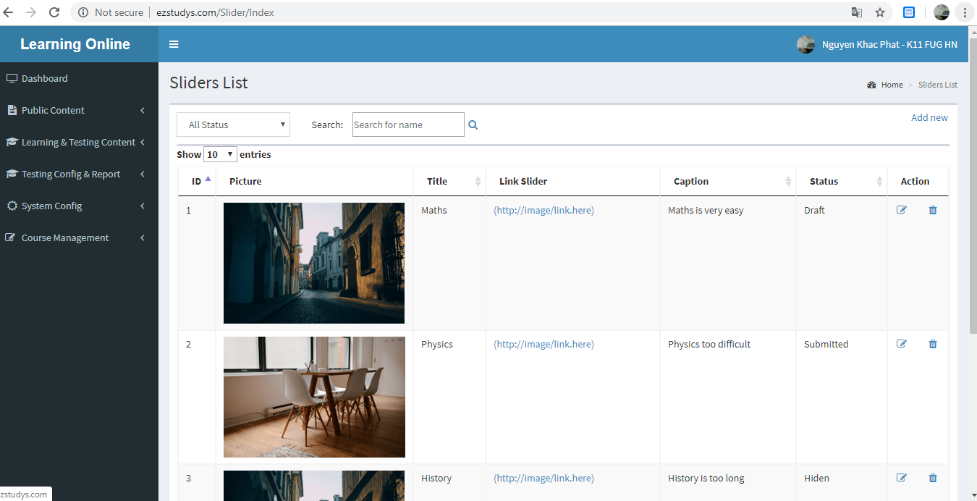

Figure 4-3: Slider View screen design

###### Class Diagram

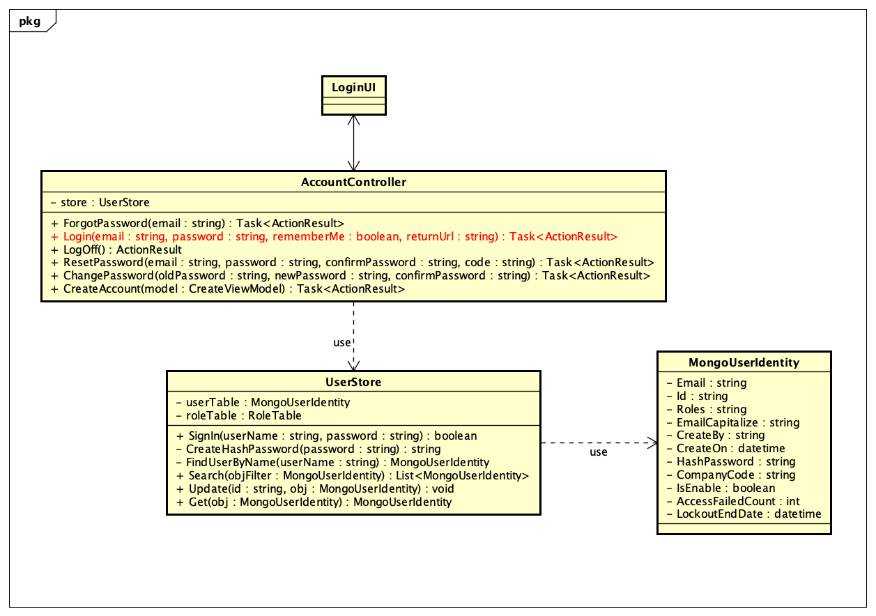

Figure 4-4: Slider View class diagram

###### Sequence Diagram

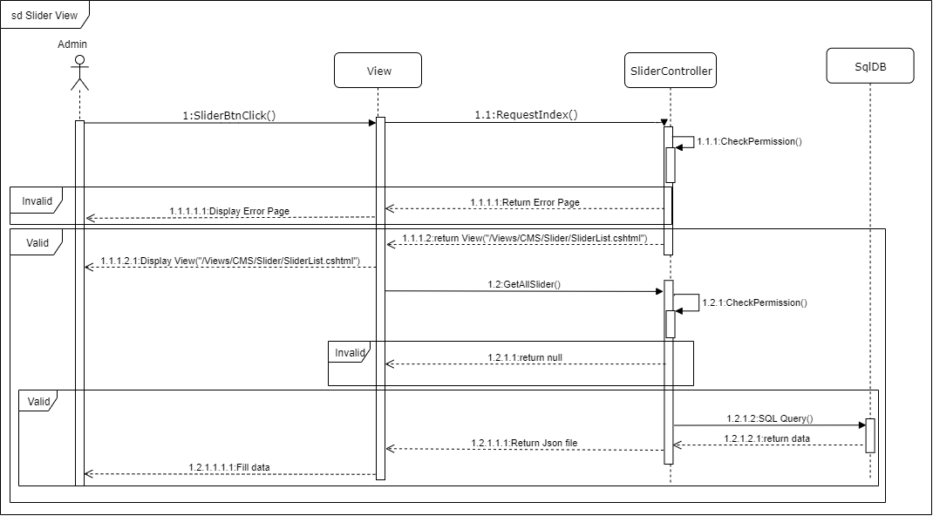

Figure 4-5: Slider View sequence diagram

##### Slider Adding

###### Screen Design

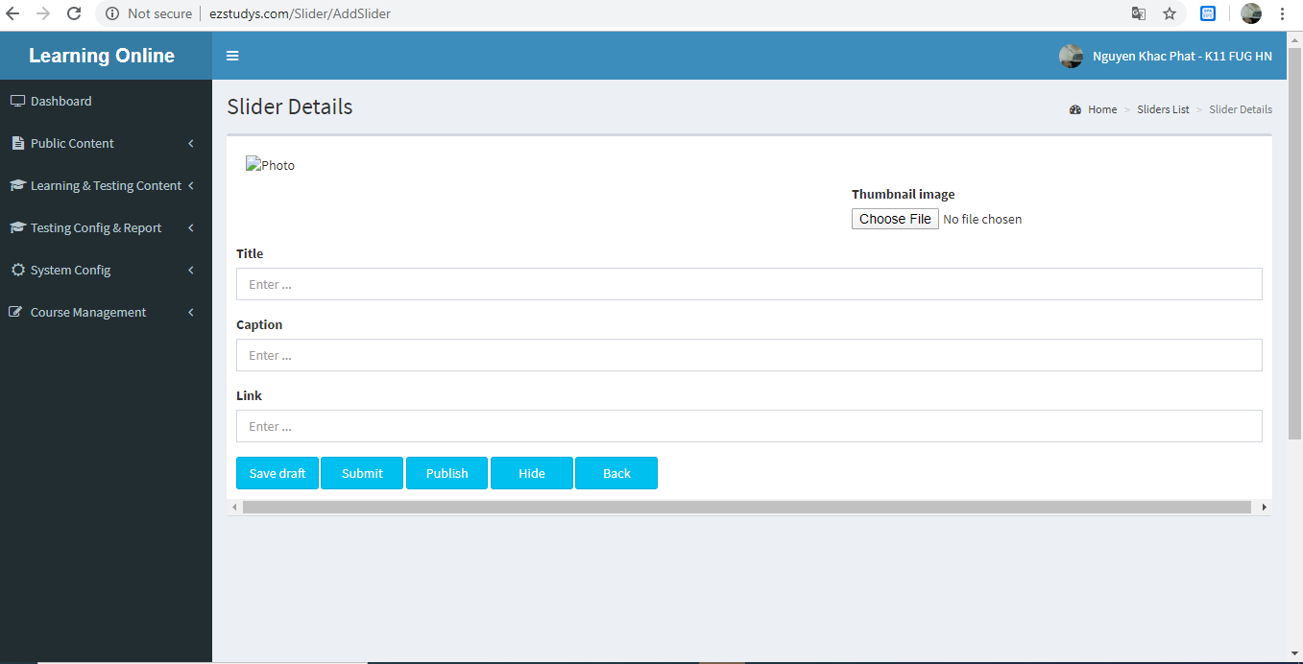

Figure 4-3: Slider Adding screen design

###### Class Diagram

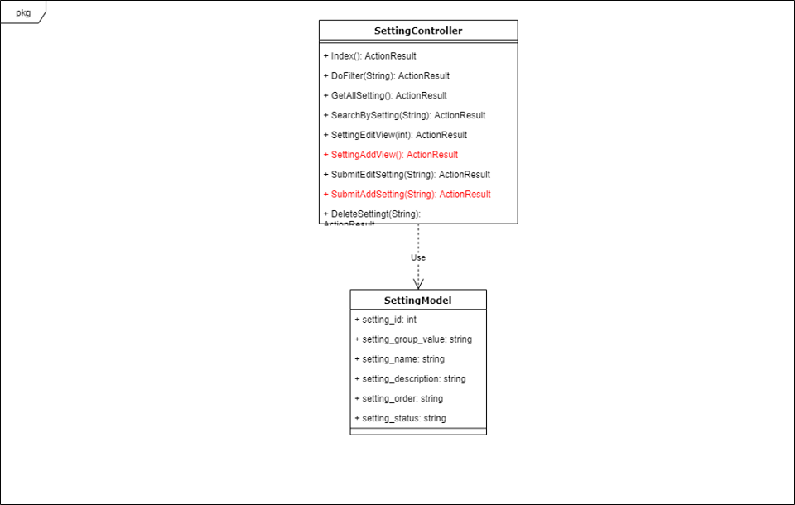

Figure 4-4: Slider Adding class diagram

###### Sequence Diagram

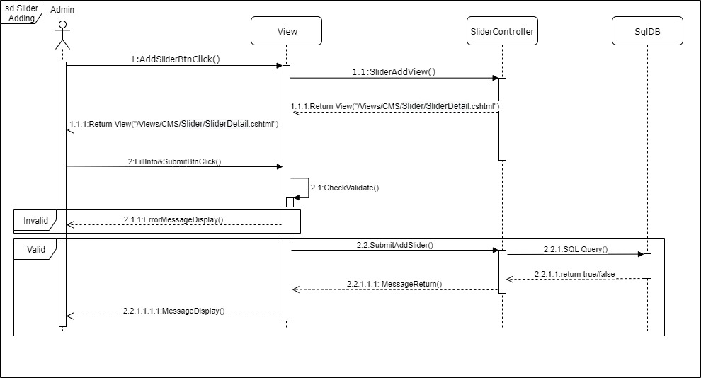

Figure 4-5: Slider Adding sequence diagram

##### Slider Eddting

###### Screen Design

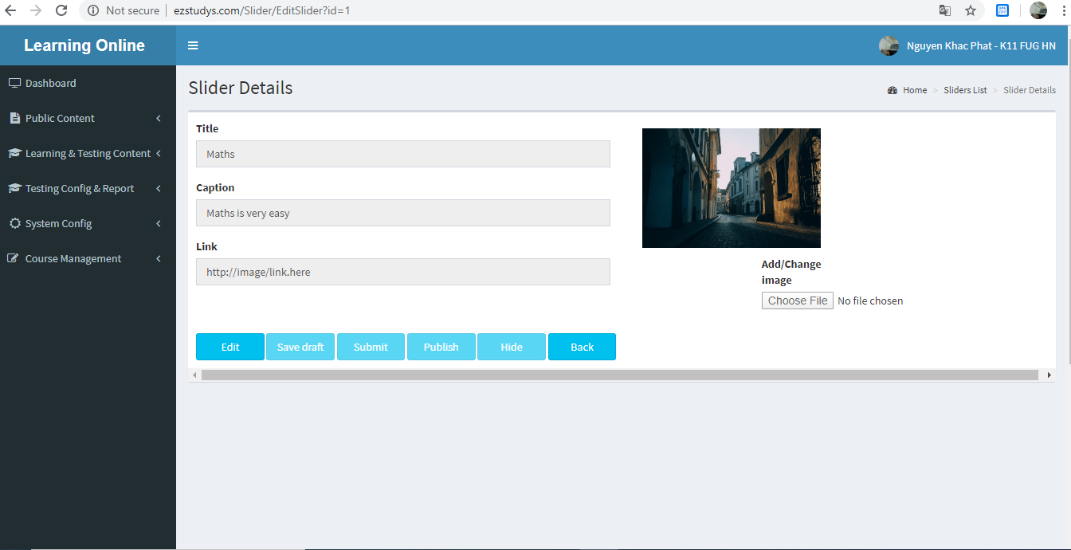

Figure 4-3: Slider Eddting screen design

###### Class Diagram

Figure 4-4: Slider Eddting class diagram

###### Sequence Diagram

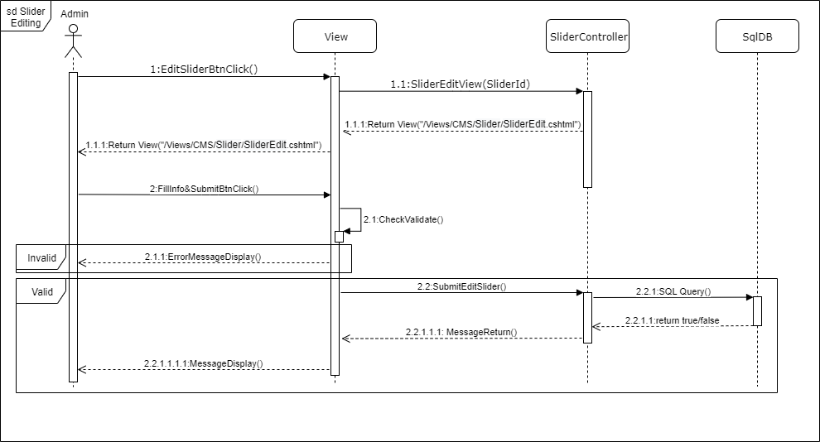

Figure 4-5: Slider Eddting sequence diagram

##### Slider Delete

###### Screen Design

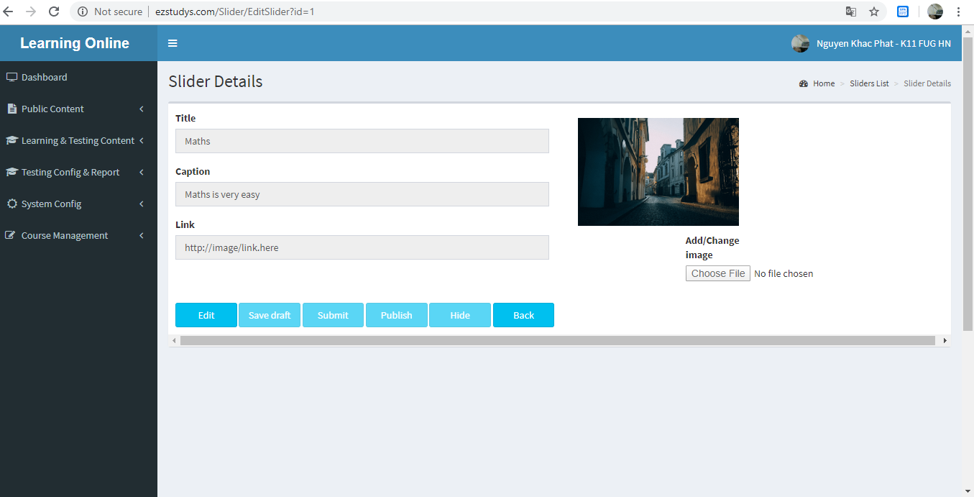

Figure 4-3: Slider Delete screen design

###### Class Diagram



Figure 4-4: Slider Delete class diagram

###### Sequence Diagram

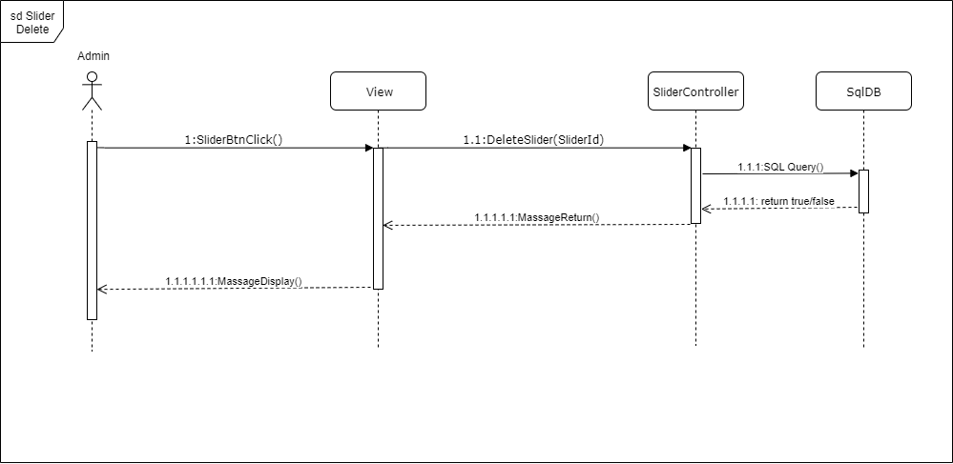

Figure 4-5: Slider Delete sequence diagram

##### Subject View

###### Screen Design

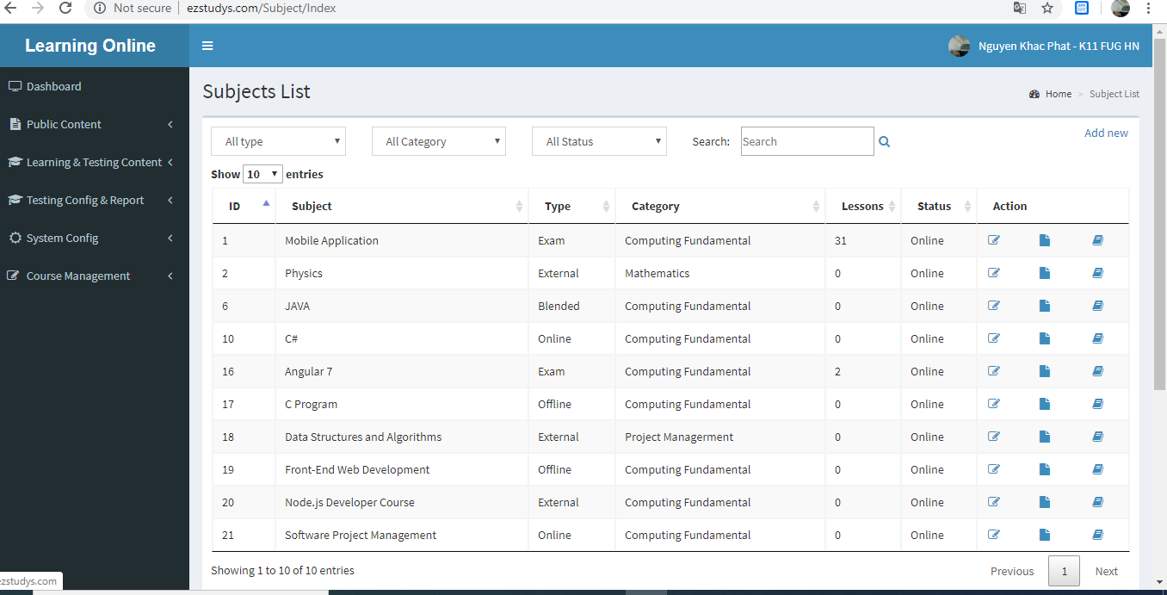

Figure 4-3: Subject View screen design

###### Class Diagram

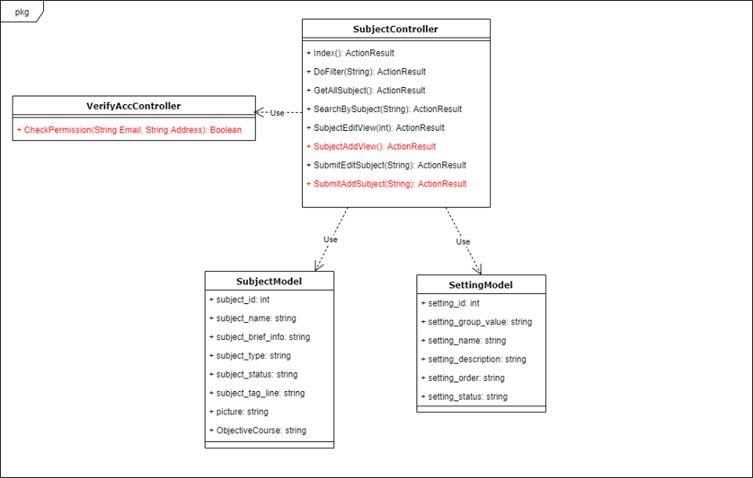

Figure 4-4: Subject View class diagram

###### Sequence Diagram

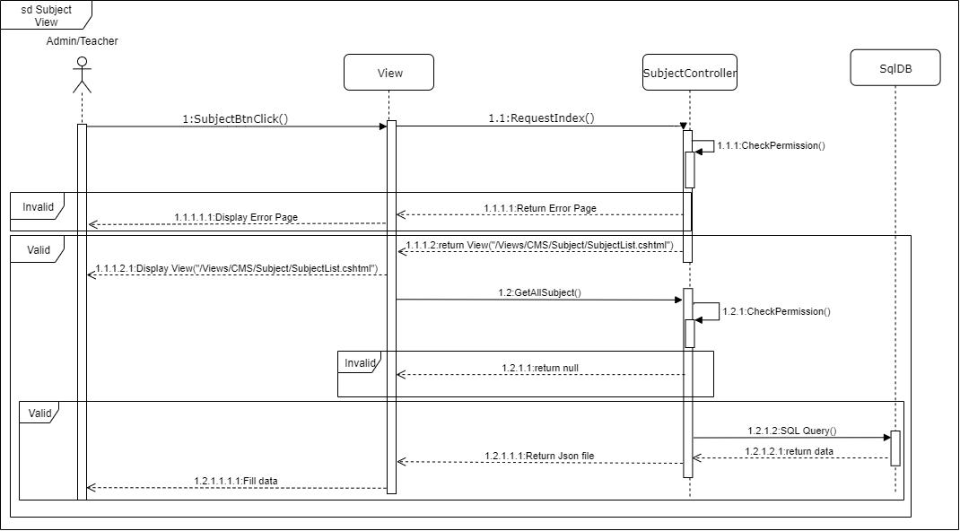

Figure 4-5: Subject View sequence diagram

##### Subject Adding

###### Screen Design

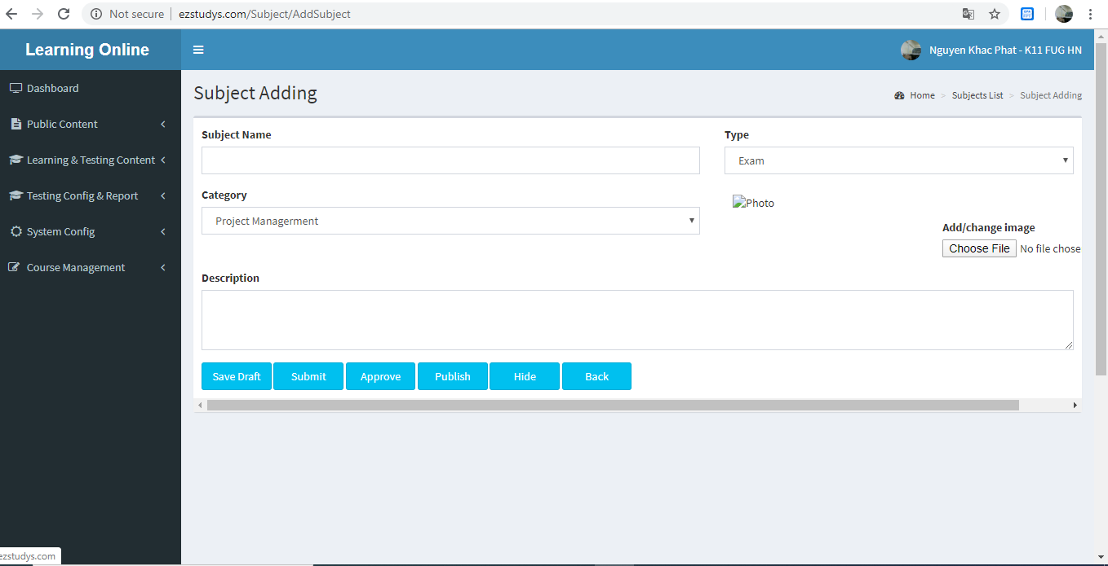

Figure 4-3: Subject Adding screen design

###### Class Diagram

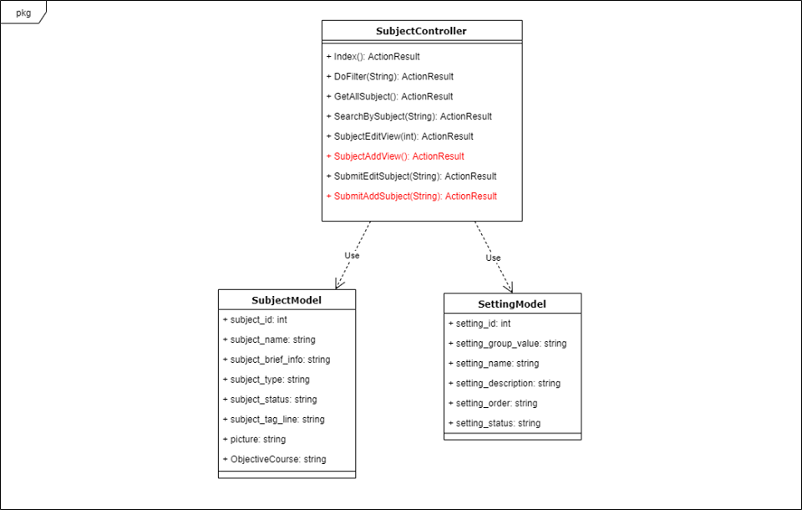

Figure 4-4: Subject Adding class diagram

###### Sequence Diagram

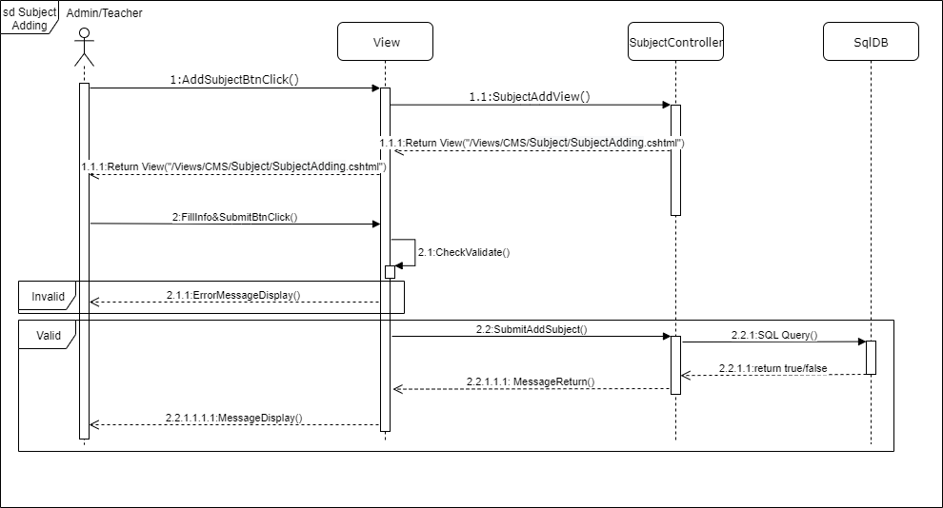

Figure 4-5: Subject Adding sequence diagram

##### Subject Eddting

###### Screen Design

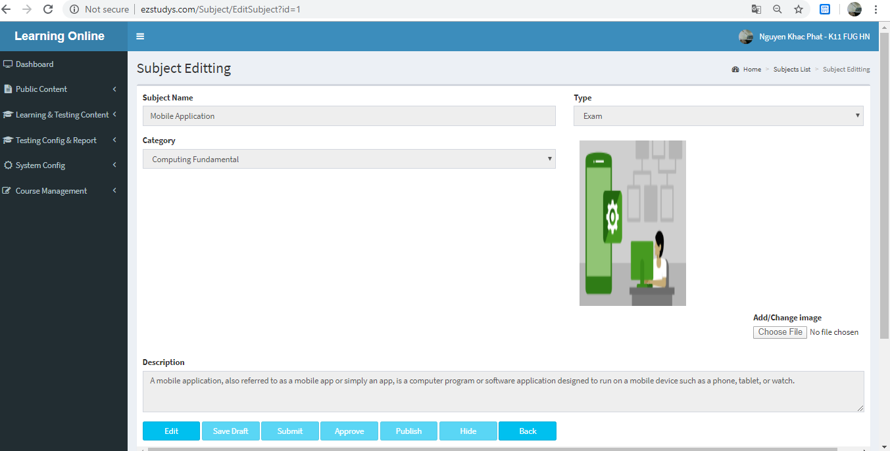

Figure 4-3: Subject Eddting screen design

###### Class Diagram

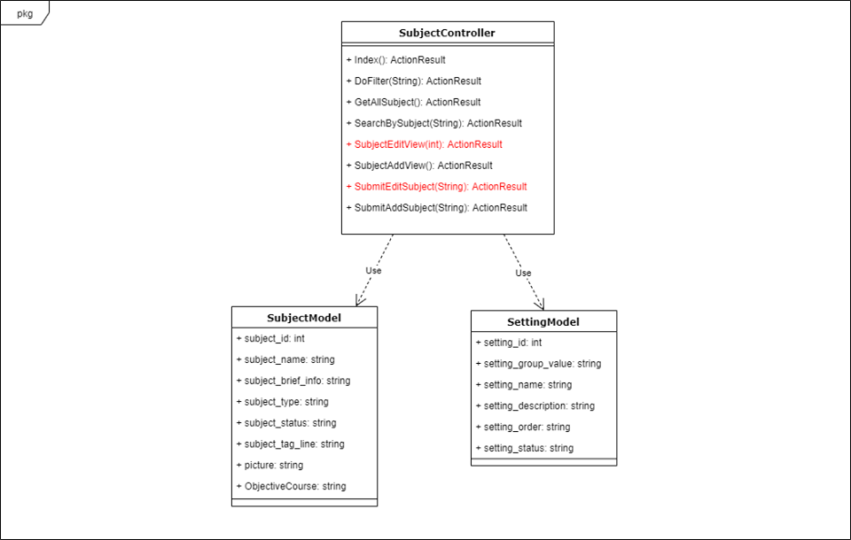

Figure 4-4: Subject Eddting class diagram

###### Sequence Diagram

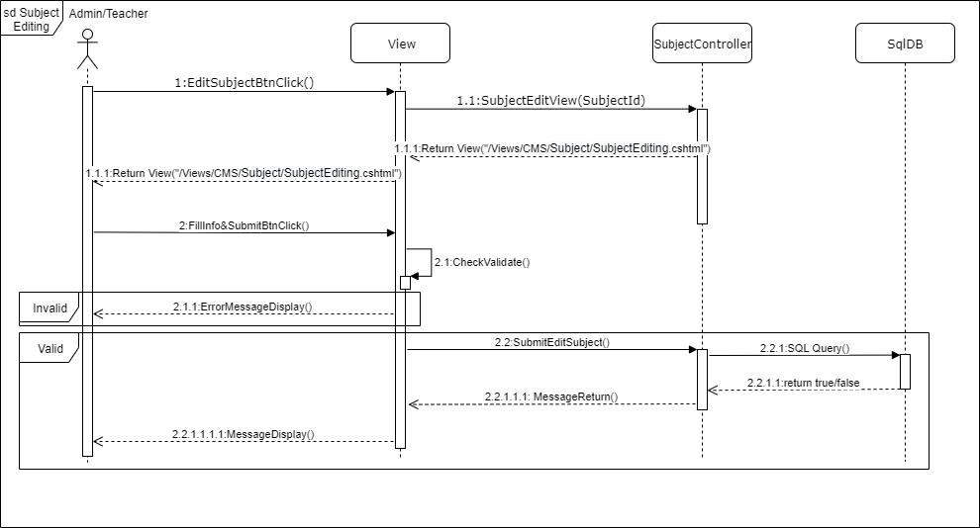

Figure 4-5: Subject Eddting sequence diagram

##### Domain View

###### Screen Design

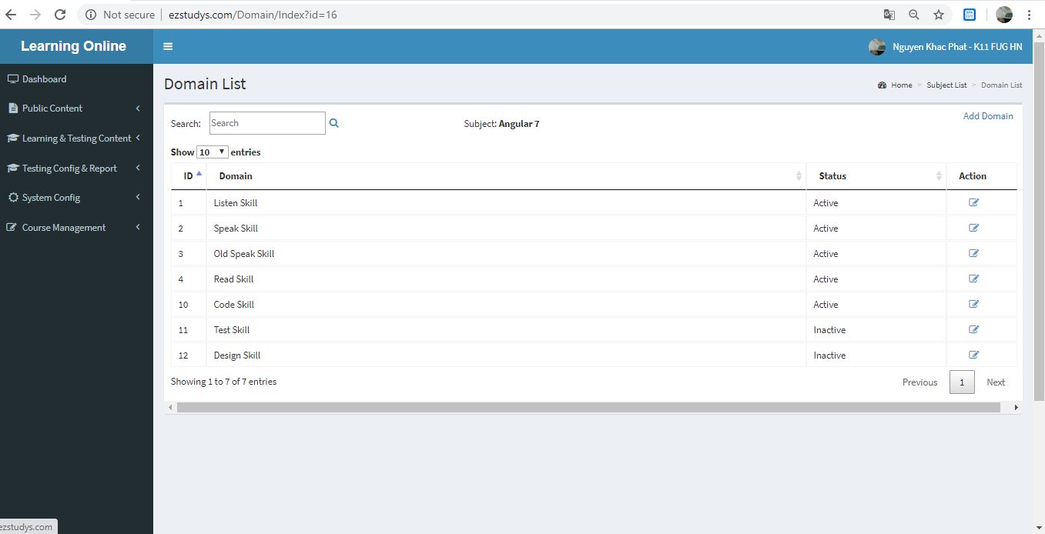

Figure 4-3: Domain View screen design

###### Class Diagram

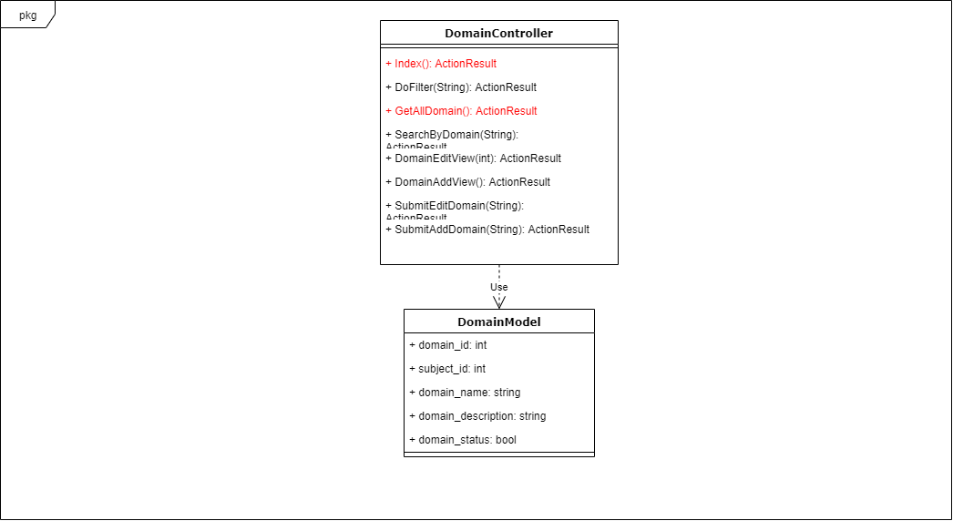

Figure 4-4: Domain View class diagram

###### Sequence Diagram



Figure 4-5: Domain View sequence diagram

##### Domain Adding

###### Screen Design

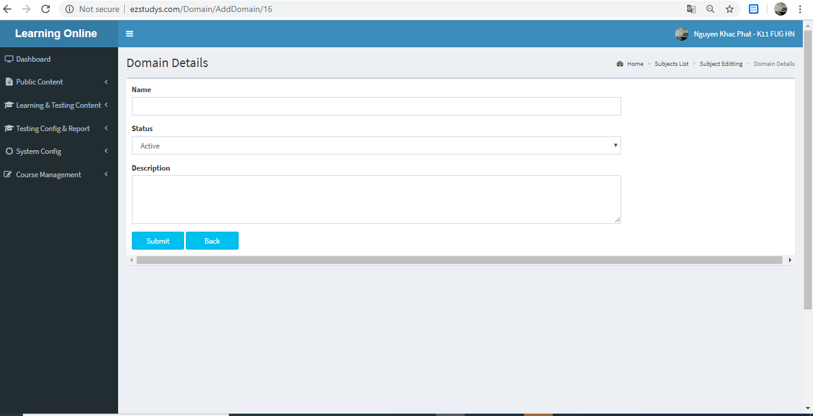

Figure 4-3: Domain Adding screen design

###### Class Diagram

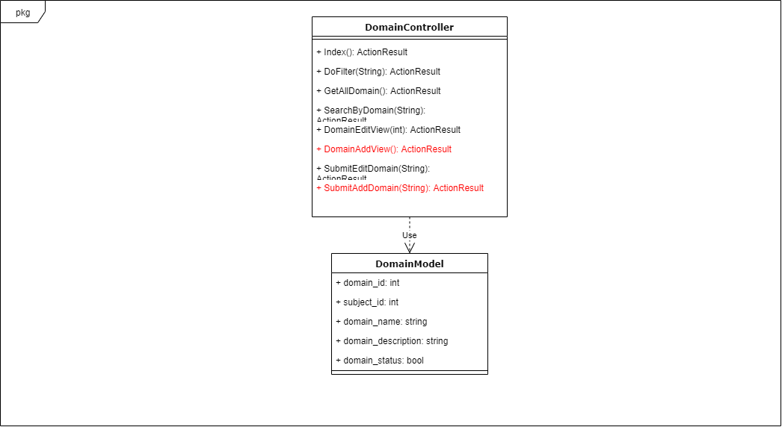

Figure 4-4: Domain Adding class diagram

###### Sequence Diagram

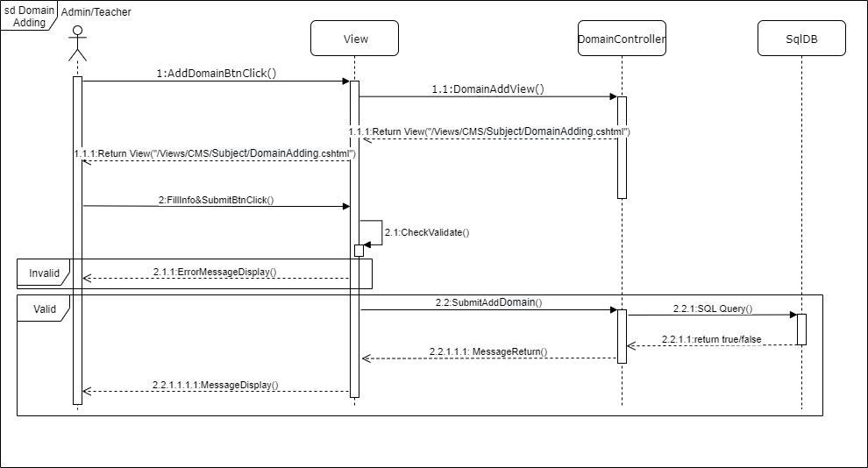

Figure 4-5: Domain Adding sequence diagram

##### Lesson View

###### Screen Design

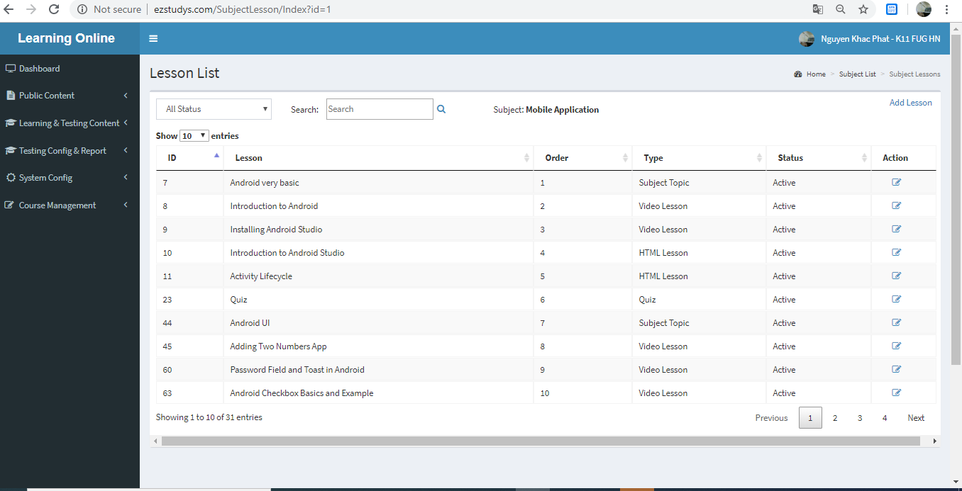

Figure 4-3: Lesson View screen design

###### Class Diagram

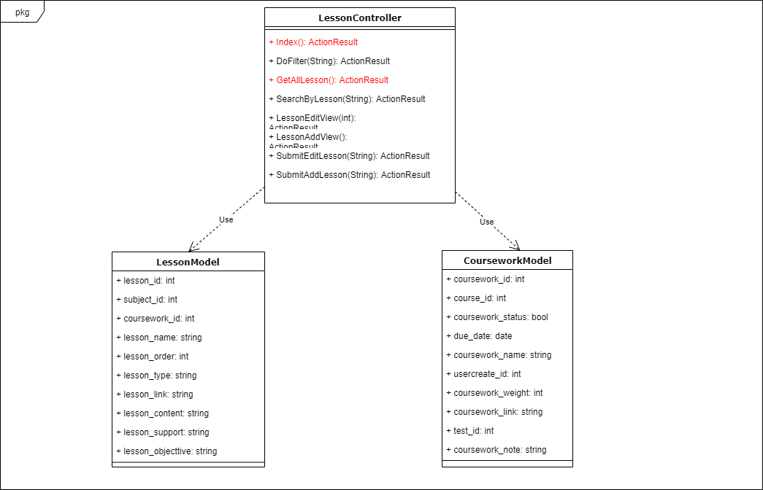

Figure 4-4: Lesson View class diagram

###### Sequence Diagram

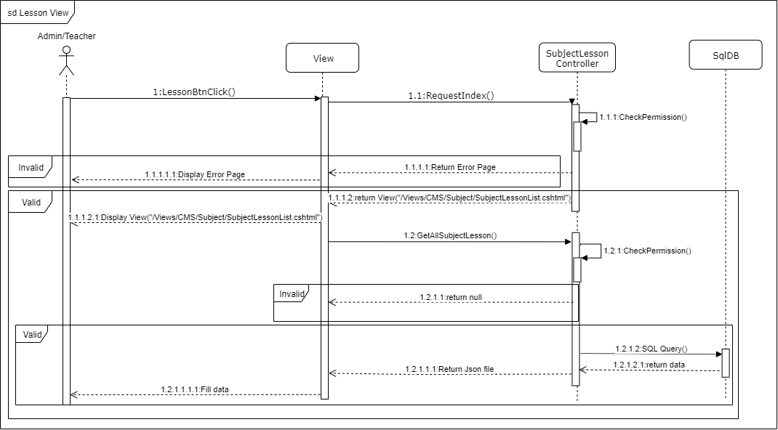

Figure 4-5: Lesson View sequence diagram

##### Lesson Adding

###### Screen Design

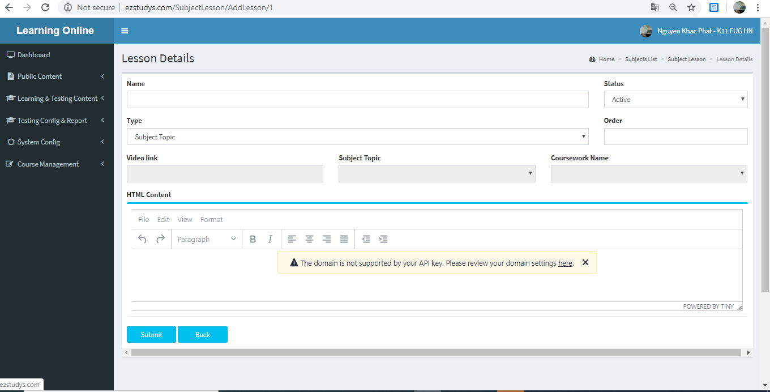

Figure 4-3: Lesson Adding screen design

###### Class Diagram

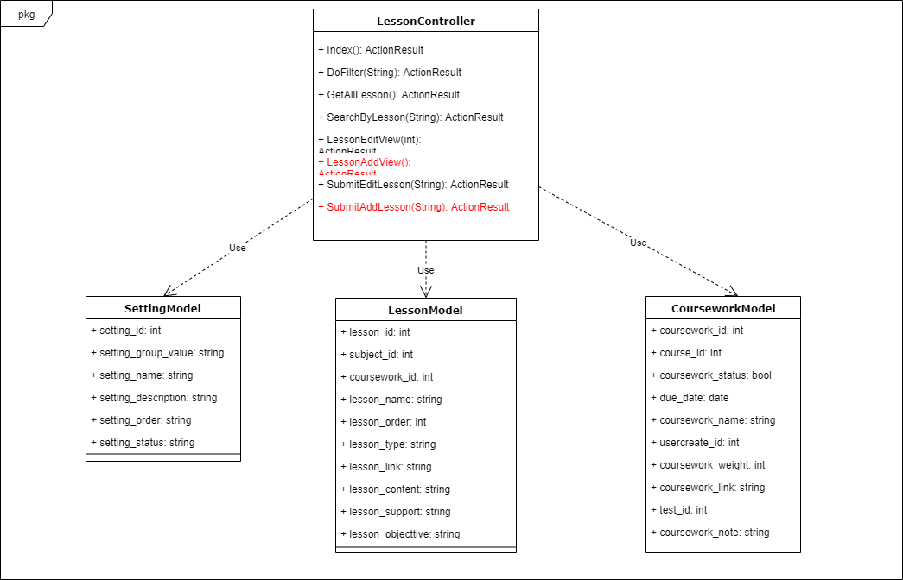

Figure 4-4: Lesson Adding class diagram

###### Sequence Diagram

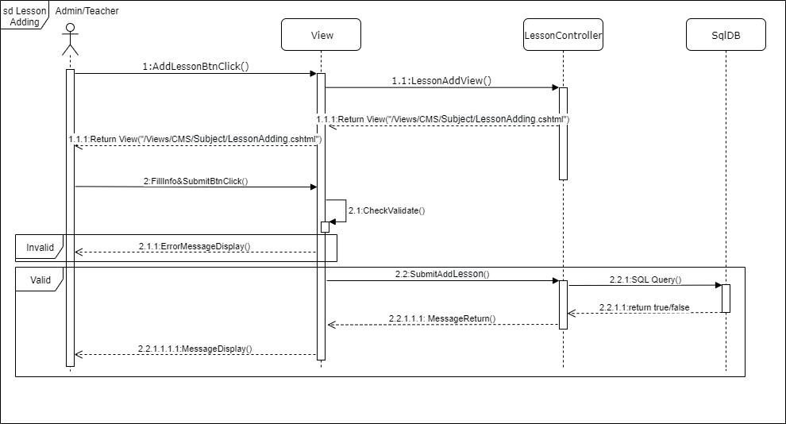

Figure 4-5: Lesson Adding sequence diagram

##### Lesson Eddting

###### Screen Design

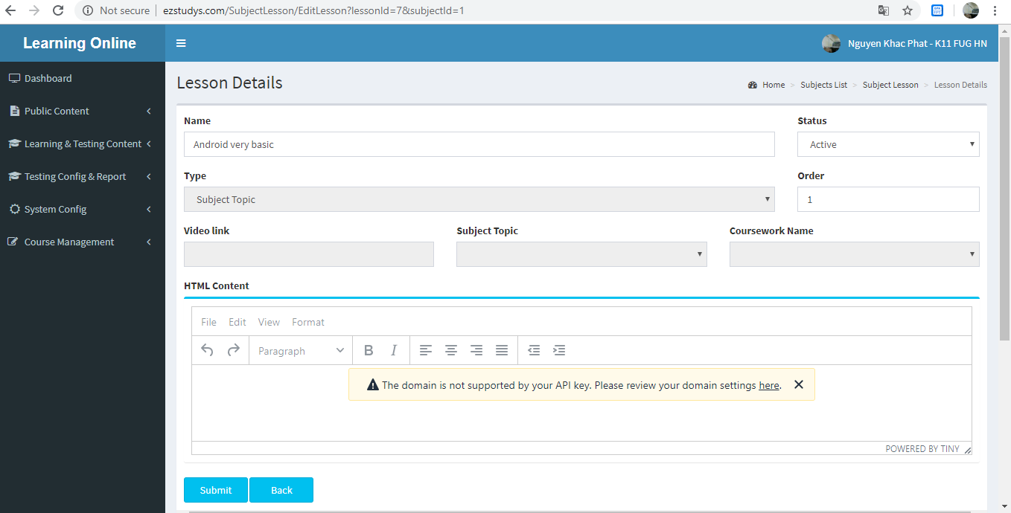

Figure 4-3: Lesson Eddting screen design

###### Class Diagram

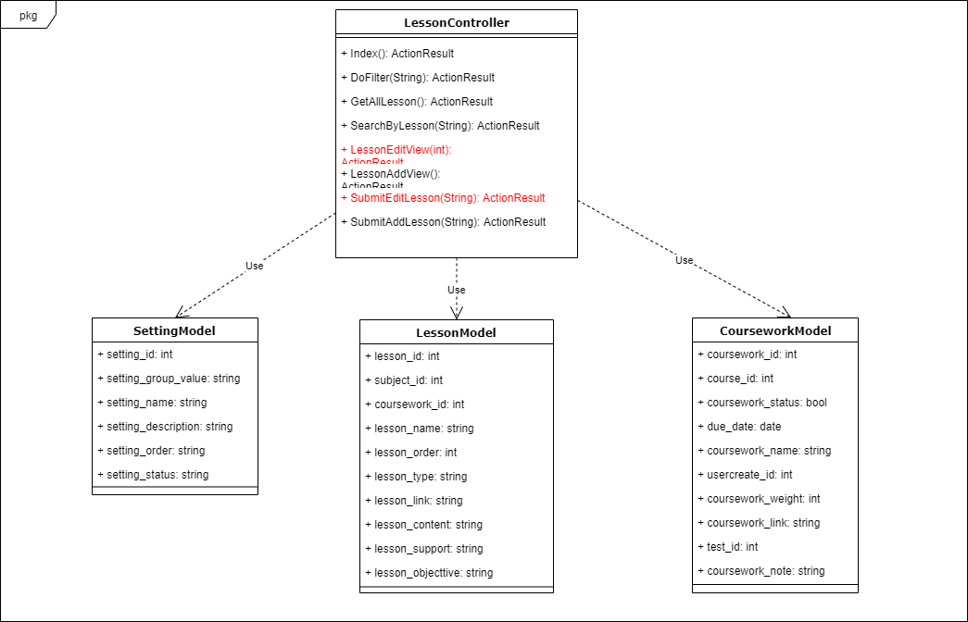

Figure 4-4: Lesson Eddting class diagram

###### Sequence Diagram

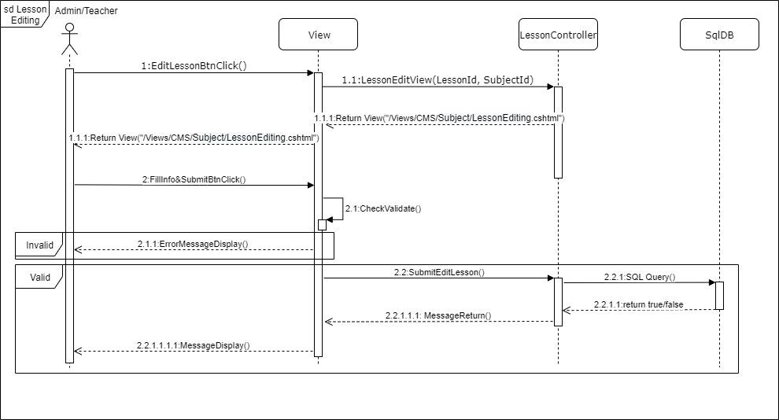

Figure 4-5: Lesson Eddting sequence diagram

##### Questions View

###### Screen Design

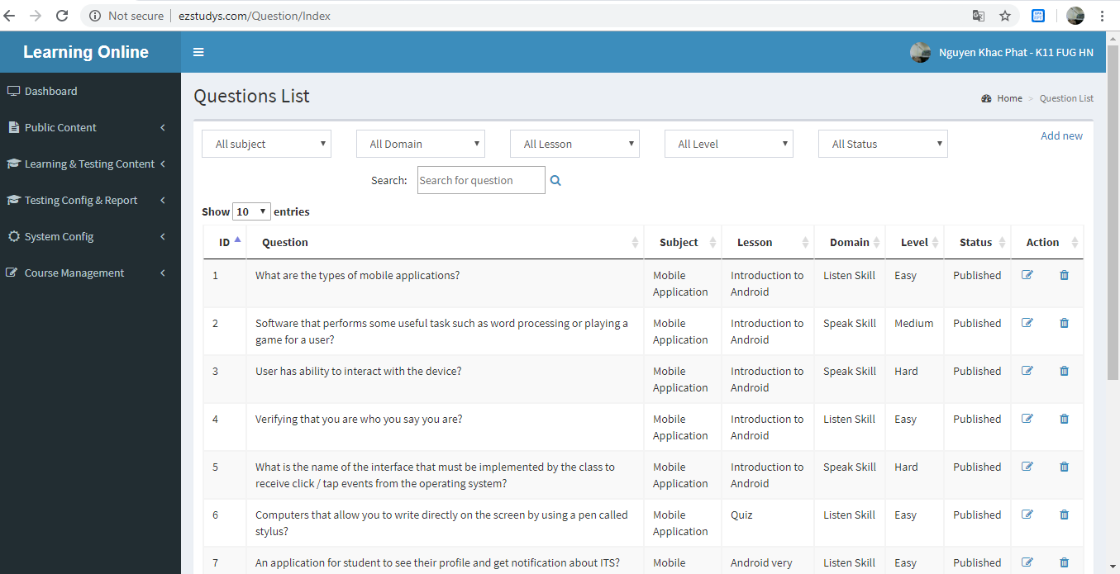

Figure 4-3: Questions View screen design

###### Class Diagram

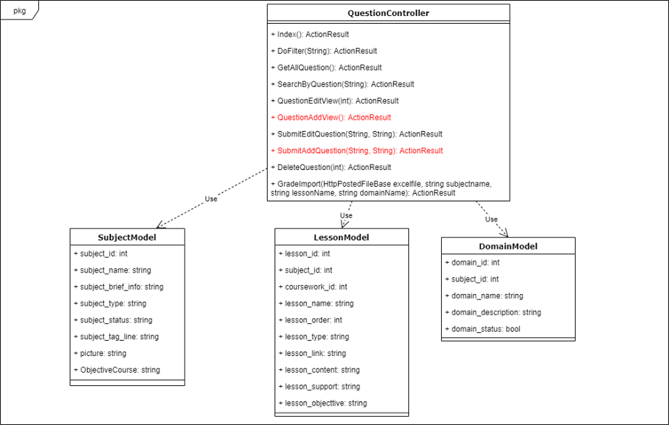

Figure 4-4: Questions View class diagram

###### Sequence Diagram

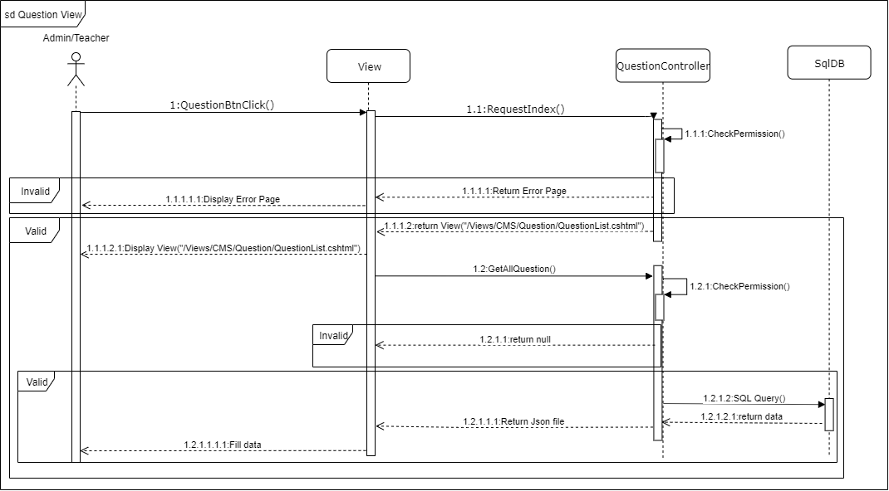

Figure 4-5: Questions View sequence diagram

##### Questions Adding

###### Screen Design

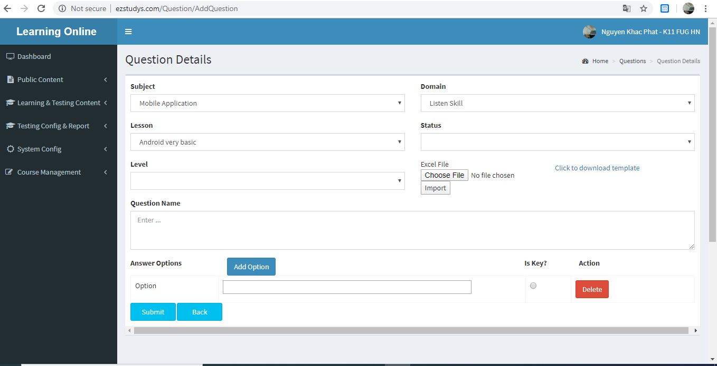

Figure 4-3: Questions Adding screen design

###### Class Diagram



Figure 4-4: Questions Adding class diagram

###### Sequence Diagram

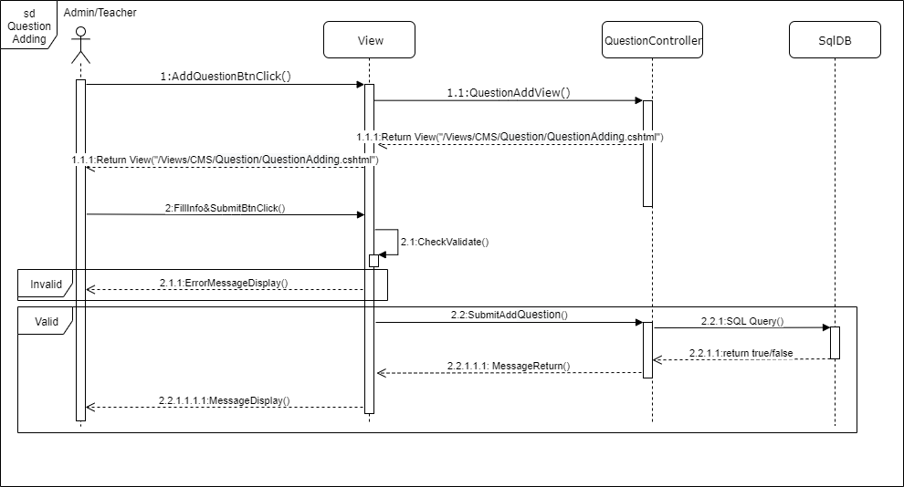

Figure 4-5: Questions Adding sequence diagram

##### Questions Eddting

###### Screen Design

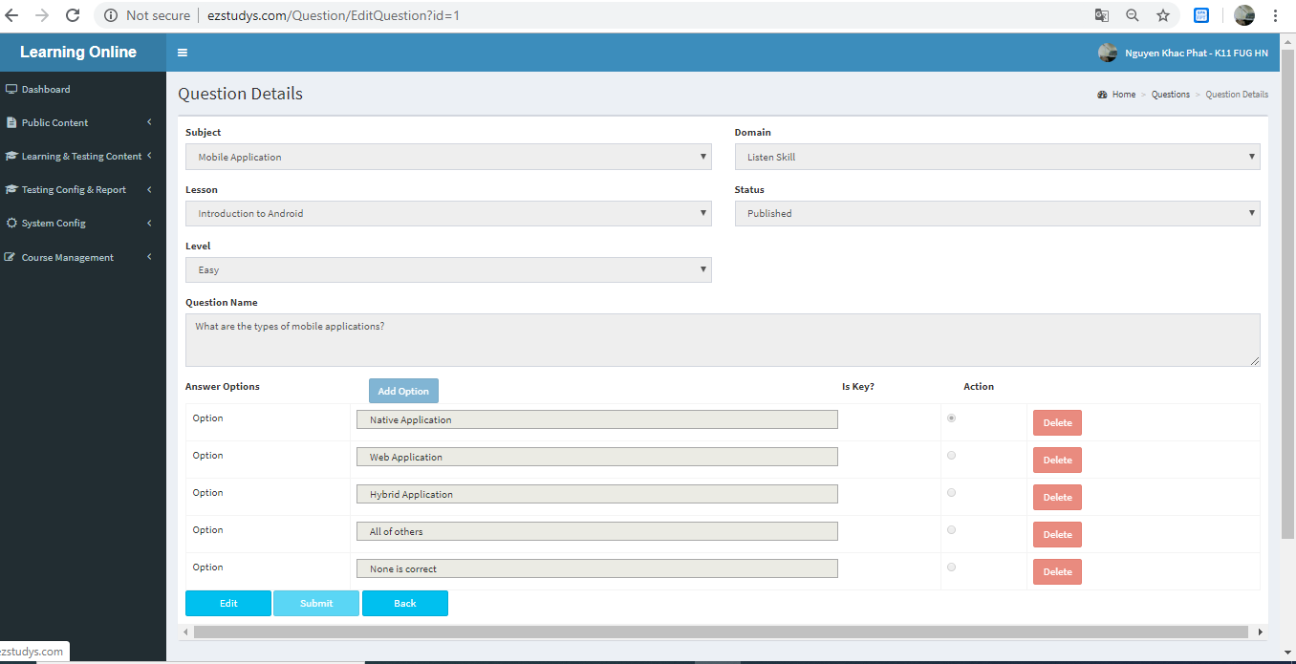

Figure 4-3: Questions Eddting screen design

###### Class Diagram

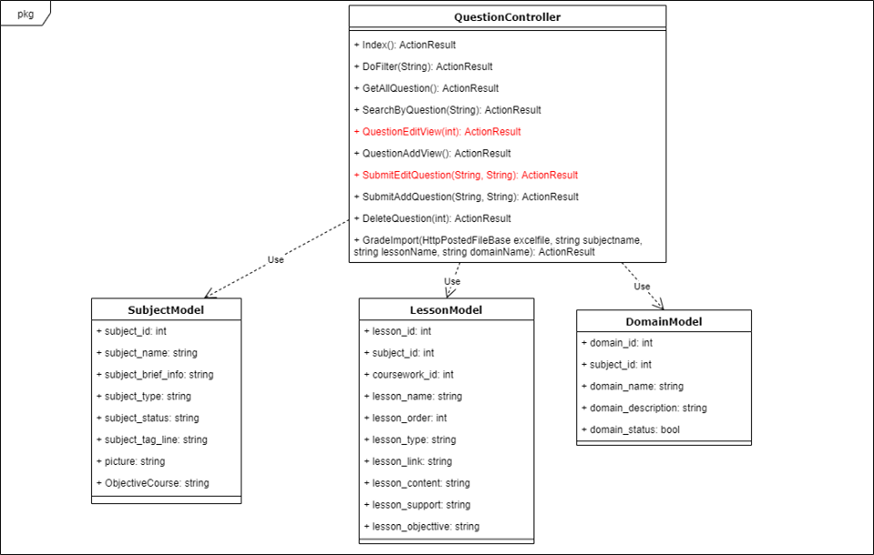

Figure 4-4: Questions Eddting class diagram

###### Sequence Diagram

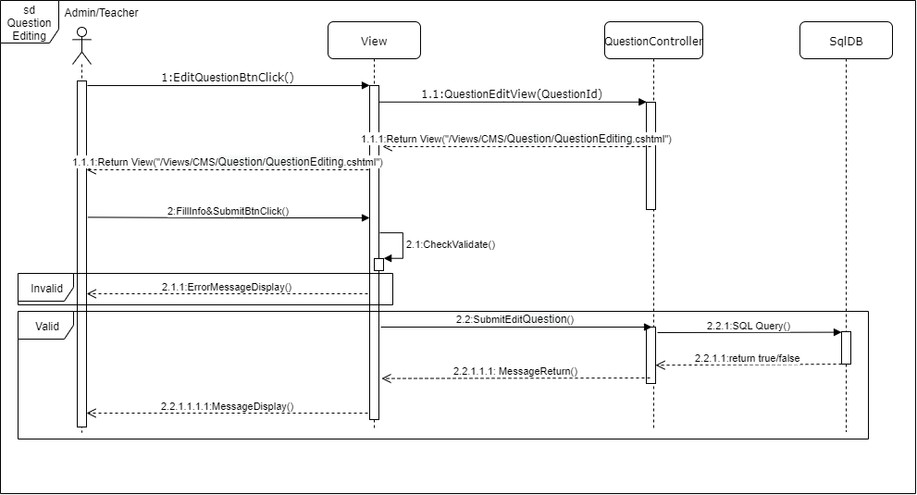

Figure 4-5: Questions Eddting sequence diagram

##### Questions Delete

###### Screen Design

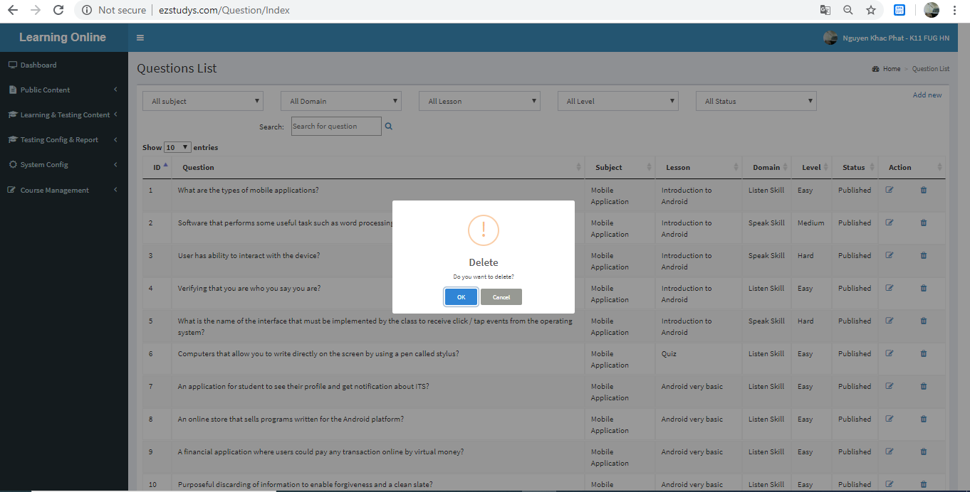

Figure 4-3: Questions Delete screen design

###### Class Diagram

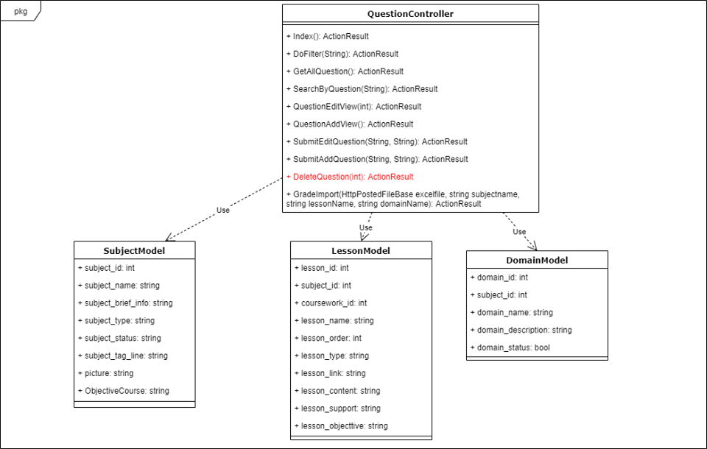

Figure 4-4: Questions Delete class diagram

###### Sequence Diagram

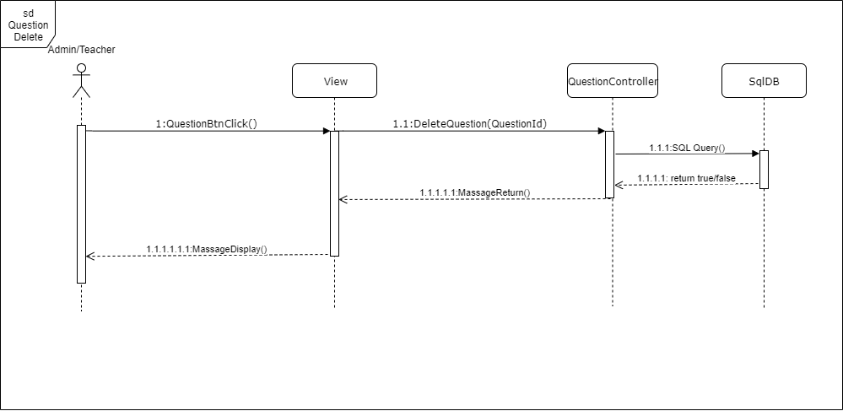

Figure 4-5: Questions Delete sequence diagram

##### Exam View

###### Screen Design

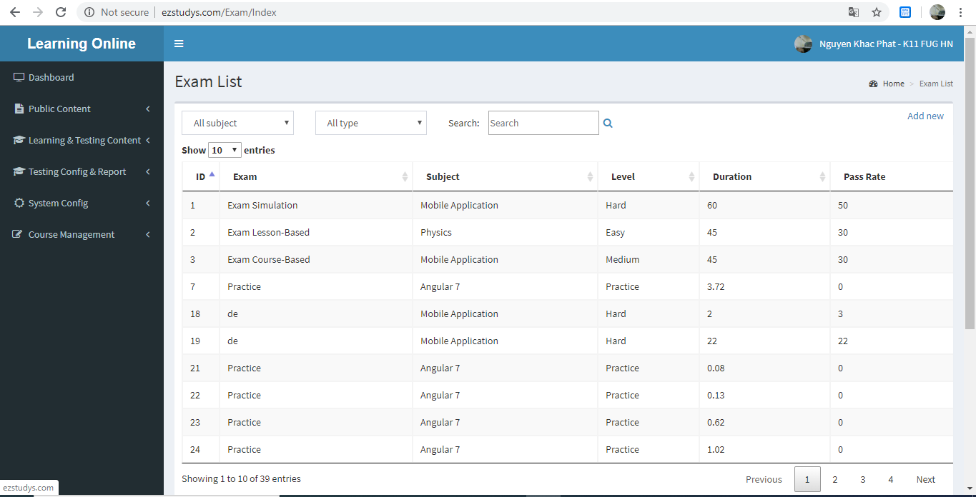

Figure 4-3: Exam View screen design

###### Class Diagram

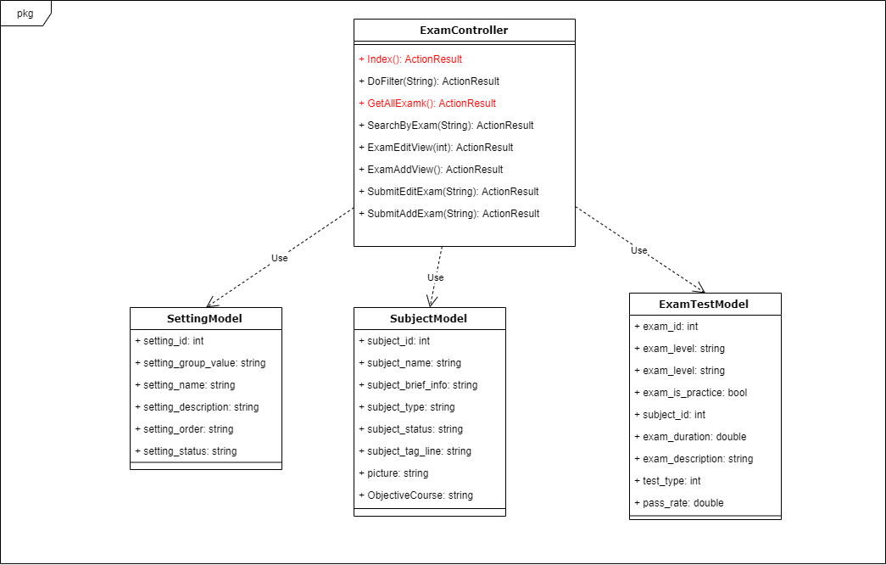

Figure 4-4: Exam View class diagram

###### Sequence Diagram

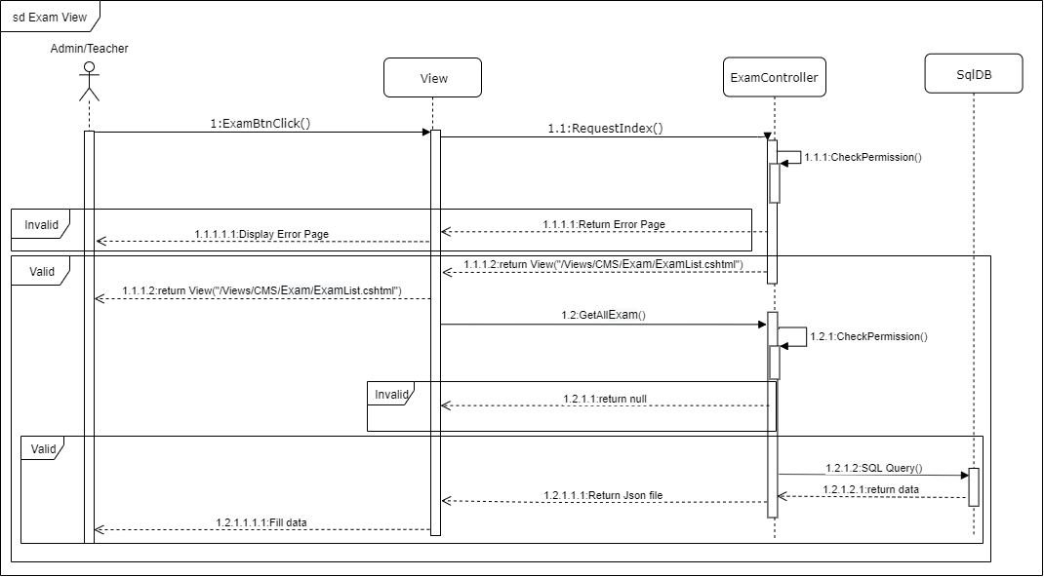

Figure 4-5: Exam View sequence diagram

##### Exam Adding

###### Screen Design

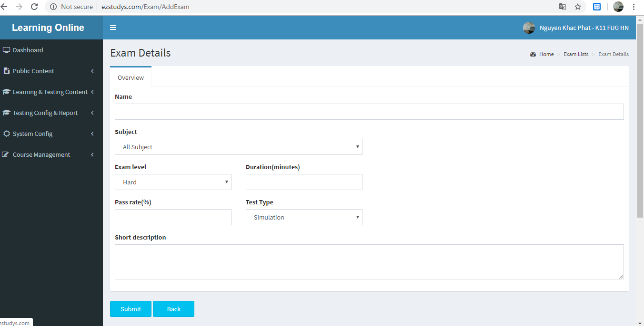

Figure 4-3: Exam Adding screen design

###### Class Diagram

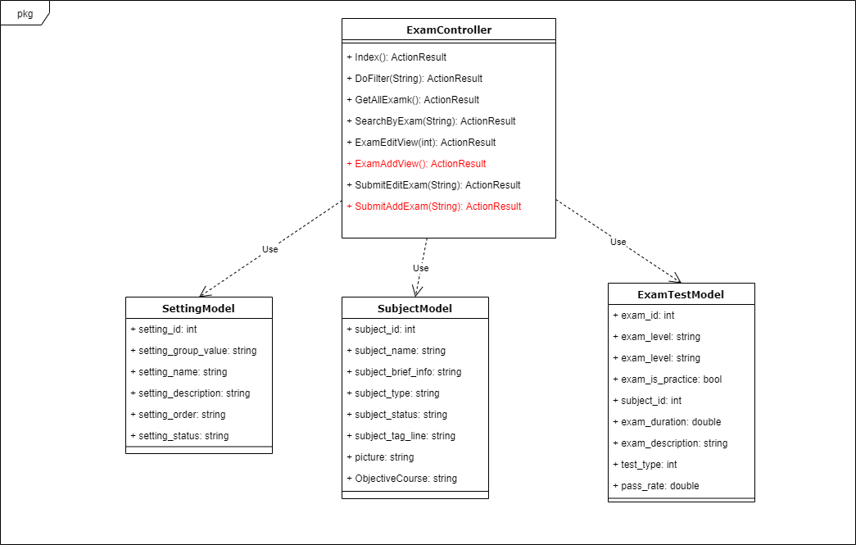

Figure 4-4: Exam Adding class diagram

###### Sequence Diagram

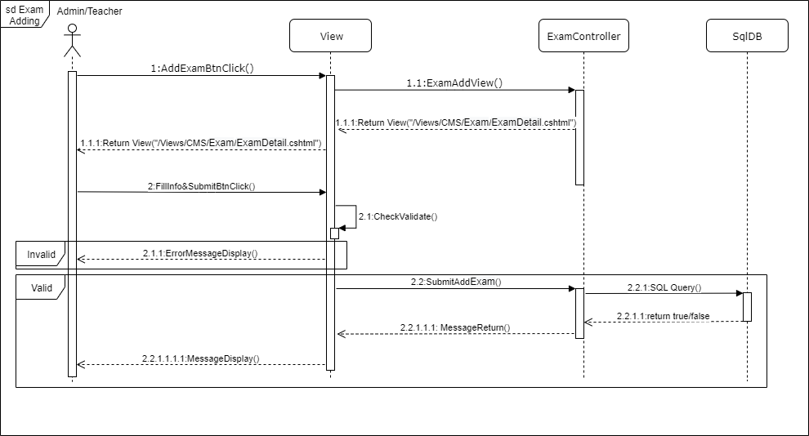

Figure 4-5: Exam Adding sequence diagram

##### Test View

###### Screen Design

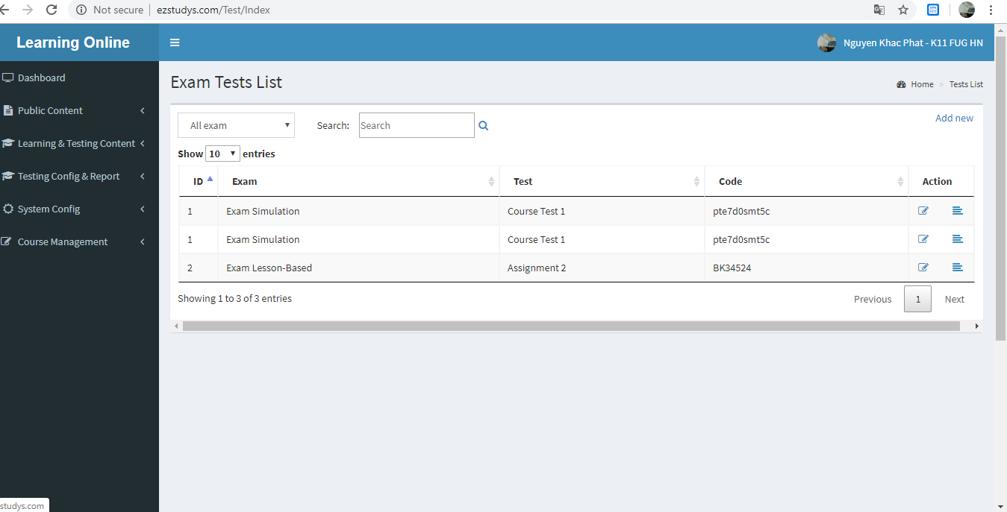

Figure 4-3: Test View screen design

###### Class Diagram

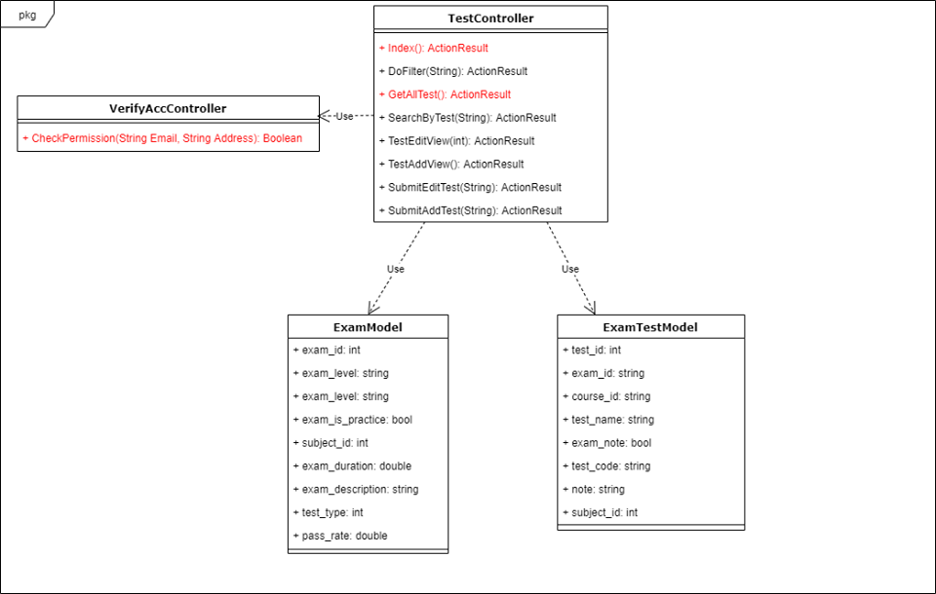

Figure 4-4: Test View class diagram

###### Sequence Diagram

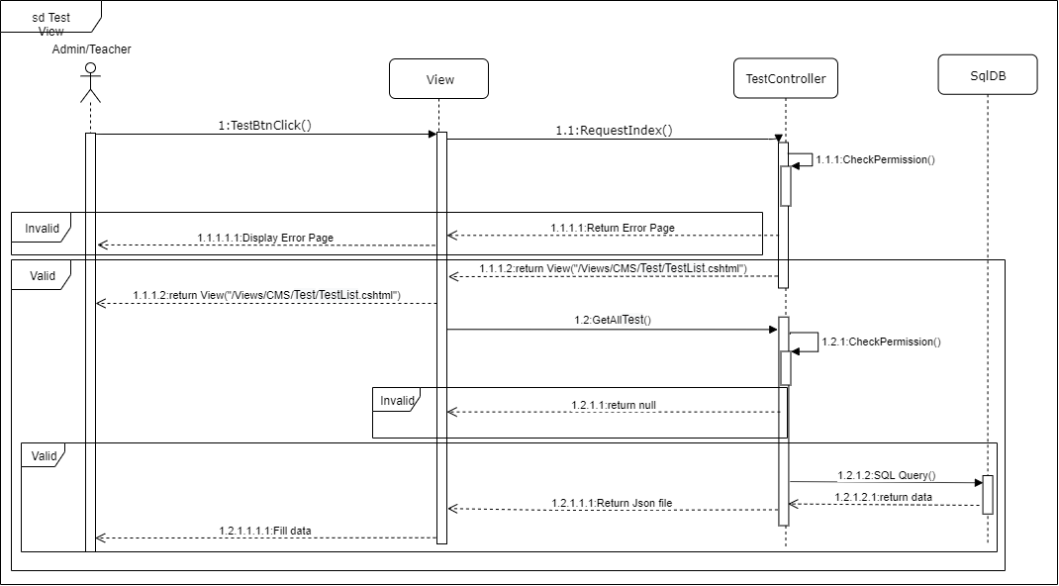

Figure 4-5: Test View sequence diagram

##### Test Adding

###### Screen Design

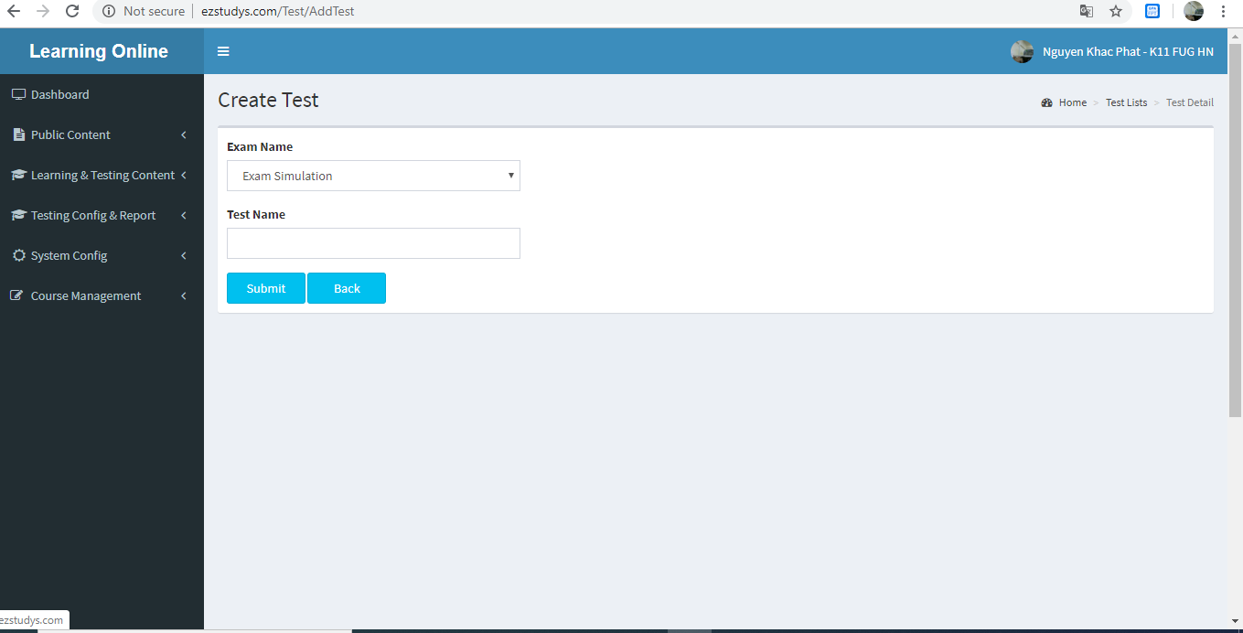

Figure 4-3: Test Adding screen design

###### Class Diagram

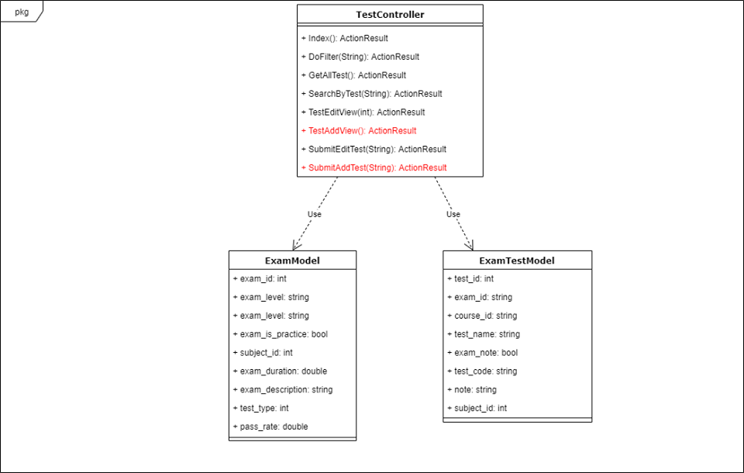

Figure 4-4: Test Adding class diagram

###### Sequence Diagram

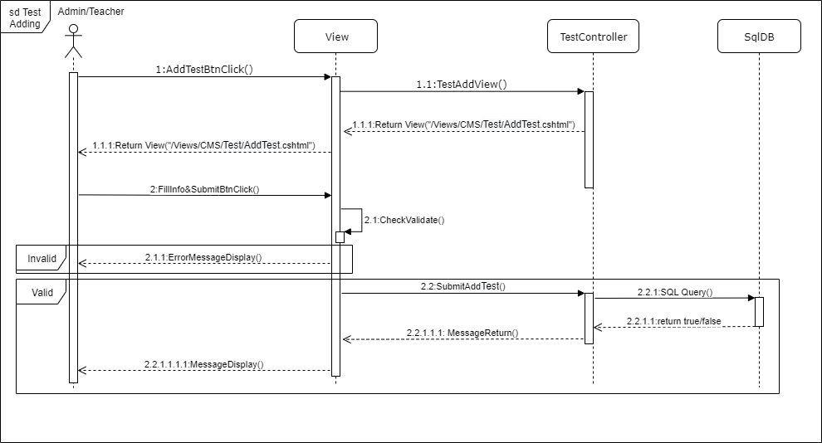

Figure 4-5: Test Adding sequence diagram

##### Test Editing

###### Screen Design

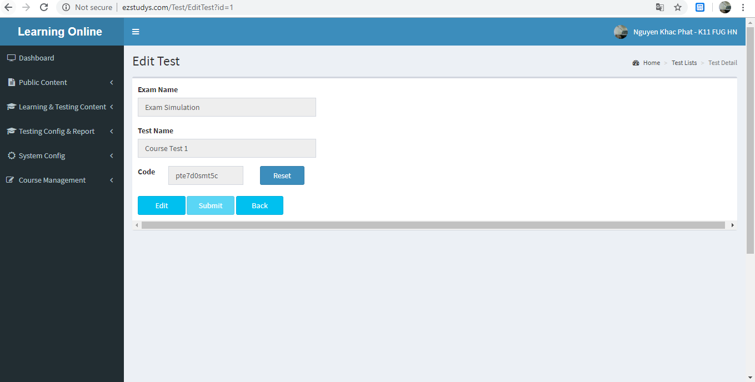

Figure 4-3: Test Editing screen design

###### Class Diagram

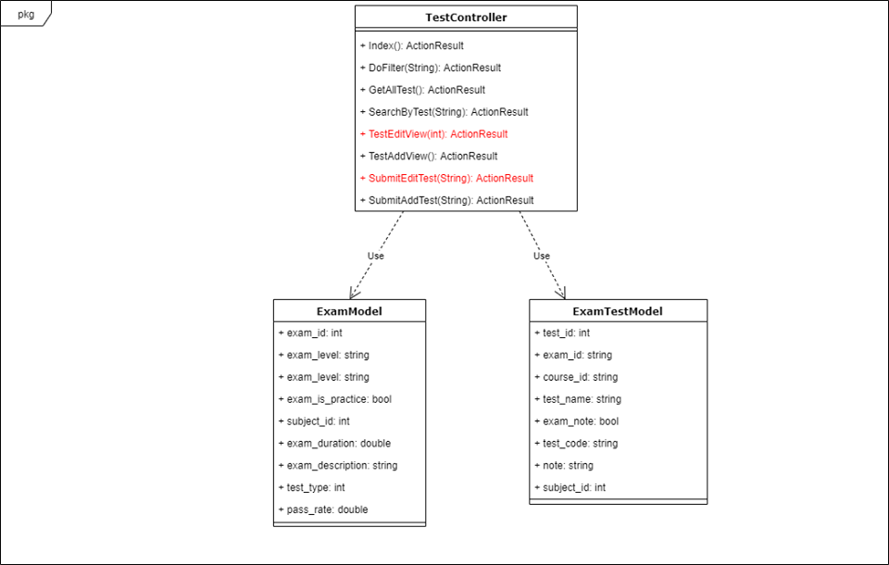

Figure 4-4: Test Editing class diagram

###### Sequence Diagram

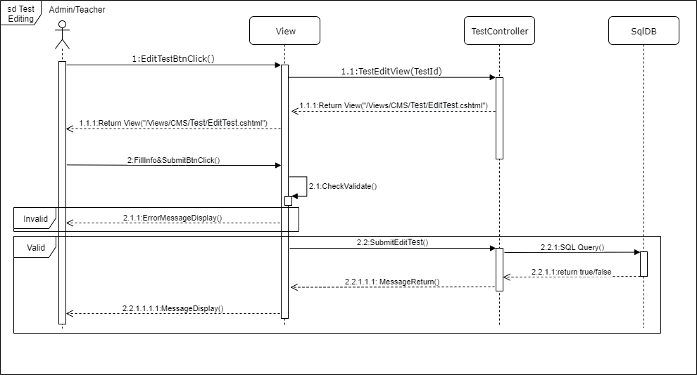

Figure 4-5: Test Editing sequence diagram

##### Exam Test Result View

###### Screen Design

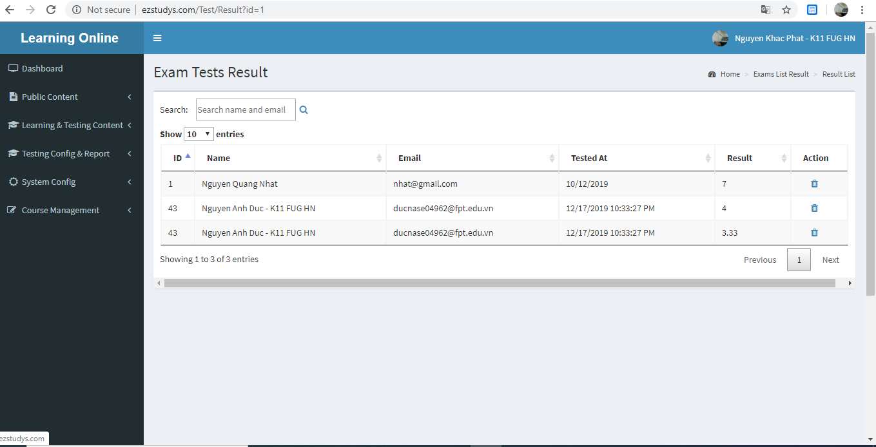

Figure 4-3: Exam Test Result View screen design

###### Class Diagram

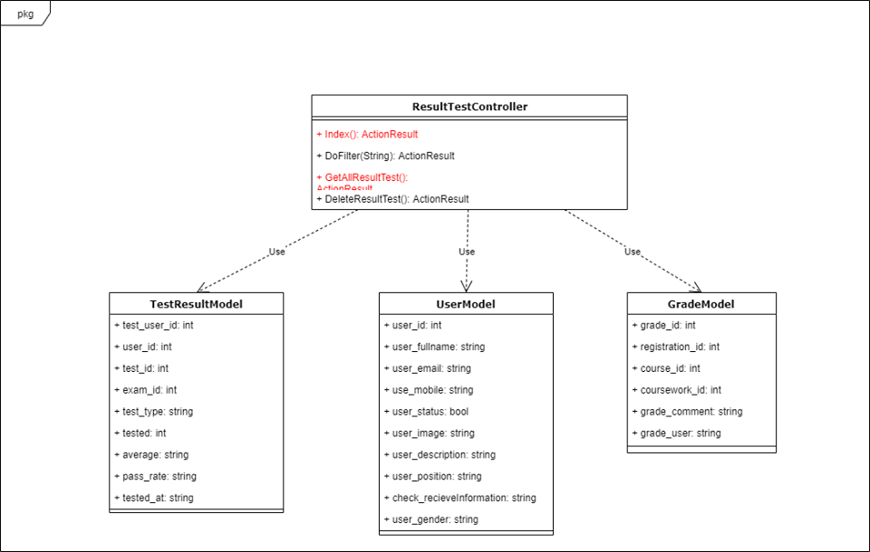

Figure 4-4: Exam Test Result View class diagram

###### Sequence Diagram

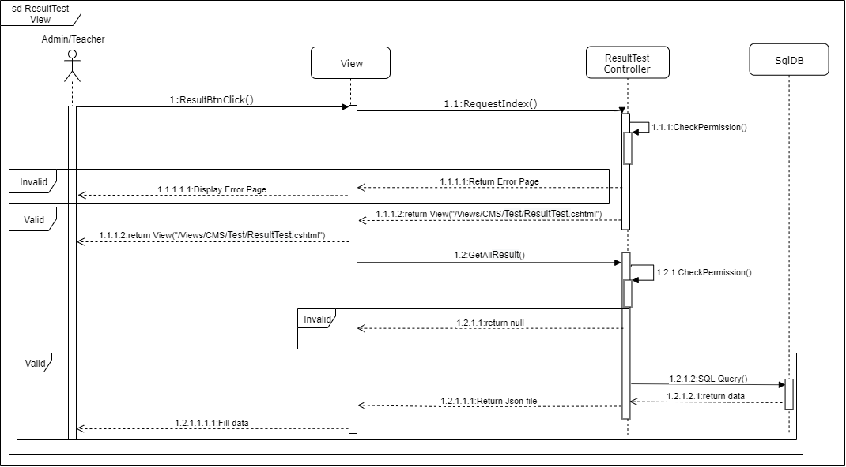

Figure 4-5: Exam Test Result View sequence diagram

##### Exam Test Result Delete

###### Screen Design

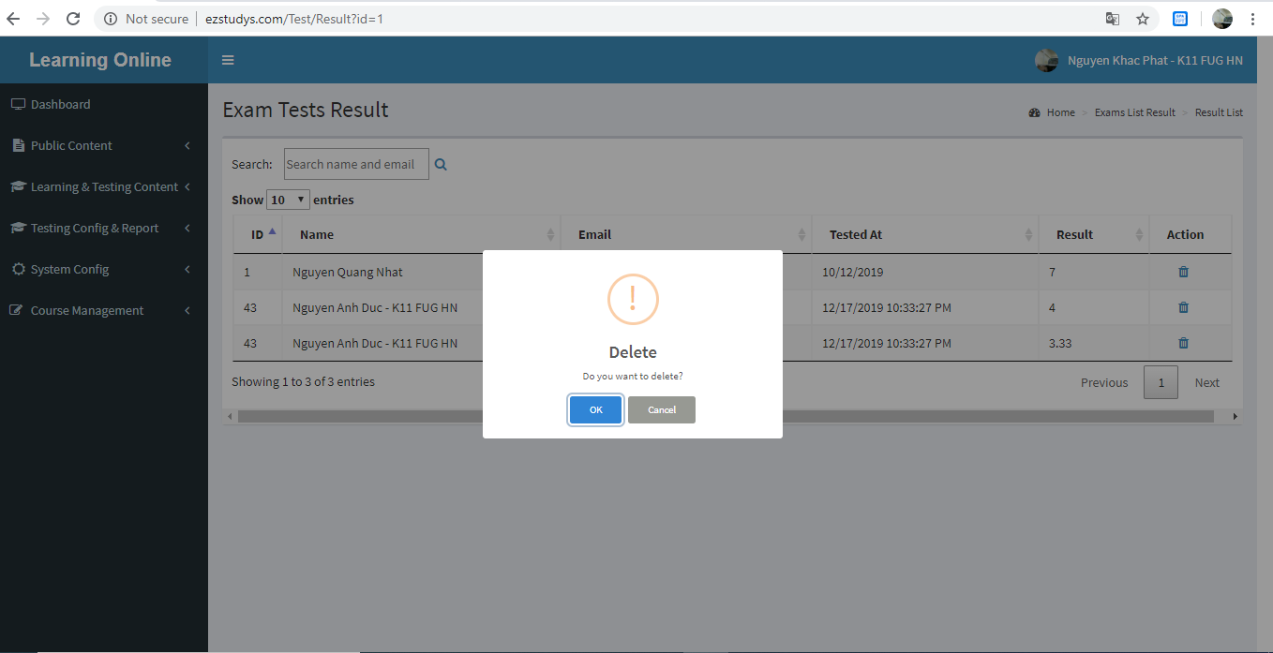

Figure 4-3: Exam Test Result Delete screen design

###### Class Diagram

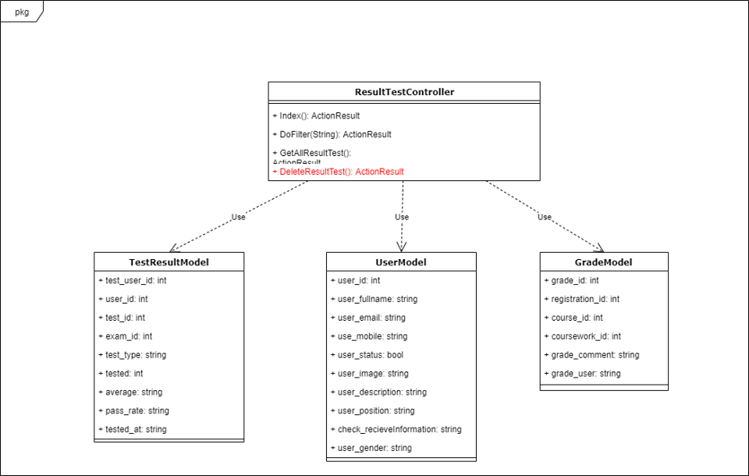

Figure 4-4: Exam Test Result Delete class diagram

###### Sequence Diagram

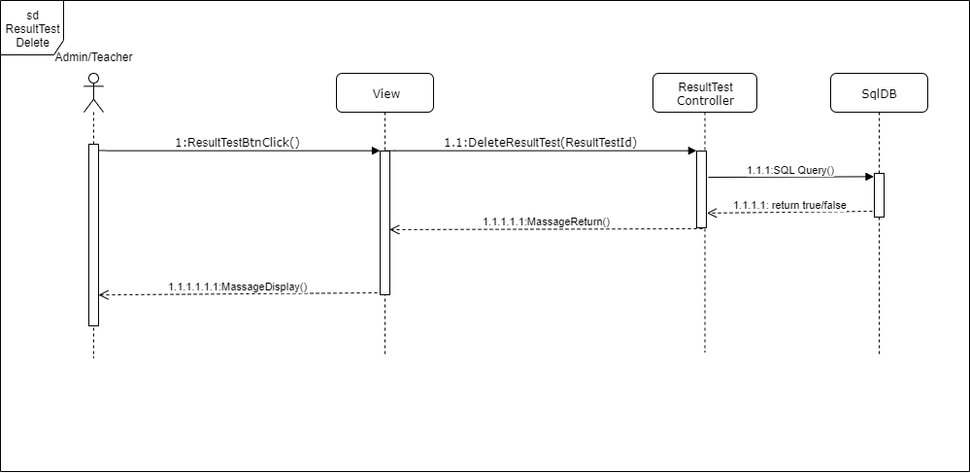

Figure 4-5: Exam Test Result Delete sequence diagram

##### Practice Result View

###### Screen Design

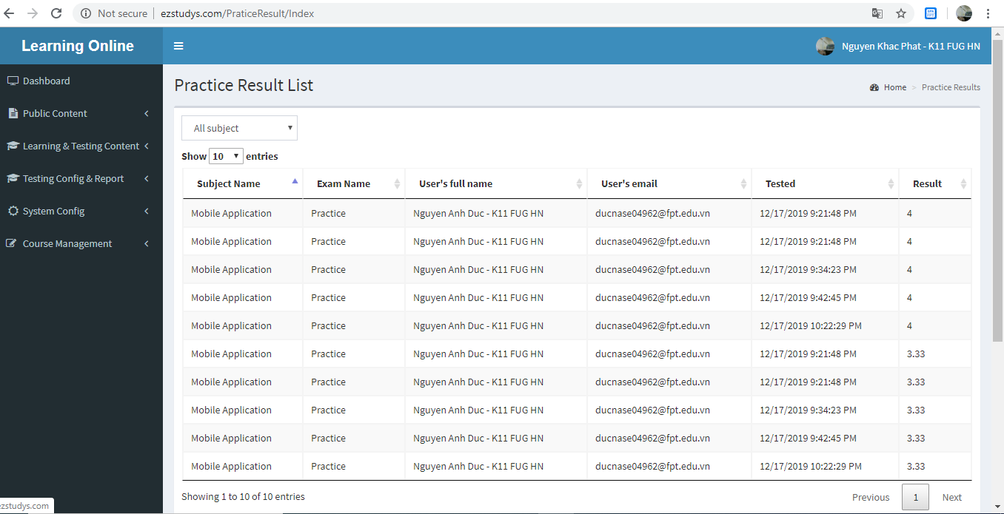

Figure 4-3: Practice Result View screen design

###### Class Diagram

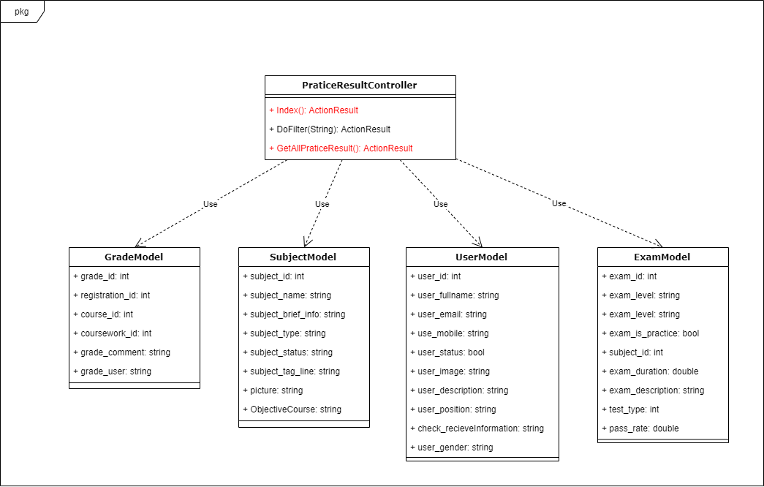

Figure 4-4: Practice Result View class diagram

###### Sequence Diagram

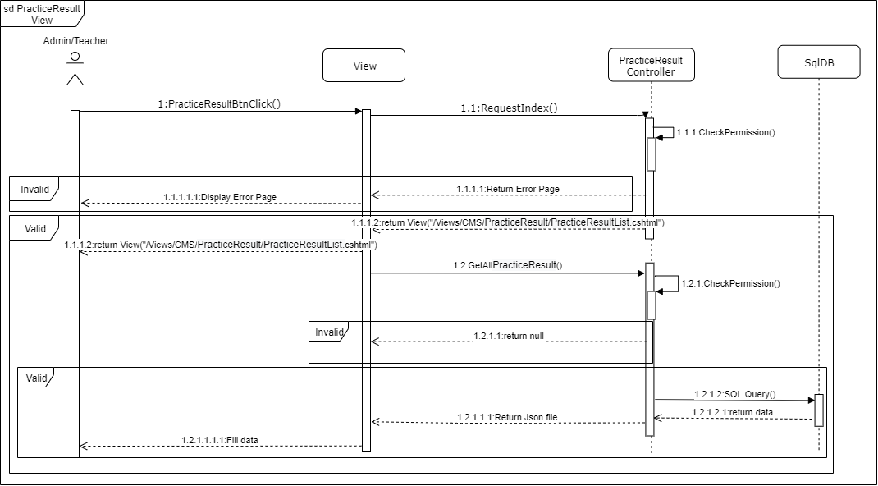

Figure 4-5: Practice Result View sequence diagram

##### Setting View

###### Screen Design

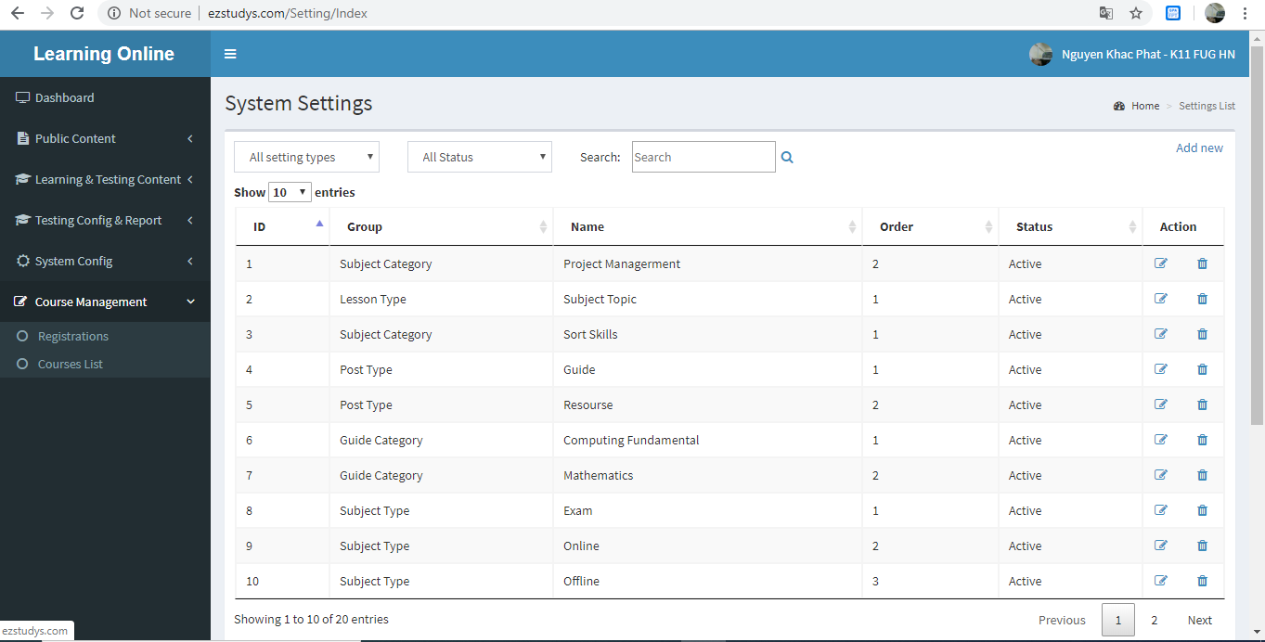

Figure 4-3: Setting View screen design

###### Class Diagram



Figure 4-4: Setting View class diagram

###### Sequence Diagram

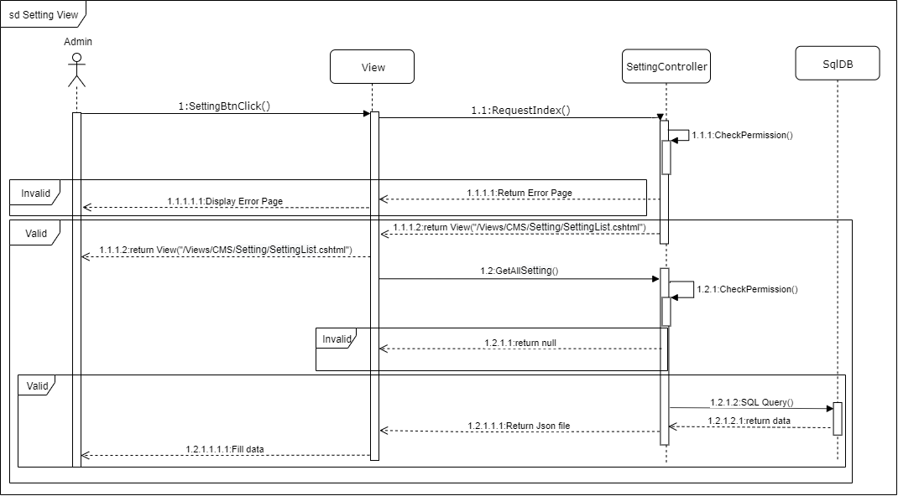

Figure 4-5: Setting View sequence diagram

##### Setting Adding

###### Screen Design

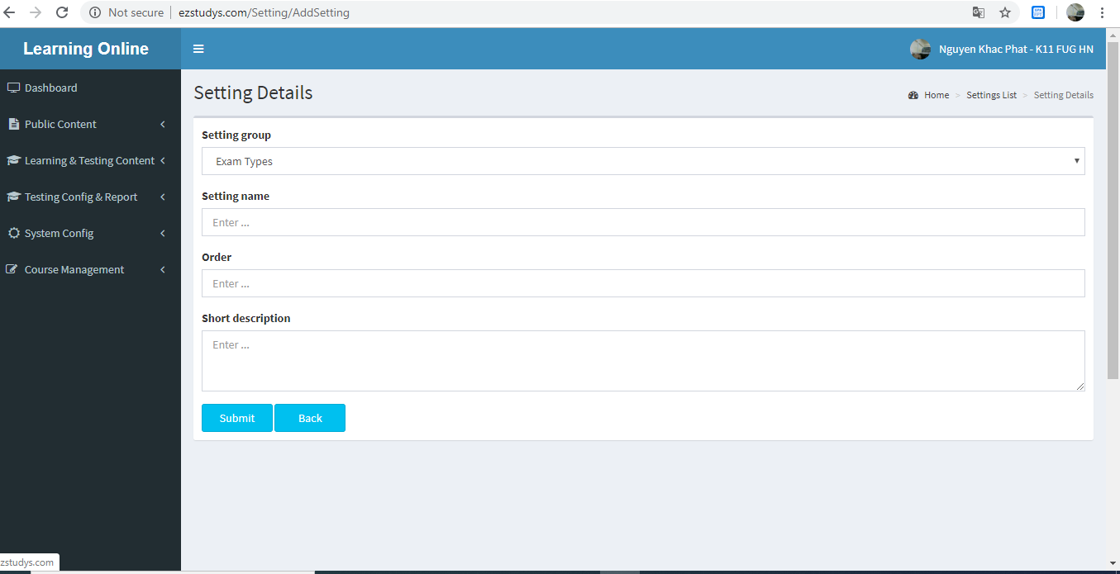

Figure 4-3: Setting Adding screen design

###### Class Diagram



Figure 4-4: Setting Adding class diagram

###### Sequence Diagram

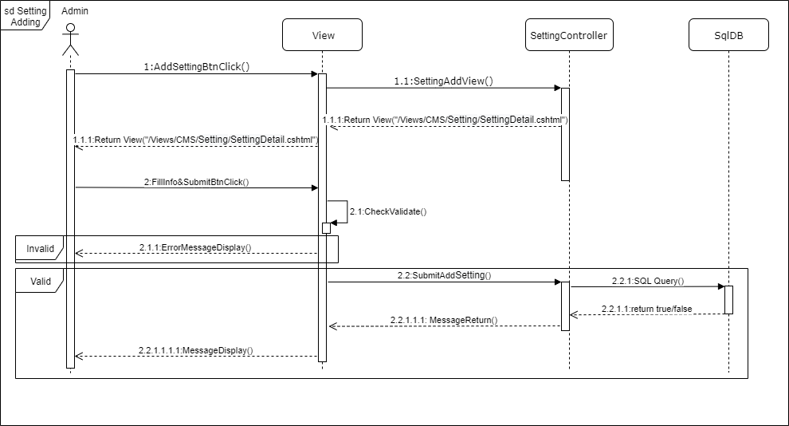

Figure 4-5: Setting Adding sequence diagram

##### Setting Editing

###### Screen Design

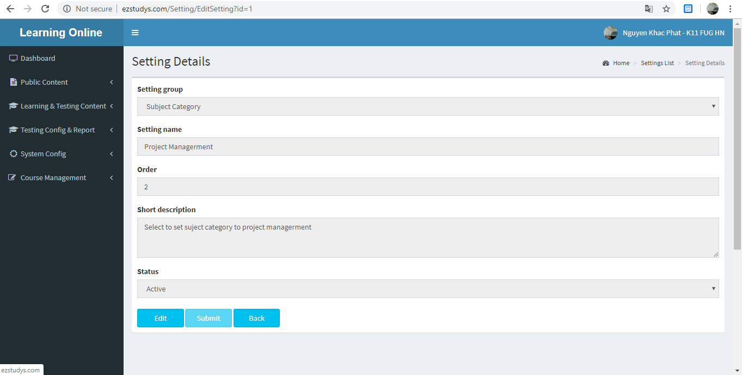

Figure 4-3: Setting Editing screen design

###### Class Diagram

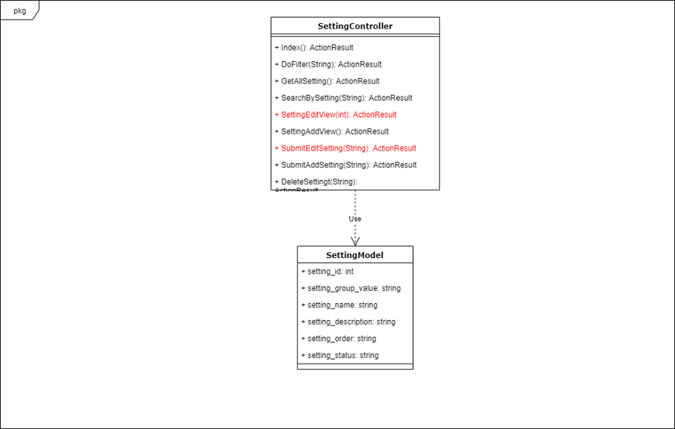

Figure 4-4: Setting Editing class diagram

###### Sequence Diagram

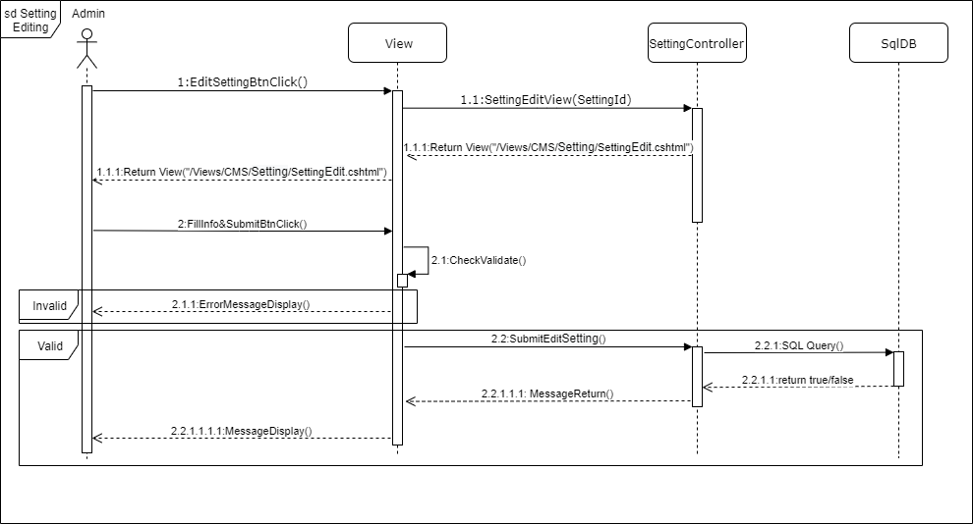

Figure 4-5: Setting Editing sequence diagram

##### Setting Delete

###### Screen Design

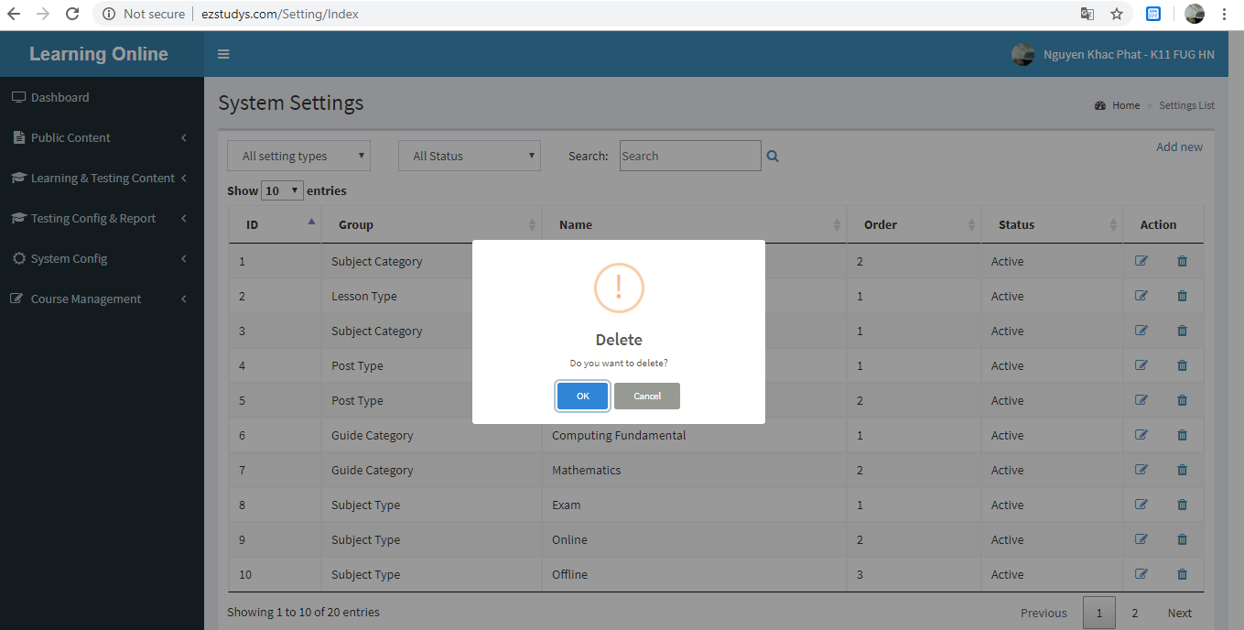

Figure 4-3: Setting Delete screen design

###### Class Diagram



Figure 4-4: Setting Delete class diagram

###### Sequence Diagram

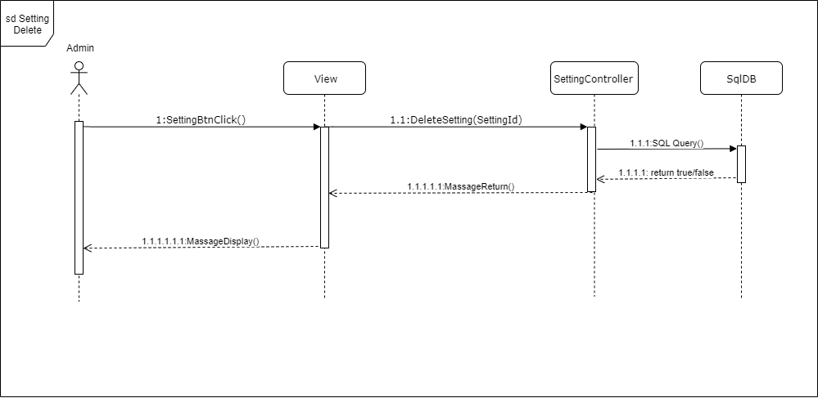

Figure 4-5: Setting Delete sequence diagram

##### Menu View

###### Screen Design

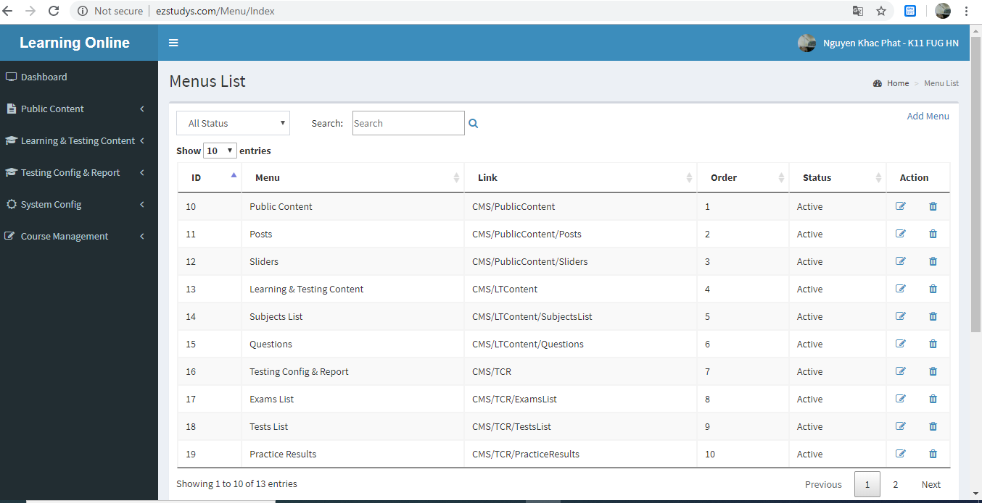

Figure 4-3: Menu View screen design

###### Class Diagram

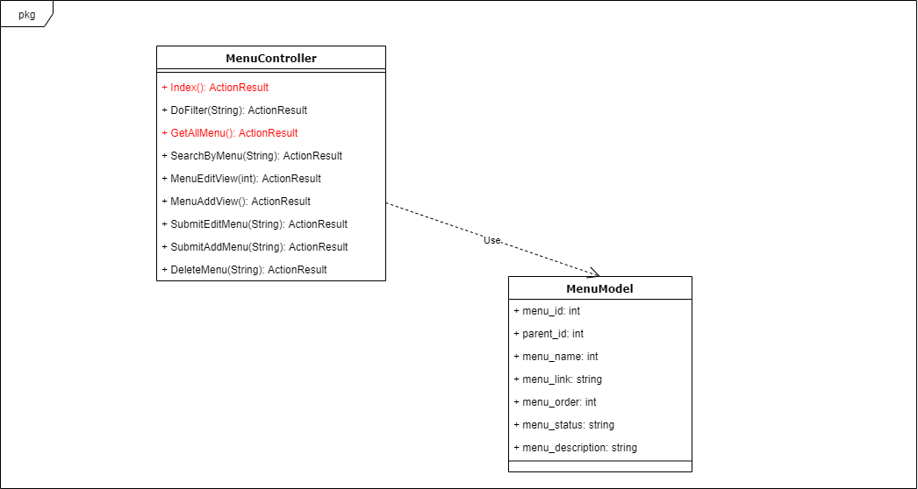

Figure 4-4: Menu View class diagram

###### Sequence Diagram

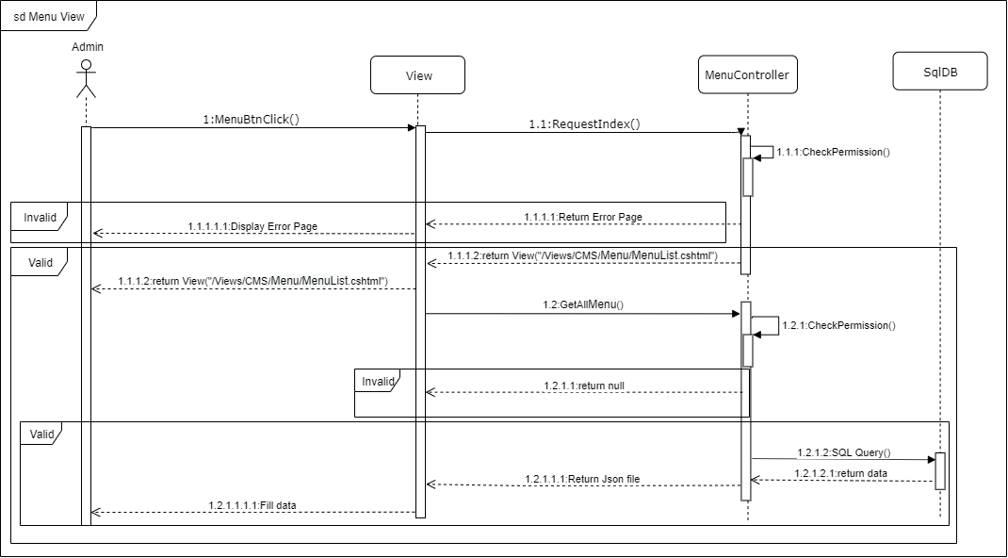

Figure 4-5: Menu View sequence diagram

##### Menu Adding

###### Screen Design

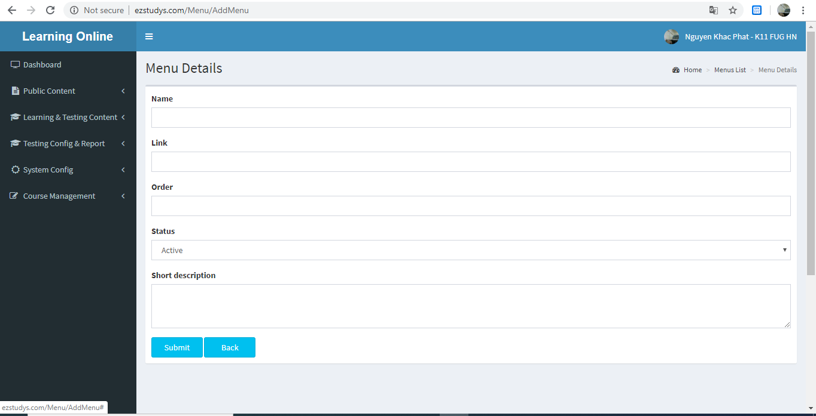

Figure 4-3: Menu Adding screen design

###### Class Diagram

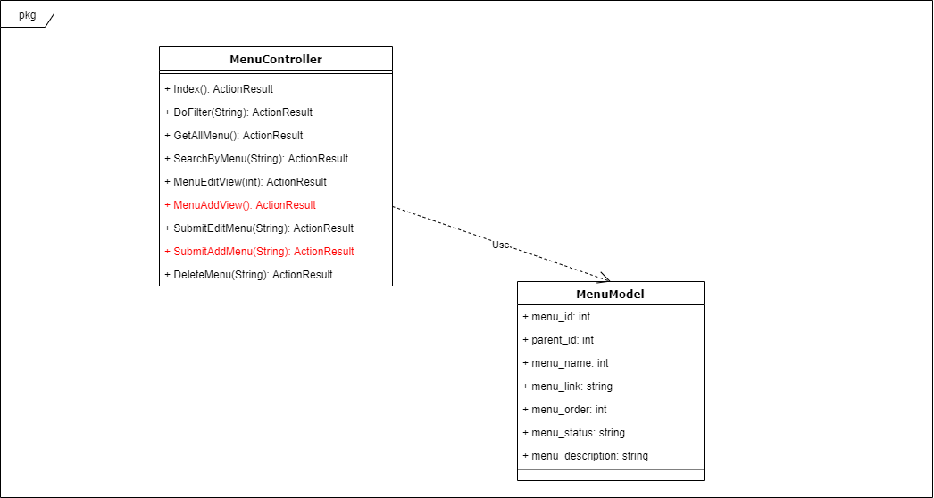

Figure 4-4: Menu Adding class diagram

###### Sequence Diagram

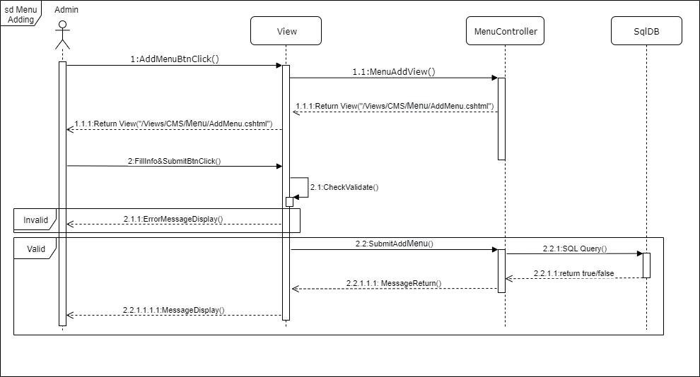

Figure 4-5: Menu Adding sequence diagram

##### Menu Editing

###### Screen Design

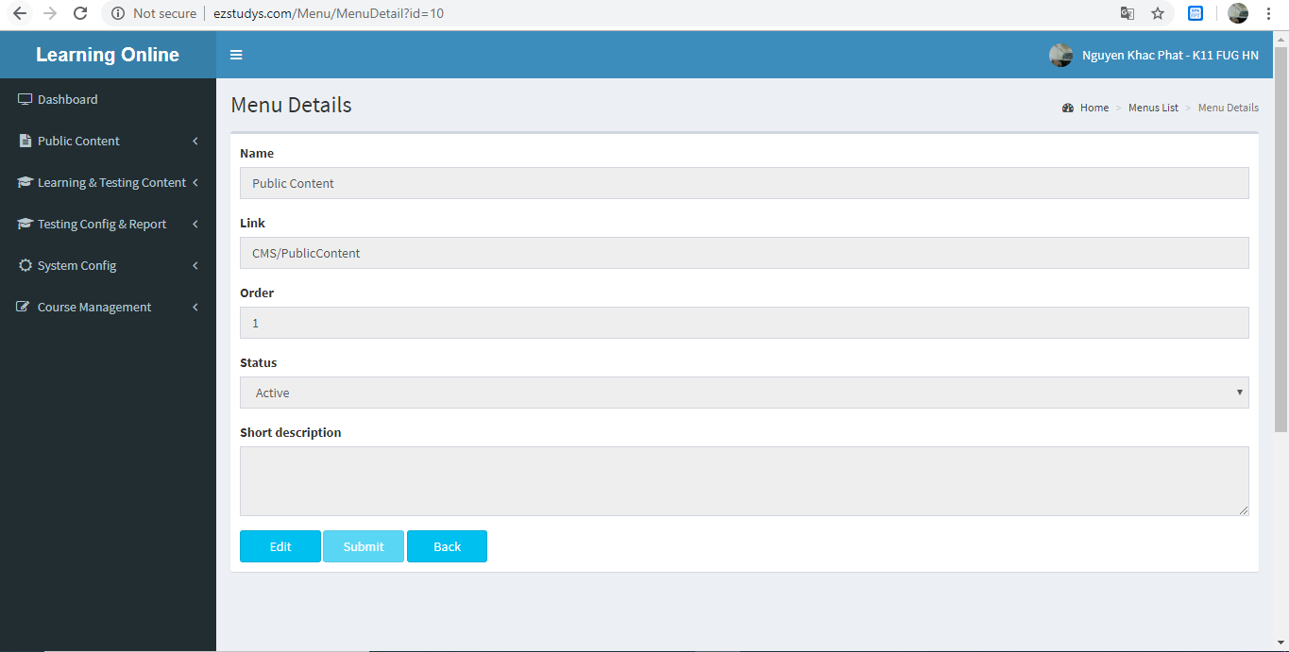

Figure 4-3: Menu Editing screen design

###### Class Diagram

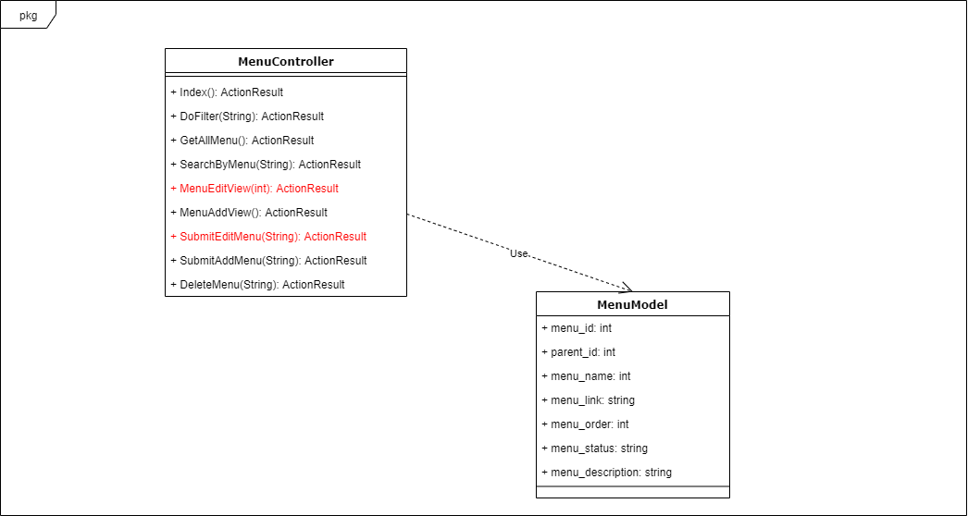

Figure 4-4: Menu Editing class diagram

###### Sequence Diagram

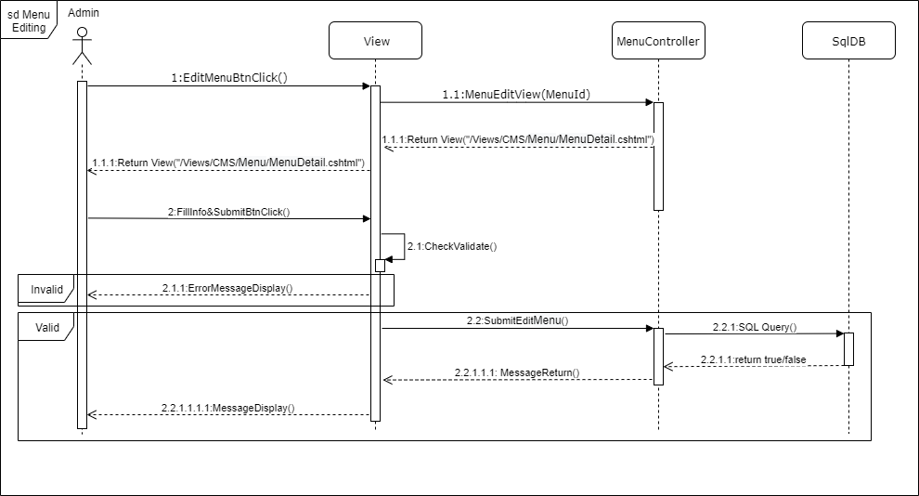

Figure 4-5: Menu Editing sequence diagram

##### Menu Delete

###### Screen Design

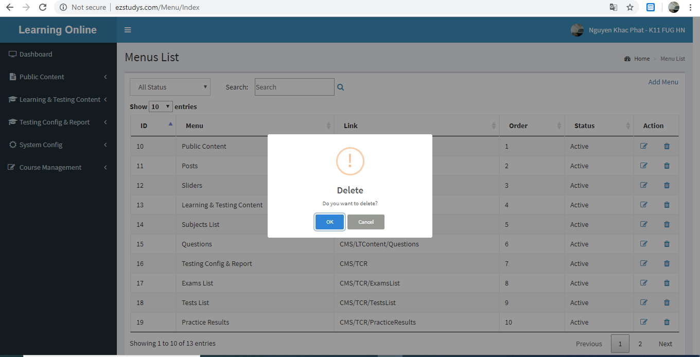

Figure 4-3: Menu Delete screen design

###### Class Diagram

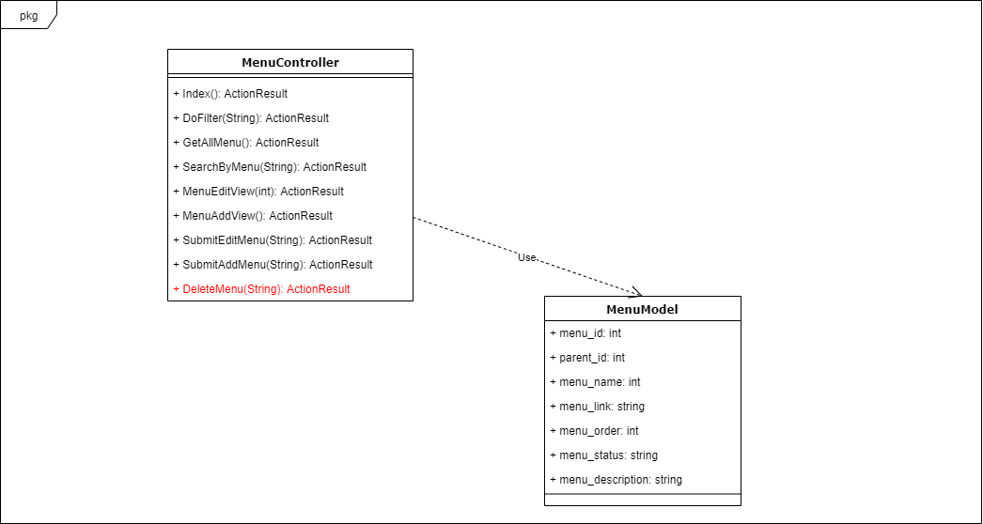

Figure 4-4: Menu Delete class diagram

###### Sequence Diagram

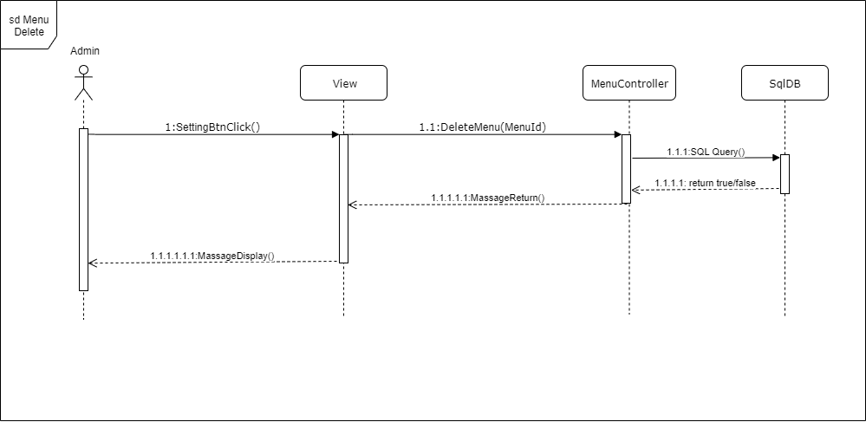

Figure 4-5: Menu Delete sequence diagram

##### Role Menu

###### Screen Design

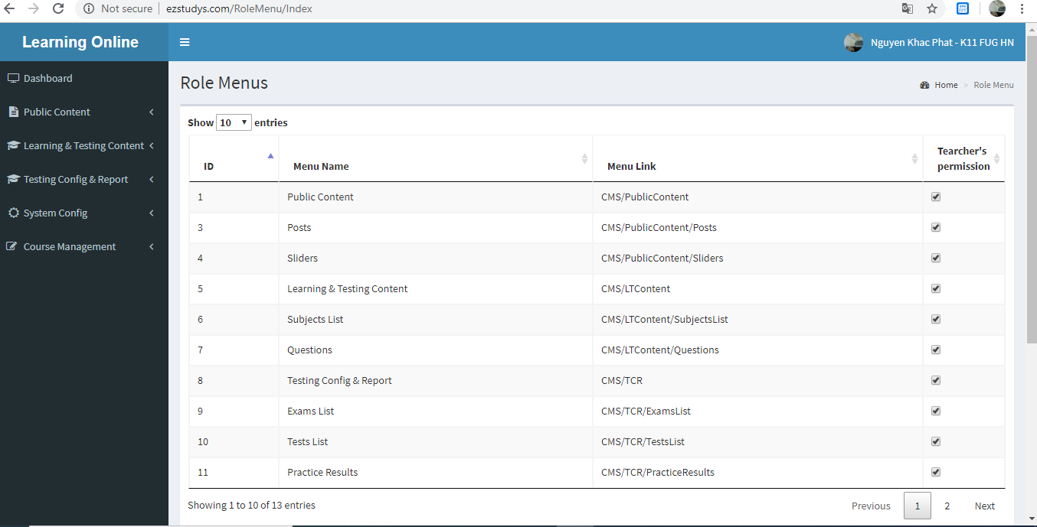

Figure 4-3: Role Menu screen design

###### Class Diagram



Figure 4-4: Role Menu class diagram

###### Sequence Diagram

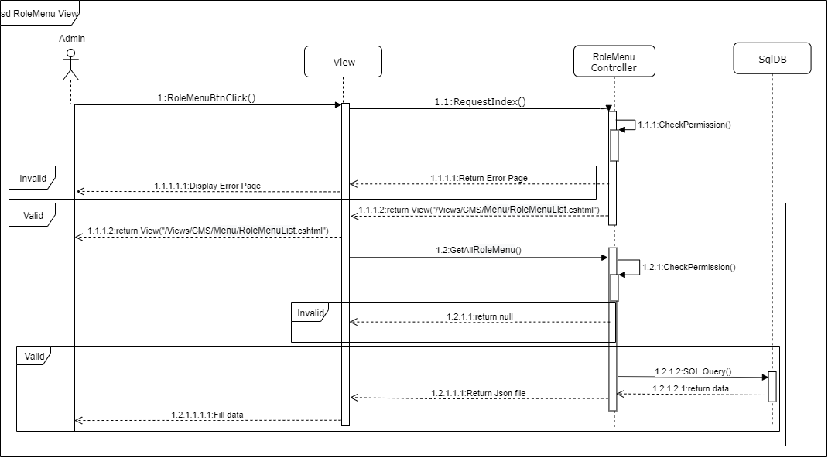

Figure 4-5: Role Menu sequence diagram

##### User Adding

###### Screen Design

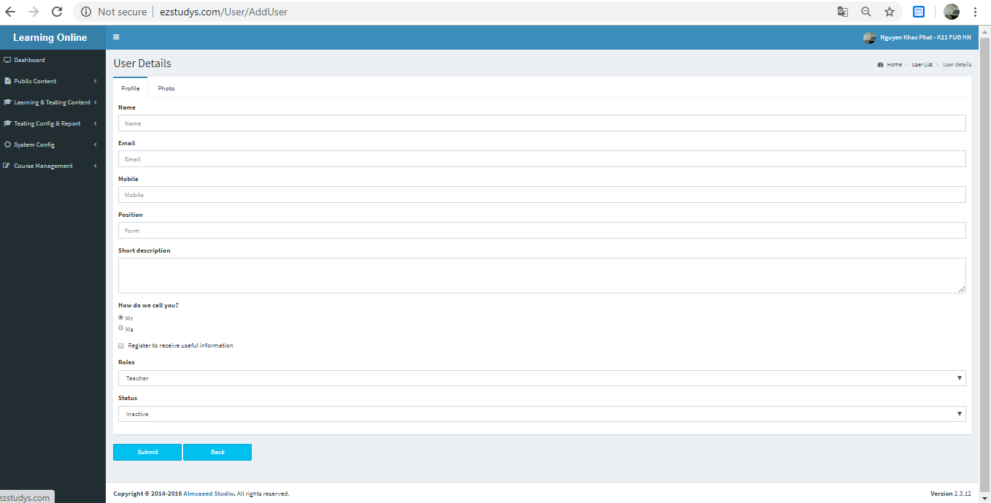

Figure 4-3: User Adding screen design

###### Class Diagram

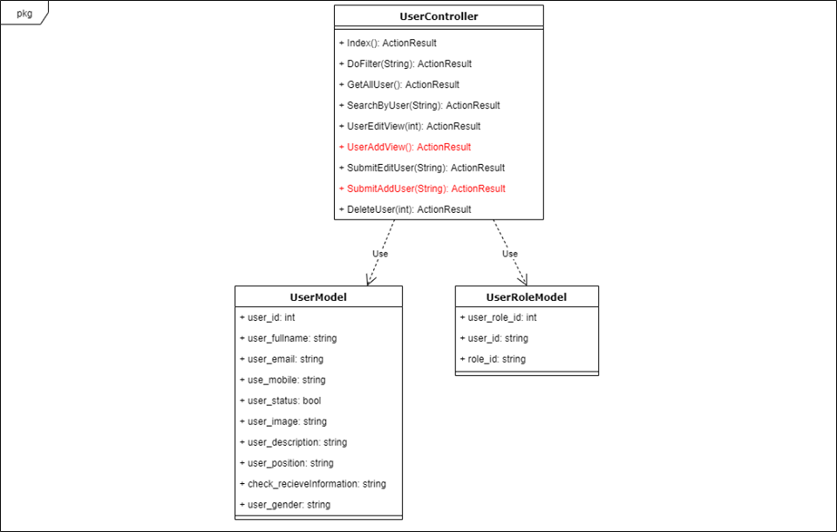

Figure 4-4: User Adding class diagram

###### Sequence Diagram

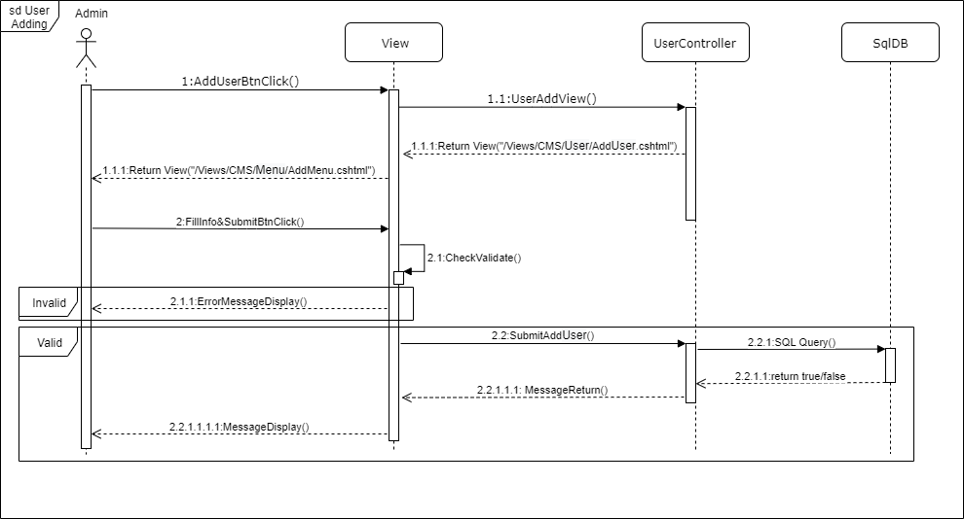

Figure 4-5: User Adding sequence diagram

##### User Editing

###### Screen Design

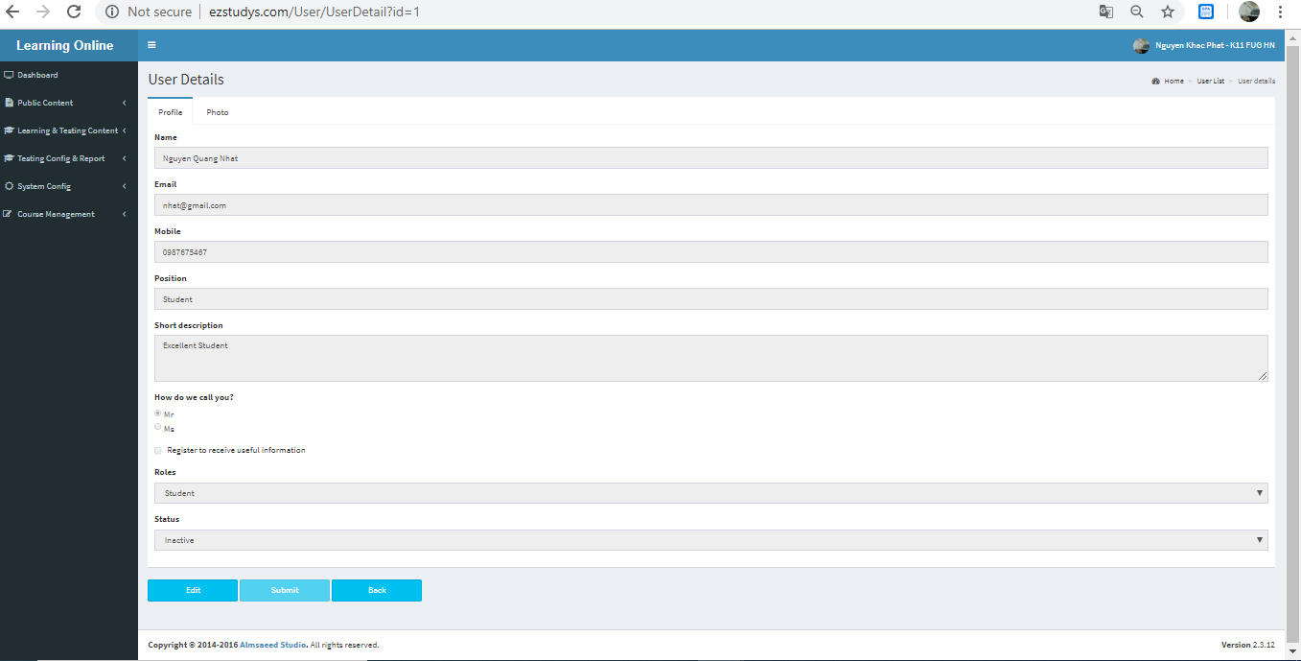

Figure 4-3: User Editing screen design

###### Class Diagram

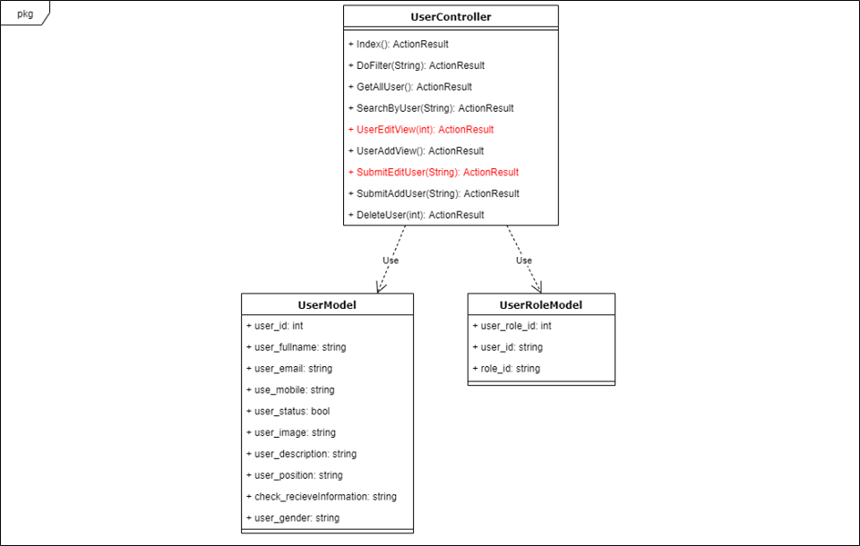

Figure 4-4: User Editing class diagram

###### Sequence Diagram

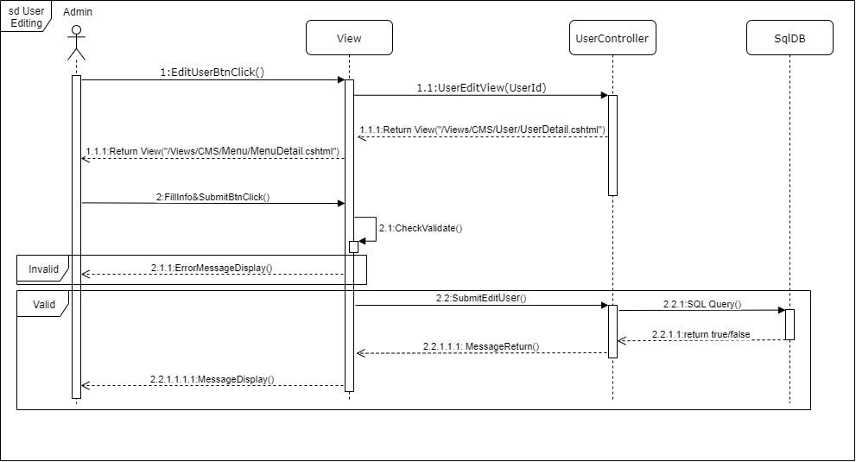

Figure 4-5: User Editing sequence diagram

##### User Delete

###### Screen Design

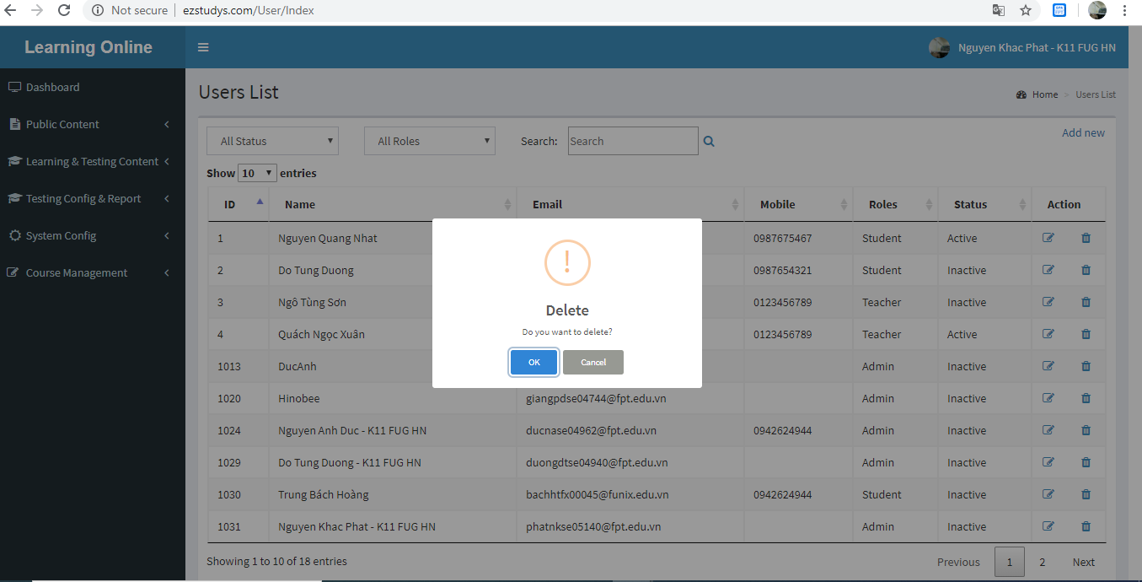

Figure 4-3: User Delete screen design

###### Class Diagram

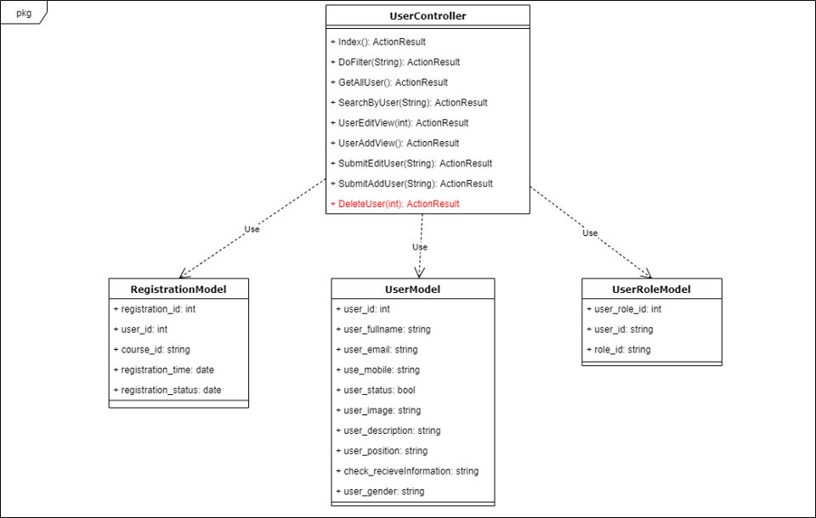

Figure 4-4: User Delete class diagram

###### Sequence Diagram

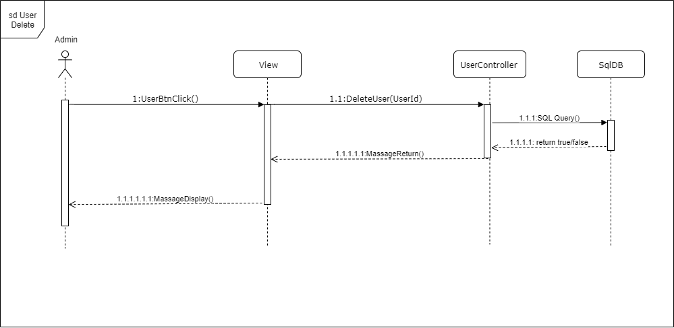

Figure 4-5: User Delete sequence diagram

##### User View

###### Screen Design

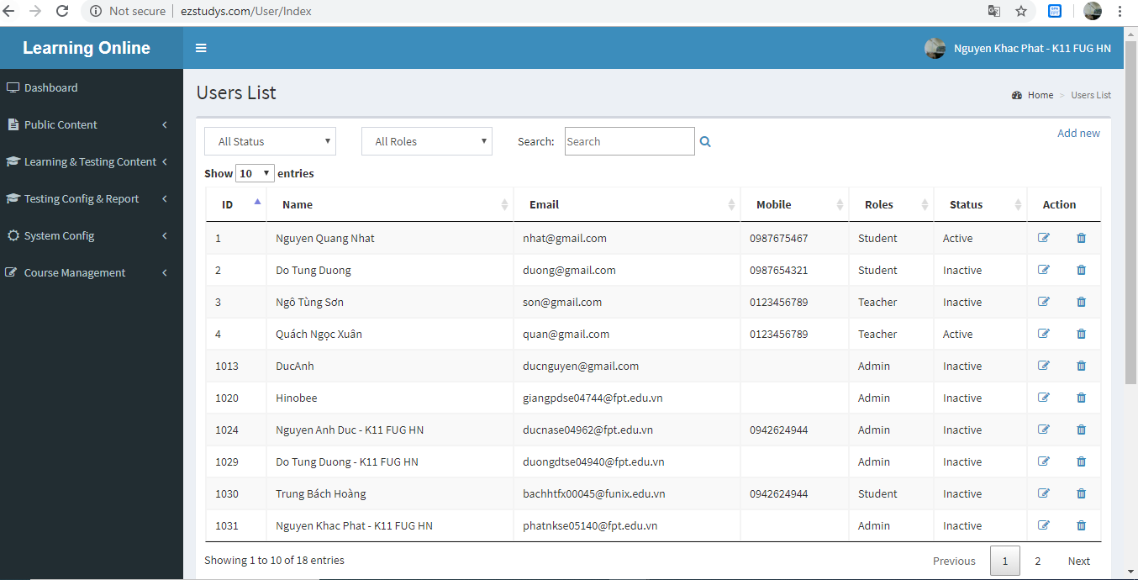

Figure 4-3: User View screen design

###### Class Diagram

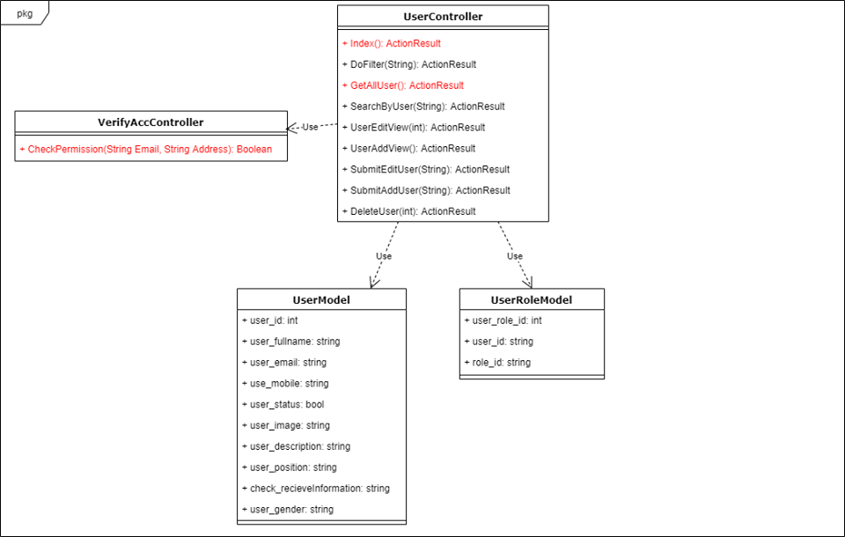

Figure 4-4: User View class diagram

###### Sequence Diagram

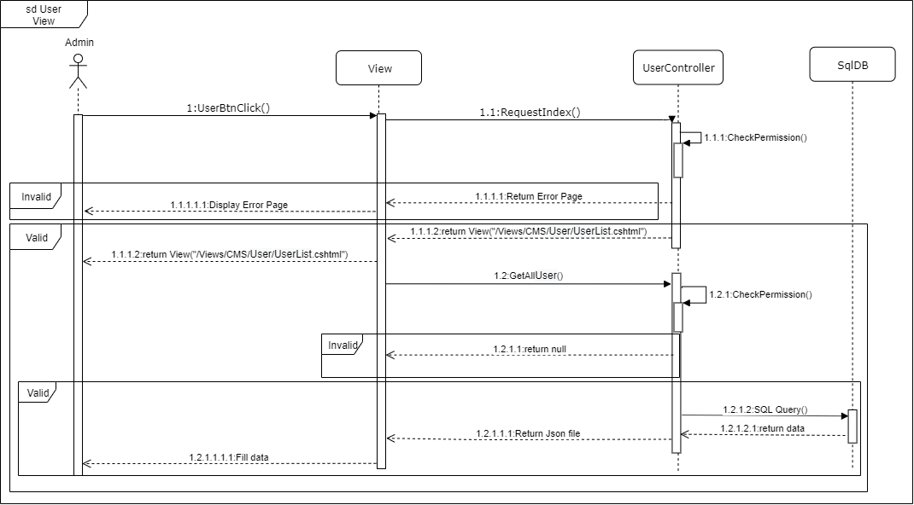

Figure 4-5: User View sequence diagram

##### Course View

###### Screen Design

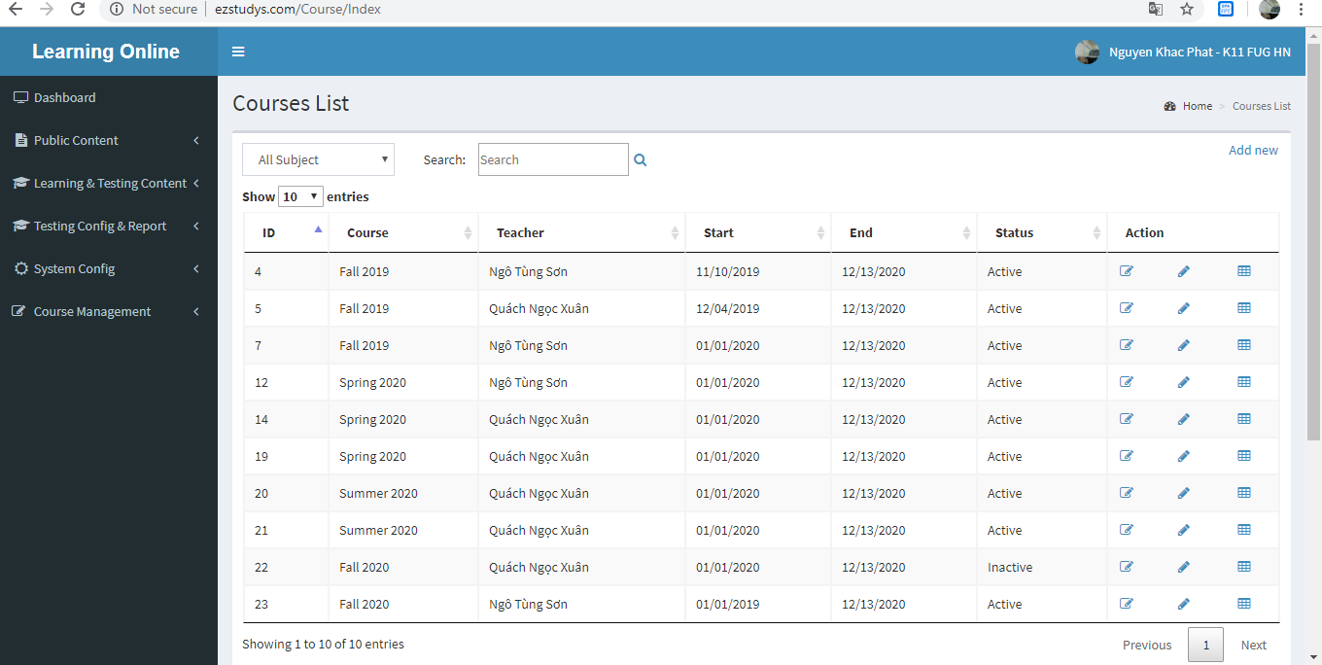

Figure 4-3: Course View screen design

###### Class Diagram

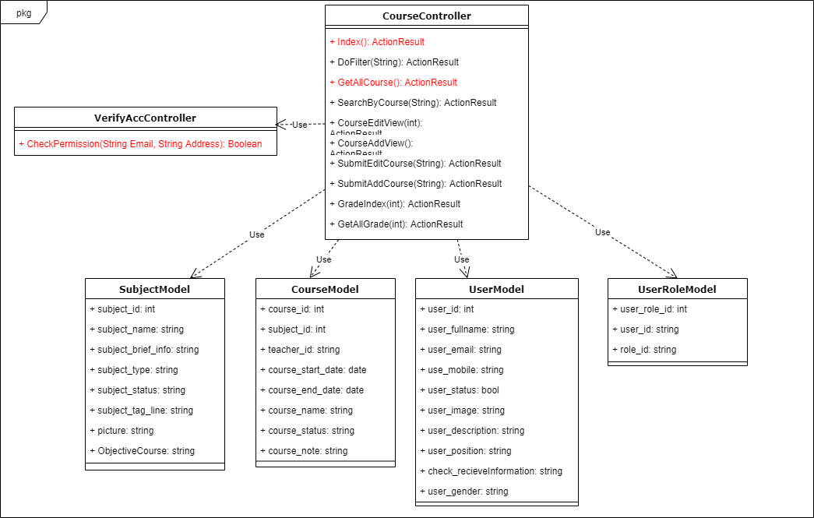

Figure 4-4: Course View class diagram

###### Sequence Diagram

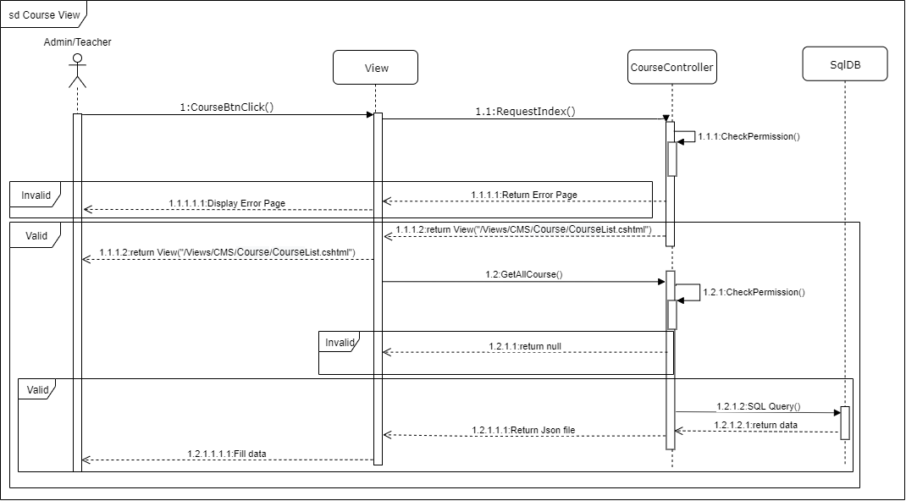

Figure 4-5: Course View sequence diagram

##### Course Adding

###### Screen Design

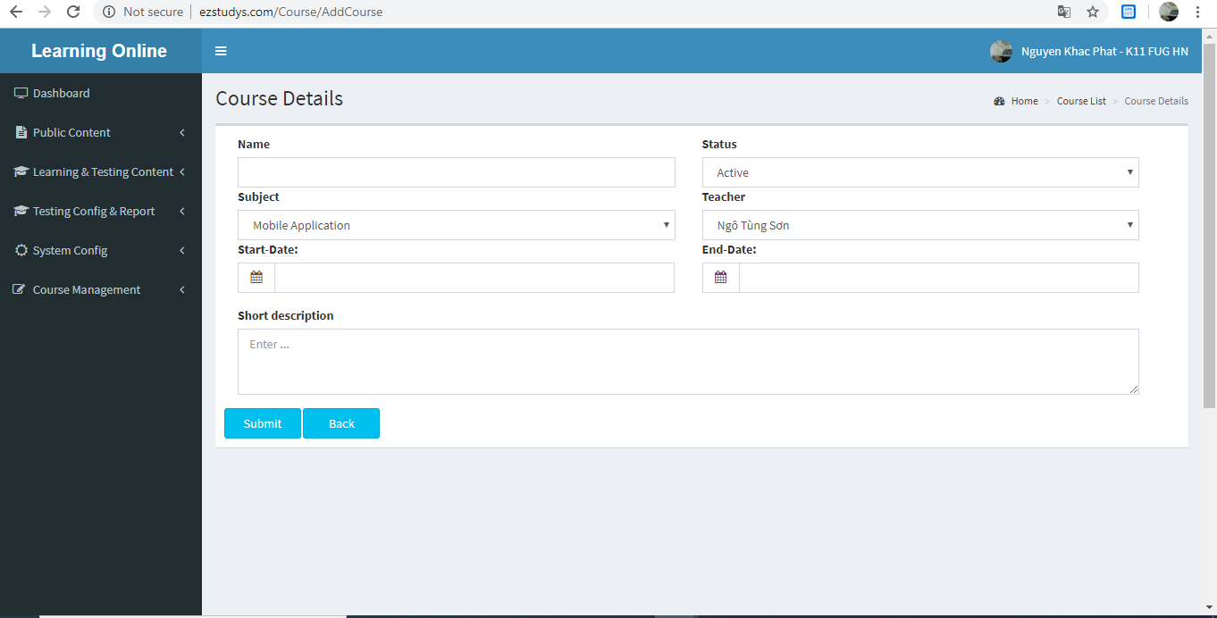

Figure 4-3: Course Adding screen design

###### Class Diagram

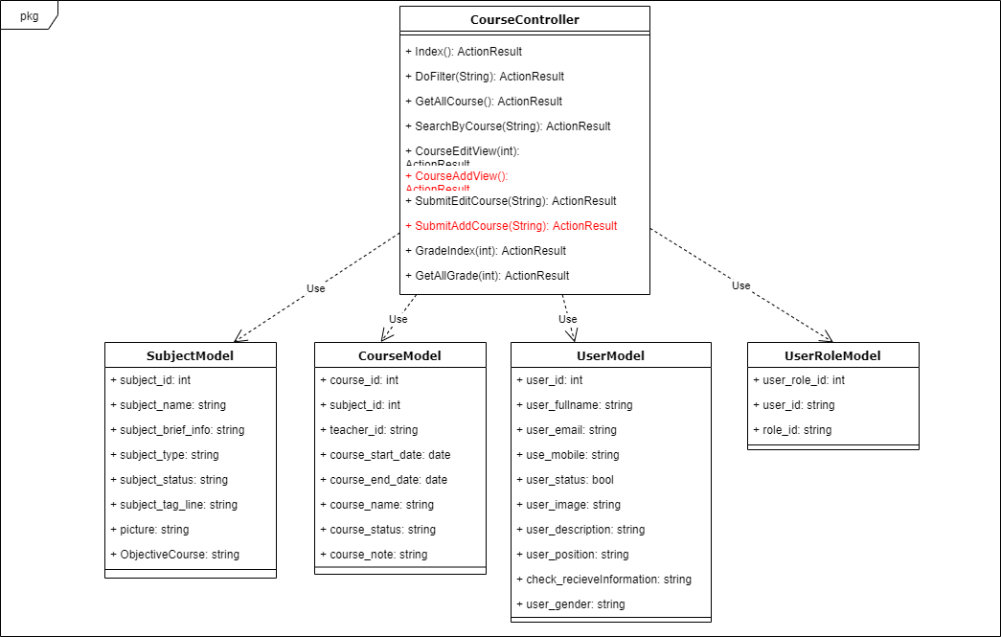

Figure 4-4: Course Adding class diagram

###### Sequence Diagram

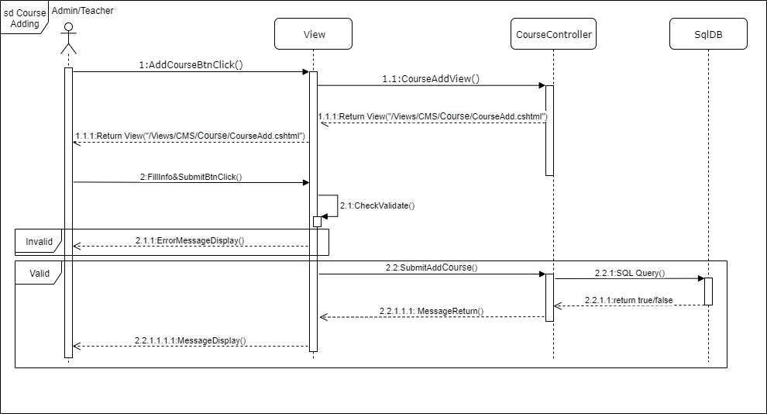

Figure 4-5: Course Adding sequence diagram

##### Course Editing

###### Screen Design

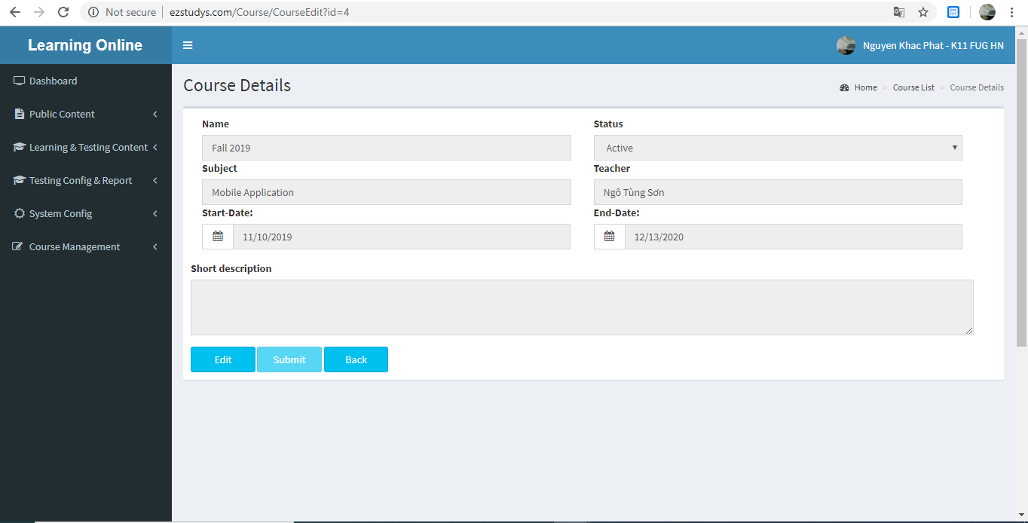

Figure 4-3: Course Editing screen design

###### Class Diagram

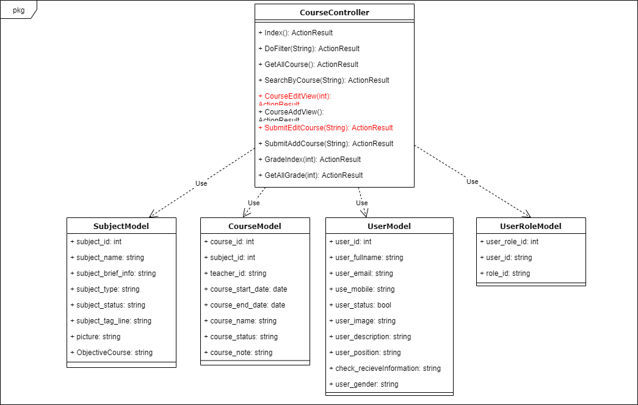

Figure 4-4: Course Editing class diagram

###### Sequence Diagram

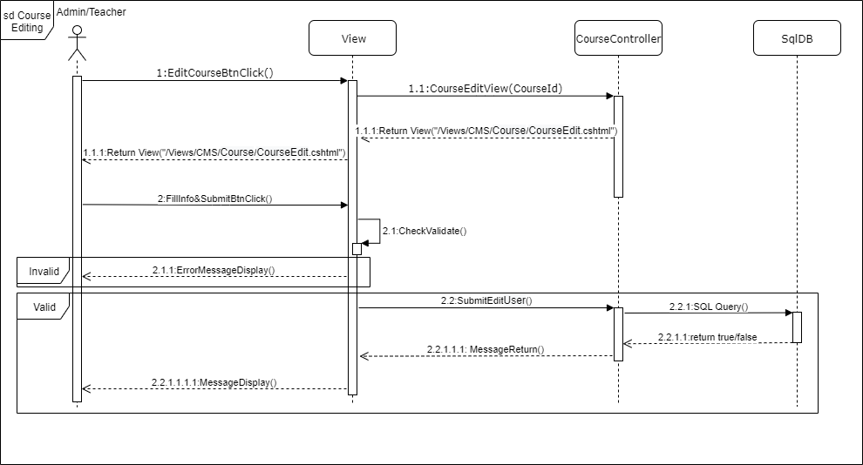

Figure 4-5: Course Editing sequence diagram

##### Course Registrations Update Status

###### Screen Design

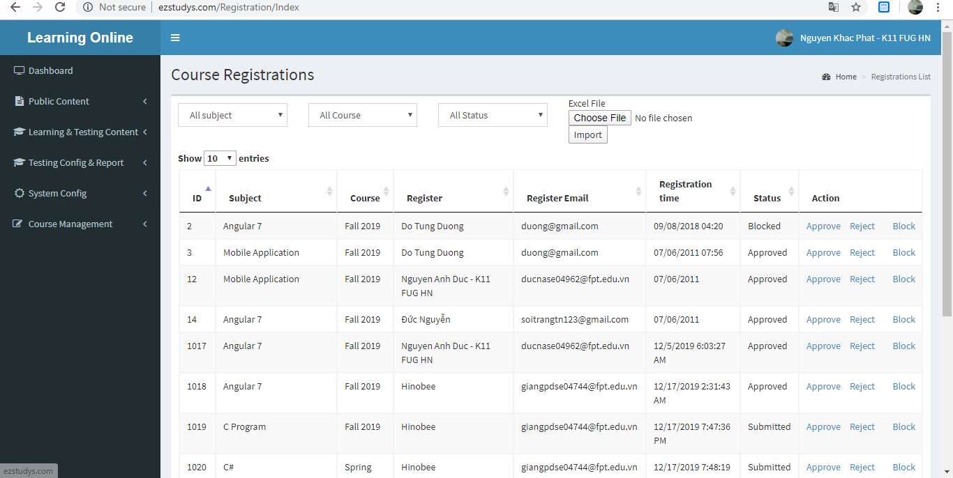

Figure 4-3: Course Registrations Update Status screen design

###### Class Diagram

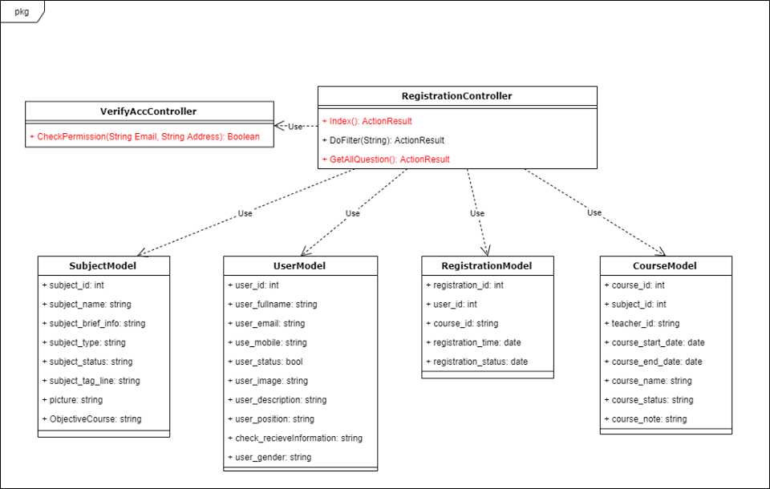

Figure 4-4: Course Registrations Update Status class diagram

###### Sequence Diagram



Figure 4-5: Course Registrations Update Status sequence diagram

##### Course Registrations Import

###### Screen Design



Figure 4-3: Course Registrations Import screen design

###### Class Diagram



Figure 4-4: Course Registrations Import class diagram

###### Sequence Diagram



Figure 4-5: Course Registrations Import sequence diagram

##### Coursework View

###### Screen Design

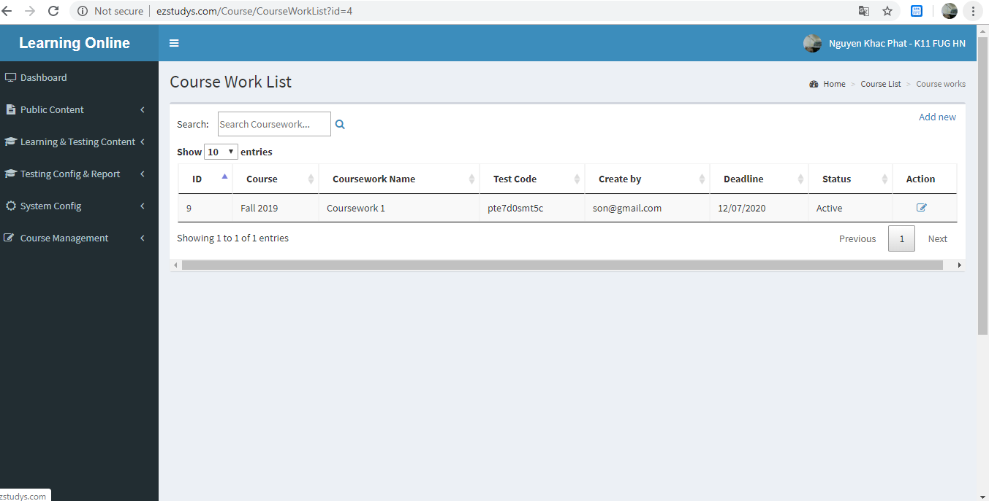

Figure 4-3: Coursework View screen design

###### Class Diagram

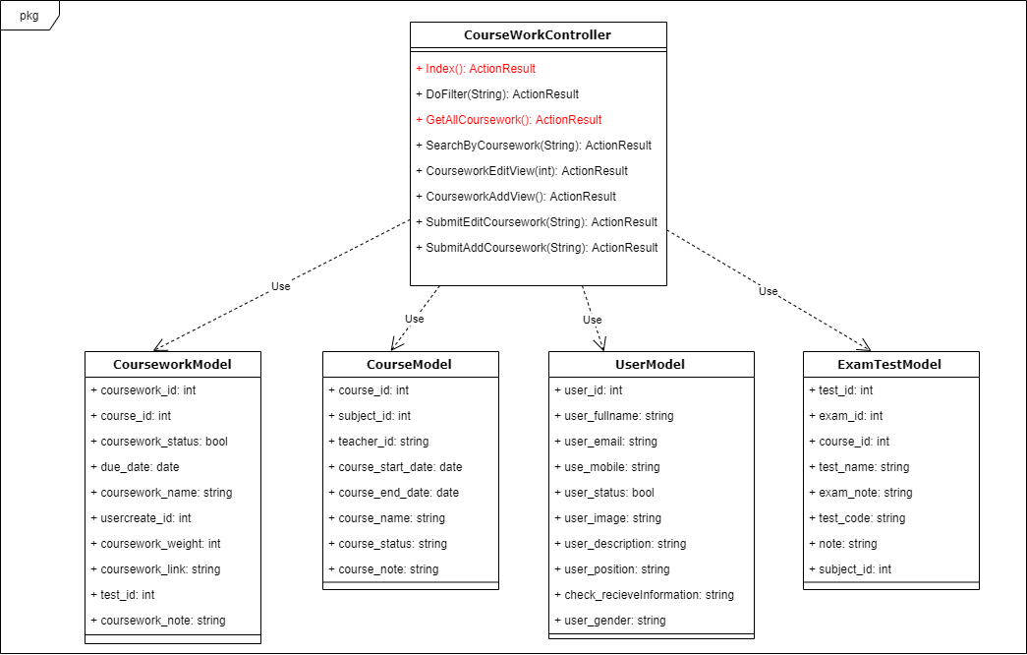

Figure 4-4: Coursework View class diagram

###### Sequence Diagram

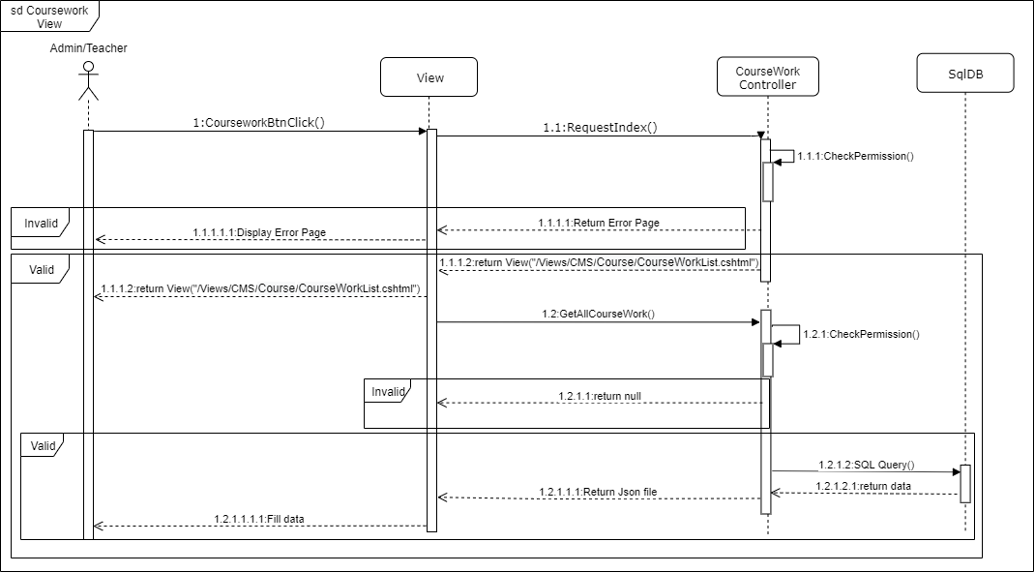

Figure 4-5: Coursework View sequence diagram

##### Coursework Adding

###### Screen Design

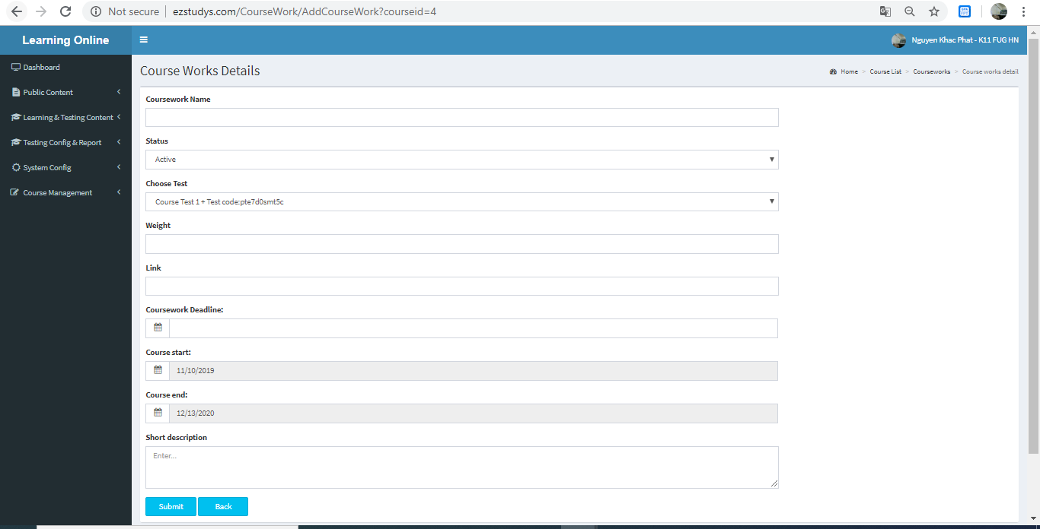

Figure 4-3: Coursework Adding screen design

###### Class Diagram

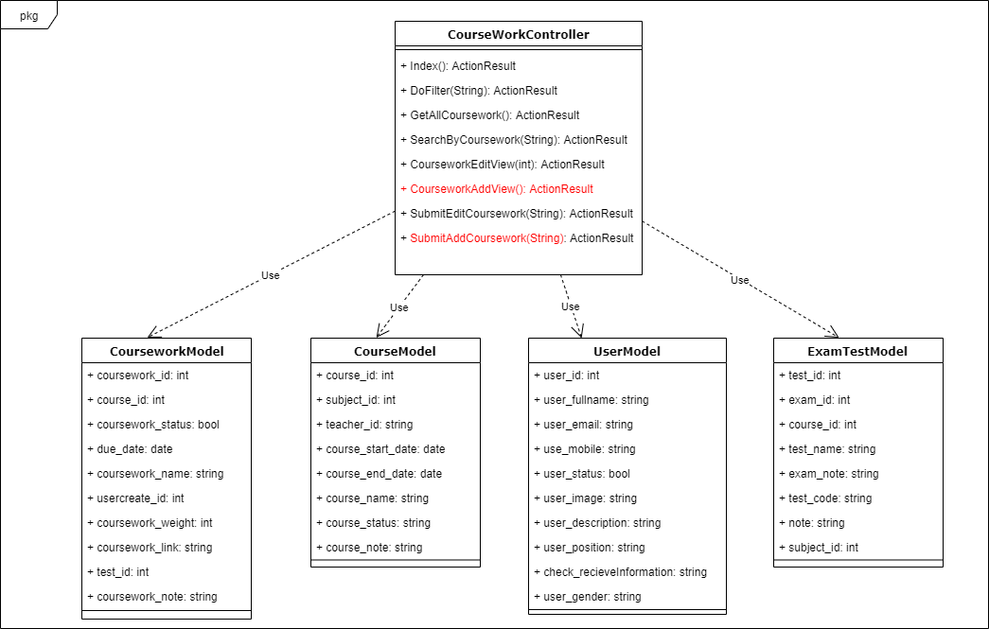

Figure 4-4: Coursework Adding class diagram

###### Sequence Diagram

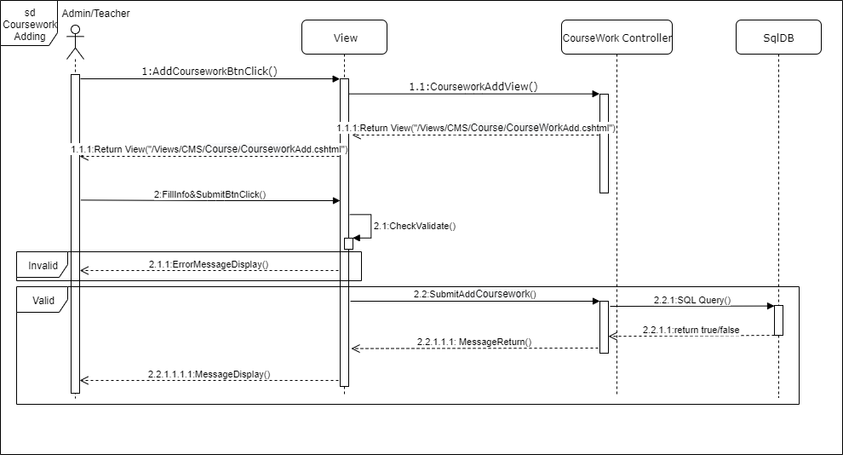

Figure 4-5: Coursework Adding sequence diagram

##### Coursework Eddting

###### Screen Design

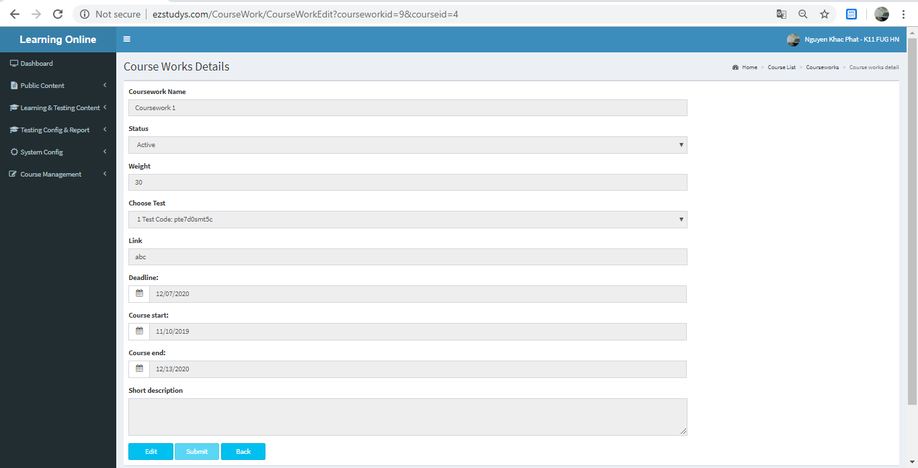

Figure 4-3: Coursework Eddting screen design

###### Class Diagram

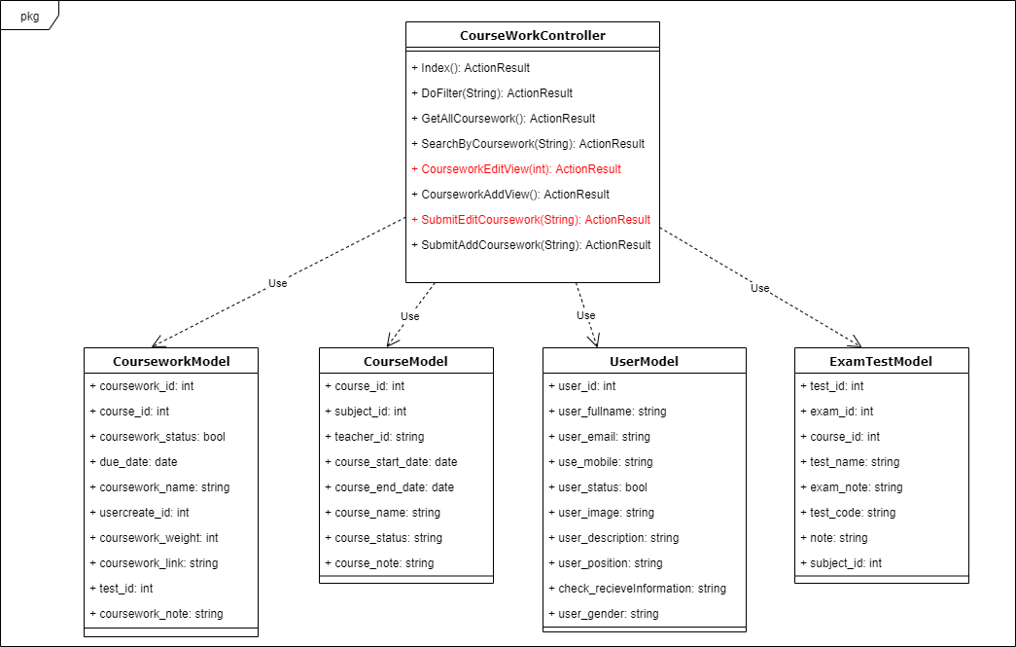

Figure 4-4: Coursework Eddting class diagram

###### Sequence Diagram

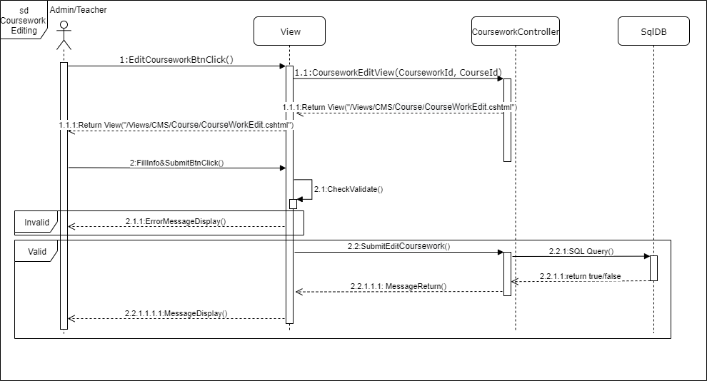

Figure 4-5: Coursework Eddting sequence diagram

##### Grade Book View

###### Screen Design

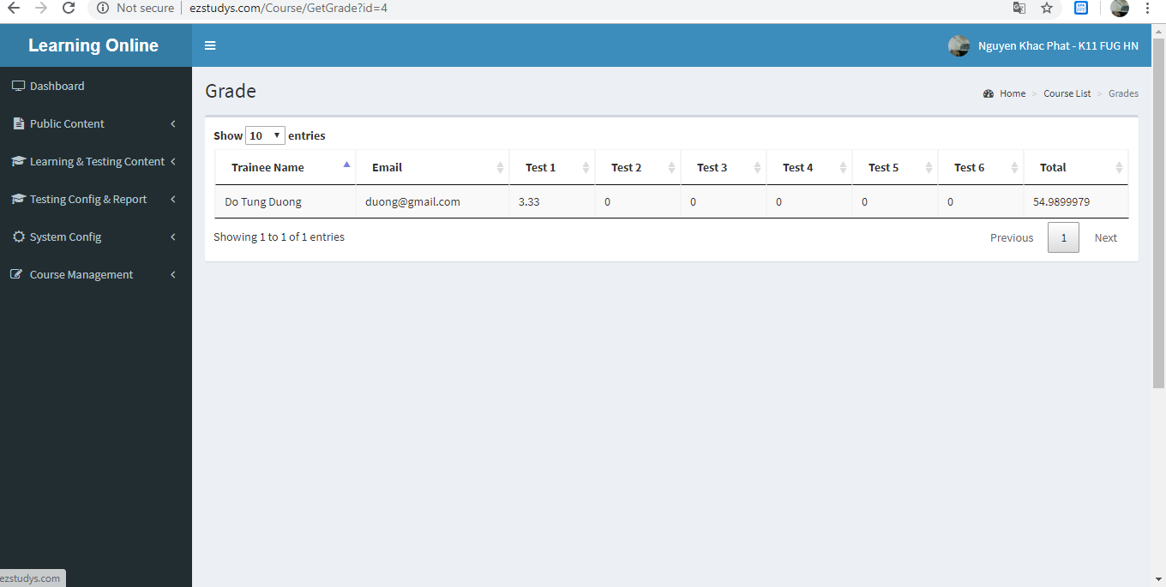

Figure 4-3: Grade Book View screen design

###### Class Diagram

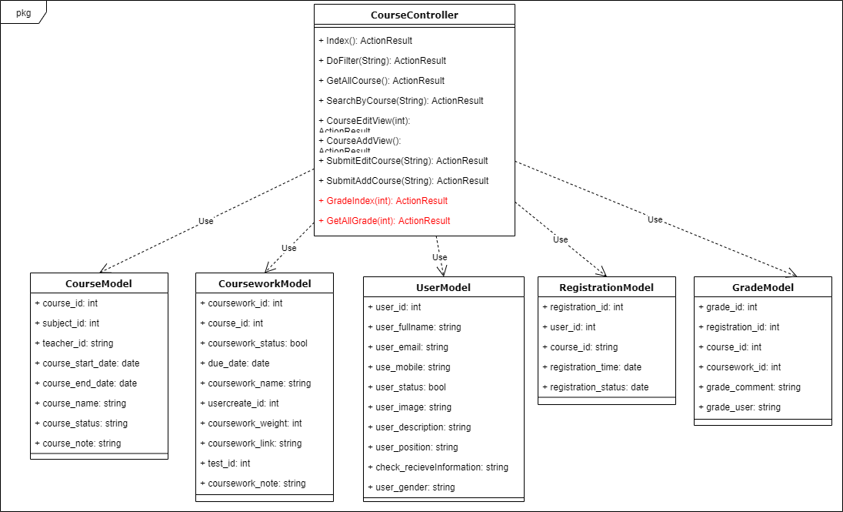

Figure 4-4: Grade Book View class diagram

###### Sequence Diagram

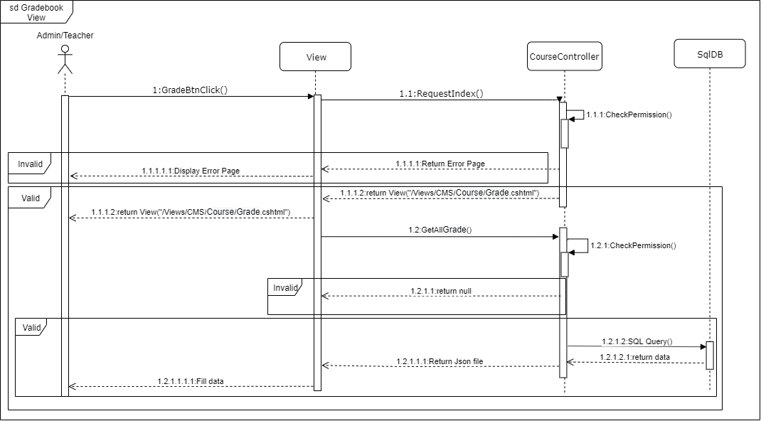

Figure 4-5: Grade Book View sequence diagram

##### Course Learning

###### Screen Design

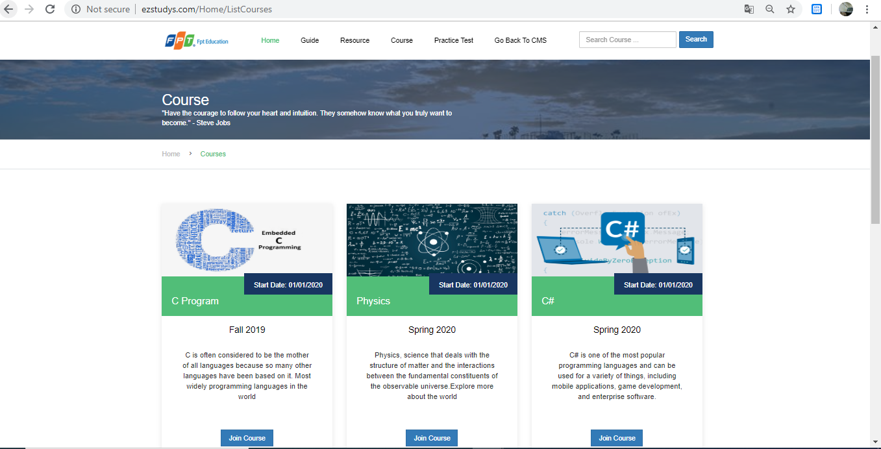

Figure 4-3: Course Learning screen design

###### Class Diagram

Figure 4-4: Course Learning class diagram

###### Sequence Diagram

Figure 4-5: Course Learning sequence diagram

##### Course Register

###### Screen Design

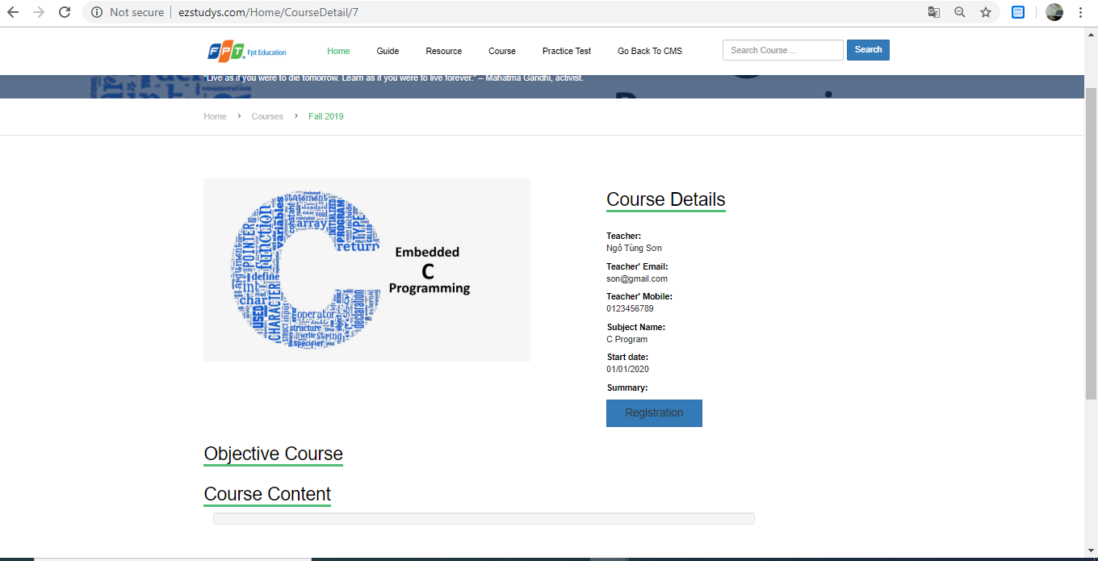

Figure 4-3: Course Register screen design

###### Class Diagram

Figure 4-4: Course Register class diagram

###### Sequence Diagram

Figure 4-5: Course Register sequence diagram

##### Test Handle

###### Screen Design

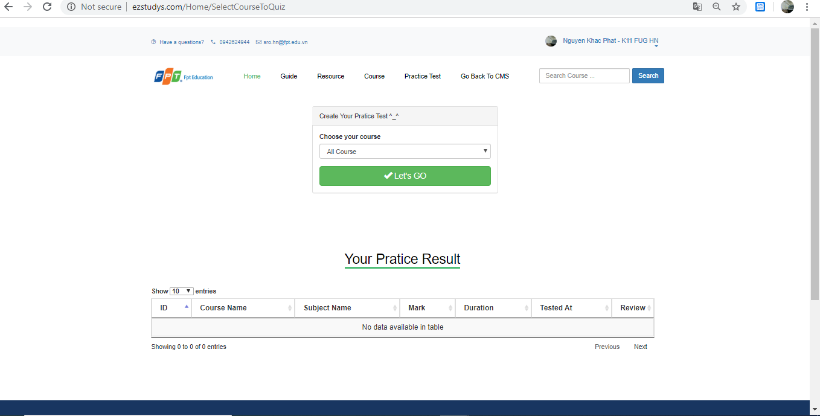

Figure 4-3: Test Handle screen design

###### Class Diagram



Figure 4-4: Test Handle class diagram

###### Sequence Diagram



Figure 4-5: Test Handle sequence diagram

##### Anwser Review

###### Screen Design

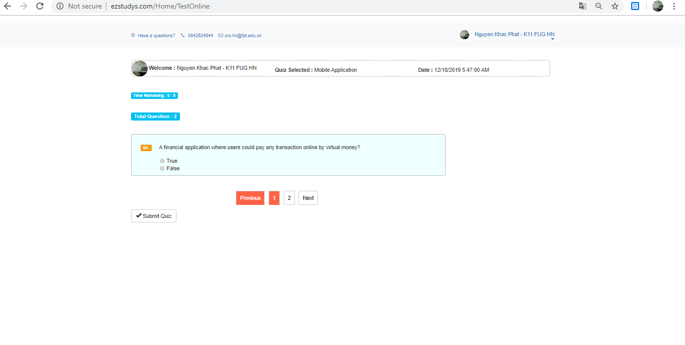

Figure 4-3: Anwser Review screen design

###### Class Diagram

Figure 4-4: Anwser Review class diagram

###### Sequence Diagram

Figure 4-5: Anwser Review sequence diagram

##### Result Review

###### Screen Design



Figure 4-3: Result Review screen design

###### Class Diagram

Figure 4-4: Result Review class diagram

###### Sequence Diagram

Figure 4-5: Result Review sequence diagram

##### Google Login

###### Screen Design

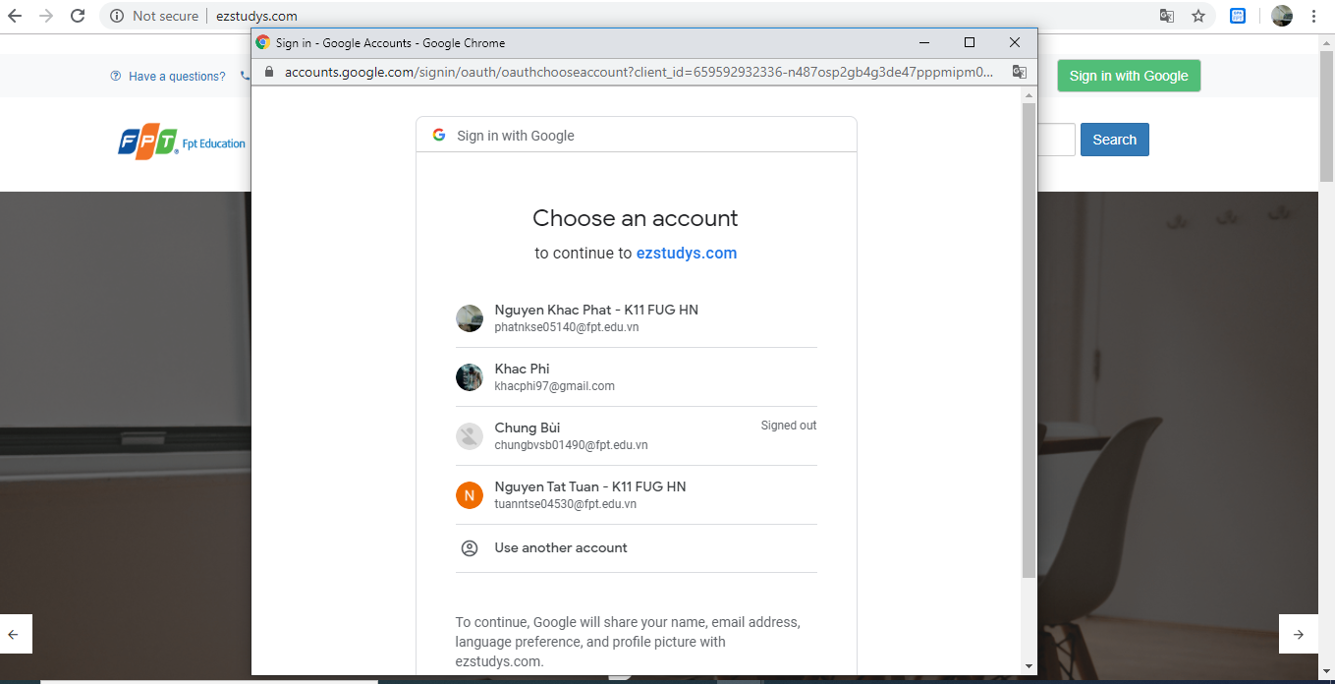

Figure 4-3: Google Login screen design

###### Class Diagram

Figure 4-4: Google Login class diagram

###### Sequence Diagram

Figure 4-5: Google Login sequence diagram

##### User Profile

###### Screen Design

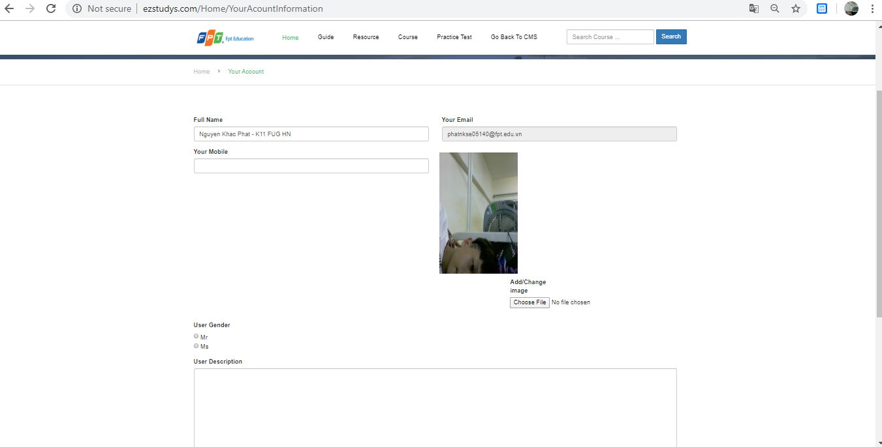

Figure 4-3: User Profile screen design

###### Class Diagram

Figure 4-4: User Profile class diagram

###### Sequence Diagram

Figure 4-5: User Profile sequence diagram

##### Home

###### Screen Design



Figure 4-3: Home screen design

###### Class Diagram

Figure 4-4: Home class diagram

###### Sequence Diagram

Figure 4-5: Home sequence diagram

##### Post Details

###### Screen Design

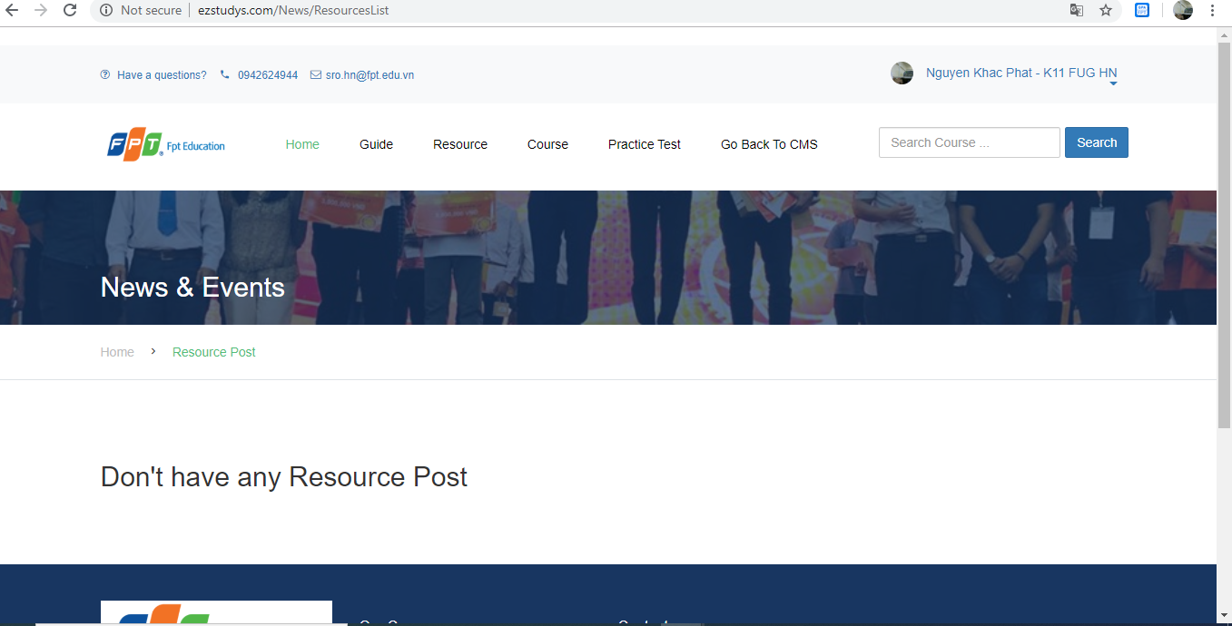

Figure 4-3: Post Details screen design

###### Class Diagram

Figure 4-4: Post Details class diagram

###### Sequence Diagram

Figure 4-5: Post Details sequence diagram

### 4.1 Database Design

#### 4.1.1 Database Diagram



*Figure 28. Database Diagram*

# Chapter 5: Software Testing Documentation

## Introduction

### Purpose

The primary purpose of this chapter is to detect and prevent defects which may be created by developers while developing the software and this may lead to software failures. On the other hand, another objective of this chapter is to provide information about the level of quality and to make sure that the end result meets the business and user requirements. It contains the following sections:

1. Scope of testing
2. Testing tool and environment
3. Resources and responsibilities
4. Test strategy: test approach, test stages
5. Test schedule
6. Feature to be tested
7. Feature not to be tested
8. Defect log
9. Test report
10. Scope of testing

Testing phases

There are 4 phases in Testing Process: Unit testing, Integration testing, System testing and Acceptance testing.

|  |  |  |
| --- | --- | --- |
| **No.** | **Test Stages** | **Description** |
| 1 | **Unit testing** | The main aim of this endeavor is to determine whether the application functions as designed. In this phase, a unit can refer to a function, individual program or even a procedure, and a White-box Testing method is usually used to get the job done. |
| 2 | **Integration testing** | Integration testing allows individuals the opportunity to combine all of the units within a program and test them as a group. This testing level is designed to find interface defects between the modules/functions. This is particularly beneficial because it determines how efficiently the units are running together. |
| 3 | **System testing** | System testing is the first level in which the complete application is tested as a whole. The goal at this level is to evaluate whether the system has complied with all of the outlined requirements and to see that it meets Quality Standards. |
| 4 | **Acceptance testing** | Acceptance testing (or User Acceptance Testing), is conducted to determine whether the system is ready for release. During this phase, the tester and some alpha test user will test the system to find out whether the application meets their business’ needs. |

Table 1.1 – Testing phases

#### Types of Testing

The test team has to test the following type on Google Chrome browser:

|  |  |
| --- | --- |
| Types of test | Description |
| Function test | * Functional testing is a quality assurance process and a type of black-box testing that bases its test cases on the specifications of the software component under test. * Functions (or features) are tested by feeding them input and examining the output. This type of testing is not concerned with how the process is done, but rather, with the results in the end. |
| GUI Test | * GUI testing is the process of testing a product's graphical user interface (GUI) to ensure it meets its specifications. This is normally done through the use of a variety of test cases. * GUI testing evaluates design elements such as layout, colors, fonts, font sizes, labels, text boxes, text formatting, captions, buttons, lists, icons, links and contents. |
| Unit Test | * Unit testing is a software testing method by which individual units of source code, sets of one or more computer program modules together with associated control data, usage procedures, and operating procedures, are tested to determine whether they are fit for use. |

Table 1.2- Type of Testings

#### Range of Testing

Team performs all functions defined in the System Requirement Specification, based on the approved version.

## Test Plan

### Testing Tools and environment

Testing tools

Study Online Front-end and Project Testing

* **Chrome Developer Tools**: To view logs, inspect view elements in web app.



*Figure 2.1: Chrome Developer Tools*

* **Microsoft Word**: Use for write test plan.



*Figure 2.2: Postman*

* **Microsoft Excel**: To manage test cases



*Figure 2.3: Excel*

NUnit : Use for perform unit tests



*Figure 2.4: Nunit*

Hardware:

|  |  |  |
| --- | --- | --- |
| **Name** | **Purpose** | **Detail** |
| Laptop Dell | Device for executing test | * CPU: Intel core i5-5250 1.6 Ghz * RAM: 4.00 GB * HDD: 500 GB |
| Macbook Pro | Device for executing test | * CPU: Intel core i7 3.1 Ghz * RAM: 16.00 GB * SSD: 512 GB * GPU: Intel Iris Graphics 6100 1536 MB |
| Laptop Asus | Device for executing test | * CPU: Core intel I5-4200HQ * RAM: 16.00 GB * HDD: 1024 GB * SSD: 128 GB |
| Laptop Dell | Device for executing test | * CPU: Intel core i7-8750H - 2.2 Ghz * RAM: 16.00 GB * HDD: 1024 GB * SSD: 128 GB |
| Laptop Asus | Device for executing test | * CPU: Intel Core i7-4600U Processor RAM: 8.00 GB * SSD: 256 GB |

Table 2.2: Testing Tools Hardware

Software:

|  |  |  |
| --- | --- | --- |
| Tool | Purpose | Version |
| Microsoft Excel | Use for manage test cases, bugs and checklist | 2010 |
| Microsoft Word | Use for write test plan | 2010 |
| NUnit | Use for perform unit tests | 3.11 |

Table 2.3: Testing Tools Software

#### Testing Environment

|  |  |  |
| --- | --- | --- |
| **Type of testing** | **Software** | **Hardware** |
| System test & Acceptance test | * Microsoft Office Excel 2016. * Microsoft Office Word 2016 * Chrome 70.0.3538.110 (64-bit) | Personal computer for developing with the minimum configuration:   * MacBook Pro (Retina, 13-inch, Early 2013) * 3 GHz Intel Core i7 * RAM: 8 GB 1600   or:   * Ubuntu 18.04 * 2.7 GHz Intel Core i5 * RAM: 8 GB |

Table 2.1 – Testing environment

### Resources and responsibilities

|  |  |  |
| --- | --- | --- |
| No. | Resource | Responsibility |
| 1 | Test leader | * Review test case and test report. * Review overall quality of the project. |
| 2 | Tester | * Performing the actual system testing. * Managing test resource and assign test task. * Create test plan. * Create test cases. * Write test report. * Executing test and testing log report. |
| 3 | Developer | * Create and perform Unit Tests. * Fix bugs. |

Table 3-1: Resources and Responsibilities

### Test Strategy

#### Test model

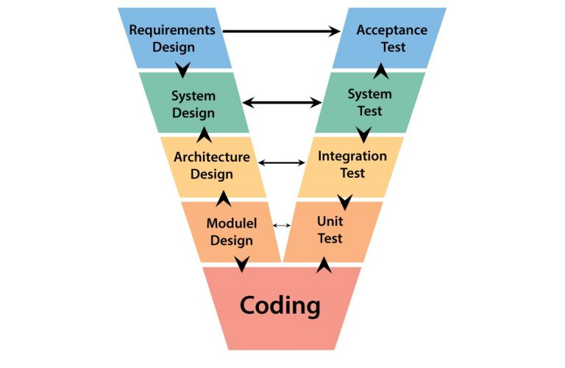

*Figure 4.1: V-Model*

Overall, we choose V-Model to implement testing process. With V-Model, software development is separated into two appropriate phase’s groups: development and testing. In this model, the verification and validation will be done side by side. It emphasizes the strict process flow to develop a quality product. The errors occurred in any phase will be corrected in that phase. Proactive defect tracking defects, which are found at early stages even, may be in the development phase before application being tested.

Specifically, Study Online is divided into 2 sub-systems: Study Online Back-end and Study Online Front-end. In each phase of process, we use specific process for each sub-system team to fit the requirement, the characteristic and the human resource of each team.

Study Online Back-end has 2 levels of test:

* Unit testing: Automation tests that cover logic of Models and Libraries.

Study Online Front-end works mostly with GUI instead of logic and it depends on Study Online Back-end, so that Study Online Front-end apply system testing which covers the whole Study Online system.

#### Test Types

Testing Study Online will be carried out in each release package as defined in project plan and will depend on internal delivery by development side. Critical tests will be defined as any new or modified tests for the Study Online system. Project manager will decide which closed defects the test team cannot determine.

Each type of Study Online Project Testing will be designated to cover a level of project, from each model level, and Study Online Project level with Unit testing combined with Database testing, System testing and Acceptance testing. On the other hand, Study Online will use several of testing type to prevent defects from code modifications and latent bugs.

The different types of testing that will be carried out this project are:

* Unit testing:
  + Testing all individual implemented methods, functions of model class or library class.
  + Unit test also includes database testing to verify constraint, transaction, default value, data types, data format, and check null and junk characters which are mentioned in database design and software requirement.
  + Implemented function’s error message and database error message will be included in this test.
* GUI testing:
  + GUI testing verifies a user’s interaction with the software. The goal of GUI testing is to ensure that the GUI provides the user with an appropriate access and navigation through the functions of the target-of-test. In addition, GUI testing ensures that the objects within the GUI function as expected and conform to requirement
  + GUI test will be performed fully on all screens.
  + This test targets to cover the verification of the overall look and feel of the Study Online system including initial position, font, text size, color, focus, initial button, tab order, label, screen sizes and sentences width.
  + Check all the GUI elements for size, position, width, length and acceptance of characters or numbers. For instance, it must be able to provide inputs to the input fields.
* Check if error messages are displayed correctly.
* Check if fonts used in application is readable.
* Check if the alignment of the text is proper.
* Check if the color of the font and warning messages is aesthetically pleasing.
* Check if images have good clarity and are properly aligned.
* Check the positioning of GUI elements for different screen resolution.
* Regression testing
  + The testing is to confirm that the bug was removed including the extent of the impact, when developers fix bug, developers and testers will confirm with each other what is the impacts of fix bug modification, after that all impact unit or function will be retested by developers then testers after that.
* Acceptance testing
  + This test type will be executed by tester with designed test cases, acceptance test is a test type conducted to determine if the requirements of a specification or contract are met.
  + It also includes alpha testing; alpha testing takes place at close relation user’s site and are free test to detect bug and strange behavior. By that, development team will improve UX and UI of system

#### Test Stages

The table below describes the stages in which common tests are executed:

|  |  |  |  |  |
| --- | --- | --- | --- | --- |
| **Type of test** | **Stage of test** | | | |
| **Unit test** | **Integration test** | **System test** | **Acceptance test** |
| Unit Tests | x | x | x |  |
| UI Tests |  |  | x | x |
| Regression Tests | x | x | x | x |
| Acceptance Tests |  |  | x | x |

Table 5.4 – Testing stages

### Test Schedule

The table below describes the test schedule for the Study Online Project:

|  |  |  |
| --- | --- | --- |
| **Test Schedule** | **Start Date** | **End Date** |
| ***Iteration 1:*** | ***12-09-2019*** | ***27-09-2019*** |
| Unit Testing | 12-09-2019 | 22-09-2019 |
| User Interface Testing | 12-09-2019 | 22-09-2019 |
| System Testing | 15-09-2019 | 26-09-2019 |
| Regression Tests | 15-09-2019 | 26-09-2019 |
| ***Iteration 2:*** | ***29-09-2019*** | ***10-11-2019*** |
| Unit Testing | 30-09-2019 | 10-10-2019 |
| User Interface Testing | 30-09-2019 | 10-10-2019 |
| System Testing | 12-10-2019 | 11-11-2019 |
| Regression Tests | 12-10-2019 | 11-11-2019 |
| Acceptance testing | 12-10-2019 | 11-11-2019 |
| ***Iteration 3:*** | ***13-11-2019*** | ***24-11-2019*** |
| Unit Testing | 13-11-2019 | 15-11-2019 |
| User Interface Testing | 15-11-2019 | 19-11-2019 |
| System Testing | 15-11-2019 | 19-11-2019 |
| Regression Tests | 20-11-2019 | 24-11-2019 |
| Acceptance testing | 20-11-2019 | 24-11-2019 |

Table 5.1 – Test schedule

#### Test Deliverables

The table below list the test deliverables for the Study Online Project:

|  |  |  |  |  |
| --- | --- | --- | --- | --- |
| **Deliverables** | **Responsibilities** | **Complete date** | | |
| **Iteration 1** | **Iteration 2** | **Iteration 3** |
| Test plan | Tester | *02-11-2019* | | |
| Test cases | Tester | 15-09-2019 | 25-10-2019 | 15-11-2019 |
| Test case review | Tester + PM | 21-09-2019 | 02-11-2019 | 18-11-2019 |
| Test data | Tester | 23-09-2019 | 05-11-2019 | 22-11-2019 |
| Defect report | All members | 27-09-2019 | 10-11-2019 | 24-11-2019 |
| Final test report | PM | 25-11-2019 | | |

Table 5.2 – Test deliverables

## 3.1Test Approach

### Unit test with NUnit

Unit testing will be done by developers and approved by technical leader. UniR use NUnit to execute unit test. UniR develop team embraces this feature to gain the following advantages:

* Reducing the level of bugs in production code.
* Save development time.
* Making is easier to change and refactor code by improving the design of code, especially with Test-driven development.
* It can easily form a document from the tests.
* It is easier to maintain than Front-end tests which are difficult to maintain with the short release cycles and frequent changes and with a complex system.
* Reducing cost of resource to corresponding Front-end testing.

### 3.1.2 Integration and System test

Detailed test cases will be described in SO_IntegrationTest.xlsx file.

As a standard definition, CFML defines that a test case is:

* A set of test data and test programs (test scripts) and their expected results. A test case validates one or more system requirements and generates a pass or fail.
* A good test case should follow two basic aspects, the Contents and the Style. Test cases for functional testing are derived from the target of test’s use case. Test cases should be developed for each use case scenario. The use case scenarios are identified by describing the paths through the use case that traverse the basic flow and alternate flows start to finish through the use case.

### Defect log

Excel is used to manage defects of SO project. Detail will be described in “SO_DefectLog.xlsx”

Processes:

* During the testing process, when a bug is found, testers access Defect Log file to log it. The bug must be described as detailed as possible with screenshots. The issue is then assigned to a developer, who is in charge of developing that module.
* Assigned developer checks out the issue in Defect Log file and fixes it. Once the bug is resolved, the assigned developer changes the issue status to “Solve” and assigns it to a tester, whose responsibility is to check the bug again.
* Tester then verifies if the bug is completely resolved. If the bug is fixed, tester changes the status to “Closed”. If the bug is not fixed, tester changes the status to “Open” and assign it to a developer again.

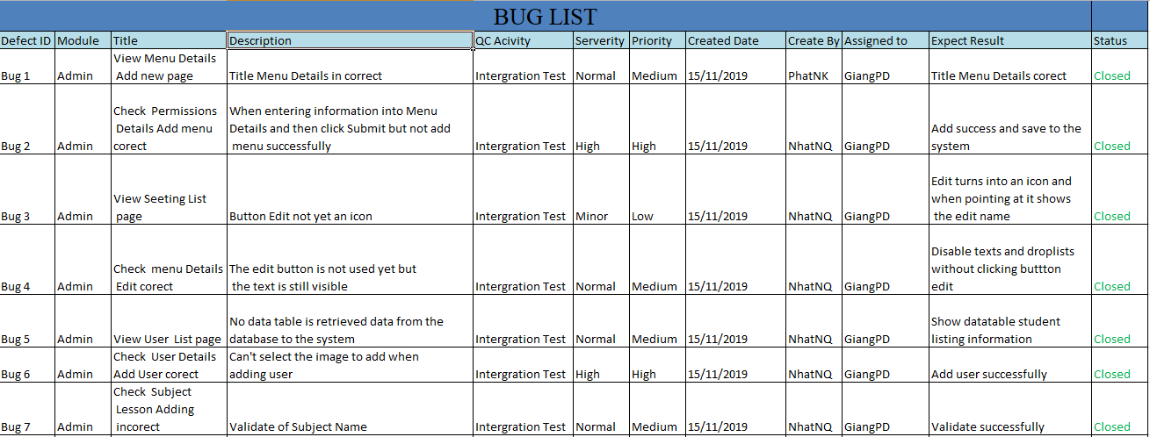

**Figure 5-2: Defect log**

## Test report

### Unit test report

### Integration and System test report

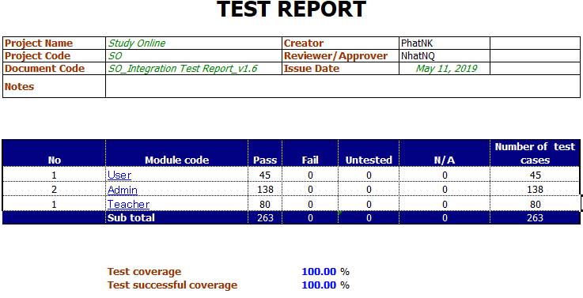

**Figure 5-5: Integration and System test report**

# Chapter 6: USER’S MANUAL

## 1.Purpose

These guidelines are the instructions of general steps for users Customer, Helper and Admin to use all functions of SPCS system.

### Detailed Guidelines

#### User web application guidelines

##### Home

User enter [<http://ezstudys.com/>](http://40.121.163.222/)  to the browser:

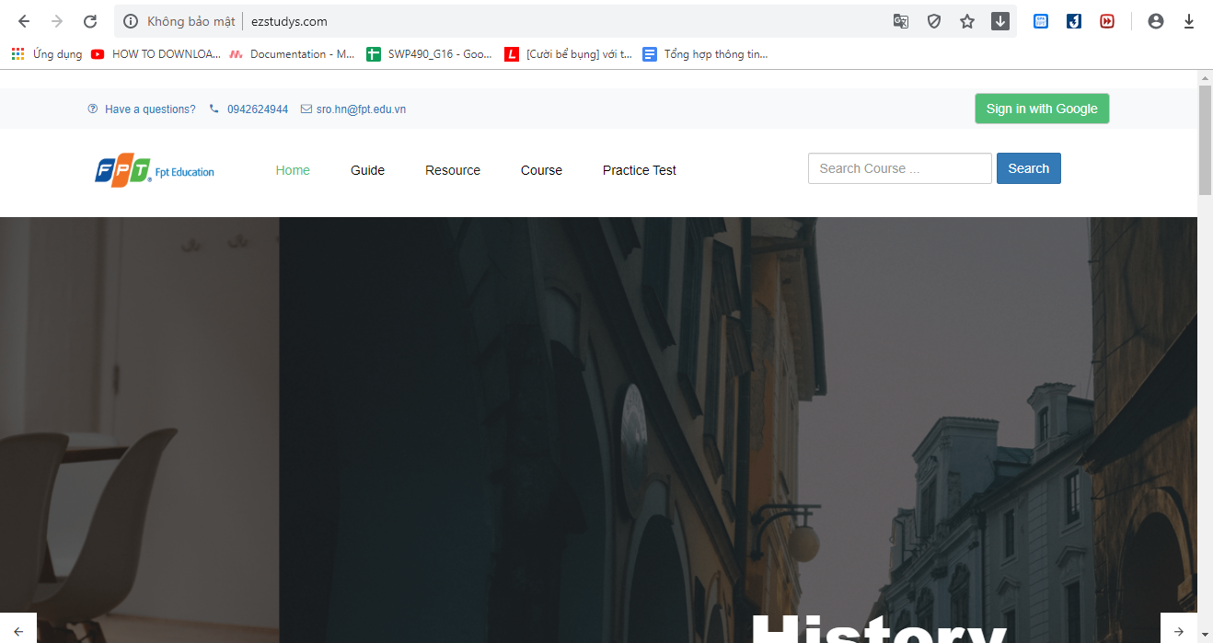

**Figure 6-1: Home**

After the user accesses the web link, the system will display the Home page for the user.

##### Guide

Remember the tutorial articles, learning resources.

Click button Guide on HomePage.

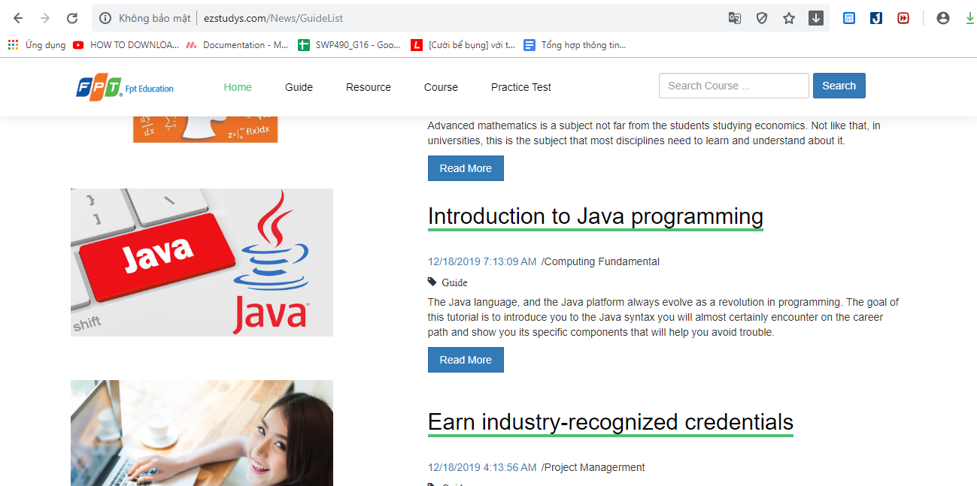

**Figure 6-2: Guide**

##### Resource

Remember the tutorial articles, learning resources.

Click button Resource on HomePage.

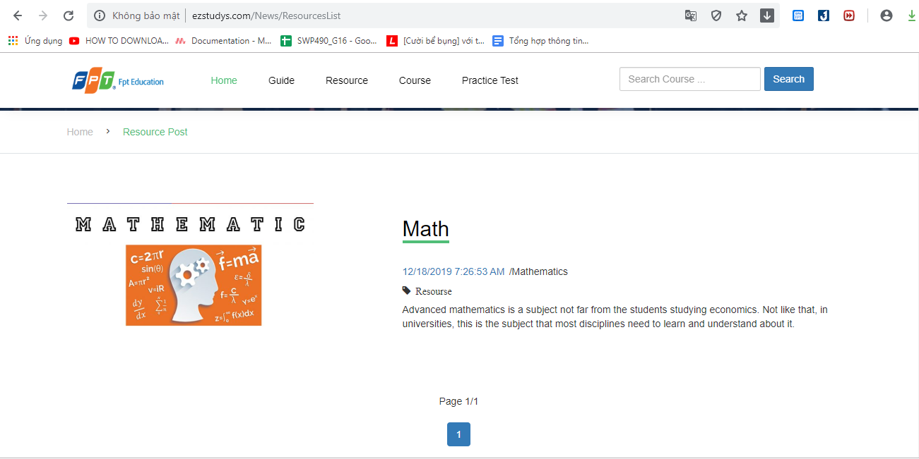

**Figure 6-3: Resource**

##### Course

Courses related to each subject. There will be 1 default course created for each course immediately after it is published.

Click button Course on HomePage.

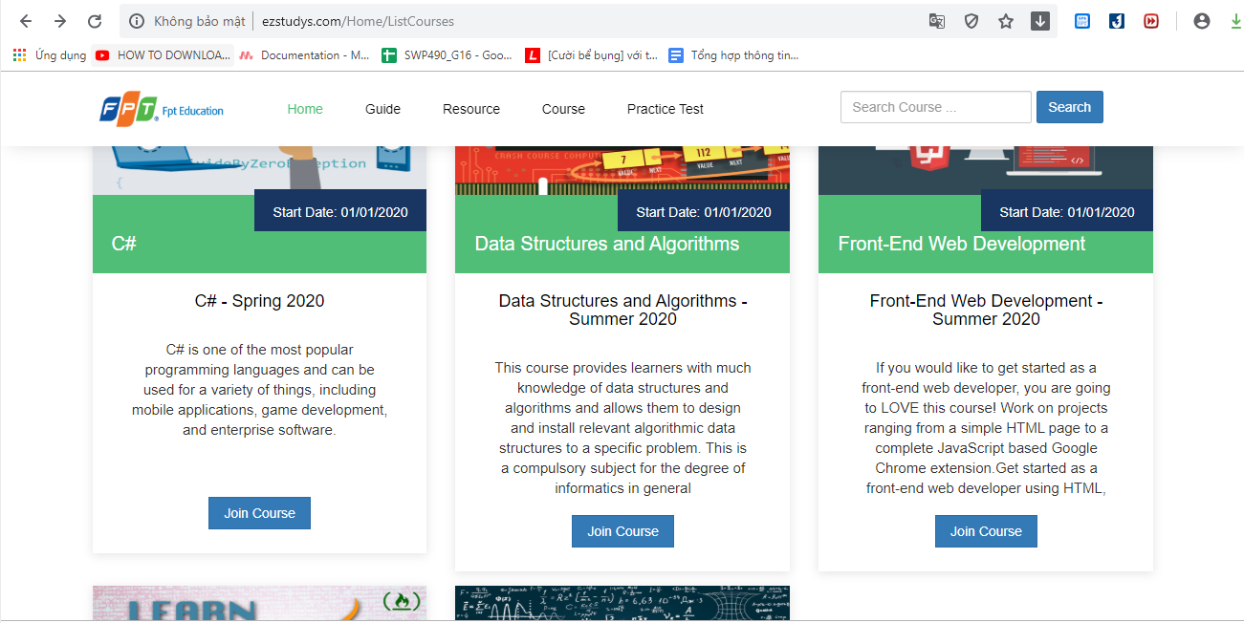

**Figure 6-4: Course**

##### Course Detail

Courses related to each subject. There will be 1 default course created for each course immediately after it is published.

Click Button “Join Course” on Course Page

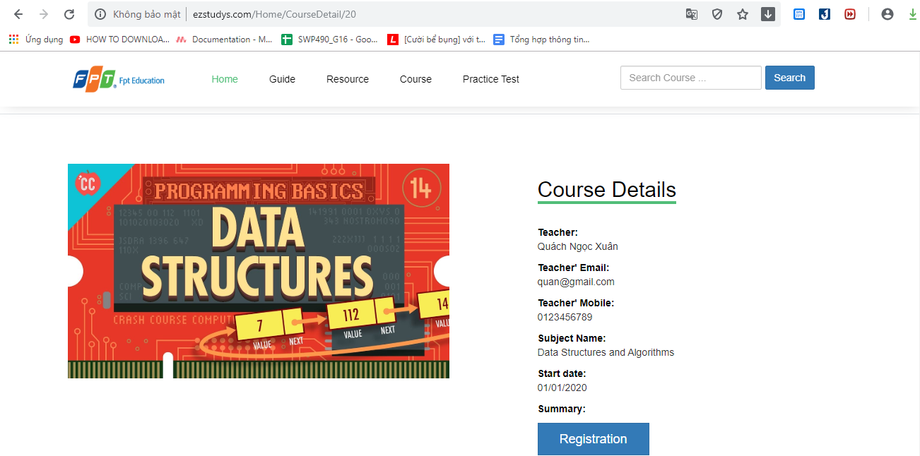

**Figure 6-5: Course Detail**

##### Click button registration you need login first

Click button Registration on Course Detail page

You need to login first

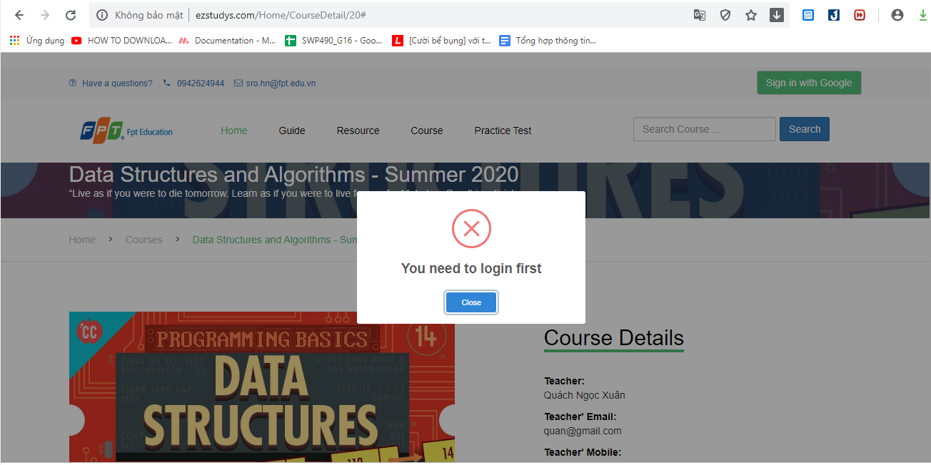

**Figure 6-6: Warning login**

##### Login

User enter email and password then click on the “Login” button. System will verify user, if the email and password is correct, the system will load about Home page. If it’s not correct an error message.

Click button “Sign in with Google”.

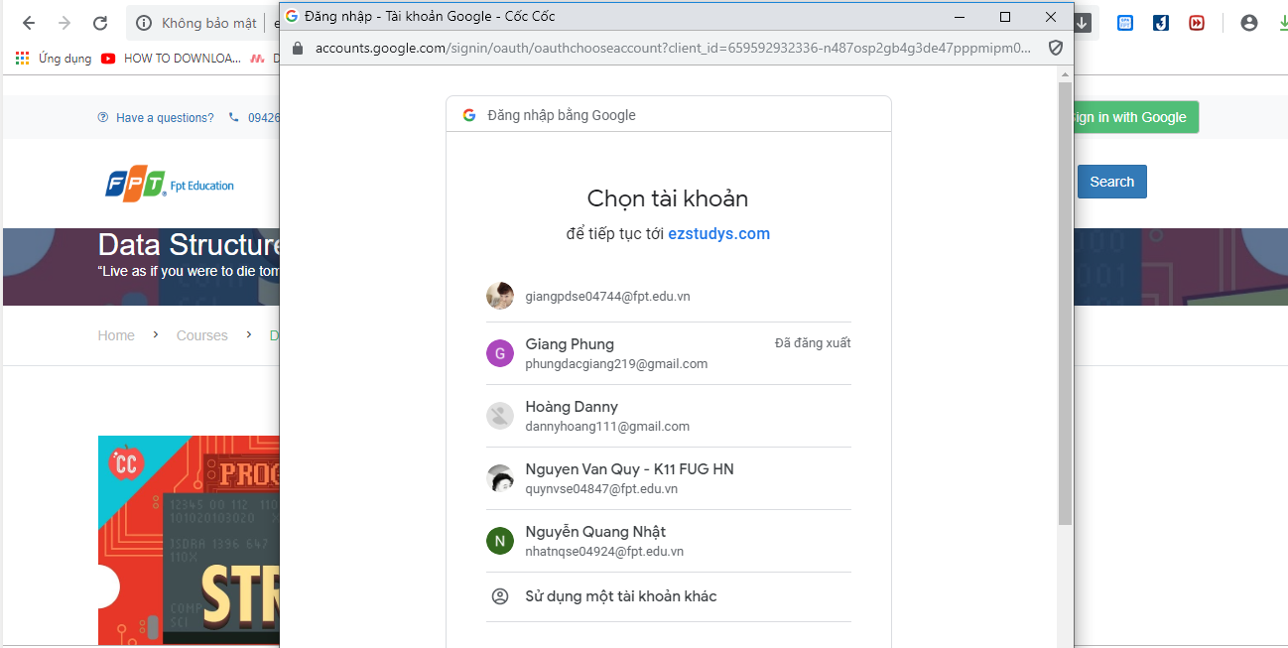

**Figure 6-7: Sign in with Google**

##### Registration Course

Click button “Registration” when login Google.

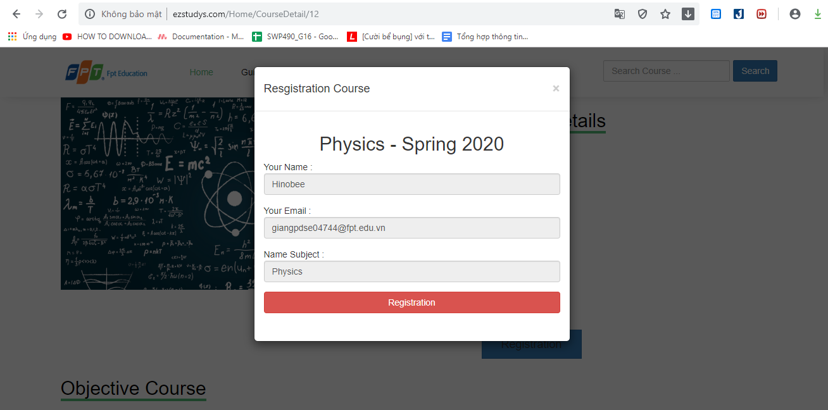

**Figure 6-8: Registration Course**

##### Registration Success and waiting for accept

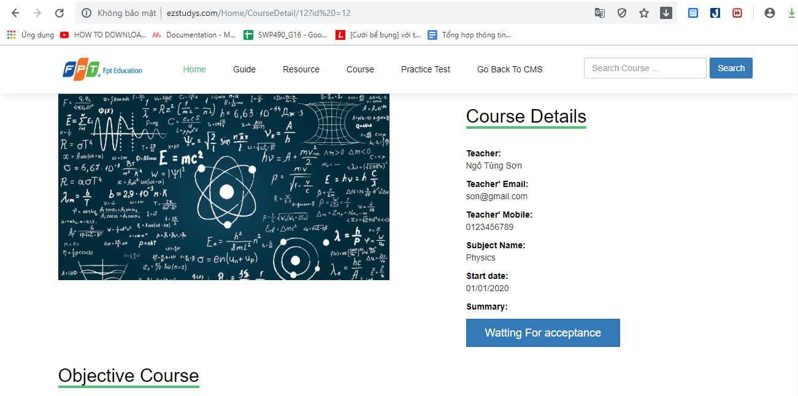

**Figure 6-9: Registration Course and Waiting**

##### My Course

List of course words for users

Click button “My Course” on My Profie and waiting for accept Course.

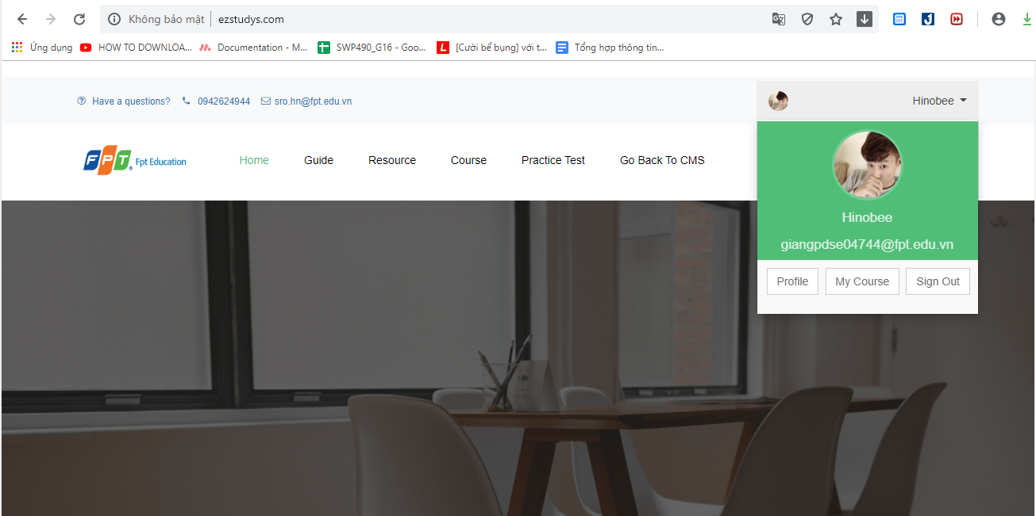

**Figure 6-10:** My Course

##### Lesson Detail

Detailed description of the subject including the lesson video and lesson content

Click button “Join Course” on Your Course page and learn Lesson if you want.

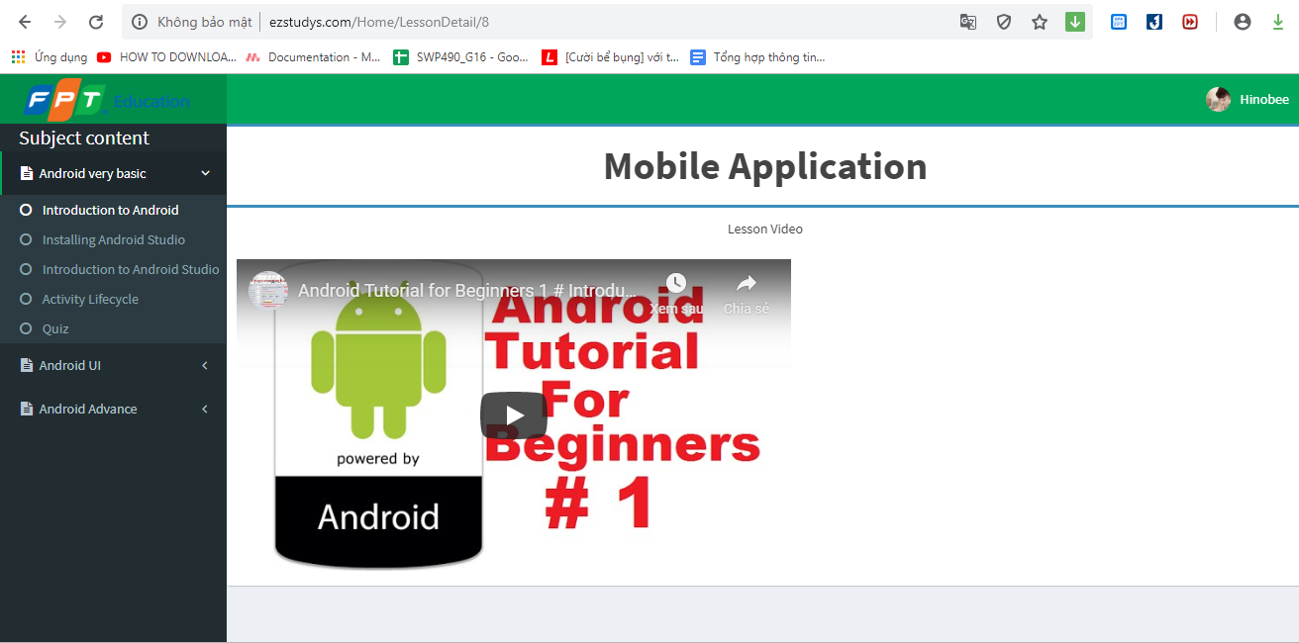

**Figure 6-11: Leson Detail**

##### Do quiz while studying

Detailed description of the subject including the lesson video and lesson content.

Click “Quiz” if subject have.

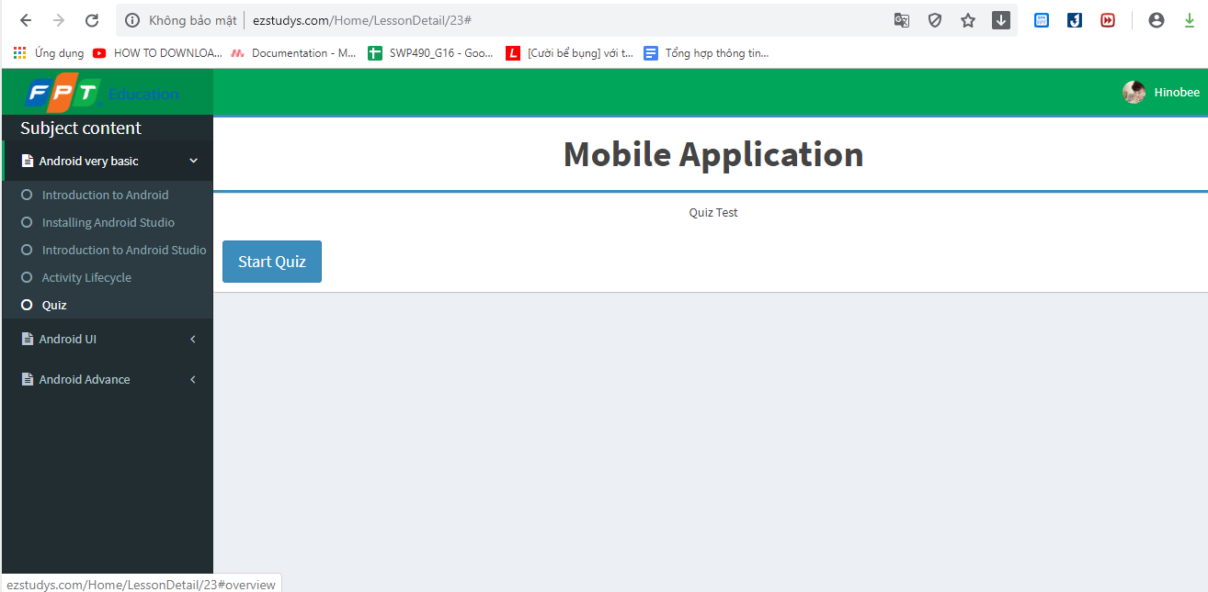

**Figure 6-12: Do quiz**

##### Enter Password

Better face protection than the test

Enter the password that the teacher provided and click button “Verify Password”

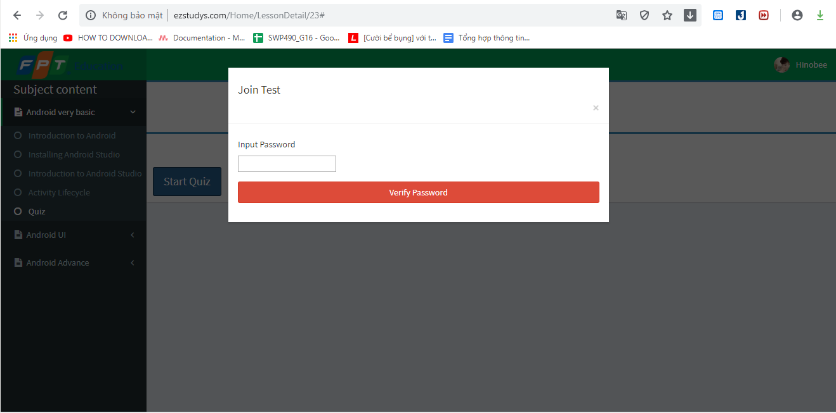

**Figure 6-13: Verify Password**

##### Start Quiz

When click button “Verify Password” go to difference tab

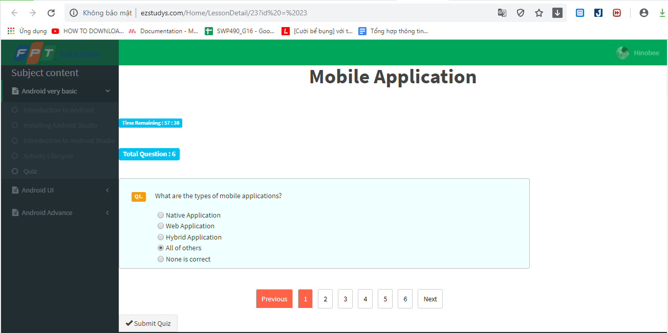

**Figure 6-14: Start Quiz**

##### Submit Quiz

Upon completion of the quiz, the user can submit the test to the system

Submit Quiz when return Home page

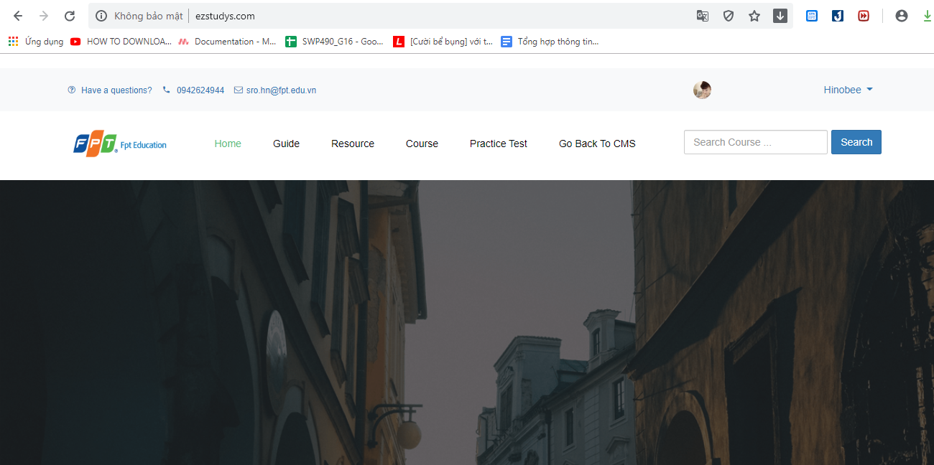

**Figure 6-15: Sumbit Quiz**

##### Practice Test

Click button Practice Test on HomePage.

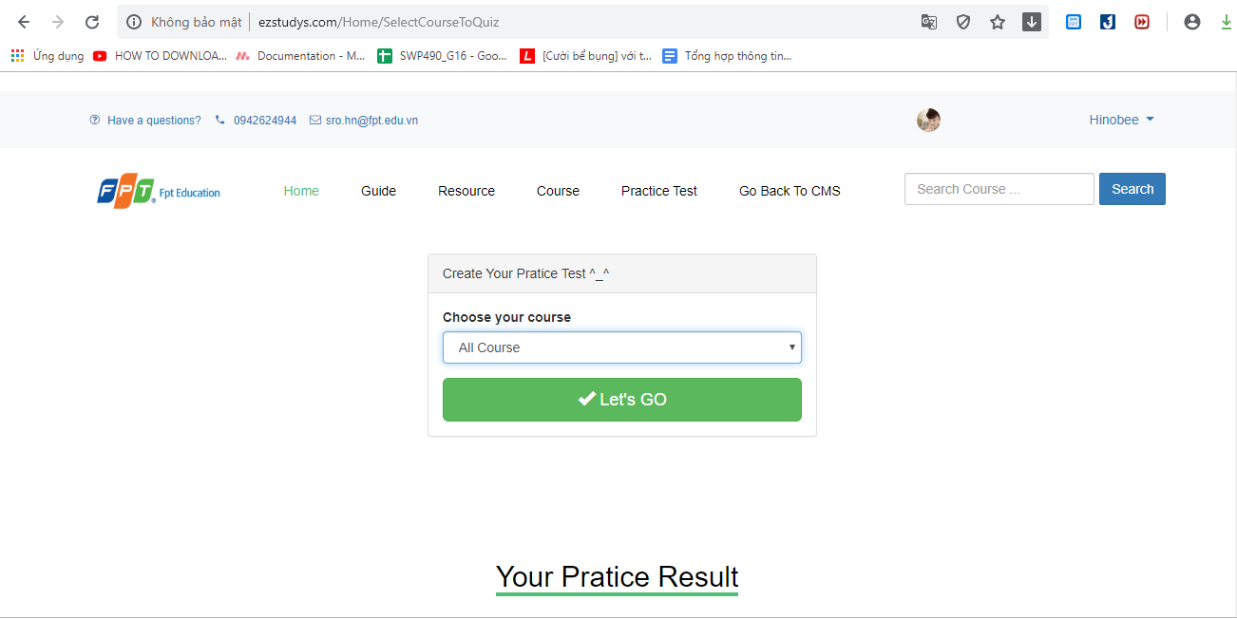

**Figure 6-16: Practice Test**

##### Do Test

Select Course and number of questions, Domain or Lesson… then “Let’s go”.

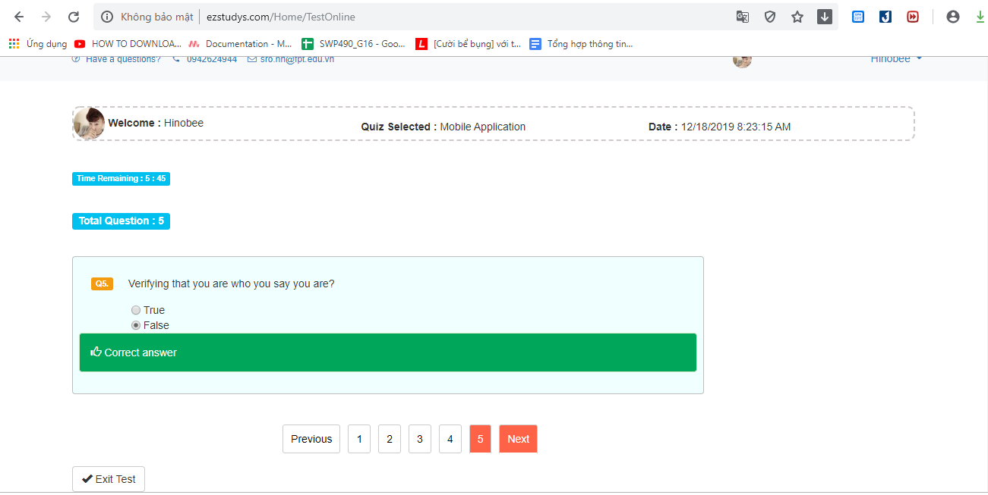

**Figure 6-17: Do Test**

##### Submit Test

Anwer question then click button “Exit Test”.

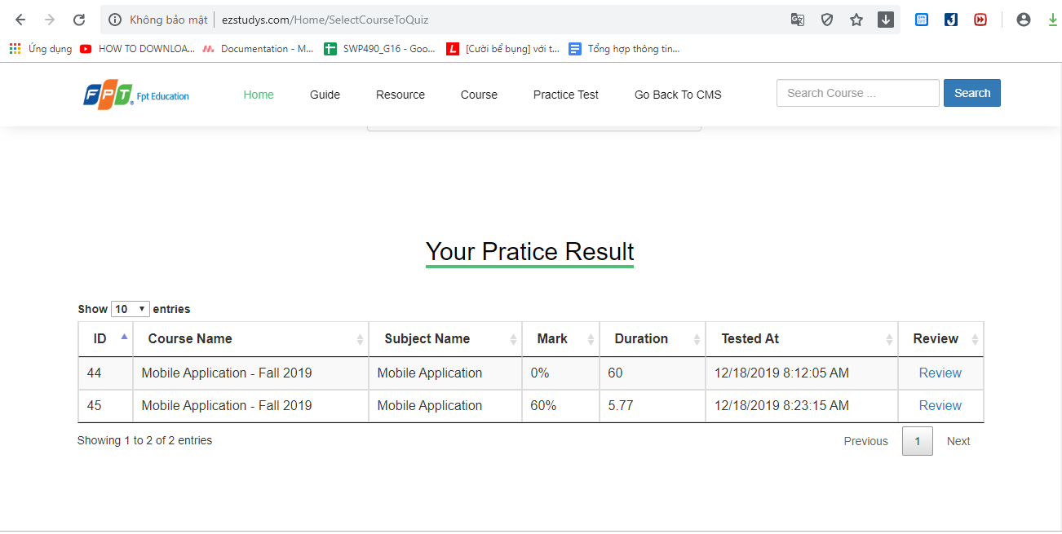

**Figure 6-18: Sunmit Test**

##### Review Test

To audit subscription, from the Home page, user choose subscription and click on “Security” hyperlink. After that, user click on “Scan” button on the top right of the screen to audit.

Click button “Review”

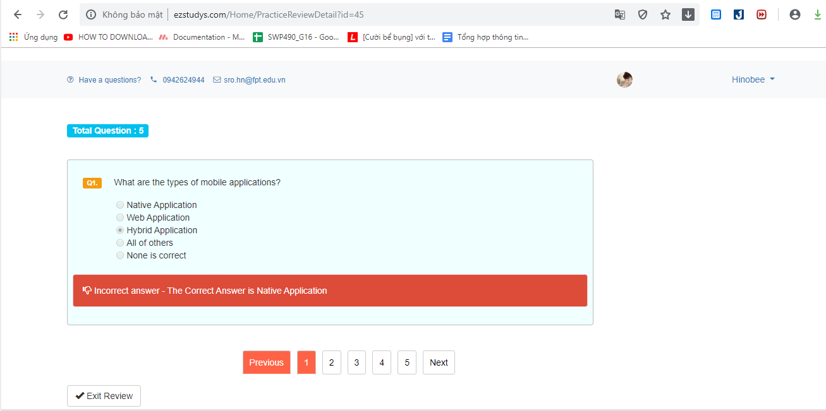

**Figure 6-19: Review Test**

##### Exit Review

To audit subscription, from the Home page, user choose subscription and click on “Security” hyperlink. After that, user click on “Scan” button on the top right of the screen to audit.

Click “Exit Review” go back Practice Test page.

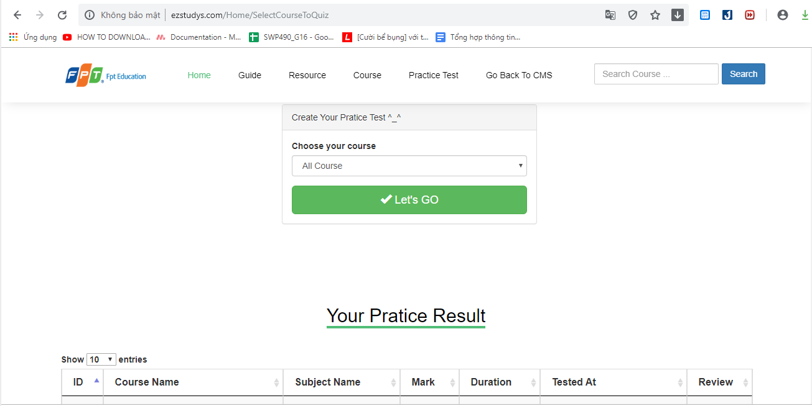

**Figure 6-20: Exit Test**

##### Your Account Information

To audit subscription, from the Home page, user choose subscription and click on “Security” hyperlink. After that, user click on “Scan” button on the top right of the screen to audit.

Click “Profie” on My Profie.

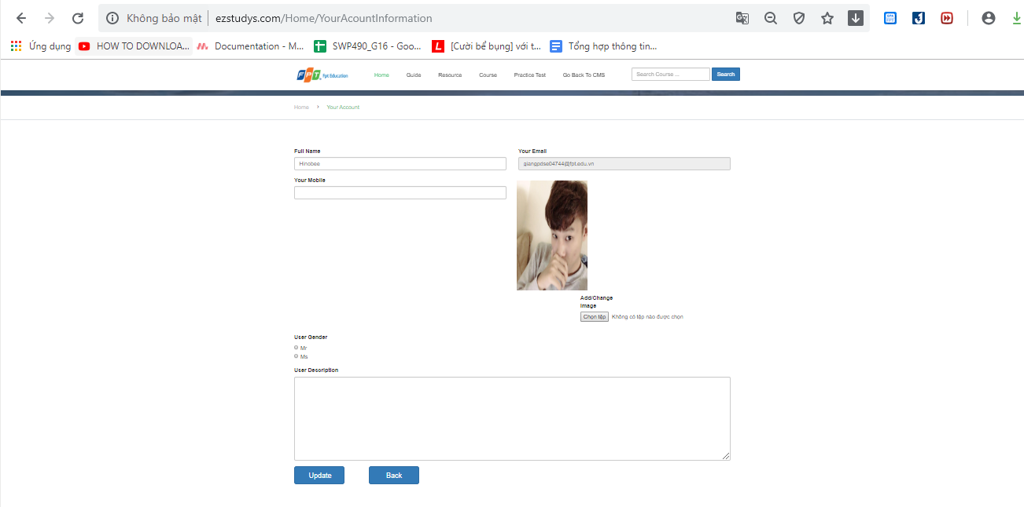

**Figure 6-21: Your Accouc ìmormation**

##### Sign out

To audit subscription, from the Home page, user choose subscription and click on “Security” hyperlink. After that, user click on “Scan” button on the top right of the screen to audit.

Click “Sign out” on My Profie. Then go back Home page.

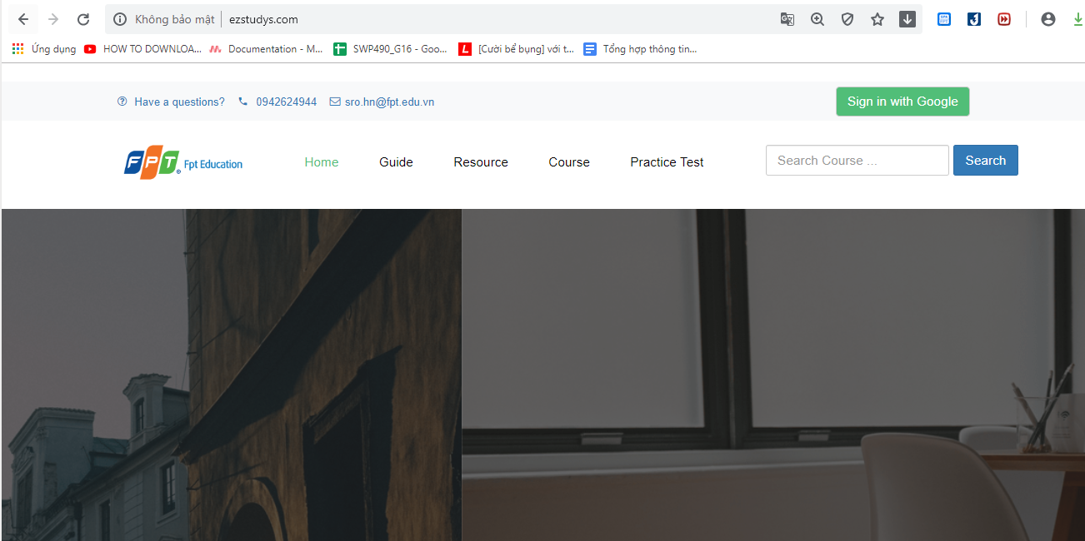

**Figure 6-22: Sign Out**

##### Click Post

To audit subscription, from the Home page, user choose subscription and click on “Security” hyperlink. After that, user click on “Scan” button on the top right of the screen to audit.

Click 1 post on Home page.

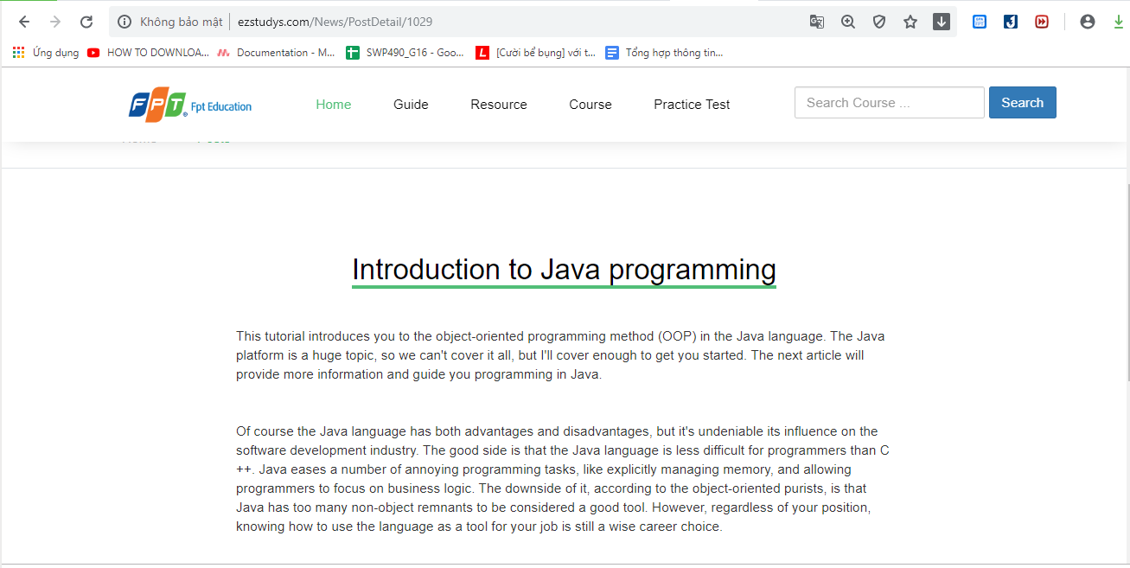

**Figure 6-23: Post Detail**

#### Admin web application guidelines

##### Home page

After Admin click on “Login” button in the Login page, the system will display Home page.

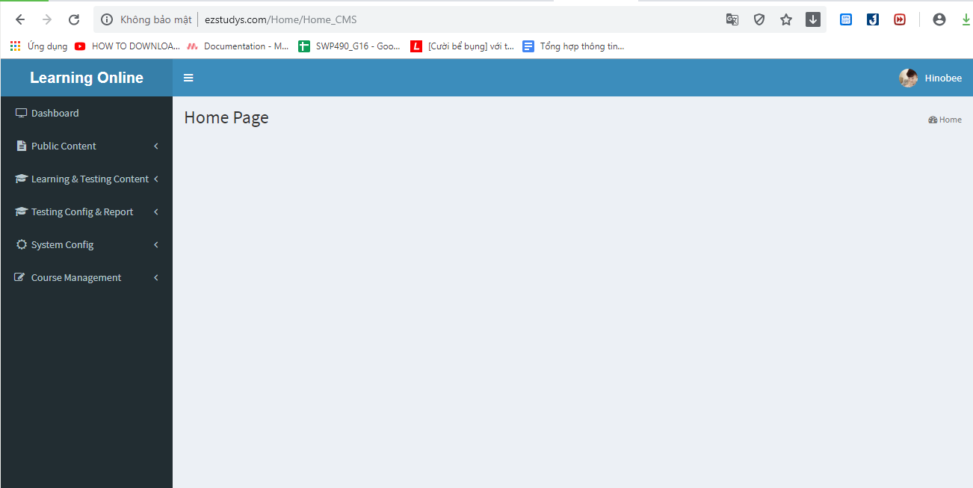

**Figure 6-24: Home Page**

##### Logout

Admin clicks on user’s name at the top right corner, a dropdown box will display. Admin click on “Logout” button to logout of the system.

Click “Log out” on My Profie. Then go back Home page.



**Figure 6-25: Logout**

##### Learning Online Logo

Click logo “Learning Online” then go to Home page User.

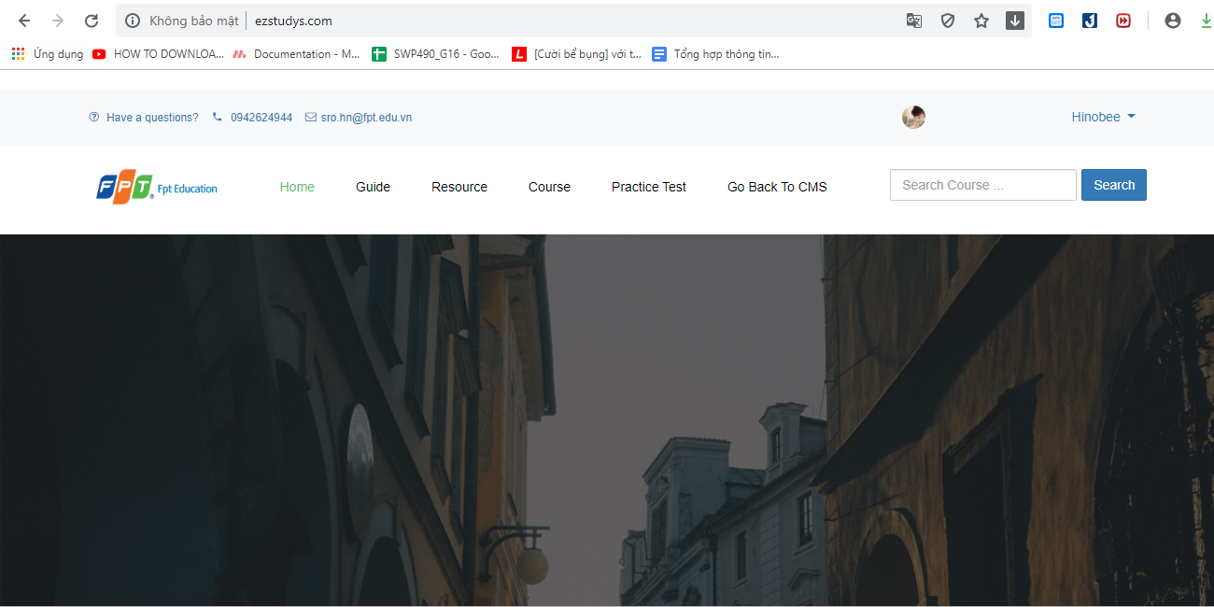

**Figure 6-26: Logo**

##### Go back to CMS

Click button “Go back to CMS”



**Figure 6-27: Go back to CMS**

##### Post

Click button “Post” on Menu bar.

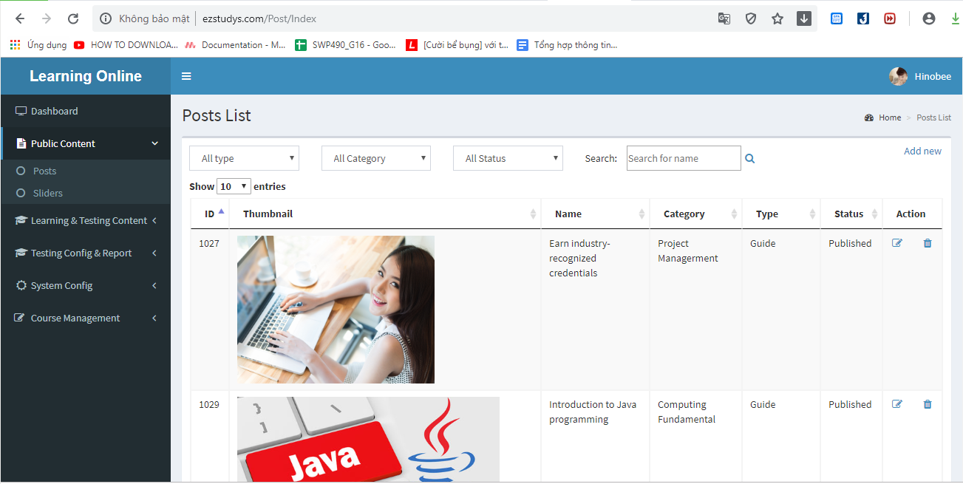

**Figure 6-28: Post view admin**

##### Function Add New

Admin click on “Manage” button on the top right corner, the web will redirect to Manage page. Admin click on “Subscription” button on the left menu to view manage subscription page.

Click button “Add Post”.

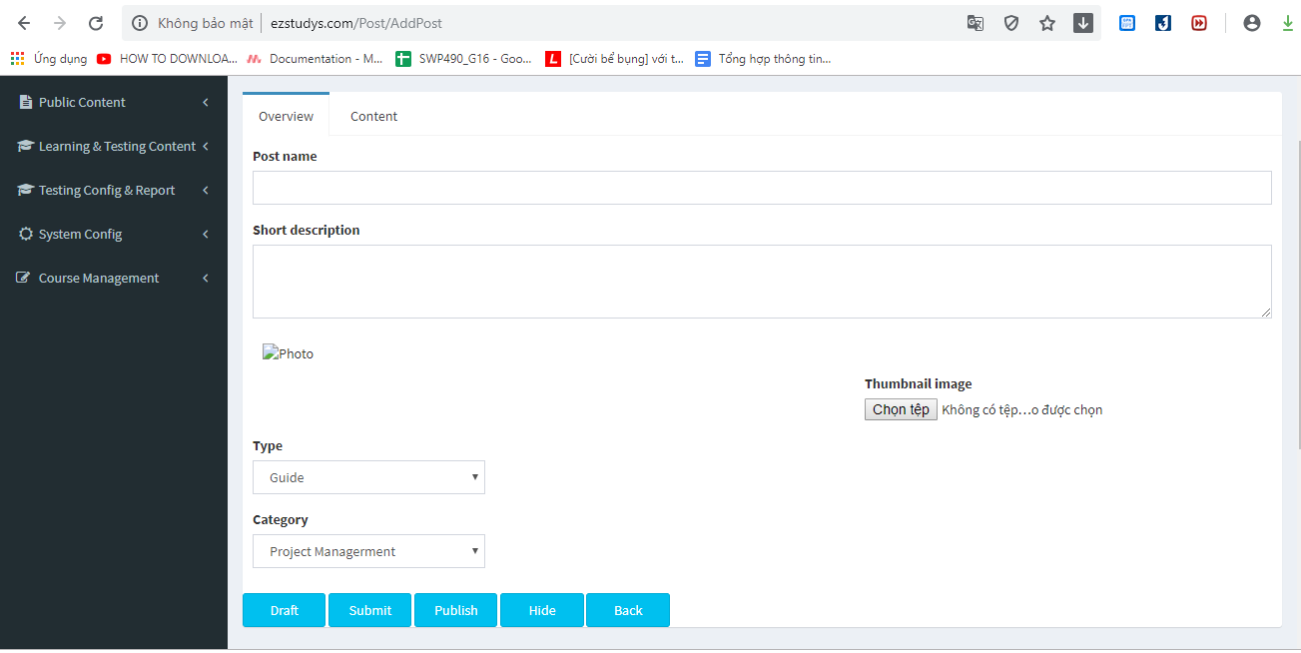

**Figure 6-29: Function** **Add new**

##### Function Edit

Admin click on “Manage” button on the top right corner, the web will redirect to Manage page. Admin click on “Subscription” button on the left menu to view manage subscription page.

Click button “Edit Post”.

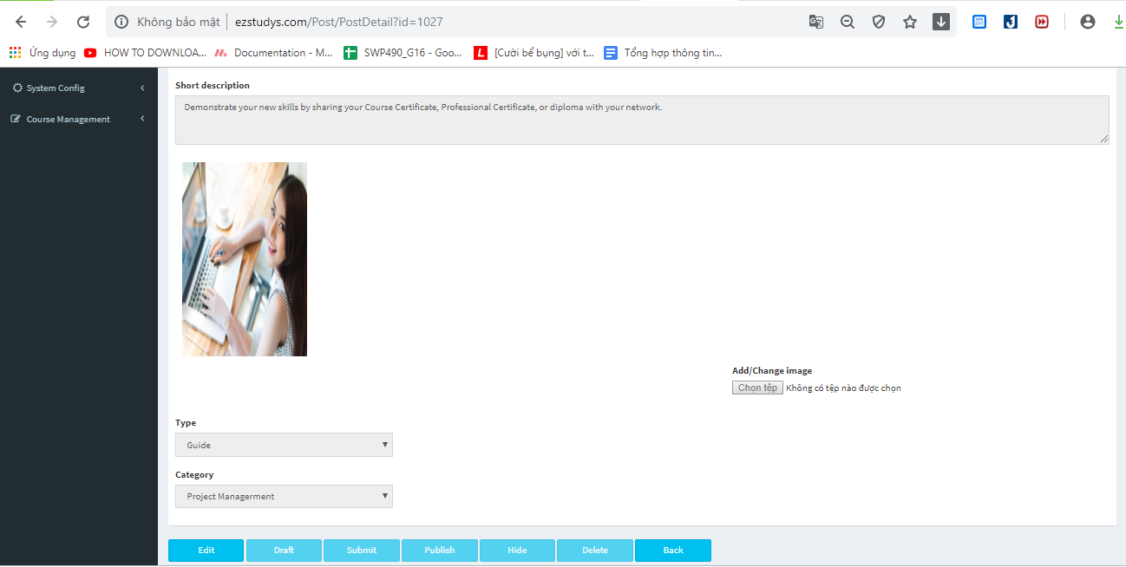

**Figure 6-30: Function** **Edit**

##### Show full data

Click drop list “Show  entries”.

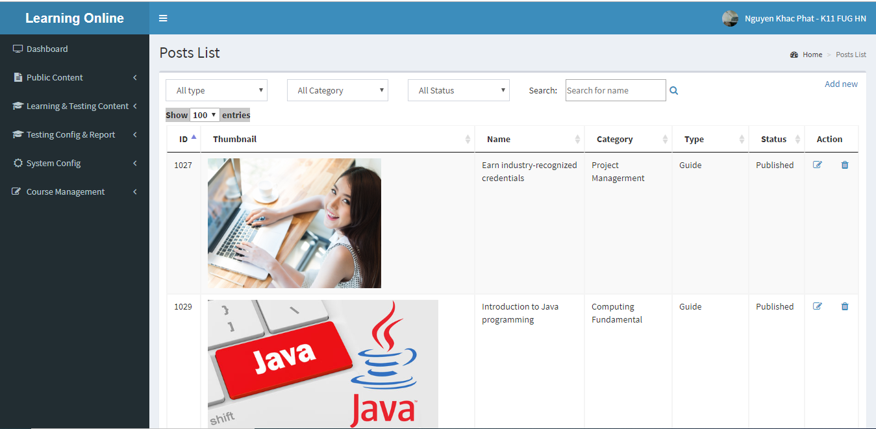

**Figure 6-31: Show full data**

.

##### Search to enter textbox

Enter information need search

Click button “Search”.

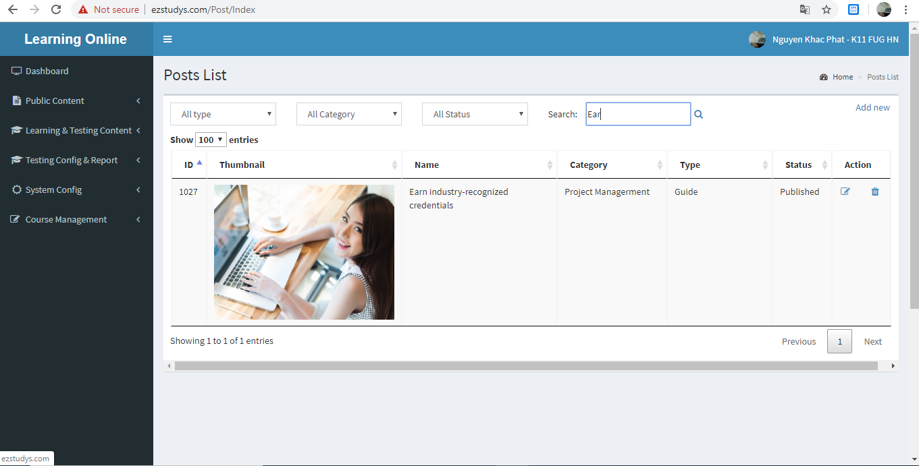

**Figure 6-32: Search data**

##### Sort data by button arrow of each column

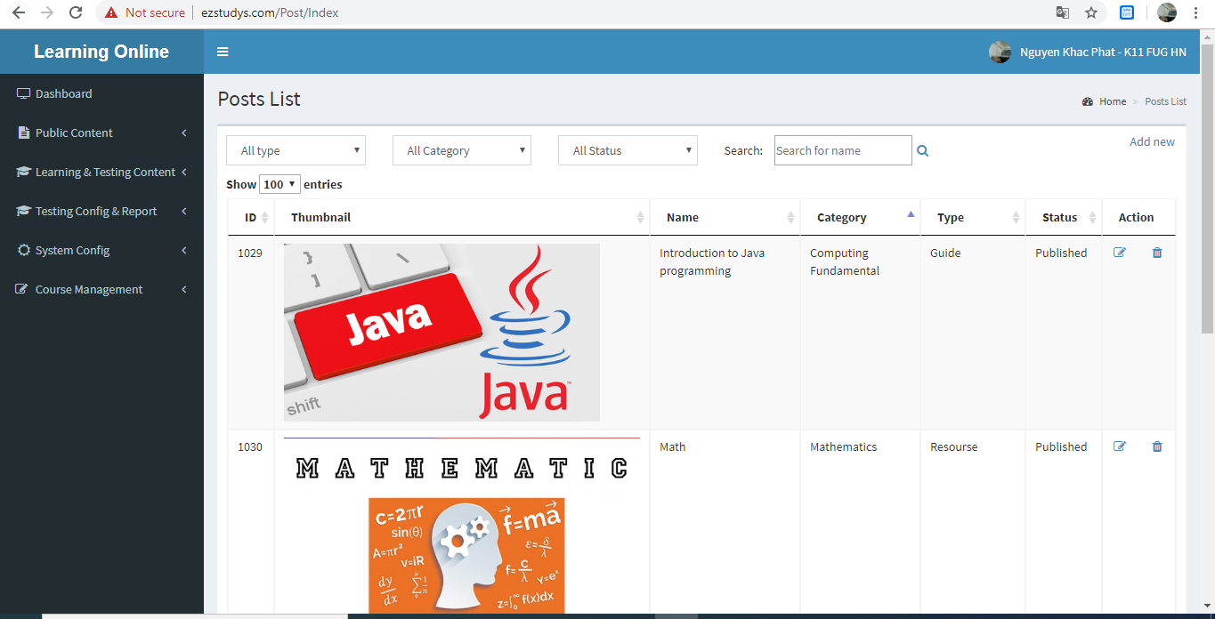

**Figure 6-33: Sort**

##### Click number of page.

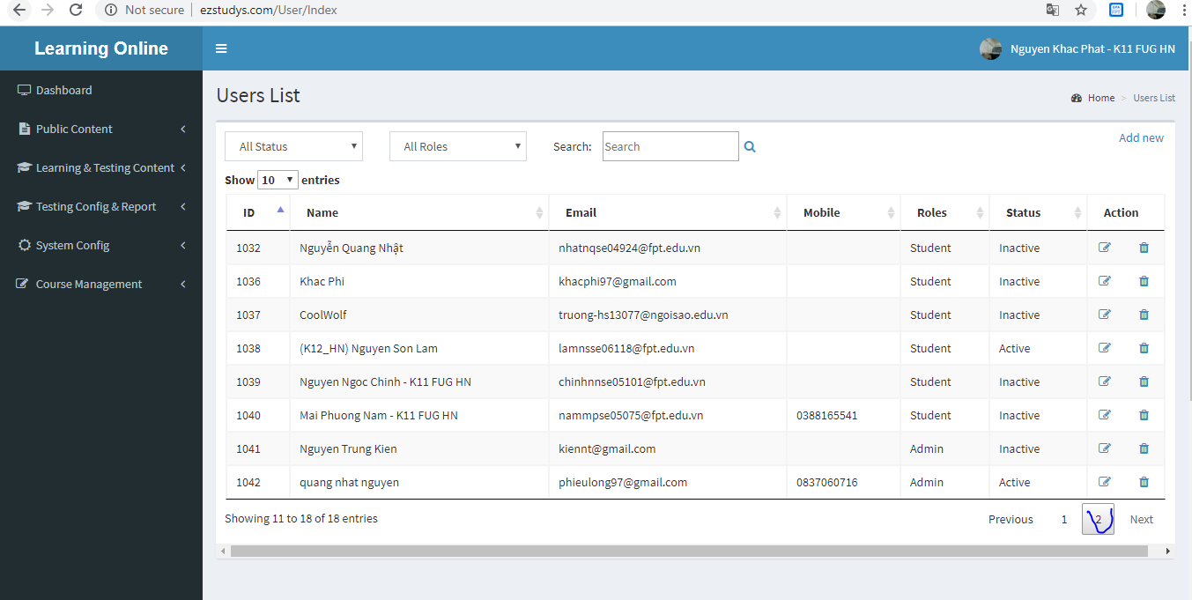

**Figure 6-34: Number of page**

1. MetaMask FAQ: <https://github.com/MetaMask/faq/>
2. MetaMask FAQ: <https://github.com/MetaMask/faq/>